Supplemental figure 4: Schematic representation of the communication between hardware (analyzers and track) and IT-systems.

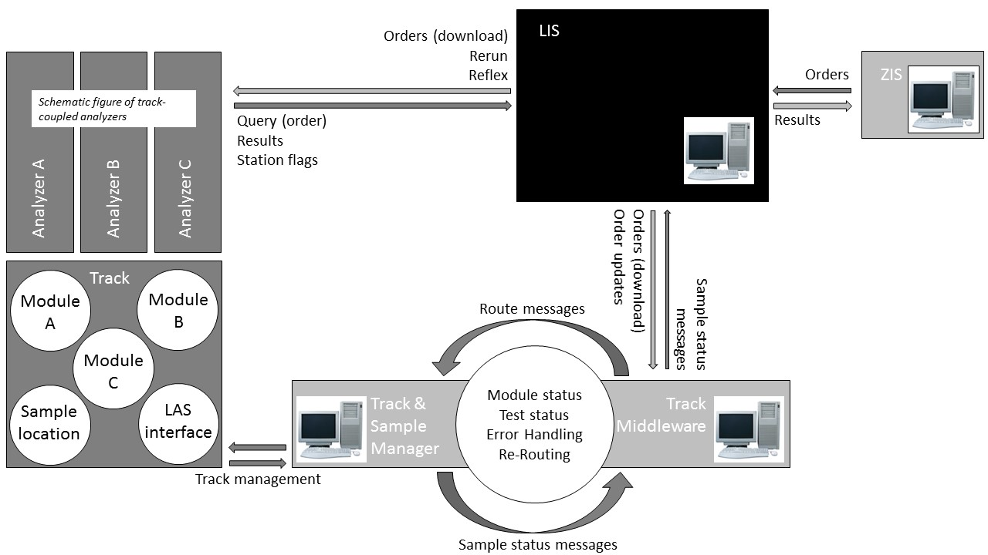
The LIMS is the only system which communicates IT-messages, either to the track or to the analyzers connected with the track. There is no direct IT-communication between the track and its connected analyzers. To summarize: LIMS is ”master” in the IT-communication.
The communication between LIMS and middleware of the track is as follows:
- The LIMS receives orders from the ZIS.
- The LIMS transmits only relevant order information (sample number, requested tests and mandatory material) via a download connection towards the Track Middleware (TM).
- Once a sample is put on the track, the TM plans a route for the sample over the track. Information from both LIMS (order information) and Track & Sample manager (TSM; information about the track status) are used.
- TSM is the ‘navigation’ system of the track and controls the track. In TSM the status of the different track modules (in- and output modules, buffers, centrifuges, rack building modules, re-/decappers, aliquoter modules and archives), LAS interface (interface which makes direct sampling from track possible), together with information about the location of the carriers and status of track components is known and transmitted to TM.
- TM transmits the route message to TSM.
- Every time a sample passes a track module a status update message is transmitted from TSM via TM to the LIMS, thereby realizing track-and-trace of samples on the track in the LIS..
- When a sample reaches via the track one of the track-connected analyzers, the analyzer queries to the LIMS which tests need to be performed.
- Once results are produced, the analyzer transmits these results directly to the LIMS.
- The LIMS subsequently reports these results to the HIS.
- The LIMS also sends a message to the TM that results are produced. When all results of a sample are produced, the sample is send to the track-connected Archive.

- Legend: Hardware is marked in grey boxes, software in light grey boxes, the LIMS is marked as a black box. IT messages the LIMS transmits are marked by a light grey arrow, receiving messages by a dark grey arrow.

Note 1:
- Upon activation of an order in the LIS, via a download connection the following information is send via the LIMS to the middleware of the track:
  - Sample number
  - Ordered tests
  - Specimen type (NB. there is no relation between sample number and material)
  - If applicable: the information for a secondary sample (sample number, volume, type of aliquot (push cap/screw cap) and information to print on the label)
- For optimal track and trace in the LIMS, the following information is send from the middleware of the track to the LIMS:
  - Arrival of a sample on each module of the track (e.g. input, buffer, centrifugation, decapper, aliquoter, recapper, output, rack builder module, archive).
  - Removal of a sample from the archive in the waste and removal of a sample from the output buffer.
- A sample will only be placed in the track-connected archive when all the results are known. The LIMS will send messages to the middleware of the track when tests are completed.
- Reruns, reflex and added tests in the LIMS will result in order update messages which are send from the LIMS to the middleware of the track.

Note 2:
Besides the LIMS, also the track middleware was configured. To keep this configuration manageable, the amount of configured tests was reduced by using ‘group codes’, which can be used for tests where analysis is performed off-line the track and when the routing on the track is similar (e.g. in the LIS, more than 200 tests are defined for allergies and these tests are performed on an off-line analyzer. As the route on the track is similar for all these allergy tests, we defined one test code in the middleware of the track). In total, about 1,000 tests are configured in the middleware of the track, instead of over 10,000 tests in the LIMS. From these 1,000 configured tests, 80-90% is performed on analyzers connected to the track.

Note 3:
Once the configuring of the LIMS and the track was realized, an intensive period of testing and training started. First simple tests and routes were tested, and step by step the complexity of testing was build up to a ‘stress test’. Multiple stress tests were performed ahead of the go life, where a representative reproduction of a ‘normal’ peak production was mimicked.

