Supplemental Material

Supplemental Methods
Sample collection and preparation
Sera were obtained between 6 and 72 hours after blood withdrawal and centrifugation at 2000g for 10 minutes, and pooled in low volumes (<15 mL). Samples were pooled to achieve an adequate volume for a robust proficiency test for all labs included in the study, since only small blood volumes could be obtained, especially for high-hepcidin concentration donors, as these donors have underlying diseases making it unethical to draw large volumes of blood.
Phlebotomy blood was processed into serum as described previously [1]. For both leftover serum and phlebotomies, one aliquot was stored for hepcidin measurement and HIV, hepatitis B, and hepatitis C testing. The rest was frozen at -80C until a total volume of 700 mL was collected.
To prepare samples for the pilot PT, we thawed all low-volume pools and phlebotomy samples that tested negative for hepatitis B, C and HIV. By mixing, we created three high-volume pools with either a low target hepcidin concentration (<2 nmol/L), a high hepcidin concentration (>8 nmol/L) or in the middle by combining small volumes of these pools in a 1:1 ratio. As a result, a three-level linearity panel was made. In addition, three more high-volume pools were made to have concentrations covering the physiological range of hepcidin, including one high target concentration (>20 nmol/L). To produce the candidate high-level calibrator, one serum pool of ~300 mL was made with a target concentration of >8 nmol/L. Cryolyoprotectant (CLP) was added to each pool and after homogenization at room temperature for approximately 30 minutes. All were distributed into glass vials and lyophilized in a freeze-dryer (Zirbus Technology, Tiel, the Netherlands) for 63 hours, as described previously [1]. The lyophilized samples were stored at 4˚C until shipment. All sample sets were transported on room temperature, as previous stability testing of the lyophilized lower and middle calibrator showed them to be stable at room temperature for up to two years [1]. Sample identification numbers were randomized (Supplemental Table 1) and the existing calibrator set was relabeled and recapped to ensure that laboratories were blinded to the nature of all samples.

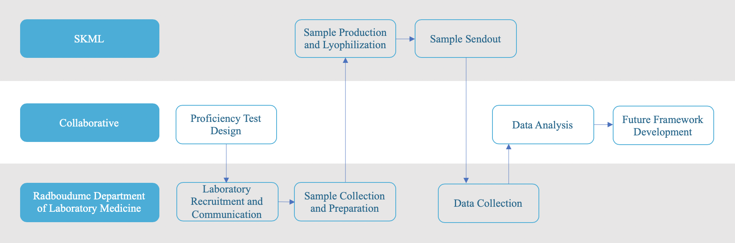
Supplemental Figure 1: Proficiency Testing Scheme. This pilot proficiency test was run as a collaboration between the Radboudumc Department of Laboratory Medicine in Nijmegen, Netherlands, and SKML in Winterswijk, Netherlands. Responsibilities were partly shared between the two organizations, as shown by the middle three tasks.
Supplemental Table 1: Proficiency test design and samples target values.
Sample Nature | Sample ID | Target Value (nmol/L)
Low Linearity Replicate 1 | HPT2020-S1 | 1.37
Low Linearity Replicate 2 | HPT2020-S4 | 1.37
Middle Linearity Replicate 1 | HPT2020-S6 | 6.06
Middle Linearity Replicate 2 | HPT2020-S8 | 6.06
High Linearity Replicate 1 | HPT2020-S3 | 11.12
High Linearity Replicate 2 | HPT2020-S5 | 11.12
Additional Sample 1 | HPT2020-S11 | 9.67
Additional Sample 2 | HPT2020-S10 | 11.69
Additional Sample 3 | HPT2020-S9 | 21.18
Low Calibrator | HPT2020-S7 | 0.95
Middle Calibrator | HPT2020-S2 | 3.75
High Calibrator | HPT2020-S12 | 9.07

The target values for the proficiency test samples were assigned using the values from the calibrated candidate reference method, MS-1. The calibrator target values are the official assigned values.
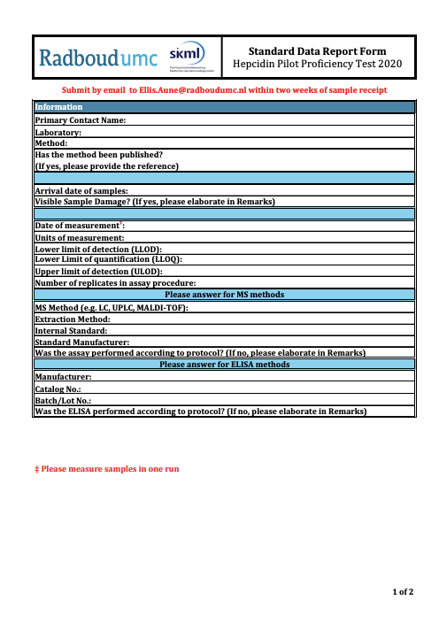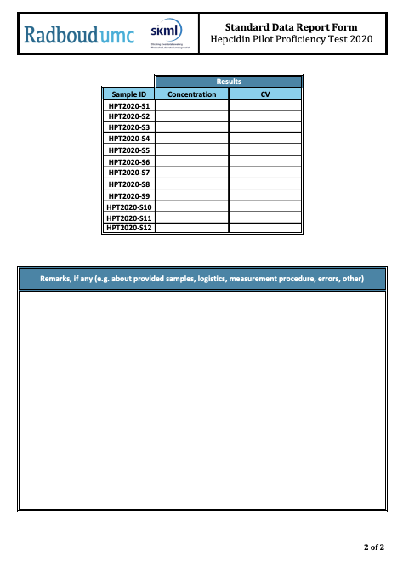
Supplemental Figure 2: Hard Copy Version of Standard Data Report Form. All laboratories were provided with the standard data report form included with the sample shipment.

Supplemental Table 2: Raw Data.
Sample Nature | ID | MS-1 | MS-2 | MS-4 | MS-5 | MS-6 | MS-7 | MS-8 | MS-9 | MS-10 | IC-1 | IC-3 | IC-5 | IC-6 | IC-7 | IC-8 | IC-9
Low Linearity Replicate 1 | S1 | 1.36 | 2.42 | 2.4 | 1.8 | 2.2 | 2.99 | 2.12 | 1.72 | 3.27 | 2.06 | 1.91 | 2.22 | 6.81 | 3.97 | 1.969 | 3.18
Low Linearity Replicate 2 | S4 | 1.36 | 2.08 | 2.3 | 2.7 | 2.17 | 3.97 | 2.2 | 1.68 | 3.27 | 2.07 | 1.85 | 2.05 | 8.42 | 3.94 | 1.88 | 2.83
Middle Linearity Replicate 1 | S6 | 5.84 | 7.26 | 7.4 | 6.4 | 7.7 | 12.04 | 10.07 | 6.05 | 11.19 | 8.16 | 7.46 | 9.25 | 23.77 | 14.28 | 8.7 | 11.13
Middle Linearity Replicate 2 | S8 | 5.84 | 7.72 | 7.5 | 7.1 | 7.52 | 11.37 | 7.98 | 5.94 | 10.96 | 8.32 | 8.40 | 9.40 | 21.00 | 12.60 | 8.23 | 11.5
High Linearity Replicate 1 | S3 | 10.68 | 12.3 | 12.6 | 11.5 | 12.6 | 18.10 | 13.65 | 9.42 | 18.65 | 14.75 | 14.99 | 14.17 | 33.65 | 24.42 | 14.14 | 17.15
High Linearity Replicate 2 | S5 | 10.68 | 11.84 | 12.6 | 6.9 | 12.1 | 18.48 | 14.89 | 10.31 | 18.82 | 13.87 | 14.23 | 15.47 | 34.10 | 23.56 | 14.75 | 17.7
Add. Sample 1 | S11 | 9.29 | 10.6 | 12.6 | 7.6 | 11.2 | 17.70 | 13.83 | 8.02 | 16.21 | 11.55 | 10.03 | 13.12 | 30.73 | 20.12 | 13.32 | 16.84
Add. Sample 2 | S10 | 11.22 | 13.0 | 13.1 | 12.1 | 13.5 | 20.00 | 14.6 | 10.81 | 20.87 | 16.72 | 14.89 | 17.78 | 36.71 | 23.77 | 19.8 | 23.77
Add. Sample 3 | S9 | 20.29 | 23.8 | 25.9 | 22.6 | 26 | 34.04 | 35.67 | 19.51 | 37.94 | 34.15 | 28.30 | >29 | 67.72 | 40.42 | >29 | >29
Low Calibrator | S7 | 0.95 | 1.64 | 1.6 | 1.7 | 1.68 | 3.80 | 1.64 | 1.21 | 2.29 | 1.40 | 1.43 | 1.27 | 5.91 | 3.15 | 1.57 | 2.09
Middle Calibrator | S2 | 3.75 | 4.82 | 5.3 | 4.9 | 5.09 | 7.85 | 5.509 | 4.26 | 7.51 | 4.33 | 4.29 | 5.16 | 16.70 | 7.27 | 4.44 | 6.5
High Calibrator | S12 | 8.68 | 9.92 | 10.8 | 6.9 | 10.2 | 15.25 | 11.85 | 7.98 | 15.45 | 9.47 | 8.43 | 11.95 | 28.36 | 20.48 | 12.32 | 14.27
MS, mass spectrometry; IC, immunochemistry; Add., additional
All data reported in ng/mL was converted to nmol/L.
Supplemental Table 3: Comparative summary data for MS and IC methods for all PT samples.
Sample | MS Average (nmol/L) | MS CV (%) | IC Average (nmol/L) | IC CV (%)
HPT2020-S1 | 2.43 | 31.5 | 3.29 | 72.4
HPT2020-S2 | 5.50 | 23.7 | 6.96 | 64.0
HPT2020-S3 | 13.15 | 28.8 | 19.10 | 38.8
HPT2020-S4 | 2.27 | 25.1 | 3.16 | 56.4
HPT2020-S5 | 13.43 | 22.6 | 19.04 | 38.9
HPT2020-S6 | 8.10 | 22.7 | 11.35 | 40.4
HPT2020-S7 | 1.85 | 43.9 | 2.4 | 69.8
HPT2020-S8 | 8.30 | 26.7 | 11.82 | 48.6
HPT2020-S9 | 27.63 | 23.7 | 42.65 | 40.9
HPT2020-S10 | 14.54 | 24.1 | 21.92 | 33.5
HPT2020-S11 | 12.05 | 28.4 | 16.53 | 43.1
HPT2020-S12 | 10.91 | 26.7 | 15.04 | 47.0
Average |  | 27.3 |  | 49.5
MS, mass spectrometry; IC, immunochemistry; CV, coefficient of variation

The averages and CVs were calculated using all laboratory reported values for each sample.

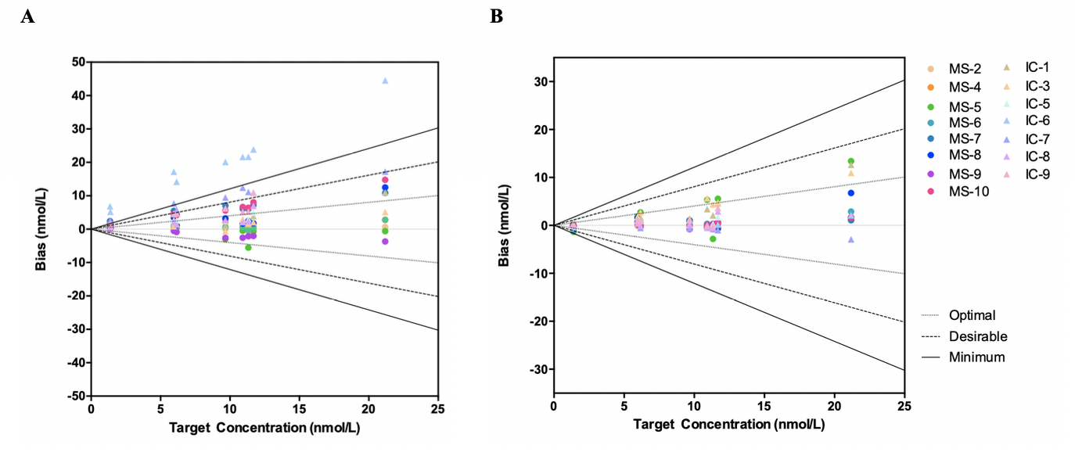

Supplemental Figure 3: Bias from target values before (A) and after standardization (B) with the three-leveled sRM including MS-5. Bias (nmol/L, y-axis) was calculated by subtracting the target value (nmol/L, x-axis), as determined by MS-1, from the reported value for each sample (n=9) from each measurement procedure. Calibration with the sRM was done using linear regression with the calibration samples (S2, S7, and S12) to recalculate the reported values. Optimal, desirable, and minimum TEa were defined as 40.3%, 80.7%, and 121.0% respectively based on reported inter- and intra-individual CVs for hepcidin [2, 3]. Data is included from all participating laboratories, regardless of analytical performance.

References
- Diepeveen LE, Laarakkers CM, Martos G, Pawlak ME, Uğuz FF, Verberne KE, et al. Provisional standardization of hepcidin assays: Creating a traceability chain with a primary reference material, candidate reference method and a commutable secondary reference material. Clin Chem Lab Med 2019;57:864-72.
- White GH, Farrance I. Uncertainty of measurement in quantitative medical testing: a laboratory implementation guide. The Clinical Biochemist Reviews. 2004;25:S1.
- Murphy AT, Witcher DR, Luan P, Wroblewski VJ. Quantitation of hepcidin from human and mouse serum using liquid chromatography tandem mass spectrometry. Blood 2007;110:1048–54.

