**Supplemental Tables and Figures**

**Table 1**. Precursor and product transitions and mass spectrometer settings.

|  |  |  |  |  |  |
| --- | --- | --- | --- | --- | --- |
|  | Precursor ion,  *m/z* | Product ion,  *m/z* | | Collision energy,  eV | Cone voltage,  V |
| Analytes |  |  |  | |  |
| 6-Sulfatoxymelatonin (quantifier)  6-Sulfatoxymelatonin (qualifier) | 329  329 | 190  158 | | 23  35 | 22  22ulfatoxymelatoninopey |
| Internal standards |  |  | |  |  |
| 6-Sulfatoxymelatonin-d4 (quantifier)  6-Sulfatoxymelatonin-d4 (qualifier) | 333  333 | 194  161 | | 23  35 | 22  22 |
|  | | | | | |

*m/z*, mass over charge ratio; eV, electron volt; V, volt.

**Table 2**. Intra- and interassay imprecision and recovery results.

|  |  |  |  |  |  |  |  |
| --- | --- | --- | --- | --- | --- | --- | --- |
|  | Intraassaya | | | Interassayb | | | Recovery |
|  | **Mean,**  nmol/L | **SD,**  nmol/L | **CV,**  % | **Mean,**  nmol/L | **SD,**  nmol/L | **CV,**  % | **Mean (range)**  % |
|  |  |  |  |  |  |  |  |
| Low | 6.39 | 0.16 | 2.5 | 6.43 | 0.35 | 5.4 | 97.4 (90–104) |
| Medium | 30.1 | 0.60 | 2.0 | 30.7 | 0.90 | 2.9 | 101 (90–111) |
| High | 111 | 2.4 | 2.1 | 114 | 3.8 | 3.4 | 101 (91–115) |
| a n=20; b n=12. | | | | | | | |

CV, coefficient of variation; SD, standard deviation.

**Table 3**. Descriptive data of study population in the biological variation study.

|  |  |  |
| --- | --- | --- |
| Individual | Sex | Age, years |
| 1 | ♂ | 24 |
| 2 | ♀ | 58 |
| 3 | ♀ | 29 |
| 4 | ♀ | 33 |
| 5 | ♂ | 39 |
| 6 | ♂ | 19 |
| 7 | ♀ | 21 |
| 8 | ♀ | 21 |
| 9 | ♀ | 48 |
| 10 | ♀ | 22 |

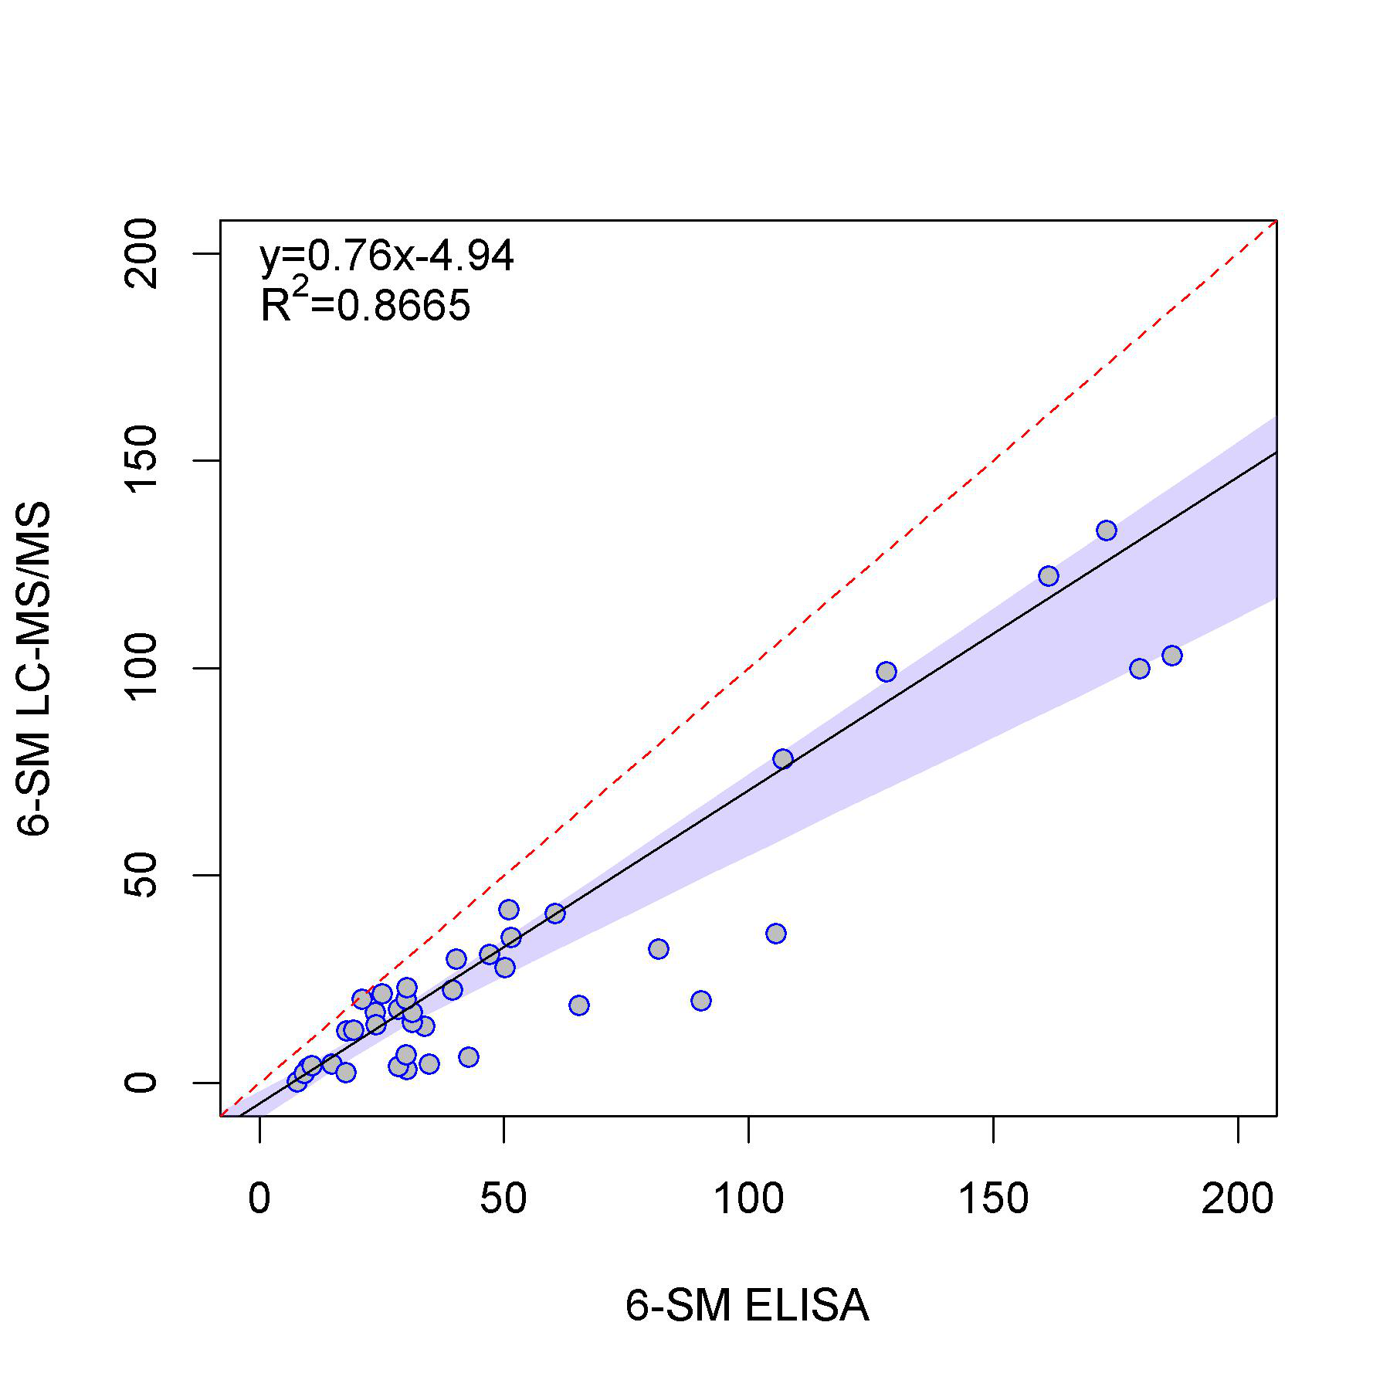

**Figure 1.** Scatter plot to compare two methods for measuring 6-sulfatoxymelatonin in 40 urine samples.

X-axis: 6-sulfatoxymelatonin concentrations measured by ELISA (in nmol/L). Y-axis: 6-sulfatoxymelatonin concentrations measured by LC-MS/MS (in nmol/L). Dashed line represents the line of identity. Passing-Bablok regression analysis is shown by the solid line. Blue shaded area represents the 95% confidence interval. Dashed line is the line of identity. Abbreviations: 6-SM, 6-sulfatoxymelatonin; LC-MS/MS, liquid chromatography tandem mass spectrometry.



**Figure 2.** Scatter plot of urinary 6-sulfatoxymelatonin excretion (nmol/24 h) in healthy individuals between 20 and 80 years old.