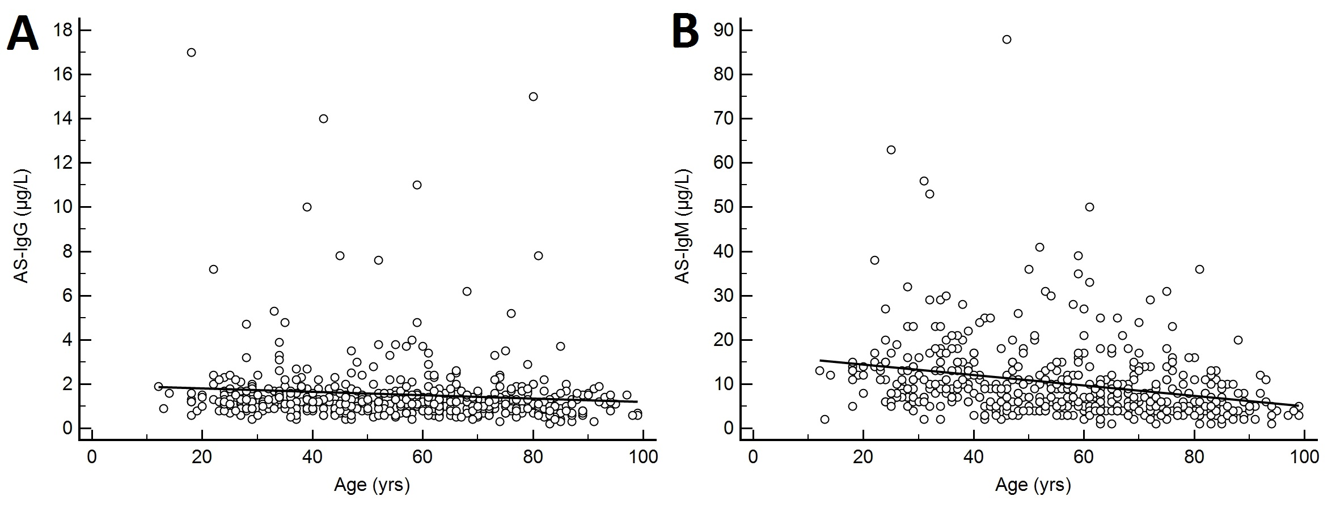 Supplementary Figure 1. Least squares regression analyses of age relative to the anti-streptavidin (AS)-IgG (A) and AS-IgM (B) concentrations. A: y (AS-IgG concentration, µg/L)=1.962–0.0078x (age, years); n=500. B: y (AS-IgM concentration, µg/L)=16.74–0.117x (age, years); n=500.

