Supplementary Figure 1. $MaxE\left(N_{UF}\right)$ as a function of $∆m$ for a 3σ analytical process with different biases. The analytical process is controlled by bracketed QC with different${ 1}_{ks}$ rules (k = 2, 2.5, 3) with a control sample analyzed by QC event (n = 1) and 100 patient samples analyzed between QC events. The value of $MaxE\left(N_{UF}\right)$ is expressed relative to that for rejection limits centered on the instrument mean ($∆m$ = 0). $∆m$ is expressed as a multiple of $s_{a}$.

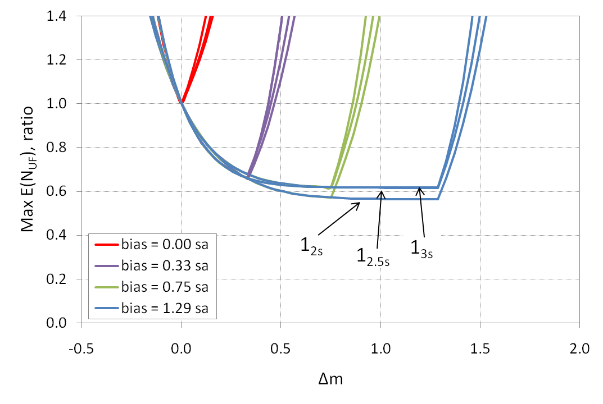

Supplementary Figure 2. $MaxE\left(N_{UF}\right)$ as a function of $∆m$ for a 3σ analytical process with different biases. The analytical process is controlled by bracketed QC with different${ 1}_{ks}$ rules (k = 2, 2.5, 3) with two control samples analyzed by QC event (n = 2) and 100 patient samples analyzed between QC events. The value of $MaxE\left(N_{UF}\right)$ is expressed relative to that for rejection limits centered on the instrument mean ($∆m$ = 0). $∆m$ is expressed as a multiple of $s_{a}$.

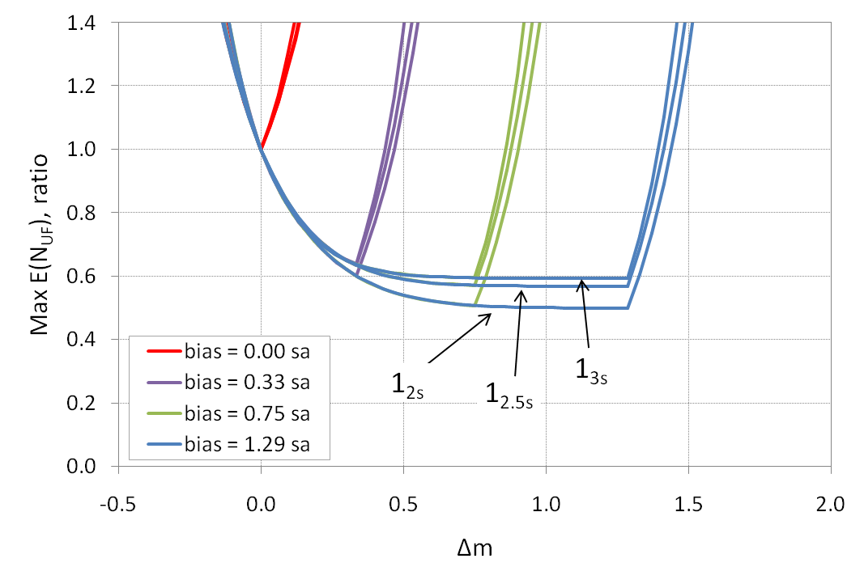

Supplementary Figure 3. $MaxE\left(N_{UF}\right)$ as a function of $∆m$ for a 4σ analytical process with different biases. The analytical process is controlled by bracketed QC with different${ 1}_{ks}$ rules (k = 2, 2.5, 3) with two control samples analyzed by QC event (n = 2) and 100 patient samples analyzed between QC events. The value of $MaxE\left(N_{UF}\right)$ is expressed relative to that for rejection limits centered on the instrument mean ($∆m$ = 0). $∆m$ is expressed as a multiple of $s_{a}$.

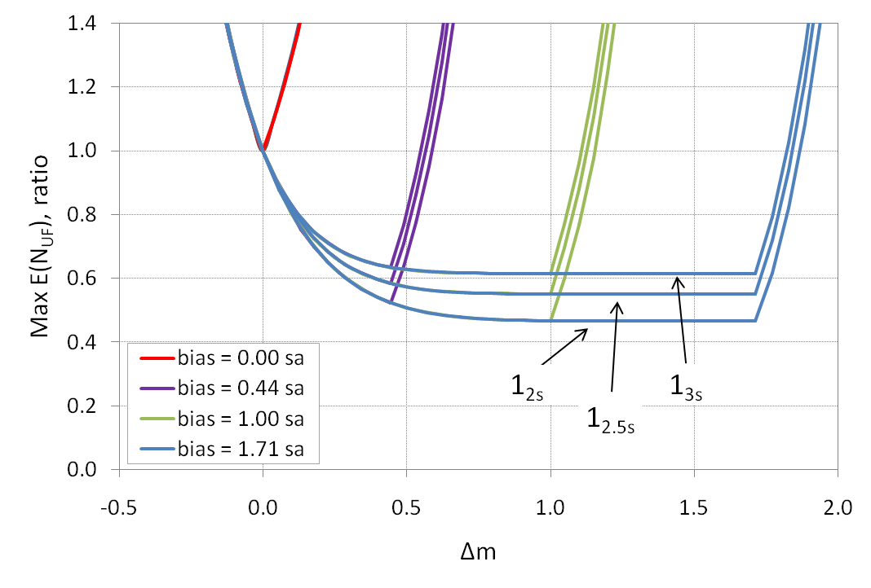

Supplementary Figure 4. $MaxE\left(N_{UF}\right)$ as a function of $∆m$ for a 6σ analytical process with different biases. The analytical process is controlled by bracketed QC with different$1_{ks}$ rules (k = 2, 2.5, 3) with two control samples analyzed by QC event (n = 2) and 100 patient samples analyzed between QC events. The value of $MaxE\left(N_{UF}\right)$ is expressed relative to that for rejection limits centered on the instrument mean ($∆m$ = 0). $∆m$ is expressed as a multiple of $s_{a}$.

