Supplementary Material
Diagnostic amyloid proteomics: experience of the UK National Amyloidosis Centre,
Diana Canetti et al.

Amyloid proteomic procedure
We use the procedure originally developed by Dogan and colleagues [1, 2]. Unfixed fat aspirates and FFPE tissues are obtained from patients attending the UK NHS National Amyloidosis Centre for diagnostic purposes, or sent for histological review from other centres. All samples are examined by Congo red staining for amyloid and by IHC as previously described [3, 4]. Congo red positive FFPE samples are micro-dissected (6µm thick sections) and captured into the lid of an Eppendorf 0.5 ml micro-centrifuge tube using a Leica LDM7 laser capture microscope. The lid is partially filled with 35µl of 10mM tris base in MilliQ water containing 1mM EDTA and 0.002% Zwittergent (TEZ buffer). The dissected material in TEZ buffer is deposited in the base of the tube by centrifugation (1000 RCF for 5 minutes). Samples are heated at 99°C for 1.5 hours followed by sonication for 1 hour in a VWR ultrasonic cleaner. Trypsin Gold (100µg) is dissolved in 100 µl of 0.05M acetic acid; 5 µl aliquots are frozen at -80°C until required. A single aliquot is thawed and diluted in 245µl of TEZ buffer and 1.5µl (30ng) is added to the sample followed by incubation overnight at 37°C. The sample is incubated with dithiothreitol (50 μg) at 99°C for 5 minutes. The final solution is removed under vacuum without heating and peptides re-suspended in 0.1% trifluoroacetic acid in water with sonication; any remaining solids are removed by centrifugation (10,000 RCF for 10 minutes). Unfixed tissue pieces, including fat aspirates, are washed with phosphate buffered saline and then digested in the same way as FFPE samples; separate tissue pieces are stained with Congo red to confirm the presence of amyloid. Proteomics data were originally collected on a Thermo Scientific Velos mass spectrometer [5] but, since August 2017, have been acquired on a Thermo Scientific™ Q-Exactive Plus Orbitrap mass spectrometer connected to an Ultimate 3000 nanoLC system [6]. The change of instrument was validated by comparing both controls and by re-analysing clinical samples from a range of tissues. Samples are trapped on a Thermo Scientific Acclaim PepMap C18 cartridge (0.3 mm x 5 mm, 5 µm/100 Å) and then chromatographed on a Thermo Scientific Easy-Spray Acclaim PepMap C18 column (75µm x 15cm, 3µm/100Å packing) eluting at 300nl/min with a 30 min linear gradient of acetonitrile:water:formic acid (5:95:0.1 – 56:44:0.1 v/v/v). A full MS scan (m/z 350-1400) is acquired with a maximum injection time of 100 ms, and the 10 most intense ions with an intensity threshold 2.0e4 are selected for higher-energy C-trap dissociation (HCD). The lock mass is set at m/z 445.12003. The normalised collision energy is 28, with an isolation width of 2 Da and dynamic exclusion of 20 s; singly charged ions are excluded. Data are analysed using Mascot software (Matrix Science, London, UK) using the Swiss-Prot human database, together with additional amyloid protein variant databases as appropriate. Search parameters are: precursor mass tolerance of 10 ppm, 0.6 Da for HCD fragments, trypsin (and semi-trypsin as required) are included as the proteolytic enzyme, two missed cleavages, included charge states +2, +3 and +4 and a significance level at p<0.05. Methionine oxidation was included as variable modification; N-methyl lysine is also included as variable modification when required. Optima LCMS grade water, acetonitrile, formic acid and trifluoroacetic acid are obtained from Fisher Scientific, UK. Each batch of clinical samples is accompanied by a number of controls which include a cytochrome C digest and a control protein (α-synuclein) added to a non-amyloid tissue sample to demonstrate LCMS integrity and trypsin sensitivity respectively. A sample of amyloidotic tissue from a patient with AL (lambda) amyloidosis is also included as a marker of the entire process from Congo red staining and laser capture dissection through to data analysis. Ideally each sample of Congo red material should be accompanied by a control cut from a Congo red negative area of tissue. This was routinely undertaken when our procedure was originally developed, and showed that the amyloid and signature proteins were mainly associated with Congo red staining. As sample throughput increased, this was no longer a viable option and the use of this additional control was discontinued. We noted that samples containing serum amyloid A (SAA) and, to a lesser extent, TTR and other amyloid proteins, could result in some carryover into the next sample. To minimise contamination, we have included an acid, base and organic injection wash protocol after every sample. The autosampler fluidics and trapping cartridge are washed between each sample using a protocol (adapted from Fang [7] to include separate washes of 10% formic acid, 0.1% trifluoroacetic acid, 1% ammonia in 50% acetonitrile, 80% methanol and 80% acetonitrile in water. We also include a full blank run between each sample to confirm that there is no carryover from sample to sample. Although this doubles the analysis time for each sample it increases confidence in the amyloid typing.

The following amyloidogenic proteins have been identified by proteomics in our patients: apolipoproteins A-I, A-IV, C2, C3, atrial natriuretic peptide, fibrinogen Aα chain, galectin-7, gelsolin, immunoglobulin light chains κ and λ, heavy chain, insulin, leukocyte cell-derived chemotaxin-2, lysozyme, β2-microglobulin, semenogelin, serum amyloid A and transthyretin. The centre does not treat amyloid-associated brain disease and we do not normally study Aβ or other proteins and peptides causing neurodegenerative diseases.

Supplementary Figure S1. Audit data for 2018 (n=433) showing the tissue type of clinical samples sent for proteomic analysis (a) and the identity of the amyloid proteins (b). The main amyloid proteins identified were the immunoglobulin light chains and TTR. Other segments represent all amyloid proteins with <10 identifications, amyloid negative and inadequate samples. Panel (c) shows the comparison of IHC and proteomics, with IHC-inconclusive samples identified by proteomics in panel (d).
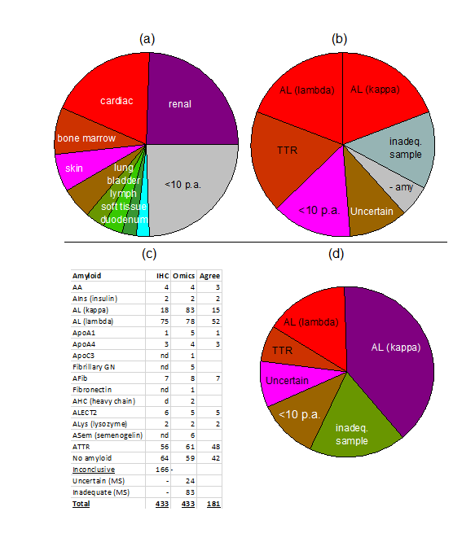
Supplementary Figure S2: Effect of acetonitrile/TFA pre-treatment of human spleen TTR fibrils on the Mascot score of the amyloid protein (TTR) and signature proteins.

Supplementary Table S1: Effect of acetonitrile/TFA pre-treatment on amyloid protein score on paired FFPE tissues.

Patient | Type of amyloidosis | Tissue | Number of proteins identified |  | Amyloid protein | Mascot score Untreated | Mascot score Treated
Patient | Type of amyloidosis | Tissue | Untreated | Treated | Amyloid protein | Mascot score Untreated | Mascot score Treated
1 | AL (kappa) | sub muc. vessels | 25 | 41 | Ig(κ) | 84 | 226
2 | AL (lambda) | laryngeal | 59 | 71 | Ig(λ) | 154 | 192
3 | ATTR | bladder | 56 | 79 | TTR | 1629 | 3015
4 | ATTR | cardiac | 15 | 55 | TTR | 415 | 1420
5 | ATTR | cardiac | 33 | 69 | TTR | 82 | 2774
6 | ATTR | cardiac | 164 | 102 | TTR | 5570 | 3933
7 | ATTR | cardiac | 37 | 41 | TTR | 888 | 783
8 | ATTR | cardiac | 43 | 63 | TTR | 1235 | 1577
Supplementary material references
1. Rodriguez FJ, Gamez JD, Vrana JA, Theis JD, Giannini C, Scheithauer BW, et al. Immunoglobulin derived depositions in the nervous system: novel mass spectrometry application for protein characterization in formalin-fixed tissues. Lab Invest. 2008;88:1024-37.
2. Vrana JA, Gamez JD, Madden BJ, Theis JD, Bergen HR, 3rd, Dogan A. Classification of amyloidosis by laser microdissection and mass spectrometry-based proteomic analysis in clinical biopsy specimens. Blood. 2009;114:4957-9.
3. Tennent GA, Cafferty KD, Pepys MB, Hawkins PN. Congo red overlay immunohistochemistry aids classification of amyloid deposits. In: Kyle RA, Gertz MA, editors. Amyloid and Amyloidosis, 1998. Pearl River, New York: Parthenon Publishing; 1999. p. 160-2.
4. Rezk T, Gilbertson JA, Mangione PP, Rowczenio D, Rendell NB, Canetti D, et al. The complementary role of histology and proteomics for diagnosis and typing of systemic amyloidosis. The Journal of Pathology: Clinical Research. 2019;5:145-53.
5. Canetti D, Rendell NB, Di Vagno L, Gilbertson JA, Rowczenio D, Rezk T, et al. Misidentification of transthyretin and immunoglobulin variants by proteomics due to methyl lysine formation in formalin-fixed paraffin-embedded amyloid tissue. Amyloid. 2017;24:233-41.
6. Taylor GW, Gilbertson JA, Sayed R, Blanco A, Rendell NB, Rowczenio D, et al. Proteomic Analysis for the Diagnosis of Fibrinogen Aalpha-chain Amyloidosis. Kidney Int Rep. 2019;4:977-86.
7. Fang J, Rand KD, Beuning PJ, Engen JR. False EX1 signatures caused by sample carryover during HX MS analyses. Int J Mass Spectrom. 2011;302:19-25.

