**Supplemental data**

The population pharmacokinetic parameters were described by the following equations, where CL and V1 are the individual parameters, θ1 is the population value of CL, θ2 the population value of V1, θ5 and θ6 are the population parameters for the influence of serum creatinine (SCR) and age on iohexol CL, respectively, and θ7, the population parameter for the influence of the body Surface Area (BSA) on V1 (Table S1):

$CL= θ_{1} . {\left(\frac{SCR}{{SCR}_{med}}\right)}^{-θ_{5}}. {\left(\frac{AGE}{{AGE}_{med}}\right)}^{-θ_{6}}$

$V_{1}= θ_{2} . {\left(\frac{BSA}{{BSA}_{med}}\right)}^{-θ_{7}}$

**Table S1**: Covariate Analysis during population PK modeling of iohexol

|  |  |  |  |  |
| --- | --- | --- | --- | --- |
| **Model description** | **OFV** | **∆OFV** | **Covariate-PK parameter relationship tested** | **Significance** |
| ***Base structural model*** | ***3827.259*** |  |  |  |
| ***Forward 1*** | ***3786.918*** | ***-40.341*** | ***+ SCR on CL*** | *** |
| ***Forward 2*** | ***3782.476*** | ***-4.442*** | ***+ UREA on CL*** | * |
| ***Forward 3*** | ***3776.604*** | ***-5.872*** | ***+ AGE on CL*** | * |
| ***Forward 4*** | ***3772.333*** | ***-4.271*** | ***+ DIAB on CL*** | * |
| ***Forward 5*** | ***3747.414*** | ***-24.919*** | ***+ BSA on V1*** | *** |
| ***Forward 6*** | ***3740.487*** | ***-6.927*** | ***+ DIU on V1*** | ***\*\**** |
| Intermediate covariate model | 3740.487 |  | SCR, UREA, AGE and DIAB on CL  BSA and DIU on V1 |  |
| ***Backward 1*** | ***3740.487*** |  |  |
|  | 3777.403 | 36.916 | - SCR on CL | *** |
|  | ***3742.527*** | ***2.04*** | ***- UREA on CL*** | ***NS*** |
|  | 3747.399 | 6.912 | - AGE on CL | ** |
|  | ***3746.359*** | ***5.872*** | ***- DIAB on CL*** | ***NS*** |
|  | 3765.578 | 25.091 | - BSA on V1 | *** |
|  | ***3746.993*** | ***6.506*** | ***- DIU on V1*** | ***NS*** |
| ***Backward 2*** | ***3742.527*** |  | ***SCR and AGE on CL + BSA on V1*** |  |
|  | 3771.658 | 29.131 | - SCR on CL | ** |
|  | 3755.455 | 12.928 | - AGE on CL | ** |
|  | 3767.107 | 24.580 | - BSA on V1 | ** |
| **Final model** | **3742.527** |  | **SCR and AGE on CL + BSA on V1** |  |

*AGE: age; BSA: body surface area; CL: clearance; DIAB: Patient with diabetes (YES/NO); DIU: treatment with diuretics (YES/NO); SCR: serum creatinine; V1: Volume of the central compartment.*

*Bold italic font indicates the model that was used as a reference for the next covariate testing.*

*NS: not statistically significant; * ≤ 0.05; ** ≤ 0.01; *** ≤ 0.001 (P ≤ 0.05 if ∆OFV ≤ 3.84 for stepwise addition and P ≤ 0.01 if ∆OFV ≤ 6.67 for backward elimination)*

**Table S2:** Final parameter estimates and bootstrap results for the full population pharmacokinetics model.

|  |  |  |
| --- | --- | --- |
| Parameter | Final parameter estimates  (%RSE) | Nonparametric 95% CI  (Bootstrap)* |
| **Structural model** | |  |
| CL (mL/min) |  |  |
| θ1 | 45.71 (2.9) | 43.32- 47.72 |
| θ5 | 0.47 (16.3) | 0.33 - 0.61 |
| θ6 | 0.22 (34.7) | 0.10 - 0. 36 |
| V1 (mL) |  |  |
| θ2 | 8312.40 (3.3) | 7833.50- 8767.69 |
| θ7 | 1.68 (16.2) | 1.18 - 2.15 |
| Q (mL/min) |  |  |
| θ3 | 162.10 (5.3) | 146.15 – 176.88 |
| V2 (mL) |  |  |
| θ4 | 6101 (4.1) | 5670 - 6670 |
| **Inter-individual variability, %CV** | |  |
| CL | 25.95 (7.7) | 22.05 - 28.94 |
| V1 | 28.35 (7.2) | 24.81 - 31.55 |
| Q | 26.59 (19.4) | 14.82 - 33.72 |
| V2 | 30.58 (13.2) | 24.31 – 37.13 |
| **Residual, unexplained variability, %CV** | |  |
| Proportional residual error | 4.2 (8.0) | 3.58 - 4.66 |

*Agemed = 55.2 years; BSA: Body Surface Area; BSAmed = 1.84 m2; CL = clearance; RSE, relative standard error; SCR: Serum creatinine; SCRmed = 139 (µmol/L); V1 = central volume of distribution; V2 = peripheral volume of distribution; *1 000 bootstrap replicates*

**Table S3**: Performance of each sampling strategy tested for Bayesian estimation. CL is expressed in mL.min-1.

|  |  |  |  |  |
| --- | --- | --- | --- | --- |
| **Limited sampling strategies (min)** | **Number of patients with sampling times fitting the strategy tested** | **Mean bias (%)** | **RMSE (%)** | **Number (%) of CLBE estimates outside ± 15% of the reference** |
| 5-120-180 | 21 | 11.24 | 4.53 | 10 (47) |
| 5-120-240 | 21 | 9.78 | 3.01 | 5 (24) |
| 5-120-270 | 22 | 7.78 | 2.75 | 4 (18) |
| 5-180-240 | 20 | 10.98 | 3.34 | 5 (25) |
| 5-180-270 | 21 | 8.12 | 3.06 | 4 (19) |
| 5-240-270 | 21 | 8.93 | 3.38 | 4 (19) |
| 20-120-180 | 8 | 9.17 | 2.65 | 1 (12) |
| 20-120-240 | 8 | 5.10 | 1.38 | 1 (12) |
| 20-120-270 | 8 | 0.93 | 0.85 | 1 (12) |
| 20-180-240 | 8 | 7.50 | 1.81 | 2 (25) |
| 20-180-270 | 8 | 3.04 | 1.08 | 1 (12) |
| 20-240-270 | 8 | 4.06 | 1.39 | 1 (12) |
| 30-120-180 | 10 | -1.50 | 1.38 | 4 (40) |
| 30-120-240 | 10 | 1.15 | 1.47 | 0 (0) |
| **30-120-270** | **10** | **0.47** | **0.88** | 0 (0) |
| 30-180-240 | 10 | 1.15 | 1.47 | 0 (0) |
| 30-180-270 | 10 | 3.85 | 1.58 | 1 (10) |
| 30-240-270 | 10 | 4.48 | 1.68 | 1 (10) |
| 45-120-180 | 22 | 16.73 | 9.61 | 8 (36) |
| 45-120-240 | 22 | 8.19 | 3.09 | 5 (23) |
| 45-120-270 | 22 | 6.04 | 3.06 | 3 (14) |
| 45-180-240 | 22 | 6.04 | 3.06 | 4 (18) |
| 45-180-270 | 22 | 7.59 | 3.37 | 5 (23) |
| 45-240-270 | 22 | 8.08 | 3.78 | 5 (23) |
| 60-120-180 | 12 | -3.14 | 2.28 | 5 (42) |
| 60-120-240 | 10 | -2.07 | 1.22 | 0 (0) |
| 60-120-270 | 12 | -1.12 | 1.60 | 0 (0) |
| 60-180-240 | 10 | 1.83 | 1.62 | 0 (0) |
| 60-180-270 | 12 | -0.75 | 1.68 | 0 (0) |
| 60-240-270 | 10 | 0.39 | 1.20 | 0 (0) |
| 90-120-180 | 12 | 6.45 | 2.72 | 1 (8) |
| 90-120-240 | 12 | 2.48 | 1.21 | 1 (8) |
| 90-120-270 | 12 | -0.02 | 0.69 | 1 (8) |
| 90-180-240 | 13 | 5.33 | 1.64 | 2 (15) |
| 90-180-270 | 13 | 1.87 | 0.89 | 1 (8) |
| 90-240-270 | 13 | 2.61 | 1.05 | 1 (8) |
| 5-45-120 | 19 | 17.12 | 6.25 | 8 (42) |
| 5-45-180 | 18 | 18.20 | 6.25 | 9 (50) |
| 5-45-240 | 19 | 13.62 | 3.78 | 7 (37) |
| 5-45-270 | 19 | 12.31 | 3.40 | 6 (31) |
| 20-90-120 | 8 | 8.45 | 2.90 | 3 (37) |
| 20-90-180 | 8 | 11.93 | 2.50 | 2 (25) |
| 20-90-240 | 8 | 8.92 | 1.68 | 2 (25) |
| 20-90-270 | 8 | 4.45 | 0.99 | 1 (12) |
| 30-60-120 | 8 | -4.37 | 2.28 | 0 (0) |
| 30-60-180 | 8 | -2.07 | 1.22 | 0 (0) |
| 30-60-240 | 8 | -0.2 | 1.31 | 0 (0) |
| **30-60-270** | **8** | **-0.64** | **0.78** | 0 (0) |

*CLBE: Clearance estimated by the Bayesian estimator; RMSE: Root Mean Square Error*

**Table S4:** Mean and median values of clearance calculated with each method (mL/min/1.73m²). GFRref and MDRD were available in 48 patients and, depending on the availability of the sampling times needed, all other formulas in 42.

|  |  |  |  |  |
| --- | --- | --- | --- | --- |
| Method | Mean  (mL/min/1.73m²) | 95% CI | Median  (mL/min/1.73m²) | 95% CI |
| GFRref | 46.4 | [41.0 ; 51.8] | 44.2 | [38.8 ; 49.7] |
| Bröchner-Mortensen | 46.4 | [41.0 ; 51.7] | 44.3 | [38.9 ; 49.6] |
| Christensen 180 min | 52.0 | [46.6 ; 57.3] | 49.1 | [43.8 ; 54.5] |
| Christensen 240 min | 50.2 | [45.1 ; 55.4] | 47.4 | [42.3 ; 52.5] |
| Christensen 270 min | 49.5 | [44.4 ; 54.5] | 47.0 | [41.9 ; 52.0] |
| Jacobsson 120 min | 55.4 | [49.8 ; 61.0] | 53.3 | [47.7 ; 58.9] |
| Jacobsson 180 min | 51.7 | [46.8 ; 56.7] | 49.2 | [44.2 ; 54.1] |
| Jacobsson 240 min | 49.1 | [44.4 ; 53.7] | 46.9 | [42.3 ; 51.6] |
| Jacobsson 270 min | 47.7 | [43.2 ; 52.2] | 46.2 | [41.7 ; 50.8] |
| MDRD | 46.6 | [41.3 ; 51.8] | 44.0 | [38.8 ; 49.2] |

**Table S5:** Predictive performance of all abbreviated formulas. CL are expressed in mL/min/1.73m².

|  |  |  |  |  |  |  |
| --- | --- | --- | --- | --- | --- | --- |
| Method | Mean bias (%) | RMSE (%) | Number CL estimates outside ± 15% of the reference | | Proportion of CL estimates outside ± 15% of the reference (%) | |
| Bröchner-Mortensen | -0.0425 | 3.4 | 0/42 | | 0.0 | |
|  |  |  |  | |  | |
| Christensen 180min | 17.9 | 46.0 | 15/42 | | 36 | |
| Christensen 240min | 11.7 | 27.9 | 9/42 | | 21 | |
| Christensen 270min | 9.7 | 24.5 | 8/42 | | 19 | |
|  |  |  |  | |  | |
| Jacobsson 120min | 26.9 | 61.4 | 19/41 | | 45 | |
| Jacobsson 180min | 17.6 | 44.1 | 14/42 | | 33 | |
| Jacobsson 240min | 9.8 | 27.1 | 8/42 | | 19 | |
| Jacobsson 270min | 6.5 | 23.3 | 7/42 | | 17 | |
|  |  |  |  |  | |
| MDRD | 4.8 | 31.1 | 22/42 | | 52 | | |

**Table S6:** Individual predictions obtained with POP-PK models with or without covariates, and expressed as 1.73m2 or not.

|  |  |  |  |  |  |  |  |  |  |  |  |  |  |  |  |  |  |  |  |  |  |  |  |  |  |  |  |  |  |  |  |  |  |
| --- | --- | --- | --- | --- | --- | --- | --- | --- | --- | --- | --- | --- | --- | --- | --- | --- | --- | --- | --- | --- | --- | --- | --- | --- | --- | --- | --- | --- | --- | --- | --- | --- | --- |
|  |  | | **With COV & non BSA-normalized (mL/min)** | | | | | | | | **Without COV & non BSA-normalized (mL/min)** | | | | | | | **With COV & BSA-normalized (mL/min/1.73m2)** | | | | | | | | | **Without COV & BSA-normalized (mL/min/1.73m2)** | | | | | | |
| ID | | BSA (m2) | GFRref | | | GFRBayes | | (P-Ref) | (P-Ref)2 | | GFRref | | GFRBayes | | (P-Ref) | (P-Ref)2 | | GFRref | | GFRBayes | | | | (P-Ref) | (P-Ref)2 | | GFRref | GFRBayes | | (P-Ref) | | (P-Ref)2 | |
| 120 | | 1.75 | 80.88 | | | 78.74 | | -2.15 | 4.60 | | 80.88 | | 76.41 | | -4.48 | 20.03 | | 79.89 | | 77.77 | | | | -2.12 | 4.49 | | 79.89 | 75.47 | | -4.42 | | 19.54 | |
| 124 | | 2.07 | 49.34 | | | 48.81 | | -0.53 | 0.28 | | 49.34 | | 49.53 | | 0.20 | 0.04 | | 41.30 | | 40.86 | | | | -0.44 | 0.20 | | 41.30 | 41.47 | | 0.16 | | 0.03 | |
| 137 | | 1.65 | 73.64 | | | 71.76 | | -1.89 | 3.58 | | 73.64 | | 69.75 | | -3.89 | 15.13 | | 77.12 | | 75.14 | | | | -1.98 | 3.93 | | 77.12 | 73.05 | | -4.07 | | 16.59 | |
| 142 | | 1.94 | 66.16 | | | 66.28 | | 0.12 | 0.01 | | 66.16 | | 64.86 | | -1.30 | 1.69 | | 59.10 | | 59.21 | | | | 0.10 | 0.01 | | 59.10 | 57.94 | | -1.16 | | 1.35 | |
| 144 | | 1.87 | 77.99 | | | 77.97 | | -0.02 | 0.00 | | 77.99 | | 77.41 | | -0.58 | 0.34 | | 72.20 | | 72.18 | | | | -0.01 | 0.00 | | 72.20 | 71.66 | | -0.54 | | 0.29 | |
| 145 | | 2.02 | 48.98 | | | 49.73 | | 0.74 | 0.55 | | 48.98 | | 50.58 | | 1.60 | 2.55 | | 41.93 | | 42.57 | | | | 0.64 | 0.41 | | 41.93 | 43.30 | | 1.37 | | 1.87 | |
| 148 | | 1.95 | 78.90 | | | 83.10 | | 4.25 | 18.08 | | 78.90 | | 83.07 | | 4.22 | 17.78 | | 69.98 | | 73.75 | | | | 3.77 | 14.24 | | 69.98 | 73.72 | | 3.74 | | 14.00 | |
| 149 | | 1.70 | 57.25 | | | 55.33 | | -1.92 | 3.68 | | 57.25 | | 54.52 | | -2.73 | 7.44 | | 58.24 | | 56.28 | | | | -1.95 | 3.81 | | 58.24 | 55.46 | | -2.78 | | 7.70 | |
| 151 | | 1.65 | 26.69 | | | 28.74 | | 2.05 | 4.21 | | 26.69 | | 28.32 | | 1.63 | 2.66 | | 27.94 | | 30.09 | | | | 2.15 | 4.61 | | 27.94 | 29.65 | | 1.71 | | 2.91 | |
| 152 | | 1.96 | 52.29 | | | 52.09 | | -0.21 | 0.04 | | 52.29 | | 52.10 | | -0.20 | 0.04 | | 46.16 | | 45.99 | | | | -0.18 | 0.03 | | 46.16 | 46.00 | | -0.17 | | 0.03 | |
|  |  | | **61.21** | | **61.26** | | | **0.05 (ME)** | | **3.50 (MSE)** | **61.21** | | | **60.66** | **-0.55 (ME)** | | **6.77 (MSE)** | **57.39** | | | **57.38** | | **-0.0031 (ME)** | | | **3.17 (MSE)** | **57.39** | | **56.77** | | **-0.62 (ME)** | | **6.43 (MSE)** |
|  |  | |  |  | | |  | | | **1.87 (RMSE)** |  |  | | |  | | **2.60 (RMSE)** |  |  | | |  | | | | **1.78 (RMSE)** |  | |  | |  | | **2.54 (RMSE)** |

*BSA: Body surface area; COV: Covariate; GFRBayes= GFR obtained using the [30-120-270] combination; P= GFR value predicted by the model; ME: Mean error, MSE: Mean squared error, RMSE: Root mean squared error.*

**Figure S1:** Plots of the NPDE after 1,000 Monte-Carlo simulations (a) NPDE vs time, (b) NPDE vs concentration and (c) NPDE distribution.

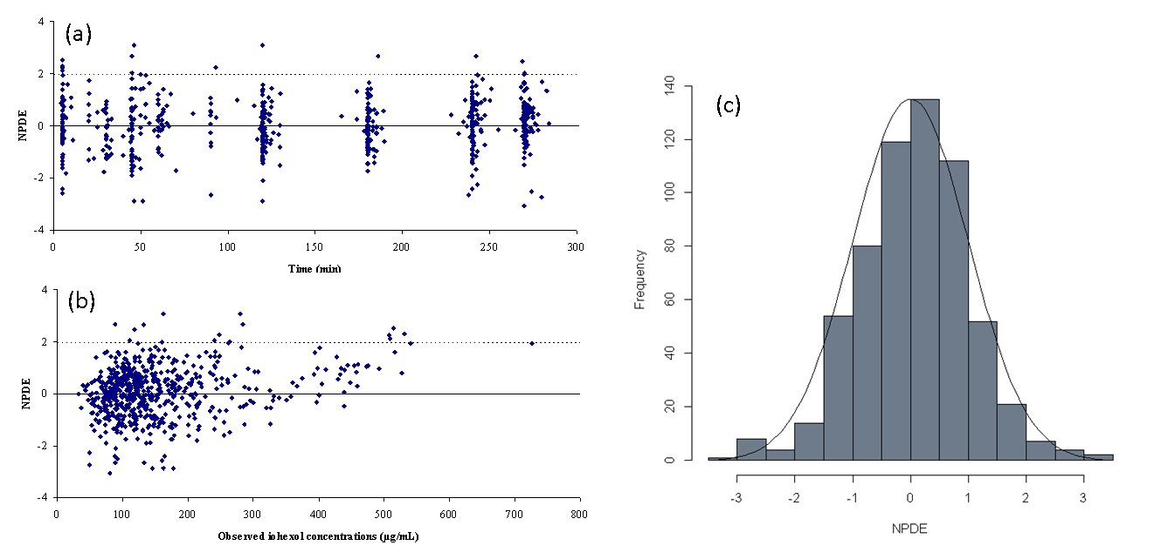

**Figure S2:** Visual Predictive Check for the full model in the index dataset. Percentiles (5%, 50%, and 95%) of predictions (blue and red dashed lines) are overlaid with the observations (symbols). Blue and red solid lines are 95% confidence intervals for the observation percentiles (500 simulations).



**Figure S3:** Agreement between GFRRef and Bayesian estimates (both in mL/min) in the validation group, when Bayesian estimates are obtained from the POP-PK model including covariates (left panel) or not (right panel).

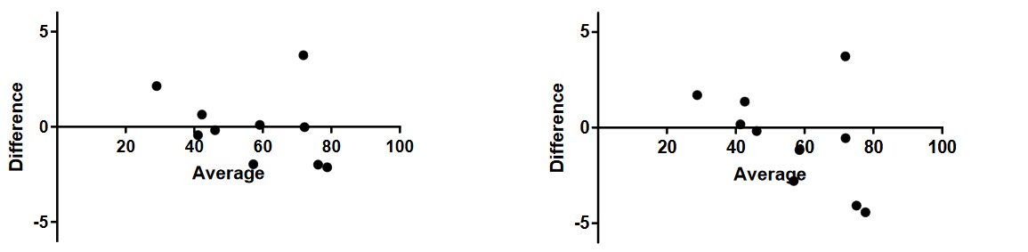

**Difference vs. average:**

**Bland-Altman plot with covariates**

**(GFR in mL/min)**

**Difference vs. average:**

**Bland-Altman plot without covariates**

**(GFR in mL/min)**