Supplemental Figures
Supplemental Figure 1: Stability at room temperature. Shown is the stability in samples from healthy and pathological subjects. The grey area marks the acceptable change limit based on biological variation. (A) Measured parameters. (B) Calculated parameters.
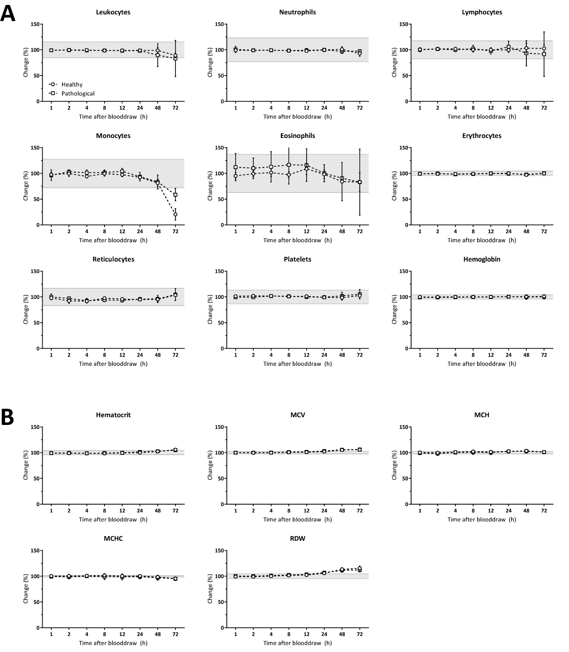

Supplemental Figure 2: Stability at 2-8 °C. Shown is the stability in samples from healthy subjects. The grey area marks the acceptable change limit based on biological variation. (A) Measured parameters. (B) Calculated parameters.
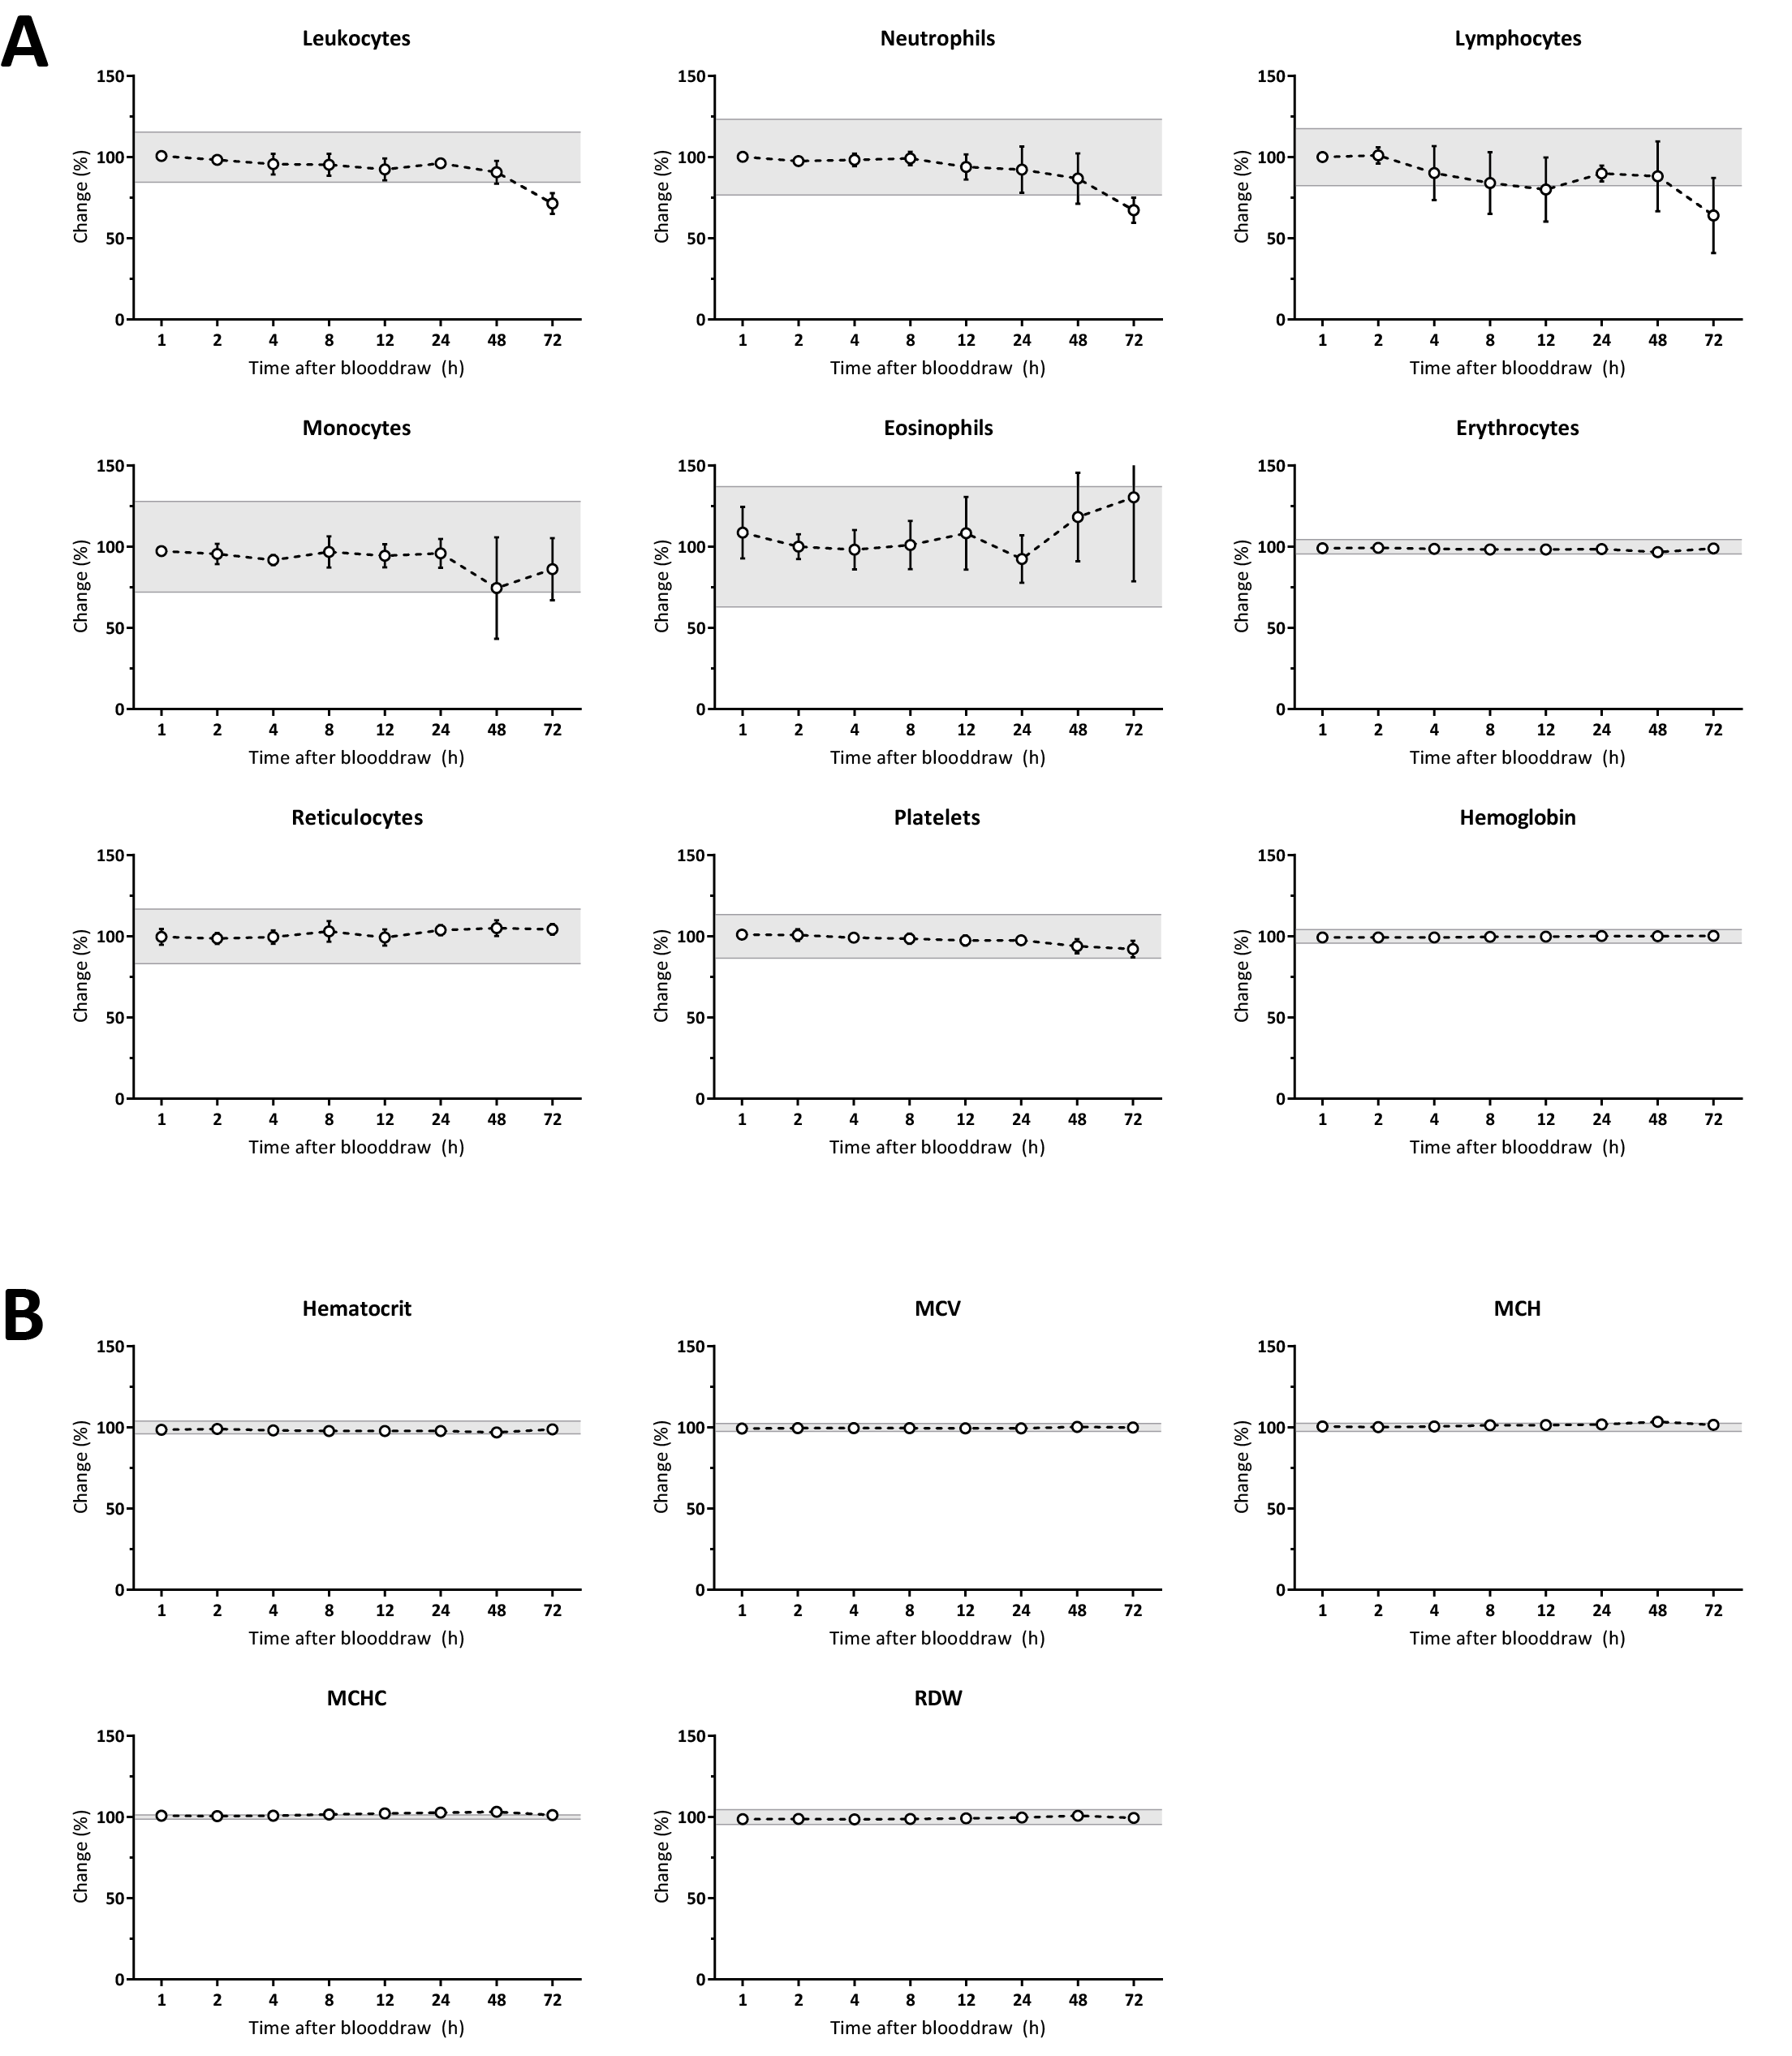

Supplemental Tables
Supplemental Table 1: Clinical cohort characteristics.
Category | Site 1 | Site 2 | Site 3 | Samples
Totalª | 484 | 505 | 484 | 1473
- Outpatients, n (%) | 162 (33.5) | 228 (45.1) | 200 (41.3) | 590 (40.1)
- Inpatients, n (%) | 322 (66.5) | 277 (54.9) | 284 (58.7) | 883 (59.9)
General wards | 171 (35.3) | 94 (18.6) | 99 (20.5) | 364 (24.7)
Intensive Care Unit | 51 (10.5) | 54 (10.7) | 50 (10.3) | 155 (10.5)
Hemato-oncology^{b} | 60 (12.4) | 108 (21.4) | 49 (10.1) | 217 (14.7)
Pregnant^{b} | 18 (3.7) | 31 (6.1) | 39 (8.1) | 88 (6.0)
Hemoglobinopathy^{b} | 3 (0.6) | 8 (1.6) | 4 (0.8) | 15 (1.0)
Neonate | 20 (4.1) | 3 (0.6) | 11 (2.3) | 34 (2.3)
Platelet <50 x 10⁹/L | 46 (9.5) | 67 (13.3) | 39 (8.1) | 152 (10.3)
  - ª Males: n=739, age 62.2 ± 19.4 years (mean ± standard deviation), range 0 – 97.6 years (median 65.9 years). Females: n=734, age 55.2 ± 21.9 years, range 0 – 97.3 years (median 58.5). ^{b} Both in- and outpatients. Numbers in parentheses are percentages versus total.

Supplemental Table 2: Limits of quantitation.
Measurand | Unit | Range tested (n) | LoQ
Leukocytes | 10⁹/L | 0.016 - 1.598 (5) | 0.07 x 10⁹/L
Neutrophils | 10⁹/L | 0.008 - 0.980 (5) | 0.08 x 10⁹/L
Platelets | 10⁹/L | 0.611 - 29.51 (3) | <1.0 x 10⁹/L
Hemoglobin | mmol/L | 0.022 - 4.661 (4) | 0.05 mmol/L
  - LoQ: limit of quantitation. Conversion factors for units: HGB (mmol/L) to g/dL: 0.6206.

Supplemental Table 3: Carryover. Shown are the average, and minimum-maximum of carryover values from three different laboratory sites.
 |  | High level |  | Low level
Measurand | Unit | Mean (range) |  | Mean (range) |  | Carryover % (range) |  | Claim
Leukocytes | 10⁹/L | 147 (110 - 174) |  | 1.88 (0.79 - 2.70) |  | 0.01 (-0.05 - 0.12) |  | SOTA
Neutrophils | 10⁹/L | 48.2 (25.8 - 56.7) |  | 0.19 (0.09 - 0.30) |  | 0.08 (-0.13 - 0.21) |  | N.A.
Erythrocytes | 10¹²/L | 7.19 (6.26 - 8.05) |  | 1.20 (0.98 - 1.41) |  | -0.07 (-2.46 - 0.51) |  | SOTA
Hemoglobin | mmol/L | 13.1 (8.69 - 15.7) |  | 2.24 (1.83 - 2.71) |  | 0.14 (-2.77 - 1.71) |  | SOTA
Reticulocytes | 10⁹/L | 632 (307 - 787) |  | 37.7 (30.3 - 51.2) |  | -0.28 (-1.23 - 0.21) |  | N.A.
Platelets | 10⁹/L | 1048 (962 - 1119) |  | 19.6 (7.32 - 36.9) |  | 0.18 (-0.08 - 0.62) |  | SOTA
  - CV values are in percentages (%). SOTA: meeting current state-of-the-art carryover [10]. N.A.: no data available. Conversion factors for units: Hemoglobin (mmol/L) to g/dL: 0.6206.

Supplemental Table 4: Sample stability at RT and 2-8 °C. Stability at RT and 2-8 °C. Shown is the maximum time (in hours) that the measurand was considered stable (i.e. within acceptable change limits).
 |  | Room temp. |  |  | 2-8 °C
Measurand | Unit | Range | Stab. (h) |  | Range | Stab. (h) |  | CL (%)
Leukocytes | 10⁹/L | 0.03 - 141 | 48 |  | 3.79 - 6.46 | 48 |  | 15.5
Neutrophiles | 10⁹/L | 1.85 - 14.3 | 72 |  | 1.91 - 4.07 | 48 |  | 23.4
Lymphocytes | 10⁹/L | 0.42 - 132 | 72 |  | 1.04 - 1.82 | 48 |  | 17.6
Monocytes | 10⁹/L | 0.29 - 1.77 | 48 |  | 0.39 - 0.55 | 72 |  | 27.9
Eosinophils | 10⁹/L | 0.00 - 1.34 | 72 |  | 0.04 - 0.44 | 72 |  | 37.1
Erythrocytes | 10¹²/L | 2.54 - 5.20 | 72 |  | 4.18 - 4.90 | 72 |  | 4.4
Hemoglobin | mmol/L | 5.06 - 9.49 | 72 |  | 8.00 - 9.33 | 72 |  | 4.2
Platelets | 10⁹/L | 9.40 - 661 | 72 |  | 194 - 471 | 72 |  | 13.4
Reticulocytes | 10⁹/L | 8.52 - 334 | 72 |  | 49.7 - 123 | 72 |  | 16.8
MCV | fL | 82.4 - 107 | 12 |  | 87.8 - 95.4 | 72 |  | 2.4
MCH | fmol | 1.71 - 2.10 | 12 |  | 1.83 - 1.99 | 72 |  | 2.5
MCHC | mmol/L | 17.8 - 22.5 | 24 |  | 20.8 - 21.6 | 72 |  | 1.3
Hematocrit | L/L | 0.25 - 0.45 | 48 |  | 0.38 - 0.45 | 72 |  | 4.0
RDW | % | 11.5 - 24.0 | 12 |  | 12.9 - 14.4 | 72 |  | 4.6
  - CL: acceptable change limit based on biological variation [6]. Conversion factors for units: HGB (mmol/L) to g/dL: 0.6206; MCH (fmol) to pg: 0.6206; MCHC (mmol/L) to g/dL: 0.06206.

Supplemental Table 5: Correlation of Alinity hq versus manual differentiation. Shown are Bland-Altman (mean difference and limits of agreement) statistics and Passing and Bablok regression (slope and intercept).
 |  |  |  | Bland-Altman statistics |  | Passing and Bablok regression
Measurand | Unit | n | Range (median) | Mean diff. (95% CI) | 95% LoA | Slope (95% CI) | Intercept (95% CI)
Neutrophils | % | 899 | 0.0 - 98.3 (65.3) | -2.08 (-2.51 to -1.66) | -2.75 to -0.89 | 0.98 (0.96 - 0.99) | -1.74 (-2.75 to -0.89)
Lymphocytes | % | 902 | 0.8 - 98.5 (22.0) | 1.16 (0.82 to 1.50) | 1.03 to 1.70 | 0.98 (0.96 - 1.00) | 1.36 (1.03 to 1.70)
Monocytes | % | 894 | 0.0 - 88.6 (6.0) | 2.50 (2.27 to 2.73) | 0.46 to 0.99 | 1.20 (1.15 - 1.24) | 0.73 (0.46 to 0.99)
Eosinophils | % | 891 | 0.0 - 33.0 (1.5) | 0.32 (0.21 to 0.44) | 0.03 to 0.08 | 1.08 (1.05 - 1.13) | 0.05 (0.03 to 0.08)
Basophils | % | 901 | 0.0 - 13.0 (0.3) | -0.17 (-0.22 to -0.12) | 0.02 to 0.03 | 0.69 (0.63 - 0.77) | 0.03 (0.02 to 0.03)
IG | % | 125 | 1.0 - 64.3 (2.5) | -0.01 (-1.26 to 1.24) | -0.35 to 1.33 | 1.10 (0.86 - 1.42) | 0.37 (-0.35 to 1.33)
NRBC | % | 63 | 1.0 - 87 (4.0) | -0.72 (-3.07 to 1.63) | -1.66 to -0.51 | 0.98 (0.81 - 1.14) | -0.99 (-1.66 to -0.51)
  - n: sample number. 95% CI: 95% confidence interval. Mean diff.: mean difference. LoA: upper and lower limits of agreement. The median reflects the comparative method (i.e., manual differentiation).

Supplemental Table 6: Performance of Alinity hq on eight external quality assessment (EQA) samples provided by the SKML.
Measurand | Unit | Range | Bias present? | Bias type | Allow. error (%)
Leukocytes | 10⁹/L | 1.14 - 12.0 | Site 1 and 2 | Proportional (-8.48%, -3.81%ª) | 15.45
Neutrophils | 10⁹/L | 0.51 - 6.64 | Site 1 | Proportional (-7.94%), constant (0.04^{b}) | 23.36
Lymphocytes | 10⁹/L | 0.18 - 4.21 | Site 1 | Proportional (-9.71%) | 17.60
Monocytes | 10⁹/L | 0.05 - 1.11 | None |  | 29.06
Erythrocytes | 10¹²/L | 1.79 - 5.85 | Site 1 | Constant (-0.04^{b}) | 4.82
Hemoglobin | mmol/L | 3.45 - 10.9 | None |  | 4.40
MCV | fL | 85.7 - 96.1 | None |  | 4.01
Platelets | 10⁹/L | 28.2 - 418 | Site 1 | Proportional (11.2%) | 15.13
  - Allowable error values are as used by the Dutch EQA program SKML [11]. ª Shown is the proportional bias of Site 1 and 2, respectively. ^{b} This constant bias does not exceed the allowable error for the measurement range tested. Conversion factors for units: HGB (mmol/L) to g/dL: 0.6206.

