**Supplementary Material**

**Materials and Methods**

This includes sections on OsPA stock; Thrombin assays using S-2238 chromophore; Prothrombin time (PT), aPTT time and fibrinogen assay; Human research ethics and statistical analysis.

Reagents

OsPA purified from snake *Oxyuranus scutellatus* venom was stored in 0.05 M Tris buffer containing 0.15 M NaCl and 50% glycerol w/v, pH 7.4, at -20°C. The OsPA protein concentration was measured using BIORAD *DC* Protein assay (Lowry), using IgG as a protein standard (Catalogue number500-0116) or by A 280 nm using molar extinction coefficient of 9.95 for 10 mg/ ml in 0.05 M tris HCl pH 7.4 buffer (based on amino composition of Factor Xa-like and Factor Va-like components). S-2238 substrate was purchased from Werfen, Australia. Purified human prothrombin was purchased from United Bioresearch, Australia. DBLTM Heparin sodium was from Hospira, Australia. Human thrombin and p-nitro aniline were from Sigma, USA.

**Thrombin assay-S-2238 chromophore**

S-2238 is a peptide based chromogenic substrate which releases p-nitro aniline on hydrolysis which is measured at 405 nm. S-2238 was designed to be relatively specific for hydrolysis by Factor Xa. 4 mL whole blood treated with 1 µg of OsPA, as shown in Figure 1B, was immediately aliquoted into microfuge tubes (t = 0 min). At the indicated times over a period of 50 mins the tubes were microfuged (1200 g x 25 sec) and 50 µL plasma was added to 1 mL 100 µM S2238 and monitored at 405 nm for 1 min. The rate of S2238 hydrolysis by thrombin in AU/min was converted to µM p-nitroaniline (pNA)/min by dividing by the micromolar absorbance of pNA at 405 nm (0.0095). This was further converted to the µM thrombin concentration in the whole blood aliquots using the Michaelis-Menten equation with kcat = 3678 m-1 and Km = 1.65 µM (3).

**Prothrombin time (PT), aPTT time and fibrinogen assay**

Blood was collected into citrate tubes (4 mL) (#4506001, Greiner Bio-One, Austria) by experienced Pathology Queensland phlebotomists at the Princess Alexandra Hospital, Brisbane Australia, from volunteers who had given signed informed consent, approved by the Metro South Ethics Committee. Blood samples were confirmed for normal prothrombin time, aPTT time, and platelet count in the Haematology Laboratory, Pathology Queensland, Princess Alexandra Hospital. Fibrinogen concentration was determined by either ELISA or Clauss fibrinogen assay. Citrate plasma was obtained by centrifugation of the normal citrated blood at 1500 g for 10 min.

**Gel electrophoresis**

**Cleavage of human prothrombin by OsPA was determined over a time course of 0-150 min and products analysed by 4-12% Bis-Tris SDS-PAGE. Gels were run at 160 V for 60 min and proteins visualised by staining with Coomassie blue dye Human prothrombin is present as a single major band at 72 kDa and was rapidly cleaved into multiple forms of thrombin by treatment with OsPA**

**Human Research Ethics**

Human research ethics approval for this study using purified snake venom fractions was obtained from Metro South Human Research Ethics Committee and The University of Queensland Human Ethics Committee: HREC Reference number: HREC/08/QPAH/005. Supply of human blood for research with ethics approval for this study was obtained from Australian Red Cross Service (ARCBS), Brisbane.

**Statistical analysis**

Excel-2013 (Formula-Statistical program) software was used for all analyses with Student’s two tailed *t* test and one way analysis of variance. Patient and sample numbers together with numerical values including mean +/- standard deviation are included in Figure legends

**(A)**

|  |  |  |  |  |
| --- | --- | --- | --- | --- |
| Material | Equation | R² | µg /U | U/mg |
| OsPA | y = 7.897-0.505 | 0.9994 | 0.283 | 3534 |

**(B)**

|  |  |  |  |  |
| --- | --- | --- | --- | --- |
| Material | Equation | R² | µg /U | U/mg |
| OsPA | y = 82.681x-0.746 | 0.9874 | 0.75 | 1333 |

**Supplementary Table 1**. Determinations of OsPA required for clotting recalcified citrated plasma in 15 seconds as one U **(A)** and recalcified citrated whole blood in 100 seconds as one U **(B)**.

**Amount (µg/4ml) 5.0 2.0 1.0 0.75 0.50 0.25 0.125 0.0**

**(A)**

**(B)**



**Venom**

**OsPA**

**Supplementary Fig 1.** Crude venom but not OsPA causes serum haemolysis at 24 h post clotting. Solid arrow in **(A)** shows that venom-caused serum haemolysis depends on the amount of venom used for clotting 4 ml of recalcified citrated whole blood. Empty arrow

in **(B)** shows no haemolysis observed in OsPA produced serum.

**RST OsPA(0.5 µg) Throm (5 µg) OsPA(1 µg) Throm (10 µg)**



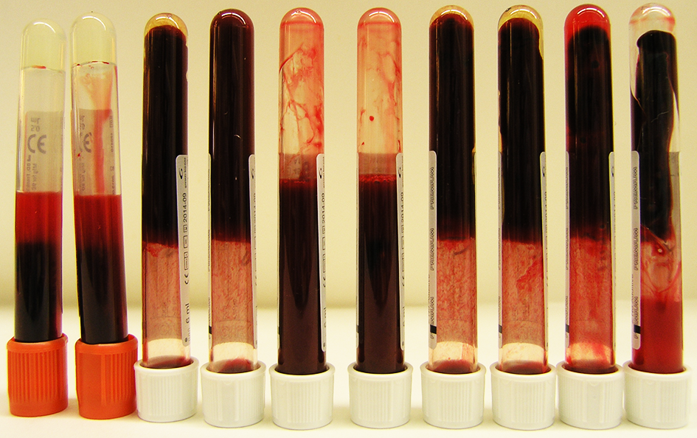

**Supplementary Figure 2.** Blood clotted images in Greiner plain blood collection tubes containing 0.5 or 1 µg of OsPA in 4 ml of recalcified citrated whole blood, compared to those with 5 or 10 µg of thrombin added. Thrombin-containing tubes (RST) were used as a control.