Supplementary Table 1. Measurands and methods of included CBC parameters.
Analytes | Methods
Erythrocytes(RBC),  x 10¹²/L | Counted (Hydrovynamic vocusing (DC Detection) / Empedans)
Hemoglobin (Hgb), g/L | Measured (SLS-Hemoglobin Method)
Hematocrit (HTC), % | Calculated, $HTC=(1/{k) × \sum{Pi /{A ×100}}}$  A: Total volume of the blood sample  k: Constant
MCH, pg | Calculated, $MCH= \frac{Hgb (g/{dL})}{RBC ({x{10}^{6}}/{µL})}x10$
MCHC, g/dL | Calculated, $MCHC=\frac{Hgb \left(g/{dL}\right)}{HTC \left(\%\right)} x10$
MCV, fL | Calculated, $MCV= \frac{HTC \left(\%\right)}{RBC ({x{10}^{6}}/{µL})}x10$
RDW-SD, fL | Calculated (X2-X1)  With the peak height assumed to be 100%, the distribution width at the 20% frequency level is RDW-SD.  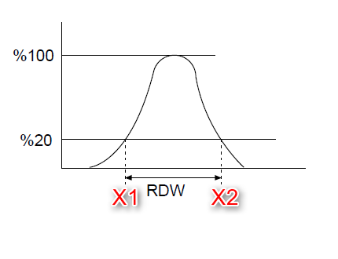
RBC-H_{e}, pg | 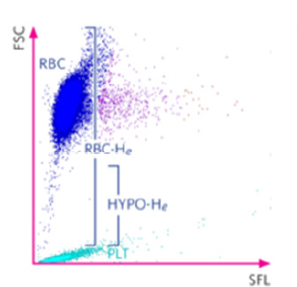 Scattergram ®  RBC-H_{e} is a measure of the haemoglobin content of mature red blood cells
Reticulocyte, x10⁹/L | Counted (Flow cytometry method using semiconductor laser)
RET-H_{e}, pg | Scattergram ®  RET-H_{e} is a measure of the haemoglobin content in reticulocytes
Leukocytes, x10⁹/L | Counted (Flow cytometry method using semiconductor laser)
Lymphocytes, x10⁹/L | Counted, (Flow cytometry method using semiconductor laser)
Monocytes, x10⁹/L | Counted (Flow cytometry method using semiconductor laser)
Neutrophils, x10⁹/L | Counted (Flow cytometry method using semiconductor laser)
Eosinophils, x10⁹/L | Counted (Flow cytometry method using semiconductor laser)
Basophils, x10⁹/L | Counted (Flow cytometry method using semiconductor laser)
PLT-I, x10⁹/L | Counted (Hydroynamic vocusing (DC Detection)/ Empedans)
PDW – SD, fL | Calculated, (Y2-Y1)  With the peak height assumed to be 100%, the istribution width at the 20% frequency level is PDW-SD.  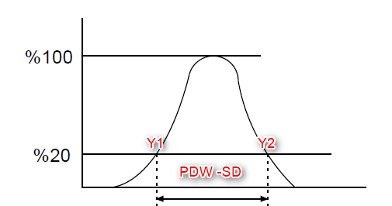
Plateletcrit, % | Calculated, $Plateletcrit=(1/{k) × \sum{Pi /{B ×100}}}$  B: Total volume of PLT in sample  k: Constant
MPV, fL | Calculated, $MPV= \frac{PCT \left(\%\right)}{PLT ({x{10}^{3}}/{µL})}x10000$
P-LCR, % | Calculated,  The P-LCR is the ratio of large platelets from the 12 fL discriminator or larger. It is calculated as a ratio comparing the number of particles between the fixed discriminator and UD, to the number of particles between LD and UD.  