Supplemental material
Gating strategy AQUIOS CL
AQUIOS CL uses a specific gating strategy for lymphocyte gating. First a broad selection of “cells” is made on a side scatter (SS)/forward scatter (FS) plot in order to exclude debris. Next, lymphocytes are separated from other leucocytes within the “cells”-gate using a double gating strategy. On a CD45/SS plot lymphocytes are selected in a “Lymphs (45)”-gate. Additionally lymphocytes are also gated on a SS/electronic volume (EV) plot, as “Lymphs EV”. EV is a measure of relative cell volume and helps differentiating lymphocytes from monocytes. In order to improve recovery of lymphocytes all events within “Lymphs (45)” and “Lymph EV” are combined as one gate, “Lymphs all”. From “Lymphs all”, a CD3+ region is defined on a CD3 histogram, named “CD3+ all”. From “CD3+ all”, CD4+/CD8- and CD4-/CD8+ populations are selected in a CD4/CD8 plot. In order to improve purity of lymphocytes the mutual events of “Lymphs (45)” and “Lymph EV” are combined as one gate, “Lymphs”. From “Lymphs”, a CD3- region is defined on a CD3 histogram, named “CD3-”. From “CD3-”, CD19+/CD56CD16- and CD19-/CD56CD16+ populations are selected in a CD19/CD56CD16 plot.

Inter-sample carry-over
Table 1: Inter-sample carry-over of AQUIOS CL.
 | CD3+ T2 (rel) |  | CD3-/CD19+ (rel) |  | CD3-/CD56CD16+ (rel)
Sample | Sample 1 | Sample 2 | Sample 1 | Sample 2 | Sample 1 | Sample 2
Single run | 7.45 | 90.4 | 89.1 | 2.73 | 2.94 | 3.61
Average consecutive  1-2 runs (n=10)  [95% CI] | 7.61  [7.51-7.70] | 90.0  [89.8-90.2] | 88.3  [88.3-88.4] | 2.84  [2.39-3.28] | 3.52  [3.28-3.75] | 3.69  [3.01-4.37]
 | CD3+ T2 (abs) |  | CD3-/CD19+ (abs) |  | CD3-/CD56CD16+ (abs)
Sample | Sample 1 | Sample 2 | Sample 1 | Sample 2 | Sample 1 | Sample 2
Single run | 1274 | 728 | 15228 | 22.0 | 503 | 29.0
Average consecutive  1-2 runs (n=10)  [95% CI] | 1239  [1236-1243] | 719  [717-721] | 14396  [14386-14407] | 22.6  [21.4-23.8] | 573  [570-576] | 29.5  [27.5-31.5]
Sample 1: sample with high CD3-/CD19+
Sample 2: sample with low CD3-/CD19+
CI: confidence interval
In bold: lowest values of both samples

Method comparison – tables
Table 2: Statistical (Passing-Bablok regression) and clinical comparison (Kappa coefficient) of Tetra-1 (T1) panel on AQUIOS CL with the dual-platform approach
 | CD3+ T1  (rel) | CD3+ T1  (abs) | CD3+/CD4+  (rel) | CD3+/CD4+  (abs) | CD3+/CD8+  (rel) | CD3+/CD8+  (abs)
All samples
n = 97
Passing Bablok slope  [95% CI] | 0.96  [0.93-0.99] | 0.94  [0.90-0.96] | 0.96  [0.94-0.97] | 0.93  [0.90-0.96] | 0.96  [0.93-0.98] | 0.94  [0.90-0.96]
Passing Bablok intercept  [95% CI] | 0.94  [-1.11-3.04] | -28.99  [-51.57- 9.93] | 1.07  [0.46-1.81] | 3.72  [-10.45-10.21] | 0.32  [-0.29-1.07] | -7.34  [-24.75-6.77]
Paediatric subpopulation
n = 42
Passing Bablok slope  [95% CI] | 0.95  [0.87-0.99] | 0.96  [0.90-1.01] | 0.96  [0.91-0.99] | 0.95  [0.87-1.01] | 0.93  [0.86-0.99] | 0.95  [0.88-1.00]
Passing Bablok intercept  [95% CI] | 1.60  [-1.50-6.69] | -50.69  [-163.0-16.92] | 0.96  [-0.91-0.99] | -4.69  [-63.25-47.85] | 0.93  [-0.37-2.63] | -16.95  [-53.45-11.84]
Post-transplant subpopulation
n = 42
Passing Bablok slope  [95% CI] | 0.96  [0.91-1.02] | 0.93  [0.81-0.99] | 0.91  [0.84-1.00] | 0.90  [0.83-1.03] | 0.95  [0.91-0.98] | 0.93  [0.83-0.99]
Passing Bablok intercept  [95% CI] | 0.29  [-3.53-4.23] | -25.42  [-68.24-39.59] | 1.66  [0.64-2.81] | 7.32  [-12.62-13.86] | 0.94  [-0.33-2.86] | -6.83  [-27.96-19.36]
CI: confidence interval
In bold: CI does not contain 1 for slope or 0 for intercept

Table 3: Statistical (Passing-Bablok regression) and clinical comparison (Kappa coefficient) of Tetra-2 (T2) panel on AQUIOS CL with the dual-platform approach
 | CD3+ T2  (rel) | CD3+ T2  (abs) | CD3-/CD19+  (rel) | CD3-/CD19+  (abs) | CD3-/CD56CD16+  (rel) | CD3-/CD56CD16+  (abs)
All samples
n = 69
Passing Bablok slope  [95% CI] | 0.96  [0.93-1.00] | 0.92  [0.89-0.95] | 1.04  [1.00-1.10] | 1.01  [0.99-1.06] | 0.98  [0.94-1.02] | 0.89  [0.84-0.96]
Passing Bablok intercept  [95% CI] | -0.89  [-1.49-3.10] | -17.66  [-66.21-23.46] | 0.12  [-0.10-0.62] | -0,04  [-7.31-1.00] | 0.63  [0.18-0.88] | 10.87  [1.165-21.13]
Paediatric subpopulation
n = 40
Passing Bablok slope  [95% CI] | 0.95  [0.91-0.99] | 0.91  [0.87-0.96] | 1.07  [1.00-1.23] | 1.04  [0.98-1.10] | 0.98  [0.90-1.02] | 0.93  [0.86-1.04]
Passing Bablok intercept  [95% CI] | 1.44  [-1.71-4.20] | 2.53  [-84.36-60.83] | 0.02  [-1.82-1.03] | -0.05  [-23.73-7.16] | 0.64  [0.20-1.11] | 6.19  [-8.74-20.08]
Post-transplant subpopulation
n = 17
Passing Bablok slope  [95% CI] | 0.97  [0.86-1.05] | 0.92  [0.76-1.02] | 0.95  [0.89-1.04] | 0.88  [0.73-1.03] | 0.95  [0.85-1.07] | 0.83  [0.72-0.99]
Passing Bablok intercept  [95% CI] | 1.43  [-5.35-8.09] | -36.10  [-120.1-48.48] | 0.15  [0.04-0.34] | 0.49  [-3.00-1.00] | 1.89  [-0.18-4.59] | 17.79  [-24.58-45.92]
CI: confidence interval
In bold: CI does not contain 1 for slope or 0 for intercept

Method comparison - figures

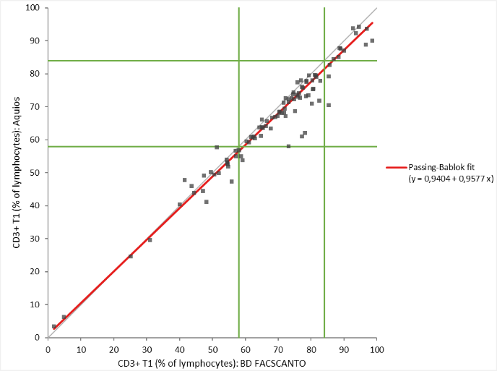
Figure 1 Passing-Bablok regression (red line) between dual-platform approach (x-axis) and AQUIOS CL (y-axis). Green lines indicate reference values. This example shows Passing-Bablok regression for CD3+ T1 (rel).

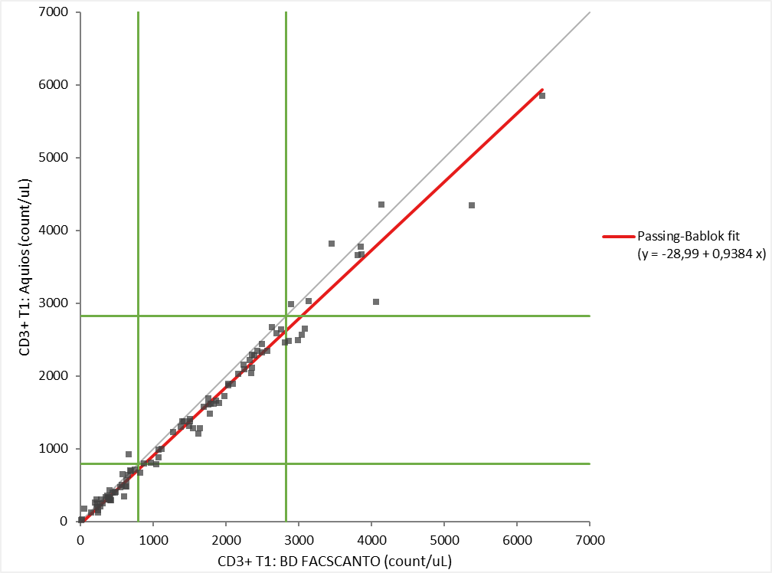
Figure 2 Passing-Bablok regression (red line) between dual-platform approach (x-axis) and AQUIOS CL (y-axis). Green lines indicate reference values. This example shows Passing-Bablok regression for CD3+ T1 (abs).

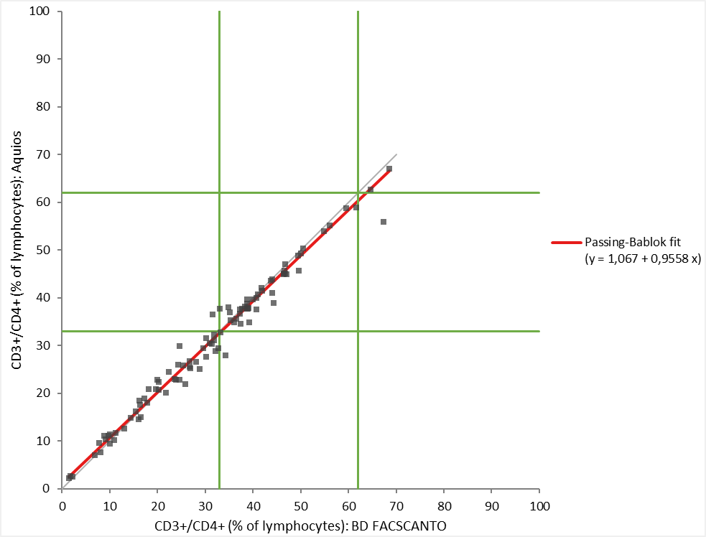
Figure 3 Passing-Bablok regression (red line) between dual-platform approach (x-axis) and AQUIOS CL (y-axis). Green lines indicate reference values. This example shows Passing-Bablok regression for CD3+/CD4+ (rel).

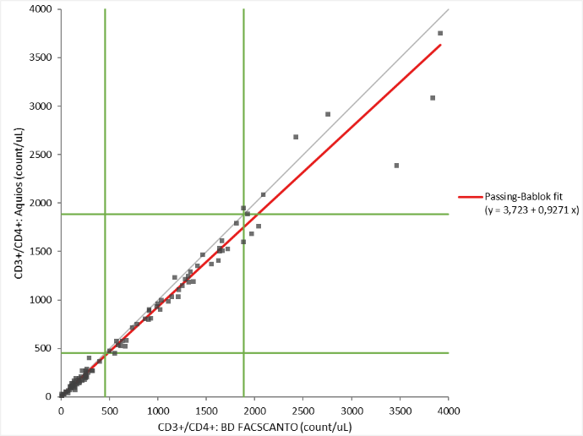
Figure 4 Passing-Bablok regression (red line) between dual-platform approach (x-axis) and AQUIOS CL (y-axis). Green lines indicate reference values. This example shows Passing-Bablok regression for CD3+/CD4+ (abs).

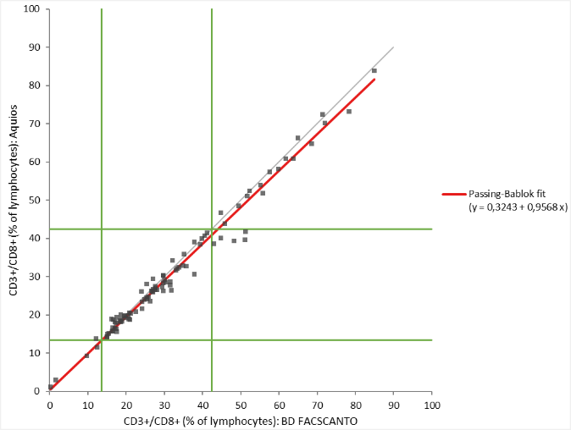
Figure 5 Passing-Bablok regression (red line) between dual-platform approach (x-axis) and AQUIOS CL (y-axis). Green lines indicate reference values. This example shows Passing-Bablok regression for CD3+/CD8+ (rel).

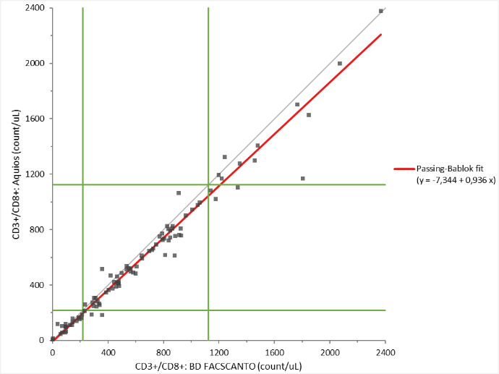
Figure 6 Passing-Bablok regression (red line) between dual-platform approach (x-axis) and AQUIOS CL (y-axis). Green lines indicate reference values. This example shows Passing-Bablok regression for CD3+/CD8+ (abs).

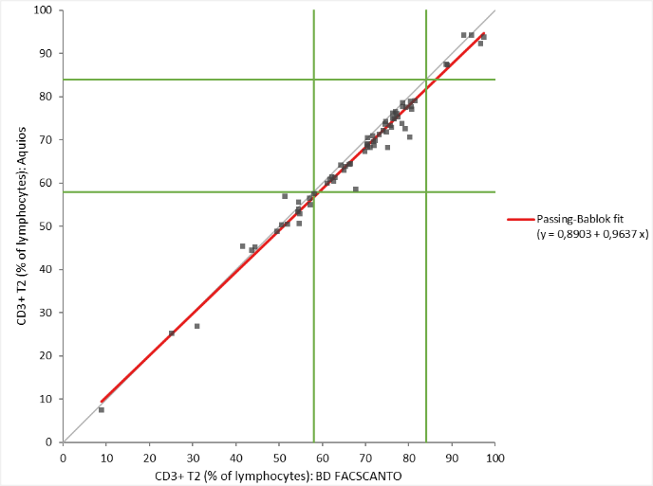
Figure 7 Passing-Bablok regression (red line) between dual-platform approach (x-axis) and AQUIOS CL (y-axis). Green lines indicate reference values. This example shows Passing-Bablok regression for CD3+ T2 (rel).

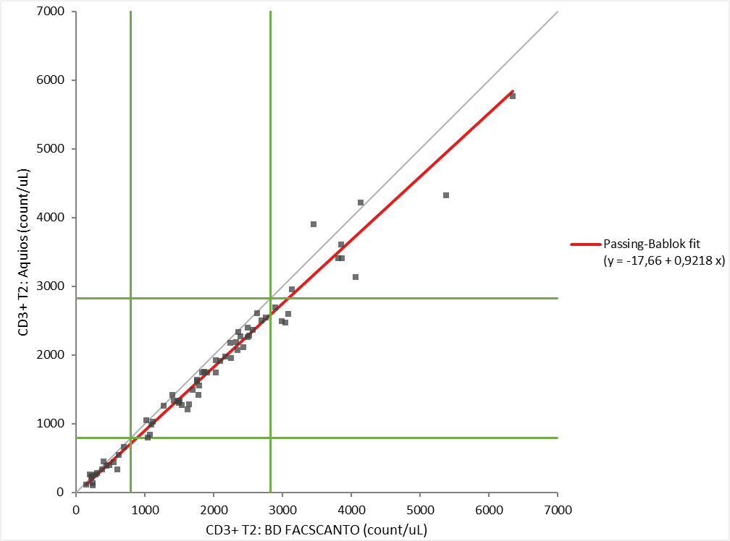
Figure 8 Passing-Bablok regression (red line) between dual-platform approach (x-axis) and AQUIOS CL (y-axis). Green lines indicate reference values. This example shows Passing-Bablok regression for CD3+ T2 (abs).

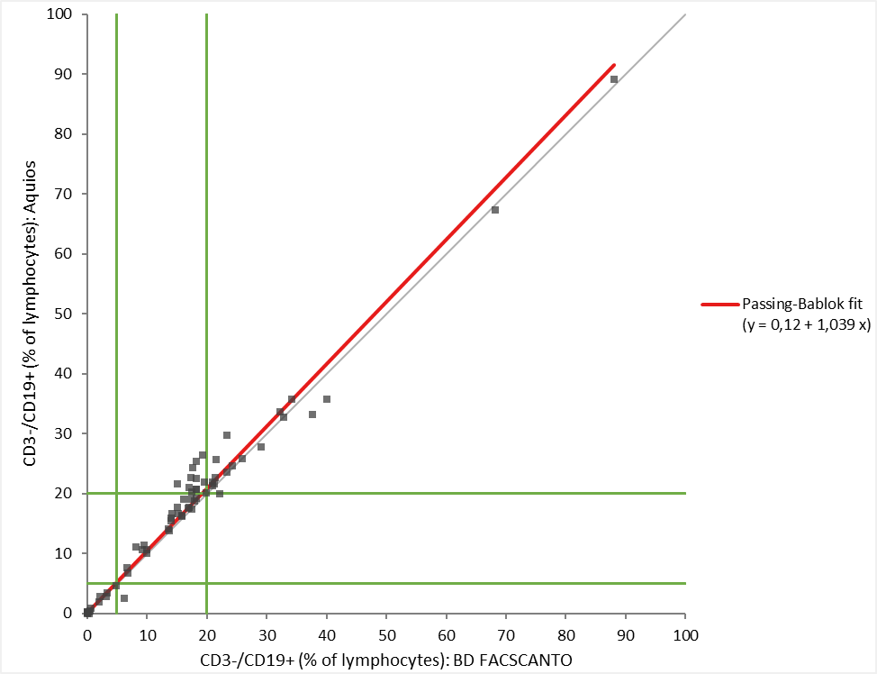
Figure 9 Passing-Bablok regression (red line) between dual-platform approach (x-axis) and AQUIOS CL (y-axis). Green lines indicate reference values. This example shows Passing-Bablok regression for CD3-/CD19+ (rel).

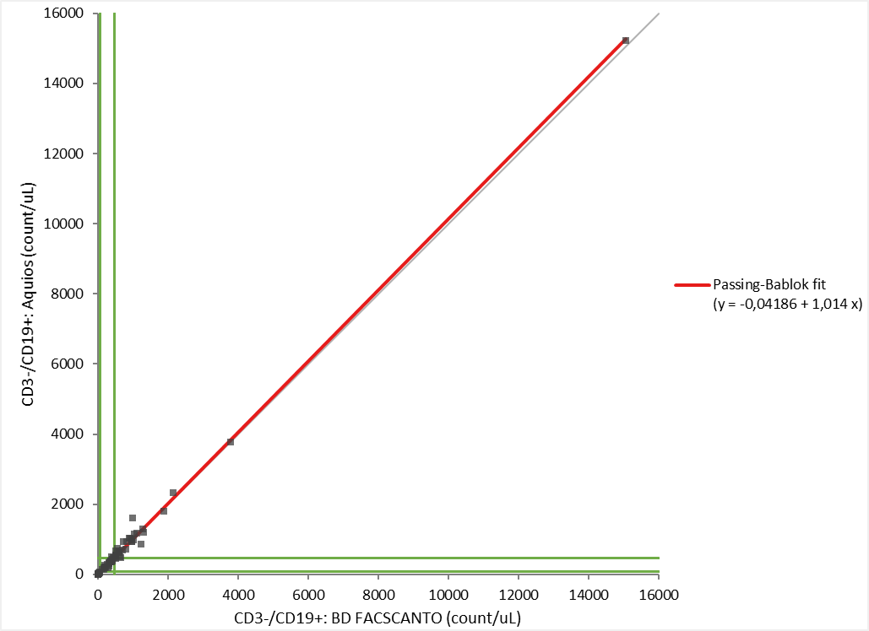
Figure 10 Passing-Bablok regression (red line) between dual-platform approach (x-axis) and AQUIOS CL (y-axis). Green lines indicate reference values. This example shows Passing-Bablok regression for CD3-/CD19+ (abs).

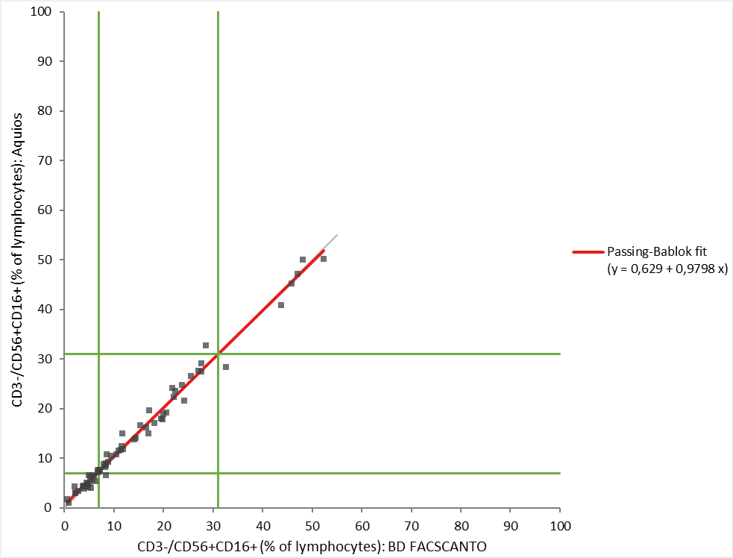
Figure 11 Passing-Bablok regression (red line) between dual-platform approach (x-axis) and AQUIOS CL (y-axis). Green lines indicate reference values. This example shows Passing-Bablok regression for CD3-/CD56CD16+ (rel).

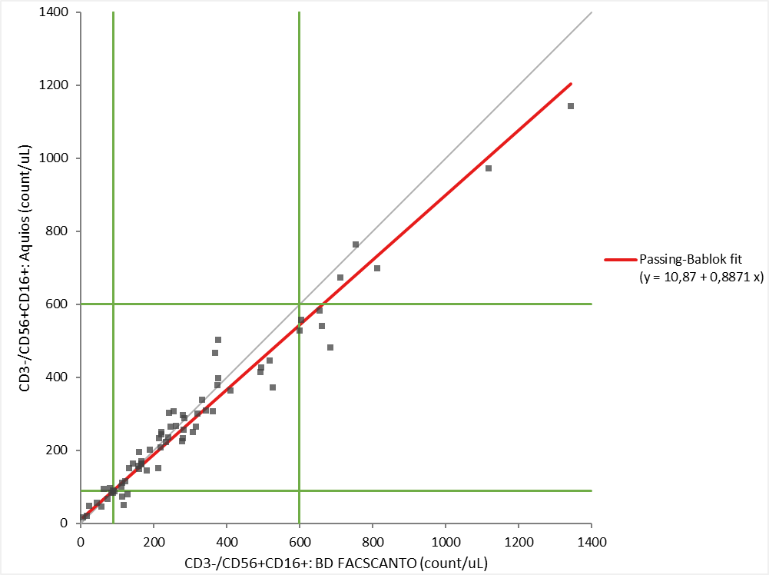
Figure 12 Passing-Bablok regression (red line) between dual-platform approach (x-axis) and AQUIOS CL (y-axis). Green lines indicate reference values. This example shows Passing-Bablok regression for CD3-/CD56CD16+ (abs).

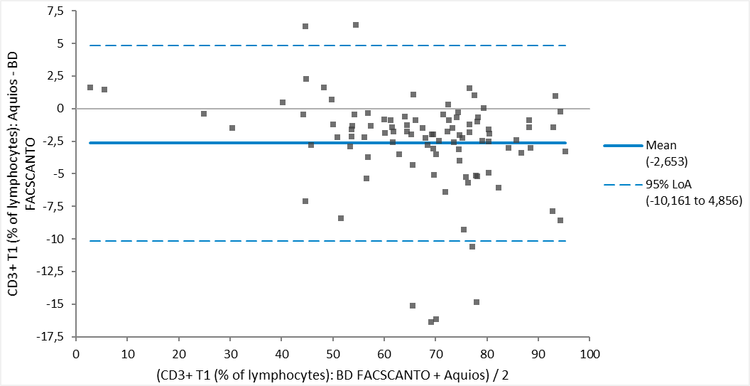
Figure 13 Bland Altman regression (full blue line) between dual-platform approach (BD Facscanto) and AQUIOS CL. Dotted blue lines indicate 95% limit of agreement. This example shows Bland Altman regression for CD3+ T1 (rel).

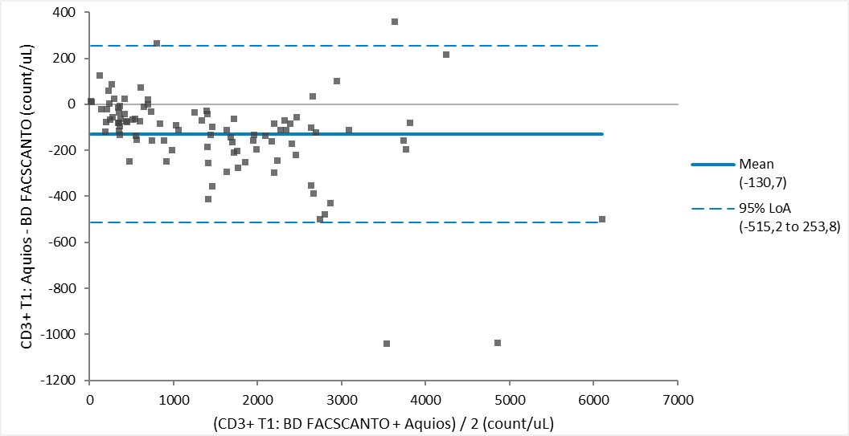
Figure 14 Bland Altman regression (full blue line) between dual-platform approach (BD Facscanto) and AQUIOS CL. Dotted blue lines indicate 95% limit of agreement. This example shows Bland Altman regression for CD3+ T1 (abs).

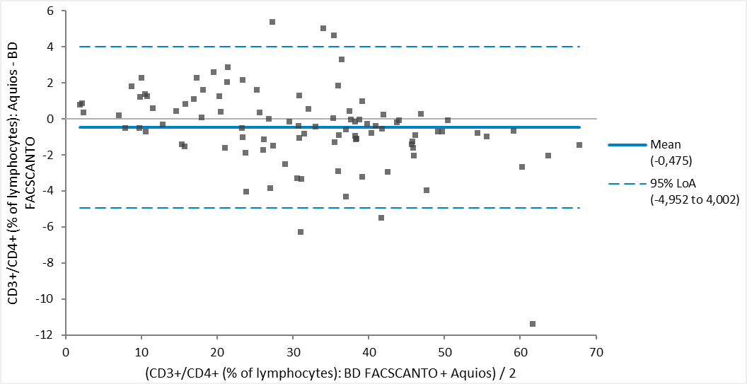
Figure 15 Bland Altman regression (full blue line) between dual-platform approach (BD Facscanto) and AQUIOS CL. Dotted blue lines indicate 95% limit of agreement. This example shows Bland Altman regression for CD3+/CD4+ (rel).

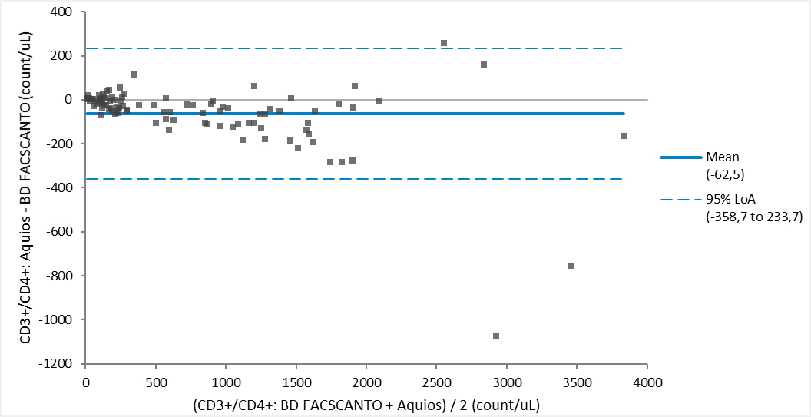
Figure 16 Bland Altman regression (full blue line) between dual-platform approach (BD Facscanto) and AQUIOS CL. Dotted blue lines indicate 95% limit of agreement. This example shows Bland Altman regression for CD3+/CD4+ (abs).

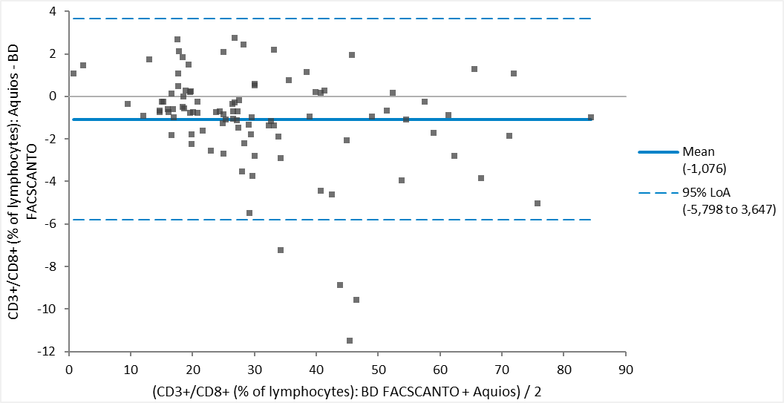
Figure 17 Bland Altman regression (full blue line) between dual-platform approach (BD Facscanto) and AQUIOS CL. Dotted blue lines indicate 95% limit of agreement. This example shows Bland Altman regression for CD3+/CD8+ (rel).

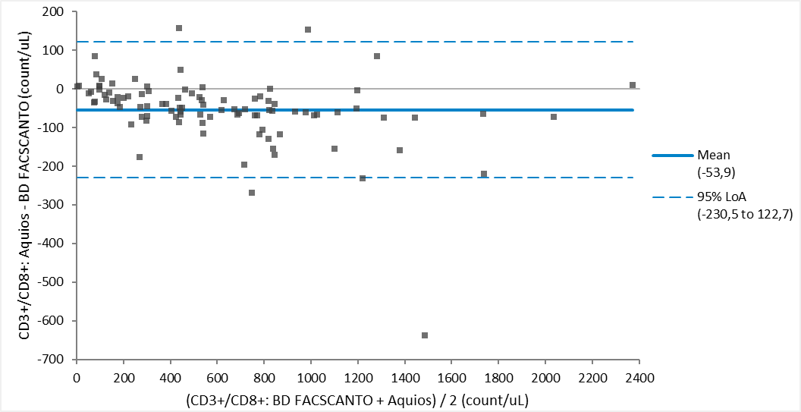
Figure 18 Bland Altman regression (full blue line) between dual-platform approach (BD Facscanto) and AQUIOS CL. Dotted blue lines indicate 95% limit of agreement. This example shows Bland Altman regression for CD3+/CD8+ (abs).

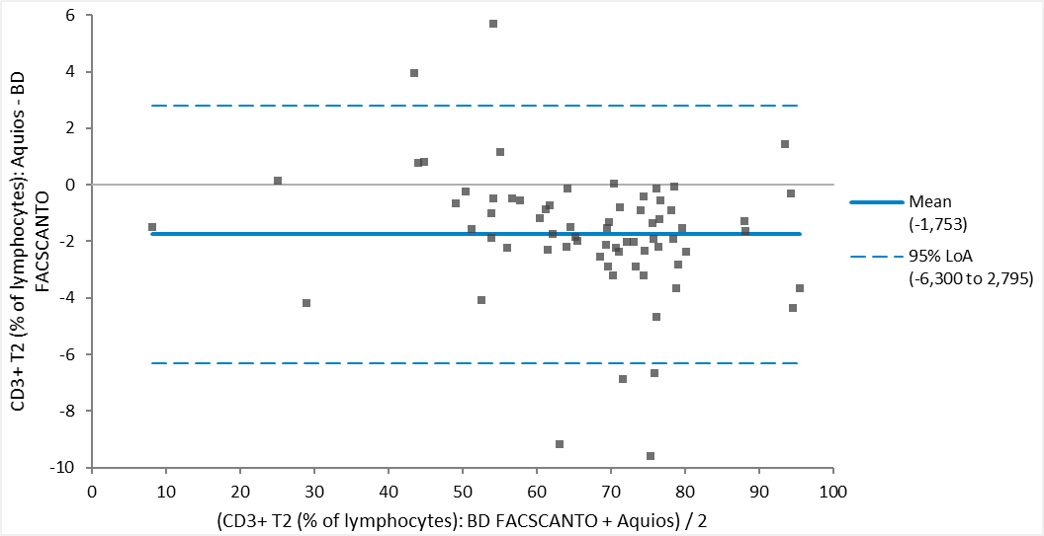
Figure 19 Bland Altman regression (full blue line) between dual-platform approach (BD Facscanto) and AQUIOS CL. Dotted blue lines indicate 95% limit of agreement. This example shows Bland Altman regression for CD3+ T2 (rel).

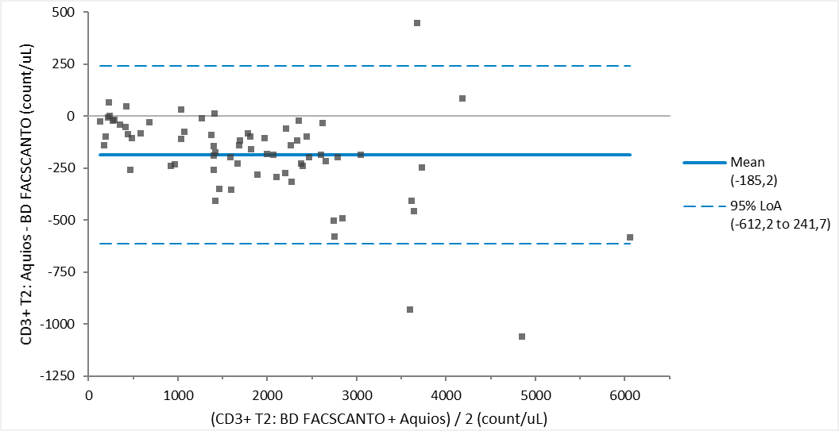
Figure 20 Bland Altman regression (full blue line) between dual-platform approach (BD Facscanto) and AQUIOS CL. Dotted blue lines indicate 95% limit of agreement. This example shows Bland Altman regression for CD3+ T2 (abs).

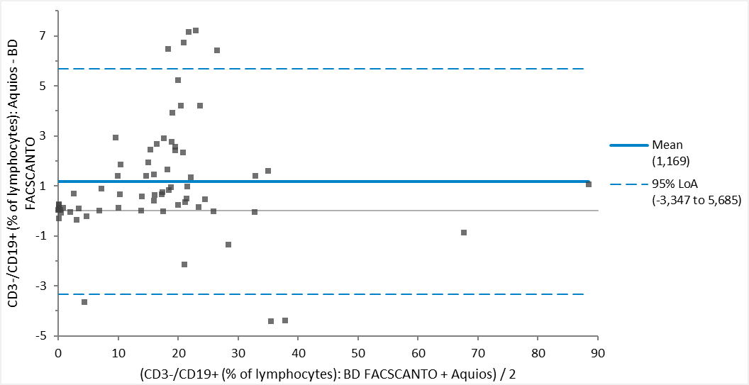
Figure 21 Bland Altman regression (full blue line) between dual-platform approach (BD Facscanto) and AQUIOS CL. Dotted blue lines indicate 95% limit of agreement. This example shows Bland Altman regression for CD3-/CD19+ (rel).

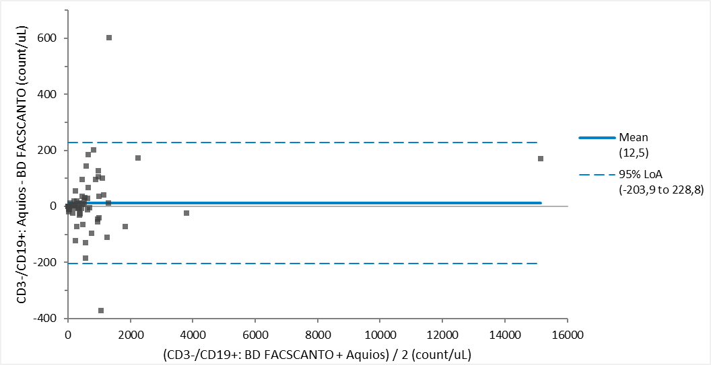
Figure 22 Bland Altman regression (full blue line) between dual-platform approach (BD Facscanto) and AQUIOS CL. Dotted blue lines indicate 95% limit of agreement. This example shows Bland Altman regression for CD3-/CD19+ (abs).

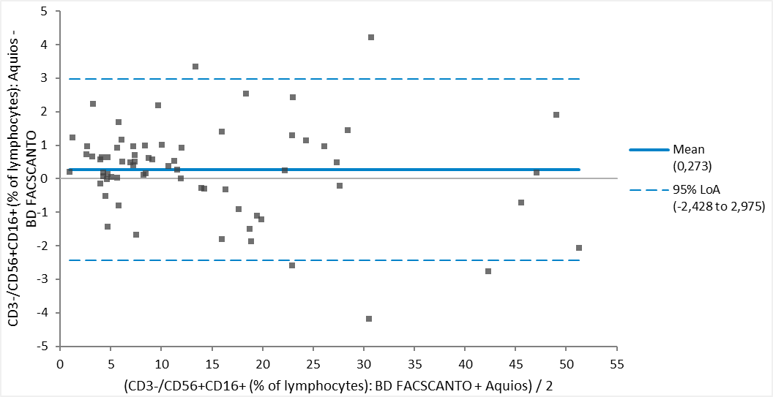
Figure 23 Bland Altman regression (full blue line) between dual-platform approach (BD Facscanto) and AQUIOS CL. Dotted blue lines indicate 95% limit of agreement. This example shows Bland Altman regression for CD3-/CD56CD16+ (rel).

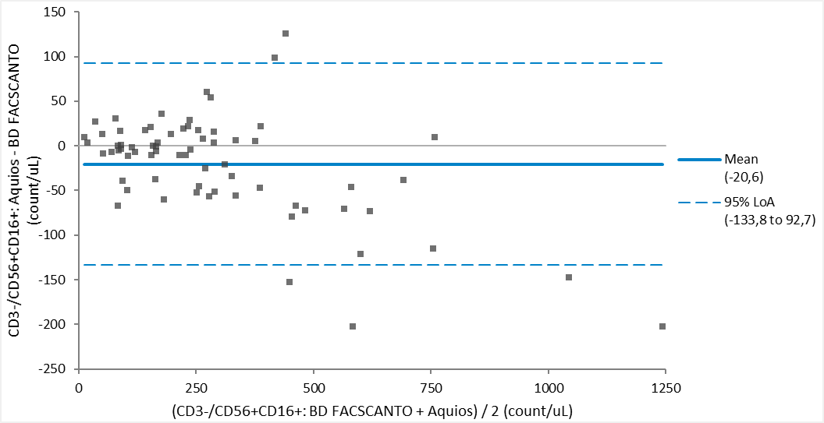
Figure 24 Bland Altman regression (full blue line) between dual-platform approach (BD Facscanto) and AQUIOS CL. Dotted blue lines indicate 95% limit of agreement. This example shows Bland Altman regression for CD3-/CD56CD16+ (abs).

