Supplemental Material

Table 1: Main demographic, clinical and laboratory characteristics of the patients with Crohn’s disease (CD), ulcerative colitis (UC) and control individuals included in the present study.

 | CD (n=100) | UC (n=100) | Control* (n=50)
Sex (male/female) | 43 (43%) /57 (57%) | 47 (47%) /53 (53%) | 19 (38%) /31(62%)
Age at sample date (mean years ± SD) | 38.03 ± 13.91 | 48.59 ± 15.63 | 48.54 ± 18.72
Age at diagnosis (mean years ± SD) | 24.87 ± 11.23 | 31.56 ± 14.02
Disease duration (mean years ± SD) | 13.16 ± 8.92 | 17.03 ± 13.77
Location or extent (%) | L1: 16 (16%)  L2: 22 (22%)  L3: 62 (62%) | E1: 11 (11%)  E2: 25 (25%)  E3: 64 (64%)
Behaviour (%) | B1:49 (49%)  B2: 27 (27%)  B3: 24 (24%)  Perianal: 30 (30%)
Age (%) | A1: 17 (17%)  A2: 73 (73%)  A3: 10 (10%)
PAB pattern reticulogranular IgA≠ positive/negative | 9 (9%) /91 (91%) | 7 (7%) /93 (93%) | 0 (0%) /50 (100%)
Anti-CUZD1 by IFA≠≠  IgA positive/negative | 9 (9%) /91 (91%) | 7 (7%) /93 (93%) | N/A
PAB pattern reticulogranular IgG≠  positive/negative | 19 (19%) /81 (81%) | 5 (5%) /95 (95%) | 0 (0%) /50 (100%)
Anti-CUZD1 by IFA≠≠  IgG positive/negative | 19 (19%) /81 (81%) | 5 (5%) /95 (95%) | N/A

*50 control samples (composed of 32 samples from patients with diseases unrelated to IBD and 18 samples from additional healthy individuals). ≠ Pancreatic tissue as substrate, ≠≠recombinant cells expressing CUZD1 as a substrate in IIF. L (location), B (behaviour) and A (age) according to Montreal classification; L1, ileal; L2, colonic; L3, ileocolonic and L4, upper disease modifier; B1, non-stricturing /non-penetrating; B2, stricturing; B3, penetrating behavior; p perianal disease modifier; A1 below 16 y, A2 between 17 and 40 y, A3 above 40 y; E1, Involvement limited to the rectum (that is, proximal extent of inflammation is distal to the rectosigmoid junction) ; E2, Left sided UC (distal UC): Involvement limited to a proportion of the colorectum distal to the splenic flexure; E3, Extensive UC (pancolitis): Involvement extends proximal to the splenic flexure ; SD, standard deviation.

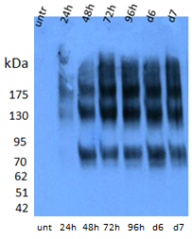

Supplementary Figure 1: Production of CUZD1 recombinant protein.
Recombinant CUZD1 was detected by Western blot analysis using an anti-CUZD1 peptide antibody. Detection of the secreted extracellular fragment of CUZD1 in the supernatant of the Expi293F cells at: 24, 48, 72, 96 hours, 6 days (d6) and 7 days (d7) after transfection. CUZD1 protein reached its peak expression 72h after transfection. Lane 1 shows untransfected cell supernatants (unt). Molecular mass markers (KDa) are shown.

Supplementary figure 2
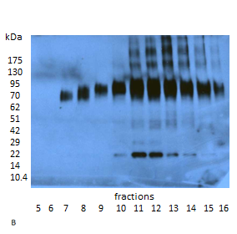
Absorbance
Number of fraction

Supplementary Figure 2: Purification of the protein fragment corresponding to the extracellular region of CUZD1 from supernatant of Expi293F cells by AIEX-FPLC.
(A) Elution chromatogram of the proteins present in the supernatant of the transfected cells. The recombinant protein was eluted in 200 mM NaCl fractions (peak inside the red box). (B) Eluted CUZD1 was monitored by Western Blot of the FPLC fractions. Bands pointed by red arrow were confirmed as CUZD1 protein by LC-MS/MS. For more discussion, see text.

