Rapid screening for targeted genetic variants via high-resolution melting curve analysis

Allison B. Chambliss¹, Molly Resnick¹, Athena K. Petrides¹, William A. Clarke¹, and Mark A. Marzinke^{1,2*}

¹Department of Pathology, Johns Hopkins University School of Medicine, Baltimore, MD, USA
²Department of Medicine, Johns Hopkins University School of Medicine, Baltimore, MD, USA

Supplemental Information: DOI 10.1515/labmed-2015-0603

Supplemental Tables

Supplemental Table 1. Primer sequences for CYP450 SNP genotyping.
Primer SNP target and orientation | Primer sequence (5’-3’) | PCR product size (bp)
CYP2C9*2-F | agaaatggaaggagatccggcgttt | 150
CYP2C9*2-R | ATATGGAGTAGGGTCACCCACCCTT | 150
CYP2C9*3-F | tgcaagacaggagccacatgc | 176
CYP2C9*3-R | CTTCGAAAACATGGAGTTGCAGTGTAGGA | 176
CYP2C19*2-F | ACAACCAGAGCTTGGCATATTG | 208
CYP2C19*2-R | GTTGATGTCCATCGATTCTTGGTG | 208
CYP2C19*3-F | CTCCATTATTTTCCAGAAACGTTTCG | 160
CYP2C19*3-R | CCCAGAAAAAAAGACTGTAAGTGG | 160
CYP2C19*17-F | CTGTTTTATGAACAGGATGAATGTGGTA | 159
CYP2C19*17-R | CGTGGCGCATTATCTCTTACAT | 159
CYP3A5*2-F | AGCTCCATTTCC CTGGAGACTTG | 150
CYP3A5*2-R | GCAAGAAAGATGTTGAAATCAATGGGGT | 150
CYP3A5*3-F | GTTGTACGACACACAGCAACCT | 201
CYP3A5*3-R | TACCACCCAGCTTAACGAATGC | 201
CYP3A5*6-F | ACAATGGAATTGTACCTTTTAAGTGGATGA | 193
CYP3A5*6-R | CTCTCAACAATCCACAAGACCCCT | 193
CYP3A5*7-F | CCACCATTGACCCTTTGGGAATGAATAC | 193
CYP3A5*7-R | ATCTCAGATTATCCAATTCTGTTTCTTTCC | 193

Supplemental Table 2. PCR cycling and HRM reaction conditions.
 | Activation step | PCR cycling | HRM holds | Temperature ramp
CYP2C9: *2, *3  CYP2C19: *3, *17 | 95°C, 5 min | 40x:  58°C, 5 s  72°C, 7 sª | 94°C, 30 s  followed by  40°C, 30 s | 65-95 °C  0.10 °C/s
CYP2C19: *2 | 95°C, 5 min | 50x:  95°C, 15 s  58°C, 15 s  72°C, 10 s^{b} | 94°C, 30 s  followed by  40°C, 30 s | 70-80 °C  0.02 °C/s
CYP3A5: *2, *3, *6, *7 | 95°C, 5 min | 40x:  95°C, 10 s  58°C, 30 s^{b} | 94°C, 30 s  followed by  40°C, 30 s | 70-84 °C  0.05 °C/s
ªEvaGreen dye detected at 510 nm.

Supplemental Table 3. Estimated allelic frequencies for assessed CYP450 SNPs.
Allele | Caucasian (%) | Asian (%) | African American (%)
CYP2C9*2 | 13 | <1 | 3
CYP2C9*3 | 7 | 4 | 2
CYP2C19*2 | 15 | 34 | 18
CYP2C19*3 | <1 | 9 | <1
CYP2C19*17 | 22 | 17 | 19
CYP3A5*2 | <1 | <1 | <1
CYP3A5*3 | 92 | 74 | 30
CYP3A5*6 | <1 | <1 | 17
CYP3A5*7 | <1 | <1 | 8
Source: Clinical Pharmacogenetics Implementation Consortium [11].
Supplemental Figure Captions

Supplemental Figure 1. Defining the genotype threshold.
The run-specific genotype confidence threshold was defined as the overall average of melting curve profile results for the duplicate reference and duplicate heterozygous controls included at the beginning and end of the run. Unknown samples over this threshold were auto-called called as reference and samples above the threshold were called as variant. The software’s terminology of ‘wild type’ is equivalent to our use of ‘reference.’

Supplemental Figure 2. Primer specificity.
Template DNA was amplified with custom-designed primers to target the SNPs of interest. Single, prominent bands at the expected base pair lengths indicated primer specificity. Lack of non-specific bands in the no-template control (NTC) lanes further indicated primer specificity and lack of undesired PCR by-products.

Supplemental Figure 3. Effect of DNA input concentration on genotyping.
For each SNP, reference, heterozygous, and homozygous DNA controls were assessed for accuracy of HRM genotyping at a wide range of DNA input concentrations. Representative results are displayed for CYP3A5*3 using 10 (A), 50 (B), and the standard 100 ng/µL DNA (C). For all DNA concentrations tested, the software accurately called sample genotypes (D).

Supplemental Figure 1.

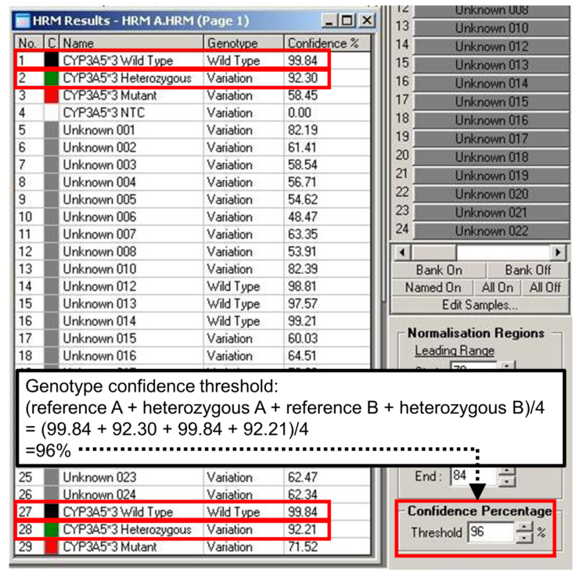

Supplemental Figure 2.

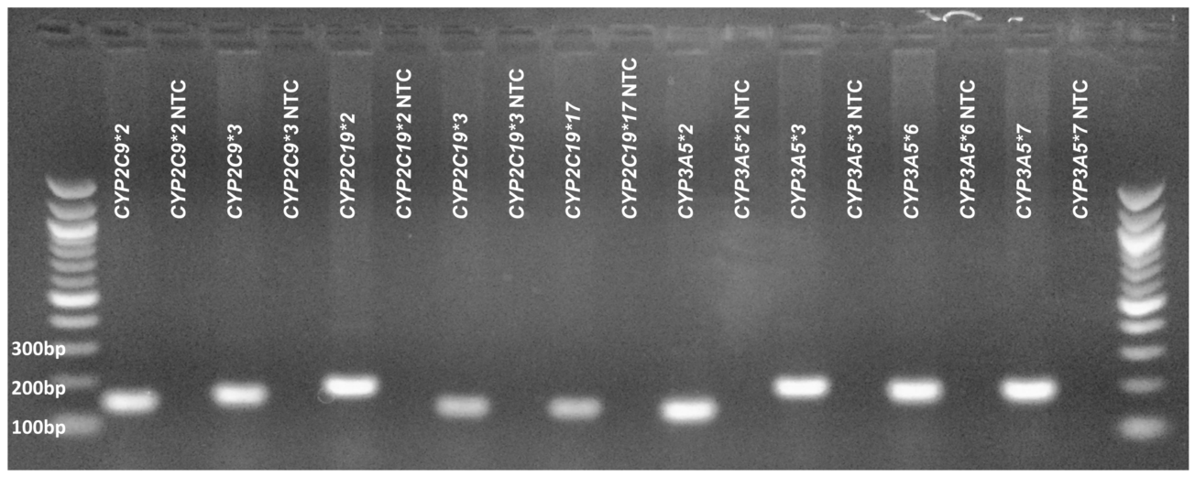
Supplemental Figure 3.

