Supplemental Material: DOI: 10.1515/cclm-2016-0340

Figure 1: Long-term stability of LysoGb3, LysoSM and HexSph at -20 ° C and -80 ° C at different time intervals.

Figure 2:LysoGb3 (A) LysoSM (B) and HexSph (C) concentrations by age and gender of healthy controls.White dots (○) represent female, black dots (●) represent male. 2.5-97.5th percentile and median are represented by dashed lines and solid lines respectively.
Figure 3: Second tier test GalSph/GlcSph. Chromatographic separation on the BEH amide column of GalSph (RT 2.35 min) and GlcSph (RT 2.6 min) in a plasma spiked with GalSph and GlcSph (A), Krabbe patient (B) , Gaucher patient (C).
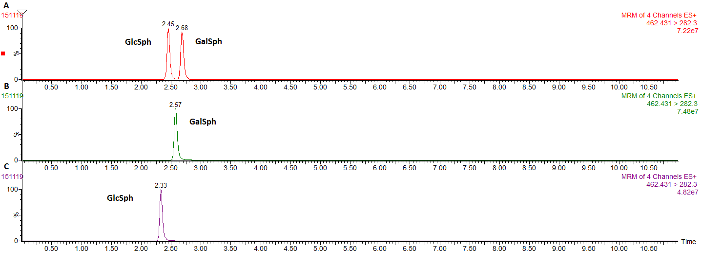

Table 1: Plasma concentrations of LysoGb3, LysoSM and HexSph in controls (median, 2.5-97.5th percentile) and patients with various lysosomal storage disorders (median, range).

 | LysoGb3,  nmol/L | LysoSM,  nmol/L | HexSph,  nmol/L
Controls (n=194) | 0.29 (0.09 – 0.46) | 10.2 (4.5 – 19.1) | 2.09 (1.15 – 3.25)
Fabry disease (n=16) | 5.88 (2.79 – 62.2) | 13.3 (6.2 – 25.1) | 3.05 (2.0 – 4.32)
Gaucher disease (n=8) | 0.67 (0.27 – 1.03) | 17.3 (8.7 – 40.6) | 74.8 (40.8 – 125)
Krabbe disease (n=3) | 0.18 (0.14 – 0.23) | 3.2 (1.3 – 4.0) | 45.5 (38 – 53.5)
Niemann-Pick disease type C (n=11) | 0.24 (0.16 – 0.56) | 34.4 (17.6 – 76.2) | 3.3 (2.27 – 8.57)

