Supplementary Material: DOI: 10.1515/cclm-2016-0194
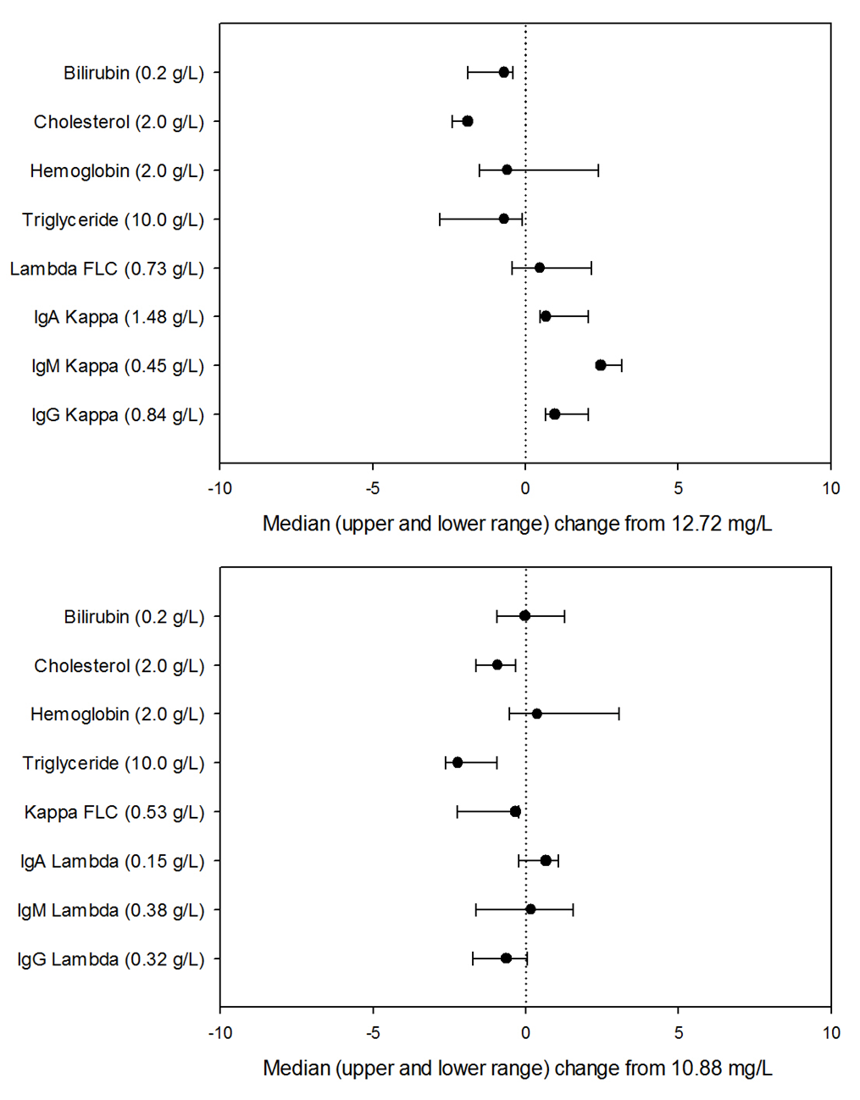
Supplementary Figure 1. Assessment of interference from common interference agents in the measurement of κ FLC (top) and λ FLC (bottom) by Seralite®.
Change (mg/L) as a result of interference (x-axes) was assessed by adding interference agents (y-axes) to serum containing normal κ (12.72 mg/L) and λ (10.88 mg/L) FLC levels. The concentration of interference agents is the final concentration in the sample.

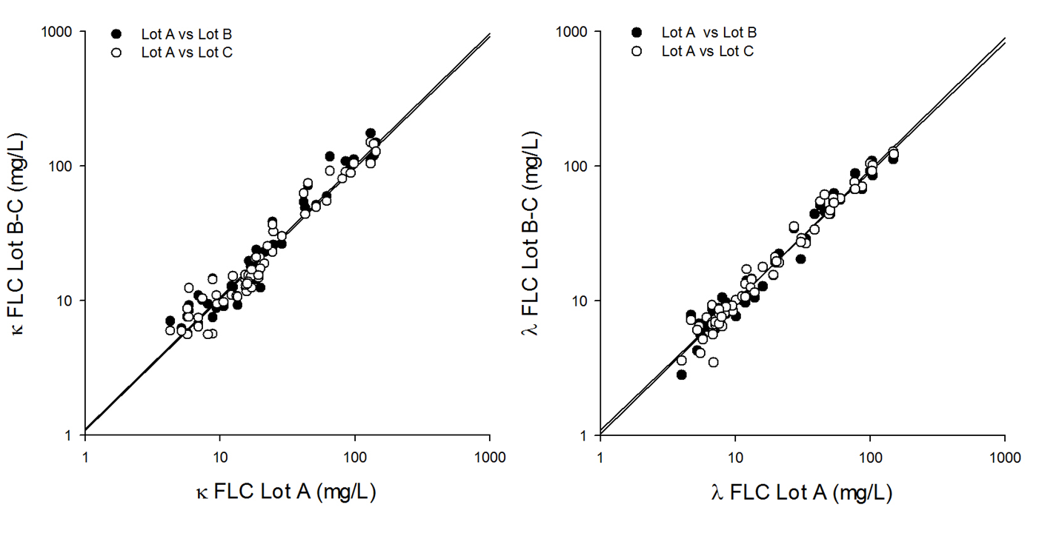
Supplementary Figure 2. Lot-to-lot variation from three independent lots of Seralite® for κ FLC (left) and λ FLC (right) when measuring 65 samples containing varying levels of free light chains.

CV % | Intra-day | Inter-day | Inter-reader
Κ FLC
Normal | 8.1 | 5.7 | 5.5
Elevated | 8.1 | 3.6 | 3.1
Highly-elevated | 9.6 | 3.9 | 4.5
λ FLC
Normal | 8.5 | 5.1 | 4.8
Elevated | 7.4 | 4.6 | 2.0
Highly-elevated | 9.0 | 7.1 | 2.6
Supplementary Table 1. Precision data using samples with varying concentrations of free light chains. For intra- and inter-day precision samples with the following concentrations were used: normal (15.9 mg/L κ FLC, 13.4 mg/L λ FLC), elevated (51.8 mg/L κ FLC, 40.5 mg/L λ FLC) and highly-elevated (136.6 mg/L κ FLC, 136.7 mg/L λ FLC). For inter-reader precision samples with the following concentrations were used: normal (11.7 mg/L κ FLC, 8.8 mg/L λ FLC), elevated (42.1 mg/L κ FLC, 48.6 mg/L λ FLC) and highly-elevated (156.7 mg/L κ FLC, 147.6 mg/L λ FLC).
Supplementary Table 2. Stability of FLC concentrations measured using Seralite for samples with varying concentrations of FLCs: low, normal, elevated and high. Data shown is the median change in FLC concentration from baseline (mg/L) across three different testing conditions: ambient room temperature (21–24°C), refrigeration (3–5 °C) and freeze-thawing. Samples stored at room temperature where tested at 0, 1, 8, 24, 48 and 72h. Samples stored in the fridge were tested at 0, 1, 2, 3, 4 and 7 days. To test the effects of freeze thaw cycles, samples were tested on day 0 then frozen and re-tested daily over 6 consecutive days.
 | Low |  | Normal |  | Elevated |  | High
 | Κ  4.5 mg/L | λ  6.7 mg/L | Κ  13.5 mg/L | λ  10.9 mg/L | Κ  38.8 mg/L | λ  40.4 mg/L | Κ  124.8 mg/L | λ  122.0 mg/L
Ambient room temperature  21–24 °C:  0–72h | 0.7 | 1.4 | -2.1 | -0.4 | -3.1 | -0.2 | -7.8 | -7.8
3–5 °C:  0–7 days | 0.7 | 1.3 | -0.1 | -0.3 | 0.4 | 1.3 | 2.3 | 1.6
Freeze thaw  6 cycles | 0.8 | 0.4 | 1.1 | 1.4 | -0.5 | 2.9 | 3.3 | 4.7

Supplementary Table 3. Samples from multiple myeloma patients previously shown to give erroneously low results by Freelite® due to antigen excess were analysed using Seralite®. Grey boxes highlight where antigen excess resulted in incorrect diagnosis using the standard dilution on Freelite®: patient 1 changes from a lambda to kappa diagnosis with re-dilution; patient 5 initially demonstrated a ratio within the normal diagnostic range (0.26–1.65) but then indicated a monoclonal lambda FLC with re-dilution. Seralite® was able to correctly identify all monoclonal FLCs in these patients using the ratio obtain from the standard dilution.
 | Freelite® (RocheHitachiCobas®C501)  Standard dilution (κ 1 in 5, λ 1 in 8) |  |  | Freelite® (RocheHitachiCobas®C501)  Offline dilution ( 1 in 100) |  |  | Seralite® dual Κ and λ lateral flow device  Standard dilution (1 in 3) |  |  | Seralite®  Offline dilution  (1 in 20/1 in 400)
Sample and involved FLC | Κ | λ | Κ:λ | Κ | λ | Κ:λ | Κ | λ | Κ:λ | Κ | λ | Κ:λ
1 - κ | 0.77 | 6.35 | 0.12 | 664 |  | 105 | 78.8 | < 2.5 | > 32
2 - κ | 37.64 | 8.66 | 4.3 | 31594 |  | 3648 | > 200 | 3.4 | >58 | 22320 |  | 6565
3 - λ | 5.63 | 39.86 | 0.14 |  | 695 | 0.01 | < 2.5 | 184.2 | < 0.013
4 - κ | 41.47 | 24.27 | 1.7 | 454 |  | 19 | 54.5 | 11.7 | 4.7
5 - λ | 6.51 | 15.63 | 0.42 |  | 1772 | 0.01 | < 2.5 | > 200 | < 0.01 |  | 39480 | >0.0006
6 - κ | 22.09 | 10.77 | 2.05 | 5435 |  | 505 | > 200 | 6.7 | > 30 | 4960 |  | 740
7 - κ | 51.05 | 8.58 | 5.95 | 562 |  | 66 | > 200 | < 2.5 | > 80 | 530 |  | >212
8 - κ | 31.31 | 5.00 | 6.26 | 3652 |  | 3652 | 135.5 | < 2.5 | > 54
9 - κ | 44.35 | 6.31 | 7.02 | 6640 |  | 1052 | 57.2 | < 2.5 | > 23
10 - κ | 46.85 | 9.48 | 4.94 | 1611 |  | 170 | 59 | 13.7 | 4.3

