Supplementary Material – Callibration curves: DOI: 10.1515/cclm-2015-0599

KLK3
 | Plate 1 |  | Plate 2 |  | Plate 3
Copies (log) | CP | copies | CP | copies | CP | copies | Average (CP) | (copies) | st dev | CV %
6 | 19,67 | 1186209 | 20,12 | 874441 | 19,80 | 1086184 | 19,86 | 1048945 | 159185 | 15
5 | 23,32 | 100000 | 23,52 | 87326 | 23,40 | 94723 | 23,41 | 94016 | 6367 | 7
4 | 26,56 | 11130 | 26,8 | 9459 | 26,79 | 9524 | 26,72 | 10038 | 946 | 9
3 | 30,22 | 932 | 30,13 | 991 | 30,15 | 977 | 30,17 | 967 | 31 | 3
2 | 33,72 | 87 | 33,47 | 103 | 34,25 | 61 | 33,81 | 84 | 21 | 26
1 | 36,26 | 16 | 36,37 | 14 | 36,26 | 16 | 36,30 | 15 | 1 | 4

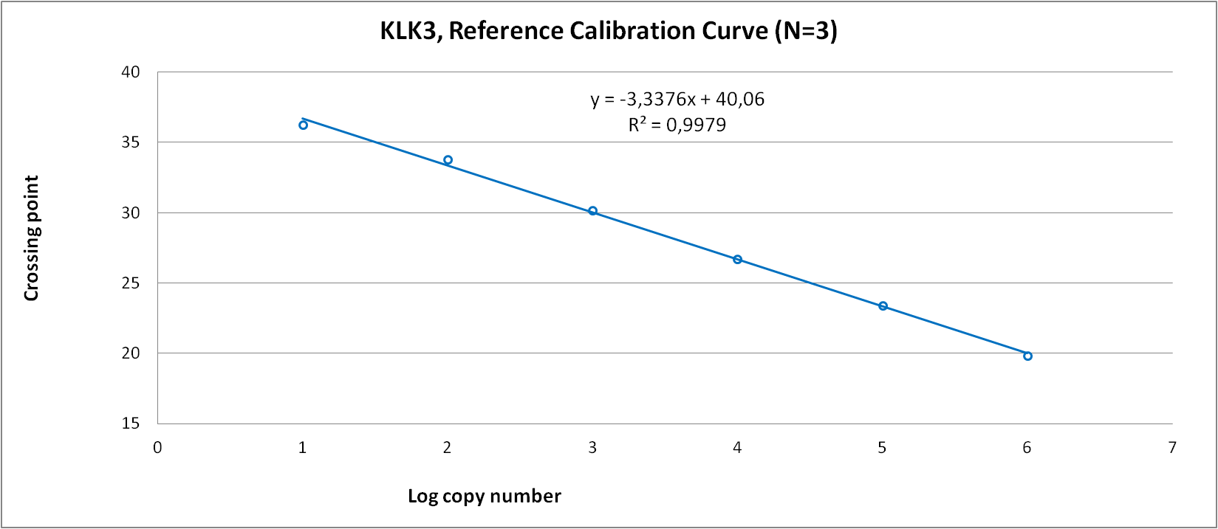
PCA3
 | Plate 1 |  | Plate 2 |  | Plate 3
Copies (log) | CP | copies | CP | copies | CP | copies | Average (CP) | (copies) | st dev | CV %
6 | 20,53 | 971558 | 20,59 | 934567 | 20,58 | 940633 | 20,57 | 948919 | 19839 | 2
5 | 23,94 | 106994 | 23,89 | 110512 | 23,91 | 109091 | 23,91 | 108866 | 1770 | 2
3 | 30,93 | 1162 | 31,01 | 1104 | 31,06 | 1069 | 31,00 | 1112 | 47 | 4
2 | 35,14 | 76 | 35,16 | 75 | 35,18 | 74 | 35,16 | 75 | 1 | 1
1 | 38,08 | 11 | 37,81 | 14 | 38,27 | 10 | 38,05 | 12 | 2 | 15

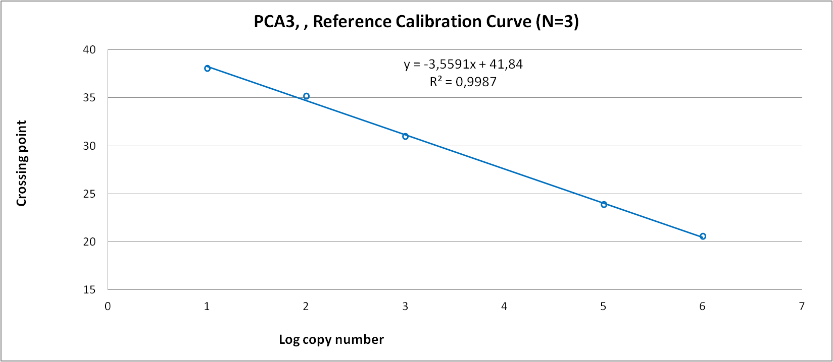

ERG
 | Plate 1 |  | Plate 2 |  | Plate 3
Copies (log) | CP | copies | CP | copies | CP | copies | Average (CP) | (copies) | st dev | CV %
6 | 18,96 | 1118364 | 19,1 | 1017560 | 19,03 | 1066772 | 19,03 | 1067565 | 50407 | 5
5 | 22,45 | 106153 | 22,61 | 95290 | 22,60 | 95935 | 22,55 | 99126 | 6094 | 6
4 | 25,93 | 10144 | 26,06 | 9292 | 26,06 | 9292 | 26,02 | 9576 | 492 | 5
3 | 29,30 | 1044 | 29,56 | 876 | 29,70 | 797 | 29,52 | 906 | 126 | 14
2 | 32,63 | 110 | 32,77 | 100 | 32,65 | 109 | 32,68 | 107 | 5 | 5
1 | 35,84 | 13 | 36,25 | 10 | 36,33 | 9 | 36,14 | 10 | 2 | 18

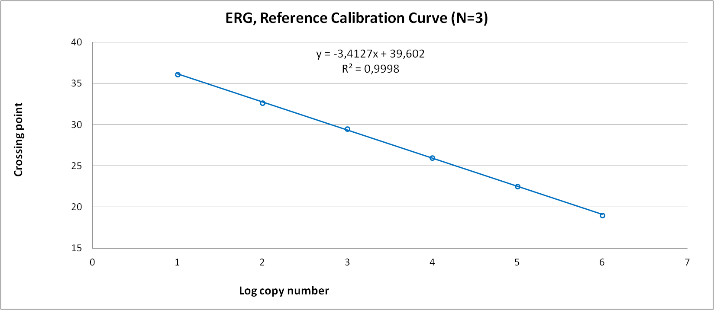
SUMMARY CALLIBRATION CURVES
Gene | KLK3 |  | PCA3 |  | ERG
Y-intercept of standard curve | 40.06 |  | 41.84 |  | 39.60
Slope of standard curve | -3.34 |  | -3.56 |  | -3.41
PCR efficiency calculated from slope | 99.35 |  | 90.97 |  | 96.35
Amplification factor | 1.99 |  | 1.91 |  | 1.96
r2 of standard curve | 0.9979 |  | 0.9987 |  | 0.9998
Linear dynamic range | 10-1E6 copies |  | 10-1E6 copies |  | 10-1E6 copies
Cq variation at lower limit | 4% |  | 15% |  | 18%

