**Supplemental data**

**Test principle Immunoassay**

The ARKTM VRC immunoassay is a homogeneous enzyme immunoassay. The assay is based on competition between VRC in the patient sample and VRC labelled with glucose-6-phosphate dehydrogenase (G6PDH) for binding the antibody reagent. In the absence of the drug, VRC labelled with glucose-6-phosphate dehydrogenase (G6PDH) will bind to the antibody and the enzyme activity is inhibited. In the presence of VRC, the enzyme activity is directly proportional to the VRC concentration in the patient sample. Active enzyme converts nicotinamide adenine dinucleotide (NAD) to NADH and this conversion is measured spectrophotometrically at 340 nm. The VRC kit was implemented on the Cobas® 8000 c502 analyzer (Roche Diagnostics, Mannheim, Germany) in the core laboratory of Ghent University Hospital (Belgium). For each test, 2.5 uL of patient sample is mixed with 100 µL of reagent 1 and 50 µL of reagent 2 (See Table 1). The formation of NADH is monitored spectrophotometrically.

**Test principle UPLC-PDA**

Chromatographic analysis of VRC was performed on an AcquityTM Ultra Performance LC with PDA-detector (Waters Ltd, Zellik, Belgium). Separation and gradient elution was achieved with an AcquityTM UPLC BEH Phenyl column (1.7 µm; 2.1 x 100 mm; Waters Ltd, Zellik, Belgium) protected with a guard column. Sample preparation was done by a solid phase extraction of 1000 µL sample, nitrogen evaporation and reconstitution with 200 µL phosphate buffer pH 2.5: methanol (40:60 v/v). The analysis was achieved with a simple linear gradient elution using 10 mM phosphate buffer pH 2.5 (A) and 10 mM phosphate buffer pH 2.5: acetonitrile (30:70 v/v) (B) as the mobile phase at a flow rate of 0.4 mL/min. The elution started with 64% A for 1.1 min, then the composition was linearly changed to 100% B over 3.65 min and maintained at this level for 1.25 min. Finally, the composition was returned to the initial composition over 0.1 min and maintained for 1.4 min. Total run time was 6.0 minutes. The column temperature was set at 45°C. Injection volume was 5 µL in full-loop mode. For each component absorbance maximum was detected by PDA-detector. The analytical measuring was found linear in the measuring range 0.5 – 20 mg/L. Measurements on QC material, with concentrations 0.5, 3.0 and 6.0 mg, showed a within-run imprecision (n=10) <5%, a between-run imprecision (10 days) <10% and a percent recovery ≥95%.

**Method linearity**

We evaluated the linearity of the VRC assay according to NCCLS guideline EP6-A. We prepared 11 different VRC dilutions of a human plasma pool, spiked with a high concentration of VRC, resulting in a series covering the range 0.5 – 16.2 mg/L. Duplicate measurements were done for each concentration, with the default criterion set at 5% for repeatability (lowest concentration < 20%). The standard errors of regression (Sy|x) and t-tests for the regression analyses showed that the third-order model fitted better than the first- and second-order models: first-order model Sy|x = 0.379; second-order model Sy|x = 0.364, with the nonlinear term being not statistically significant (p=0.10); third-order model Sy|x 0.315, with the nonlinear coefficients being statistically significant (p<0.05). However, as the difference between the first- and third-order model was within the allowable error of 10%, the deviation from linearity is considered not clinically important and hence, linearity is acceptable within its measurement range (Supplemental Data, Figure 1).

**Tables and Figures**

**Supplemental Table 1:** Application protocol of the ARKTM VRC Immunoassay on the Cobas® 8000 c502

|  |  |
| --- | --- |
| ARK Voriconazole Application c502 |  |
| Assay | Rate-A |
| Reaction time | 5 |
| Measurement point 1 | 17 |
| Measurement point 2 | 28 |
| Wavelength (Primary) | 340 |
| Wavelength (2nd) | None |
| Sample volume | 2.5 |
| R1 reagent volume | 100 |
| R2 reagent volume | 50 |
| Absorbance limit | 32000 |
| Assay direction | Increase |
| Cell detergent | Detergent 1 |
| Stirring level | 2 |
| Calibration type | RCM, (6 Point, 6 Span, 0 Weight) |
| Range unit | µg/mL |
| Calib. standard (1) | 0.00 |
| Calib. standard (2) | 1.00 |
| Calib. Standard (3) | 2.00 |
| Calib. Standard (4) | 4.00 |
| Calib. Standard (5) | 8.00 |
| Calib. Standard (6) | 16.00 |

**Supplemental Table 2:** Results for interference of the ARKTM VRC Immunoassay on the Cobas® 8000 c502.

|  |  |
| --- | --- |
| **Composition** | **VRC concentration (mg/L) (mean of duplicate measurement)** |
| no VRC | <0.4 |
| VRC 3 mg/L | 3.4 |
| no VRC, fluconazole 30 mg/L | <0.4 |
| VRC 3 mg/L + fluconazole 30 mg/L | 3.3 |
| no VRC, itraconazole 20 mg/L | <0.4 |
| VRC 3 mg/L + itraconazole 20 mg/L | 3.4 |
| no VRC, posaconazole 20 mg/L | <0.4 |
| VRC 3 mg/L + posaconazole 20 mg/L | 3.2 |
| no VRC, VRC N-oxide 10 mg/L | <0.4 |
| VRC 3 mg/L + VRC-oxide 10 mg/L | 3.2 |

**Supplemental Figure 1**

**A.**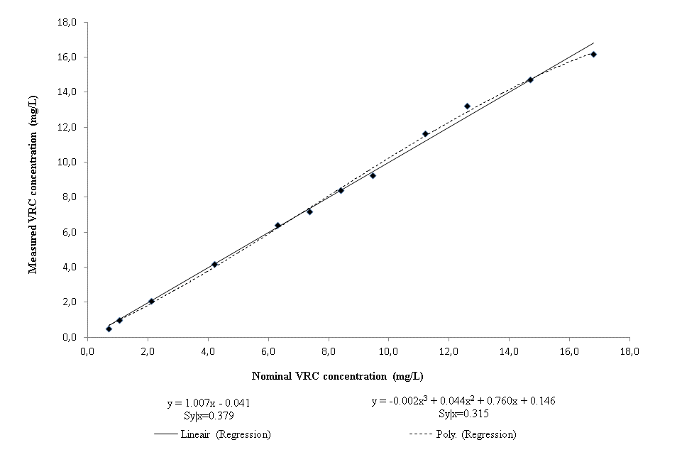

**B.**

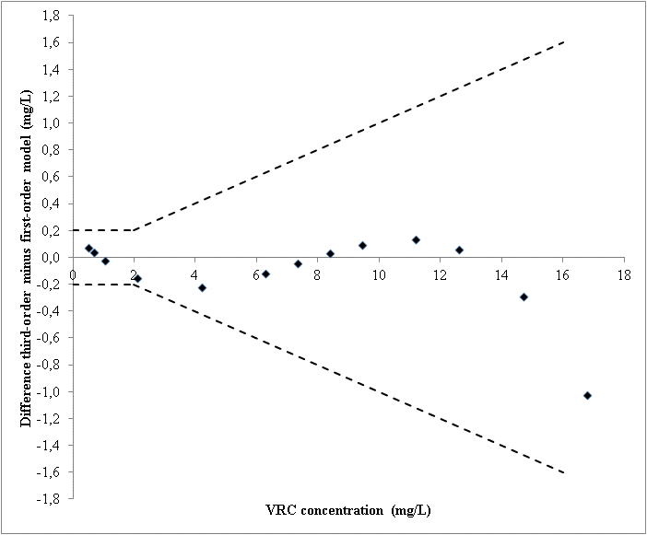

**Figure 1:** Results for linearity of the ARKTM VRC Immunoassay on the Cobas® 8000 c502. Voriconazole was added and diluted in blank plasma. (A) Mean VRC results of duplicate measurements are shown in function of the nominal VRC concentration. Linear and third-order polynomial regression lines are shown. (B) Linearity difference plot where the differences between the first and third-order model (Y-axis) are plotted against the VRC concentration (X-axis).

**Supplemental Figure 2**



**Figure 2:** Determination offunctional sensitivity of the ARKTM VRC Immunoassay on the Cobas® 8000 c502. Five dilutions with a known concentration were analyzed in triplicate for five days. Coefficients of variation on these measurements over five days are represented by individual dots.