**SUPPLEMENTAL MATERIAL:** DOI: [10.1515/cclm-2014-0592](http://dx.doi.org/10.1515/cclm-2014-0748)

**Figure 1:** Epitope location for BNP immunoassays (from IFCC database July 2011)

**-?-:** epitope locations not precisely known

M: monoclonal

O:oligoclonal

m: mouse

**H2N-**SPKMVQGSGC10FGRKMDRISS20SSGLGCKVLRRH-COOH

**Abbott 5--**- Mm -----**1326---** Mm -----**32**

**Alere 5--**- Mm -----**13**Om **?**

**Beckman 5--**- Om ------**13**Mm **?**

**Siemens (Bayer) 14-----**- Mm -----**2127--** Mm --**32**

**Siemens (DB) 14-----**- Mm -----**2127--** Mm --**32**

**Shionogi 14-----**- Mm -----**2127--** Mm --**32**

**-** M**-: Capture Antibody**

**-** M- **: Detection Antibody**

**Figure 2:** Epitope location for NT-proBNP immunoassays (from IFCC database July 2011)

**-?-:** epitope locations not precisely known

M: monoclonal

P:polyclonal

m: mouse

g: goat

O-glycosylation sites (serine, threonine)

**H2N-**HPLGSPGSAS10DLETSGLQEQ20RNHLQGKLSE30LQVEQTSLEP40LQESPRPTGV50WKSREVATEG60IRGHRKMVLY70TLRAPR-COOH

**Alere 27-** Mm --**3142---** Mg --**46**

**BioMérieux1-------------------**Pg ----------------------**2139--------**Pg ----------**50**

**Mitsubishi 1-------------------**Pg ----------------------**2139--------**Pg ----------**50**

**Nanogen** Mm +Pg -?- Pg -?-

**OCD 1-------------------** Pg ----------------------**2139--------** Pg ----------**50**

**Response27-** Mm --**3139--------**Pg ----------**50**

**Roche 1 1-------------------**Pg ----------------------**2139--------**Pg ----------**50**

**Roche 2 27-** Mm --**3142---** Mg --**46**

**Siemens (DB) 22-**----Mg ----**2842---** Mg --**46**

**Siemens (DPC) 1-------------------**Pg ----------------------**2139--------**Pg ----------**50**

**-** M**-: Capture Antibody**

**-** M-**: Detection Antibody**

**Figure 3:** Box plot (distribution) of natriuretic peptide individual results from the study samples measured by the tested methods and divided according to NYHA stages.

Part A: Box plot showing Access® (n=19), Architect® (n=19), Centaur® (n=19) and Triage® (n=19) BNP levels. Part B: Box plot showing Elecsys® (n=39), CobasH232® (n=36), Vidas® (n=39), Vista® (n=39), Vitros® (n=39), andXpand® (n=39) NT-proBNP levels.

.

**A**

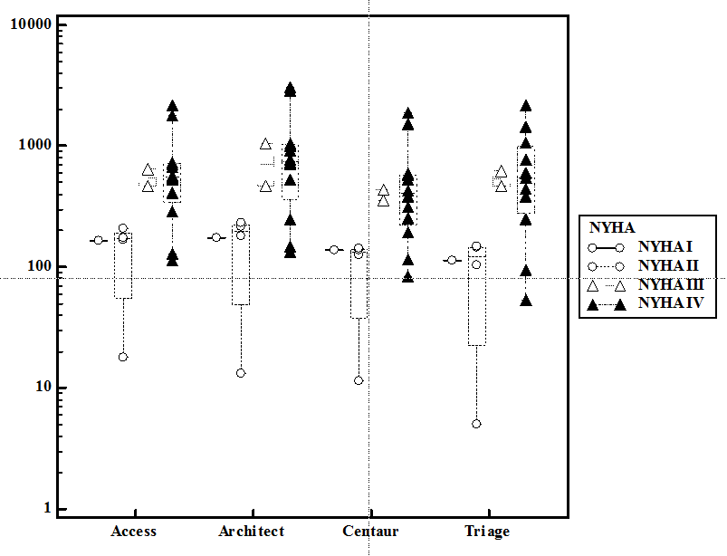

**B**

