Supplemental data

Table S1. Structure and activity of insulin analogues.
Name | Length of action | Sequence
Actrapid | Rapid | Human recombinant insulin
Humalog (lispro) | Rapid | B28:29 Pro/Lys swopped
Novorapid (aspart) | Rapid | Pro replaced with Asp at B28
Apidra (glulisine) | Rapid | Asp replaced with Lys at B3 and Lys replaced by Glu at B29
Lantus (glargine) | Long | Asp replaced with Gly at A21 + 2 Arg to carboxy-terminal of B chain
Levemir (detemir) | Long | C14 fatty acid chain B29
M1 |  | Asp replaced with Gly at A21  Glargine metabolite n°1
M2 |  | Asp replaced with Gly at A21, des-Thr at B30  Glargine metabolite n°2

Table S2. Commercially available insulin assays.

Assays/Manufacturer | Assay type | Automatisation | References | Method principle | Category of immunoassay | Antibodies
Access (Beckman) | IEMA | Automated | Owen, 2004 | Paramagnetic microparticles coated with anti-insulin monoclonal antibody and anti-insulin monoclonal antibody alkaline phosphatase conjugate. | Two-site immunometric | Monoclonal
Advia Centaur IRI (Siemens) | ICMA | Automated | Owen, 2004 Morovat, 2007 Krull, 2009 Heald, 2006 | Two-site "sandwich" immunoassay using direct luminescent technology. The first antibody is a monoclonal mouse anti-insulin antibody labeled with acridinium ester. The second antibody is a monoclonal mouse anti-insulin antibody, which is coupled to paramagnetic particles | Two-site immunometric | Monoclonal
Architect (Abbott Laboratories) | ICMA | Automated | Moriyama, 2006 | One-step chemiluminescent immunoassay that uses paramagnetic microparticles coated with anti-insulin monoclonal antibody and acridinium-labeled anti-insulin monoclonal antibody conjugate. | Two-site immunometric | Monoclonal
Wallac AutoDELFIA Insulin (PerkinElmer) | IFMA | Automated | Vieira, 2007 Heald, 2006 | Two-site fluoroimmunometric assay. Two monoclonal antibodies (derived from mice) directed against separate antigenic determinants on the insulin molecule. Solid phase monoclonal anti-insulin IgG and europium-labeled monoclonal anti-insulin IgG. | Two-site immunometric | Monoclonal
Bi-insulin IRMA (CIS Bio) | IRMA | Manual | Agin, 2006 | Immunoradiometric assay. Two monoclonal anti-insulin antibodies, one adsorbed on the tube walls and the other is iodine labelled. | Two-site immunometric | Monoclonal
Elecsys (Roche Diagnostics) | IECMA | Automated | Sapin, 2001 Krull, 2009 Heald, 2006 | Biotinylated monoclonal antibody reacting with streptavidin-coated particles and a second monoclonal antibody labelled with ruthenium. | Two-site immunometric | Monoclonal
Coat-A-Count (Siemens) | RIA | Manual | Owen, 2004 | Competition method. Solid-phase radioimmunoassay^{. 125}I-labeled insulin competes for a fixed time with insulin in the patient sample for sites on insulin-specific antibody. | Competition | Polyclonal
Human Insulin Specific RIA (Millipore) | RIA | Manual |  | Competition between labeled tracer and unlabeled antigen for the limited and constant number of binding sites on the antibody. Guinea pig anti-human insulin specific antibody. Polyclonal antibodies. | Competition | Polyclonal
INS-EASIA (DIAsource) | IEMA | Manual |  | Two monoclonal antibodies directed against distinct epitopes of insulin. One adsorbed on microtiter well and one labelled with horseradish peroxidase. | Two-site immunometric | Monoclonal
Ins-IRMA (Immunotech, Beckman) | IRMA | Manual |  | Two-site non-competitive assay. Two monoclonal antibodies. One (capture antibodies) attached to the surface of the plastic tube and one (signal antibody) labelled with ¹²⁵I. | Two-site immunometric | Monoclonal
INSI-CTK IRMA (DiaSorin) | IRMA | Manual |  | One-step solid-phase immunoradiometric assay. Anti-insulin monoclonal antibody bound to polystyrene tubes and 125I-labelled anti-insulin monoclonal antibody. | Two-site immunometric | Monoclonal
INSIK-5 (DiaSorin) | RIA | Manual |  | Competition between labelled insulin and insulin contained in calibrators or samples to be assayed for a fixed and limited number of antibody binding sites. Guinea pig antiserum. | Competition | Polyclonal
Insulin-CT (Cis Bio) | RIA | Manual |  | Competition between the labelled insulin contained in standards for a fixed and limited number of antibody binding sites bound on the solid phase (coated tubes). Guinea pig anti-porcine insulin serum coated on the tubes. | Competition | Polyclonal
INS-IRMA (DIAsource) | IRMA | Manual |  | Two monoclonal antibodies against distinct epitopes of insulin. One (capture antibodies) attached to the surface of the plastic tube and one (signal antibody) labelled with ¹²⁵I | Two-site immunometric | Monoclonal
Liaison (DiaSorin) | ICMA | Automated | Gruson, 2011 | One-step immunoluminometric sandwich assay using directly mouse anti-insulin monoclonal antibody coated magnetic microparticles and mouse anti-insulin monoclonal antibody conjugated to isoluminol. | Two-site immunometric | Monoclonal
ST AIA-PACK IRI (Tosoh) | IEMA | Automated | Moriyama, 2006 | Two site immunoenzymometric assay. Insulin is bound with monoclonal antibody immobilized on a magnetic solid phase and enzyme-labelled monoclonal antibody. | Two-site immunometric | Monoclonal

ICMA: ImmunoChemiluminoMetricAssay, IECMA: ImmunoElectroChemiluminoMetricAssay, IEMA: ImmunoEnzymoMetricAssay, IFMA: ImmunoFluoroMetricAssay, IRMA: ImmunoRadioMetricAssay, RIA: RadioImmunoAssay.

Table S3. Actrapid immunoreactivity (% of recovery).
 | Concentration (mIU/L)
 | Concentration (mIU/L) | Actrapid®
Access (Beckman) | 10 | 81
Access (Beckman) | 30 | 80
Access (Beckman) | 100 | 85
Access (Beckman) | 200 | 86
Advia Centaur IRI (Siemens) | 10 | 102
Advia Centaur IRI (Siemens) | 30 | 99
Advia Centaur IRI (Siemens) | 100 | 110
Advia Centaur IRI (Siemens) | 200 | 114
Architect (Abbott Laboratories) | 10 | 76
Architect (Abbott Laboratories) | 30 | 72
Architect (Abbott Laboratories) | 100 | 79
Architect (Abbott Laboratories) | 200 | 81
Wallac AutoDELFIA Insulin (PerkinElmer) | 10 | 96
Wallac AutoDELFIA Insulin (PerkinElmer) | 30 | 94
Wallac AutoDELFIA Insulin (PerkinElmer) | 100 | 97
Wallac AutoDELFIA Insulin (PerkinElmer) | 200 | 103
Bi-insulin IRMA (CIS Bio) | 10 | 98
Bi-insulin IRMA (CIS Bio) | 30 | 103
Bi-insulin IRMA (CIS Bio) | 100 | 102
Bi-insulin IRMA (CIS Bio) | 200 | 98
Cobas/Elecsys (Roche Diagnostics) | 10 | 98
Cobas/Elecsys (Roche Diagnostics) | 30 | 92
Cobas/Elecsys (Roche Diagnostics) | 100 | 94
Cobas/Elecsys (Roche Diagnostics) | 200 | 93
Coat-A-Count (Siemens) | 10 | <50
Coat-A-Count (Siemens) | 30 | 26
Coat-A-Count (Siemens) | 100 | 48
Coat-A-Count (Siemens) | 200 | 50
Human Insulin Specific RIA (Millipore) | 10 | 113
Human Insulin Specific RIA (Millipore) | 30 | 103
Human Insulin Specific RIA (Millipore) | 100 | 100
Human Insulin Specific RIA (Millipore) | 200 | 94
Ins-EASIA (DIAsource) | 10 | 164
Ins-EASIA (DIAsource) | 30 | 94
Ins-EASIA (DIAsource) | 100 | 84
Ins-EASIA (DIAsource) | 200 | 101
Ins-IRMA (Immunotech Beckman) | 10 | 90
Ins-IRMA (Immunotech Beckman) | 30 | 87
Ins-IRMA (Immunotech Beckman) | 100 | 96
Ins-IRMA (Immunotech Beckman) | 200 | 89
INSI-CTK IRMA (DiaSorin) | 10 | 113
INSI-CTK IRMA (DiaSorin) | 30 | 104
INSI-CTK IRMA (DiaSorin) | 100 | 103
INSI-CTK IRMA (DiaSorin) | 200 | >100
INSIK-5 (DiaSorin) | 10 | 52
INSIK-5 (DiaSorin) | 30 | 70
INSIK-5 (DiaSorin) | 100 | 89
INSIK-5 (DiaSorin) | 200 | 72
Insulin-CT (Cis Bio) | 10 | 88
Insulin-CT (Cis Bio) | 30 | 106
Insulin-CT (Cis Bio) | 100 | 116
Insulin-CT (Cis Bio) | 200 | 125
INS-IRMA (DIAsource) | 10 | 171
INS-IRMA (DIAsource) | 30 | 138
INS-IRMA (DIAsource) | 100 | 150
INS-IRMA (DIAsource) | 200 | 149
Liaison (DiaSorin) | 10 | 97
Liaison (DiaSorin) | 30 | 95
Liaison (DiaSorin) | 100 | 100
Liaison (DiaSorin) | 200 | 99
ST AIA-PACK IRI (Tosoh) | 10 | 98
ST AIA-PACK IRI (Tosoh) | 30 | 97
ST AIA-PACK IRI (Tosoh) | 100 | 108
ST AIA-PACK IRI (Tosoh) | 200 | 107

Figures S1. Regression of theoretical analogue (mU/L) or metabolite (pmol/L) concentrations vs measured concentrations (mIU/L) with human insulin immunoassays.
Regression lines were plotted only for analogues or metabolites that passed the linearity test.
• / — : Actrapid®. Other symbols are explained in the tables to the Figure.

Access
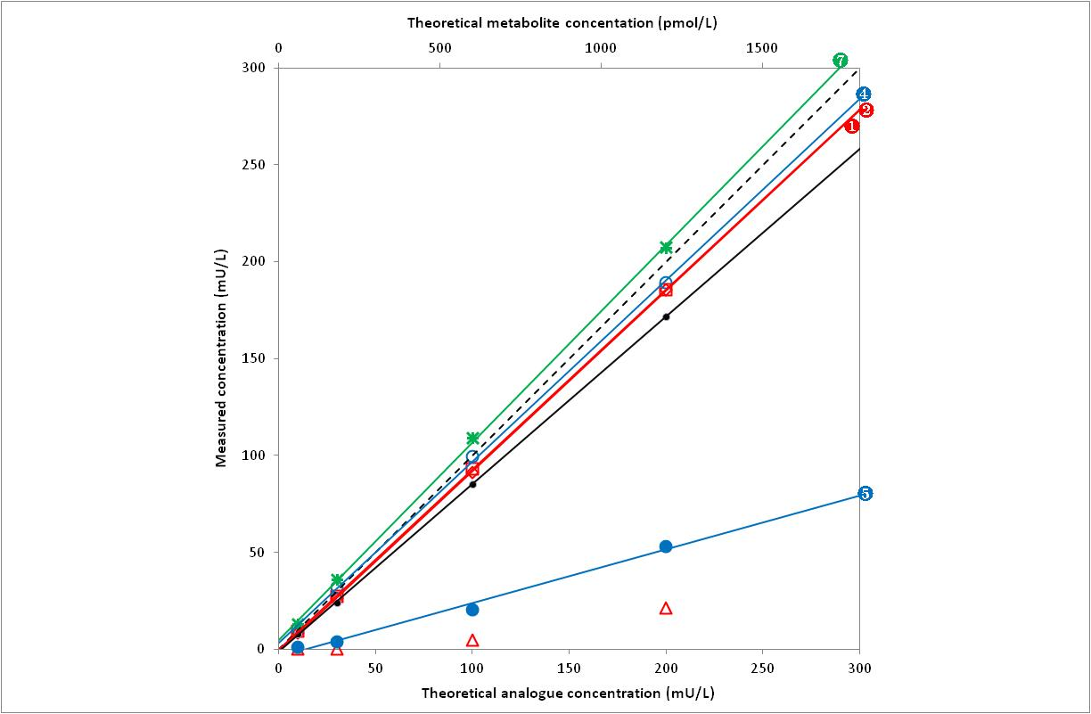

Symbols |  | Analogue | Linearity (p) |  | Slope (SD) |  | Intercept (SD) |  | Sy│x
 |  | Lispro | Accepted | (0.930) | 0.932 | (0.013) | -1.162 | (1.513) | 3.45
 |  | Aspart | Accepted | (0.956) | 0.930 | (0.012) | -0.290 | (1.406) | 3.21
 |  | Glulisine | Rejected | (< 0.001) | - |  | - |  | -
 |  | Glargine | Accepted | (0.182) | 0.937 | (0.013) | 3.394 | (1.433) | 3.27
 |  | Detemir | Accepted | (0.114) | 0.277 | (0.013) | -4.010 | (1.514) | 3.45
 |  | M1 | Rejected | (0.048) | - |  | - |  | -
 |  | M2 | Accepted | (0.286) | 6.122 | (0.083) | 27.815 | (9.345) | 21.31

Centaur
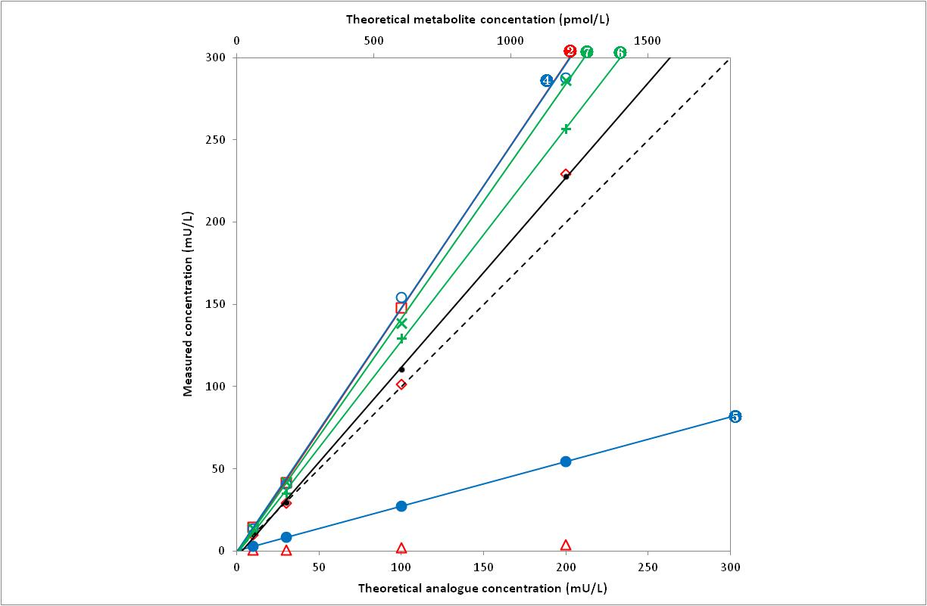

Symbols |  | Analogue | Linearity (p) |  | Slope (SD) |  | Intercept (SD) |  | Sy│x
 |  | Lispro | Rejected | (0.001) | - |  | - |  | -
 |  | Aspart | Accepted | (0.078) | 1.491 | (0.017) | -1.745 | (1.012) | 1.93
 |  | Glulisine | Rejected | (0.044) | - |  | - |  | -
 |  | Glargine | Accepted | (0.098) | 1.483 | (0.040) | -0.644 | (3.405) | 7.41
 |  | Detemir | Accepted | (0.998) | 0.271 | (0.013) | 0.387 | (1.473) | 3.36
 |  | M1 | Accepted | (0.815) | 7.771 | (0.159) | -10.671 | (17.946) | 40.92
 |  | M2 | Accepted | (0.460) | 8.566 | (0.126) | -7.769 | (12.725) | 28.60

Architect
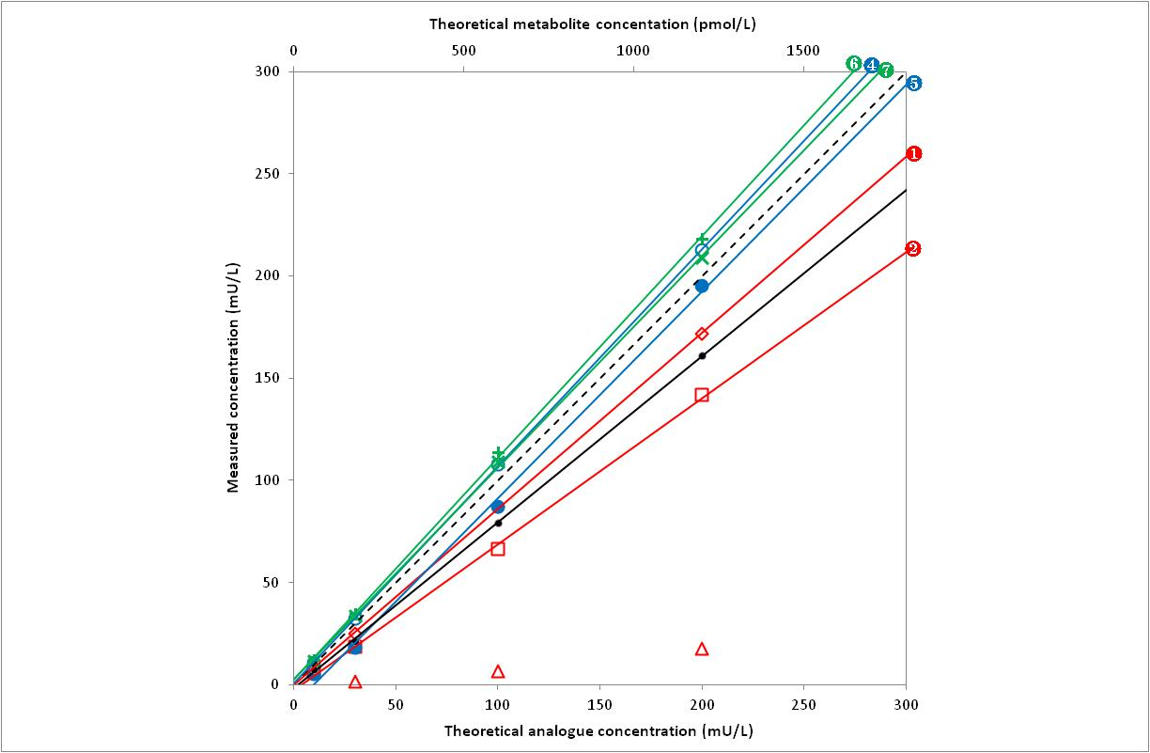

Symbols |  | Analogue | Linearity (p) |  | Slope (SD) |  | Intercept (SD) |  | Sy│x
 |  | Lispro | Accepted | (0.789) | 0.862 | (0.011) | -0.214 | (1.231) | 2.81
 |  | Aspart | Accepted | (0.316) | 0.715 | (0.013) | -2.571 | (1.504) | 3.43
 |  | Glulisine | Rejected | (0.002) | - |  | - |  | -
 |  | Glargine | Accepted | (0.953) | 1.063 | (0.021) | 0.651 | (2.348) | 5.35
 |  | Detemir | Accepted | (0.638) | 1.012 | (0.049) | -9.672 | (5.514) | 12.57
 |  | M1 | Accepted | (0.133) | 6.515 | (0.066) | 15.105 | (7.490) | 17.08
 |  | M2 | Accepted | (0.348) | 6.218 | (0.088) | 17.161 | (9.901) | 22.58

Wallac Autodelfia
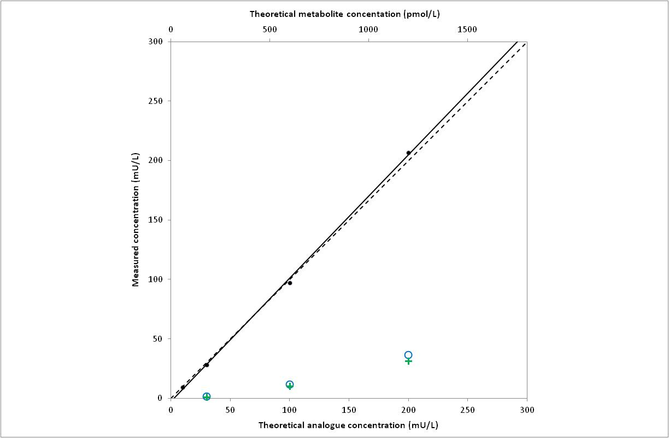

Symbols |  | Analogue | Linearity (p) |  | Slope (SD) |  | Intercept (SD) |  | Sy│x
 |  | Lispro | Insufficient data |  | - |  | - |  | -
 |  | Aspart | Insufficient data
 |  | Glulisine | Insufficient data |  | - |  | - |  | -
 |  | Glargine | Rejected | (< 0.001) | -
 |  | Detemir | Insufficient data
 |  | M1 | Rejected | (< 0.001) | - |  | - |  | -
 |  | M2 | Insufficient data

Bi-insulin IRMA
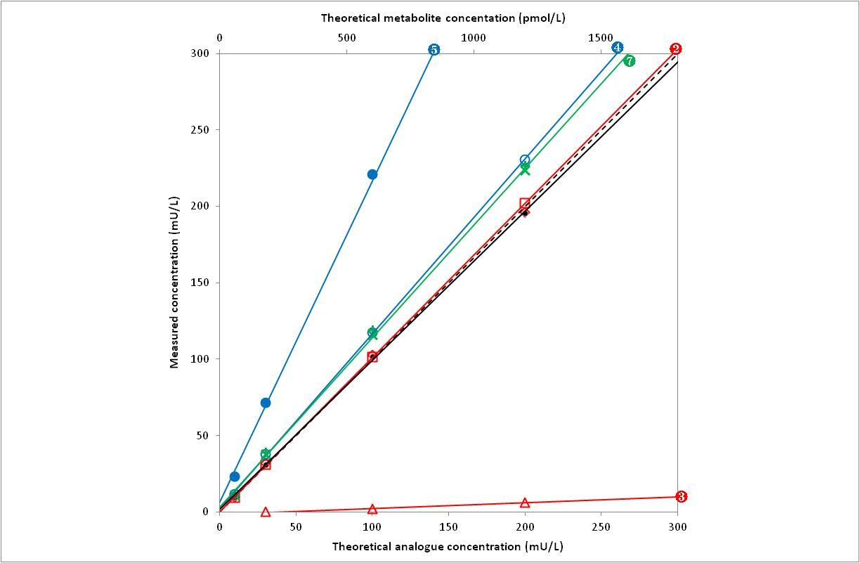

Symbols |  | Analogue | Linearity (p) |  | Slope (SD) |  | Intercept (SD) |  | Sy│x
 |  | Lispro | Rejected | (0.049) | - |  | - |  | -
 |  | Aspart | Accepted | (0.897) | 1.010 | (0.013) | 0.123 | (1.471) | 3.35
 |  | Glulisine | Accepted | (0.603) | 0.038 | (0.009) | -1.359 | (1.343) | 1.51
 |  | Glargine | Accepted | (0.166) | 1.145 | (0.009) | 1.950 | (1.066) | 2.43
 |  | Detemir | Accepted | (0.889) | 2.102 | (0.087) | 6.319 | (9.823) | 22.40
 |  | M1 | Rejected | (0.017) | - |  | - |  | -
 |  | M2 | Accepted | (0.114) | 6.660 | (0.080) | 17.544 | (9.004) | 20.53

Elecsys
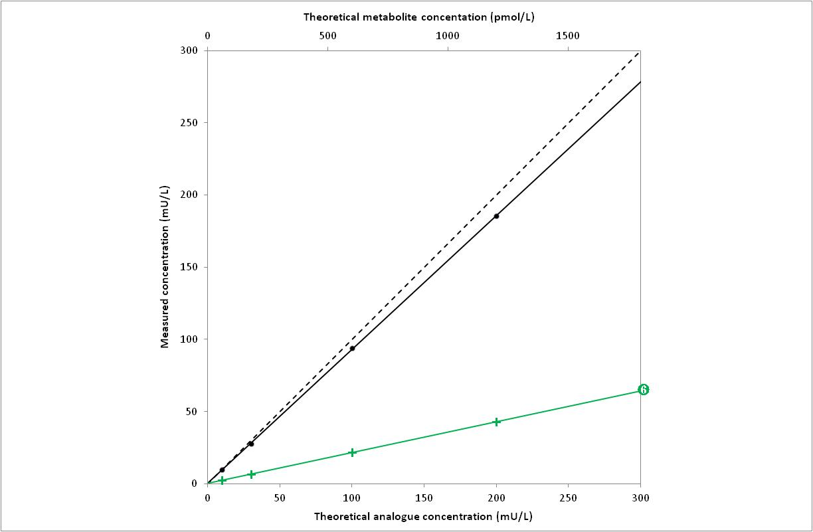

Symbols |  | Analogue | Linearity (p) |  | Slope (SD) |  | Intercept (SD) |  | Sy│x
 |  | Lispro | Insufficient data |  | - |  | - |  | -
 |  | Aspart | Insufficient data |  | - |  | - |  | -
 |  | Glulisine | Insufficient data |  | - |  | - |  | -
 |  | Glargine | Insufficient data |  | - |  | - |  | -
 |  | Detemir | Insufficient data |  | - |  | - |  | -
 |  | M1 | Accepted | (0.816) | 1.281 | (0.006) | 1.317 | (0.626) | 1.43
 |  | M2 | Insufficient data |  | - |  | - |  | -

Coat-A-Count
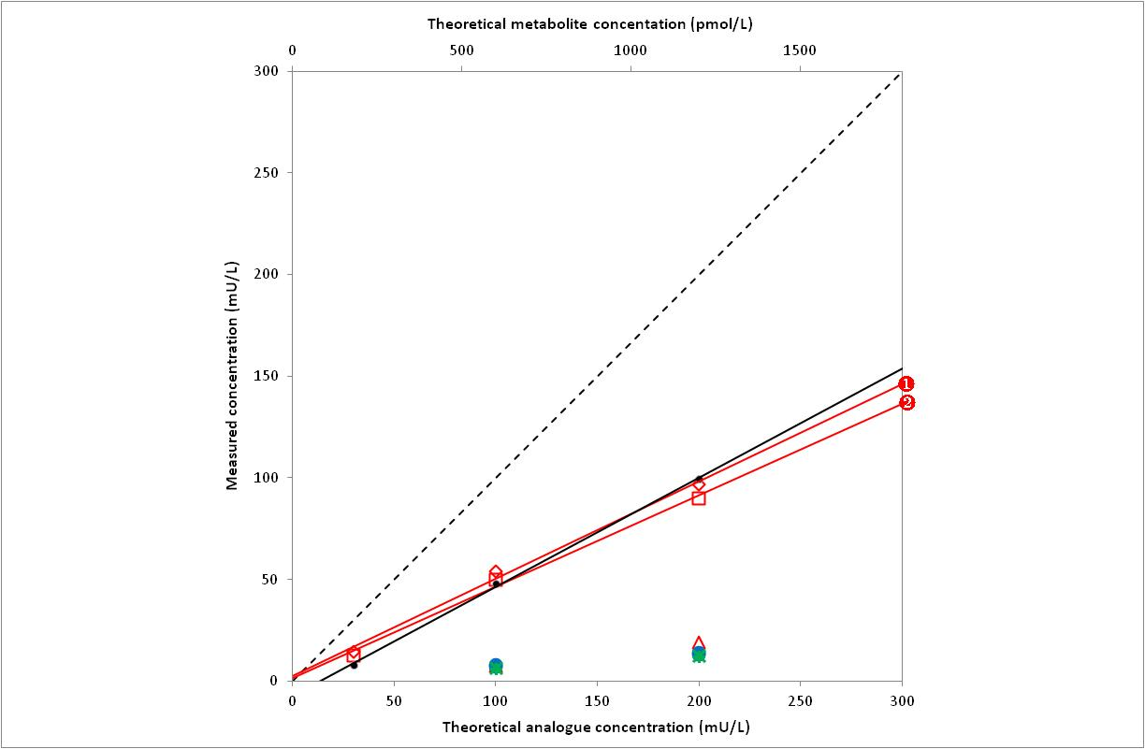

Symbols |  | Analogue | Linearity (p) |  | Slope (SD) |  | Intercept (SD) |  | Sy│x
 |  | Lispro | Accepted | (0.233) | 0.479 | (0.032) | 2.433 | (4.105) | 6.60
 |  | Aspart | Accepted | (0.066) | 0.450 | (0.021) | 1.375 | (2.716) | 4.36
 |  | Glulisine | Insufficient data |  | - |  | - |  | -
 |  | Glargine | Insufficient data |  | - |  | - |  | -
 |  | Detemir | Insufficient data |  | - |  | - |  | -
 |  | M1 | Insufficient data |  | - |  | - |  | -
 |  | M2 | Insufficient data |  | - |  | - |  | -

Specific RIA
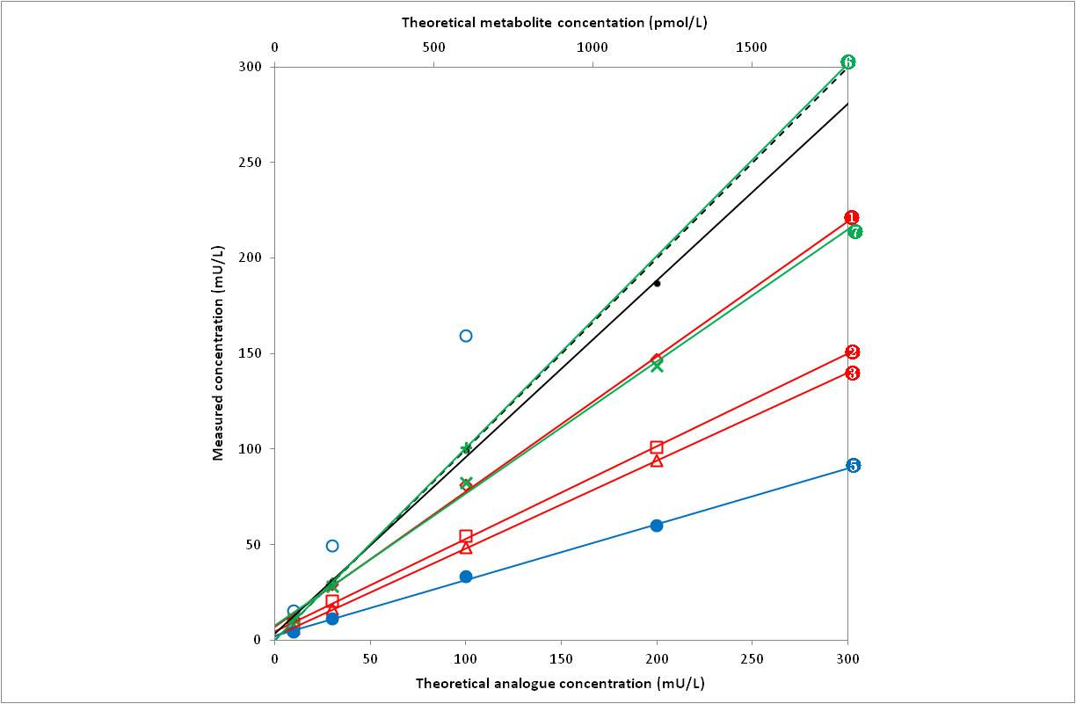

Symbols |  | Analogue | Linearity (p) |  | Slope (SD) |  | Intercept (SD) |  | Sy│x
 |  | Lispro | Accepted | (0.181) | 0.708 | (0.017) | 6.987 | (1.964) | 4.48
 |  | Aspart | Accepted | (0.293) | 0.485 | (0.009) | 4.751 | (0.948) | 1.97
 |  | Glulisine | Accepted | (0.755) | 0.460 | (0.004) | 2.136 | (0.431) | 0.80
 |  | Glargine | Rejected | (0.003) | - |  | - |  | -
 |  | Detemir | Accepted | (0.142) | 0.292 | (0.007) | 2.390 | (0.814) | 1.52
 |  | M1 | Accepted | (0.666) | 5.259 | (0.445) | 34.263 | (49.597) | 93.68
 |  | M2 | Accepted | (0.598) | 4.147 | (0.259) | 47.264 | (31.923) | 61.25

Ins EASIA
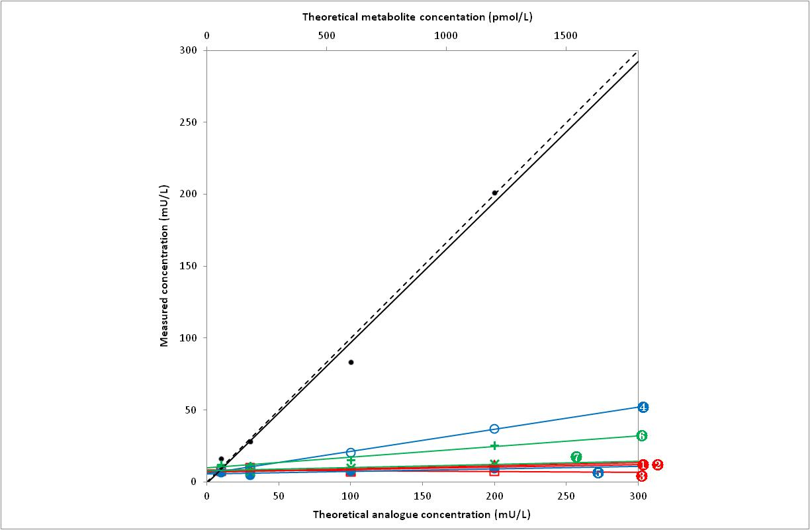

Symbols |  | Analogue | Linearity (p) |  | Slope (SD) |  | Intercept (SD) |  | Sy│x
 |  | Lispro | Accepted | (0.752) | 0.017 | (0.012) | 7.176 | (1.397) | 3.19
 |  | Aspart | Accepted | (0.165) | -0.006 | (0.007) | 8.433 | (0.830) | 1.89
 |  | Glulisine | Accepted | (0.632) | 0.021 | (0.009) | 7.175 | (0.988) | 2.25
 |  | Glargine | Accepted | (0.400) | 0.154 | (0.009) | 5.867 | (0.986) | 2.25
 |  | Detemir | Accepted | (0.565) | 0.018 | (0.009) | 5.564 | (1.000) | 2.28
 |  | M1 | Accepted | (0.380) | 0.442 | (0.074) | 59.848 | (8.403) | 19.16
 |  | M2 | Accepted | (0.421) | 0.130 | (0.044) | 47.607 | (5.022) | 11.45

Ins IRMA Immunotech
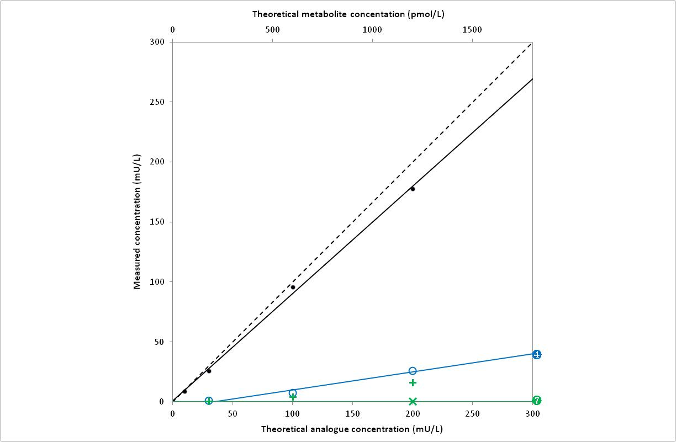

Symbols |  | Analogue | Linearity (p) |  | Slope (SD) |  | Intercept (SD) |  | Sy│x
 |  | Lispro | Insufficient data |  | - |  | - |  | -
 |  | Aspart | Insufficient data |  | - |  | - |  | -
 |  | Glulisine | Insufficient data |  | - |  | - |  | -
 |  | Glargine | Accepted | (0.110) | 0.151 | (0.016) | -5.096 | (2.075) | 3.33
 |  | Detemir | Insufficient data |  | - |  | - |  | -
 |  | M1 | Rejected | (0.013) | - |  | - |  | -
 |  | M2 | Accepted | (0.984) | 0.013 | (0.005) | 2.641 | (0.790) | 1.00

Insi-CTK-IRMA
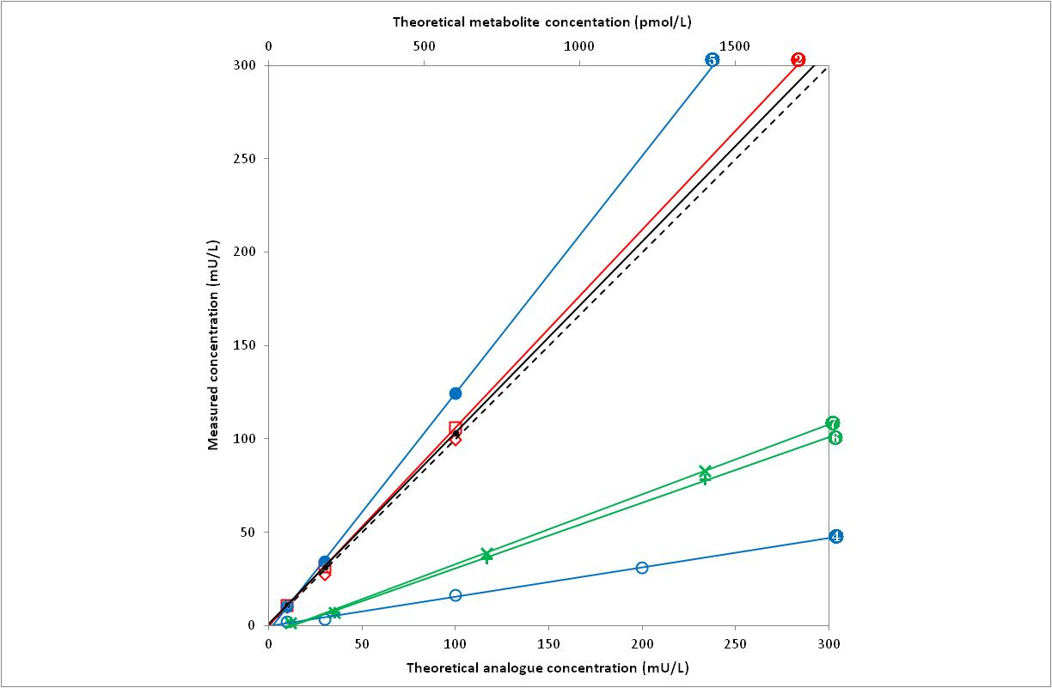

Symbols |  | Analogue | Linearity (p) |  | Slope (SD) |  | Intercept (SD) |  | Sy│x
 |  | Lispro | Rejected | (0.040) | - |  | - |  | -
 |  | Aspart | Accepted | (0.821) | 1.061 | (0.022) | 0.014 | (1.358) | 2.60
 |  | Glulisine | Insufficient data |  | - |  | - |  | -
 |  | Glargine | Accepted | (0.804) | 0.157 | (0.012) | -0.057 | (1.384) | 3.15
 |  | Detemir | Accepted | (0.900) | 1.272 | (0.121) | -2.864 | (7.297) | 13.95
 |  | M1 | Accepted | (0.863) | 2.870 | (0.184) | -29.692 | (21.664) | 45.07
 |  | M2 | Accepted | (0.690) | 3.058 | (0.108) | -32.015 | (12.669) | 26.36

INSIK-5
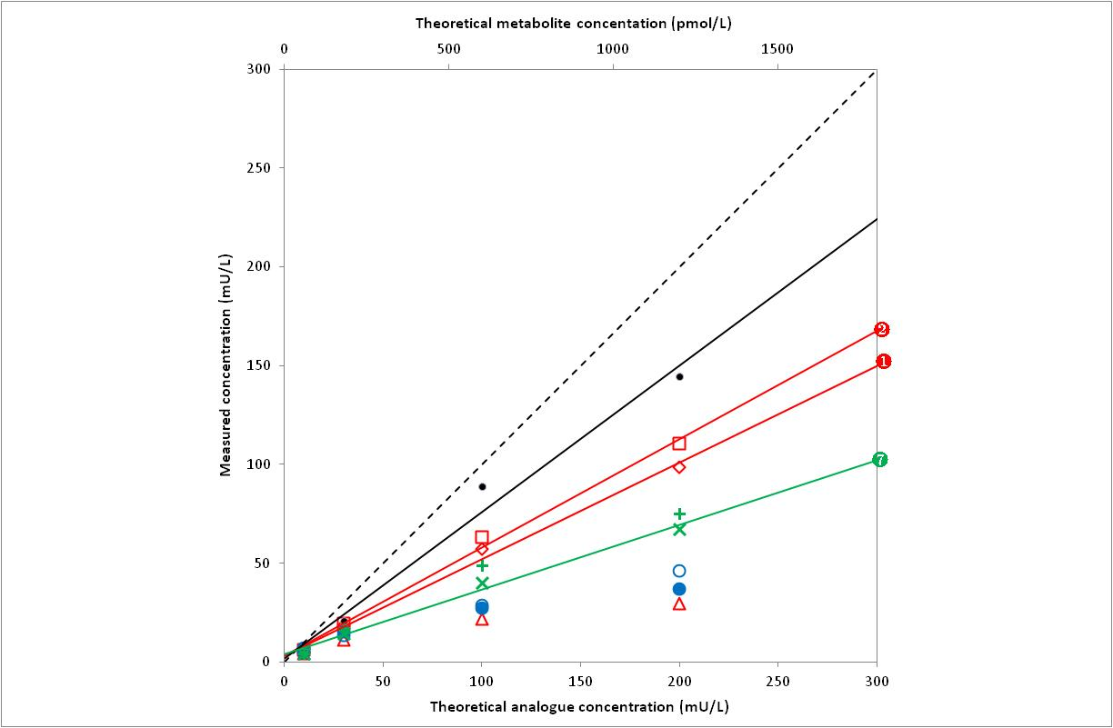

Symbols |  | Analogue | Linearity (p) |  | Slope (SD) |  | Intercept (SD) |  | Sy│x
 |  | Lispro | Accepted | (0.255) | 0.490 | (0.026) | 3.248 | (2.949) | 6.73
 |  | Aspart | Accepted | (0.473) | 0.549 | (0.032) | 3.343 | (3.568) | 8.14
 |  | Glulisine | Rejected | (< 0.001) | - |  | - |  | -
 |  | Glargine | Rejected | (0.007) | - |  | - |  | -
 |  | Detemir | Rejected | (0.002) | - |  | - |  | -
 |  | M1 | Rejected | (0.007) | - |  | - |  | -
 |  | M2 | Accepted | (0.193) | 1.965 | (0.112) | 23.390 | (12.647) | 28.84

Insulin CT
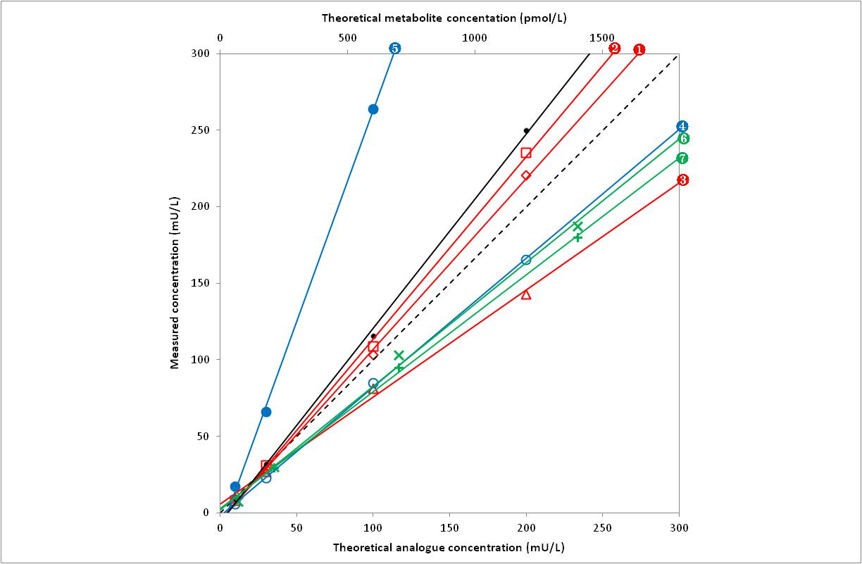

Symbols |  | Analogue | Linearity (p) |  | Slope (SD) |  | Intercept (SD) |  | Sy│x
 |  | Lispro | Accepted | (0.416) | 1.115 | (0.023) | -4.512 | (2.560) | 5.84
 |  | Aspart | Accepted | (0.407) | 1.192 | (0.028) | -5.674 | (3.146) | 7.17
 |  | Glulisine | Accepted | (0.114) | 0.700 | (0.023) | 5.664 | (2.596) | 5.92
 |  | Glargine | Accepted | (0.659) | 0.842 | (0.020) | -1.810 | (2.280) | 5.20
 |  | Detemir | Accepted | (0.654) | 2.760 | (0.140) | -13.170 | (8.461) | 16.17
 |  | M1 | Accepted | (0.628) | 6.237 | (0.158) | 21.316 | (17.808) | 40.61
 |  | M2 | Accepted | (0.158) | 6.601 | (0.205) | 13.661 | (23.159) | 52.81

Insulin IRMA Biosource
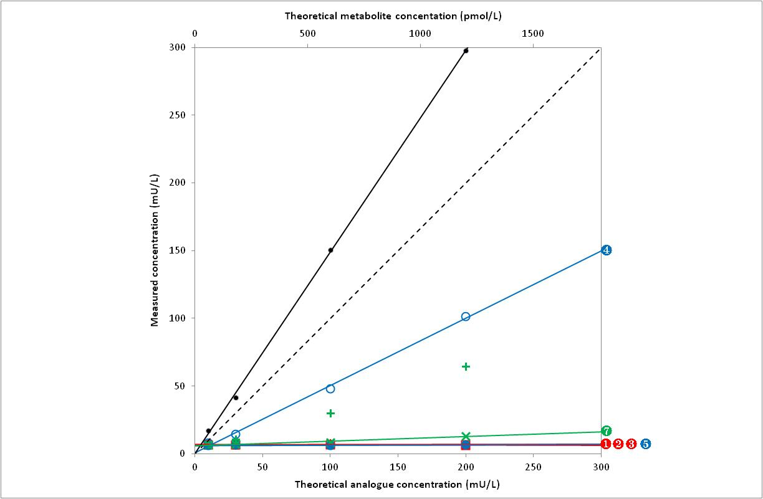

Symbols |  | Analogue | Linearity (p) |  | Slope (SD) |  | Intercept (SD) |  | Sy│x
 |  | Lispro | Accepted | (0.849) | 0.001 | (0.004) | 6.728 | (0.419) | 0.95
 |  | Aspart | Accepted | (0.948) | 0.001 | (0.004) | 6.542 | (0.457) | 1.04
 |  | Glulisine | Accepted | (0.669) | -0.002 | (0.006) | 6.864 | (0.642) | 1.46
 |  | Glargine | Accepted | (0.601) | 0.498 | (0.024) | 0.555 | (2.675) | 6.10
 |  | Detemir | Accepted | (0.885) | 0.003 | (0.003) | 6.219 | (0.359) | 0.82
 |  | M1 | Rejected | (0.004) | - |  | - |  | -
 |  | M2 | Accepted | (0.306) | 0.208 | (0.018) | 34.883 | (2.052) | 4.68

Liaison
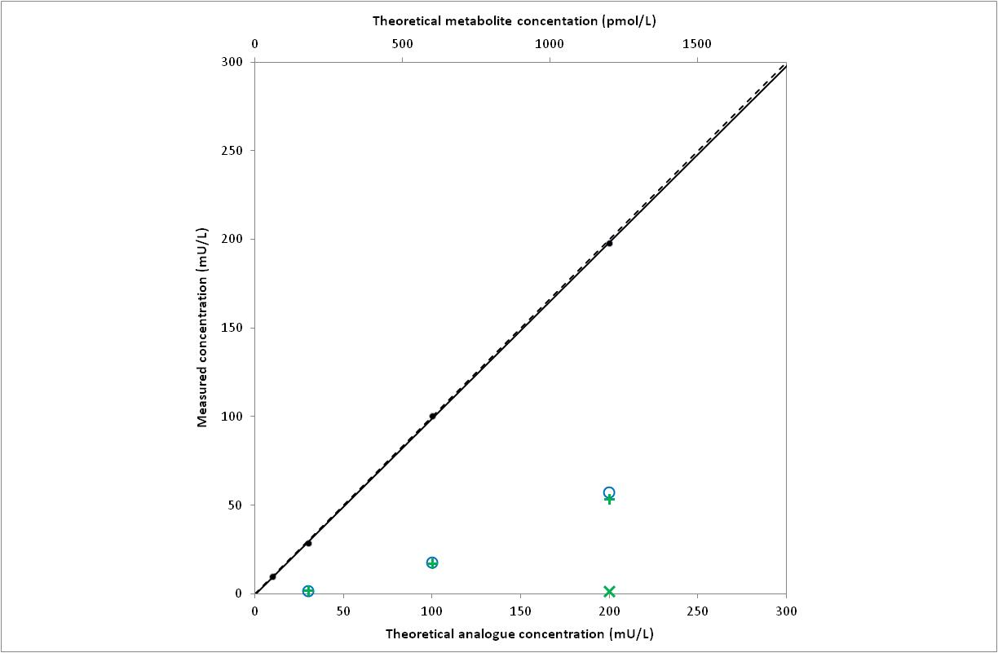

Symbols |  | Analogue | Linearity (p) |  | Slope (SD) |  | Intercept (SD) |  | Sy│x
 |  | Lispro | Insufficient data |  | - |  | - |  | -
 |  | Aspart | Insufficient data |  | - |  | - |  | -
 |  | Glulisine | Insufficient data |  | - |  | - |  | -
 |  | Glargine | Rejected | (< 0.001) | - |  | - |  | -
 |  | Detemir | Insufficient data |  | - |  | - |  | -
 |  | M1 | Rejected | (< 0.004) | - |  | - |  | -
 |  | M2 | Insufficient data |  | - |  | - |  | -

St AIA-Pack IRI
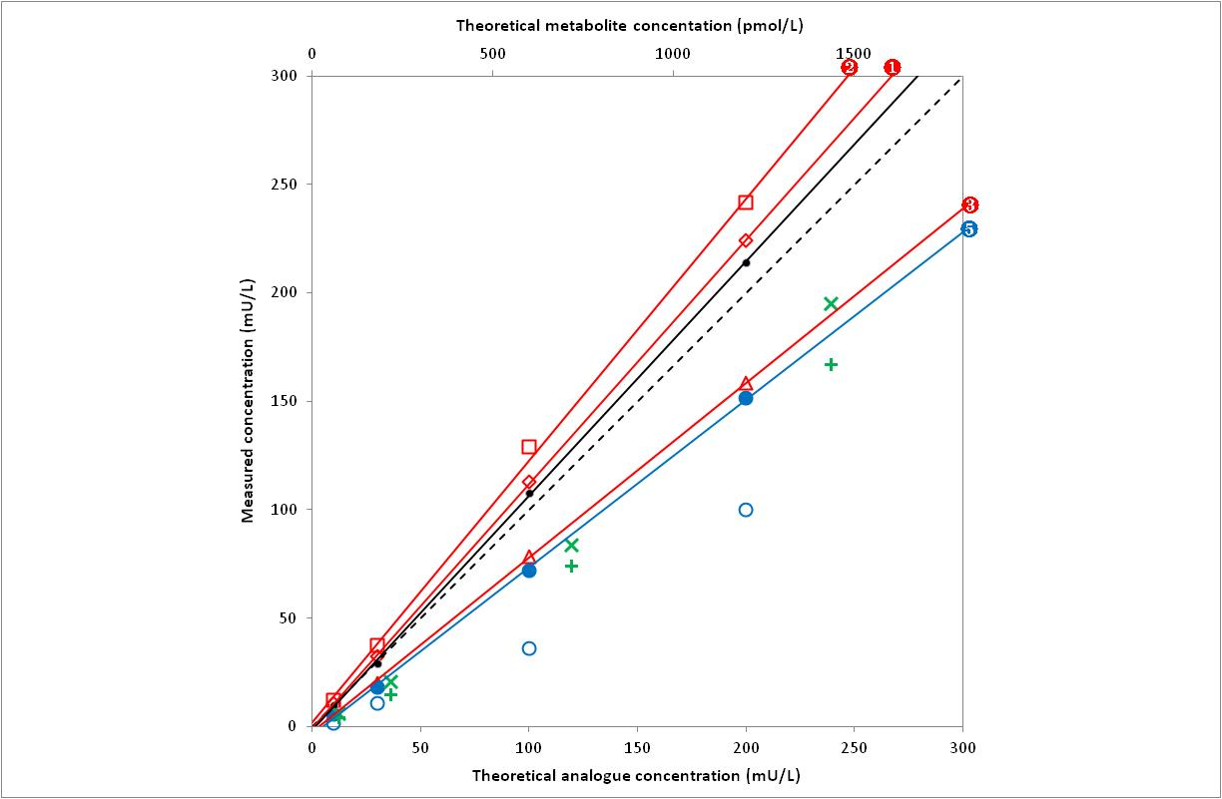

Symbols |  | Analogue | Linearity (p) |  | Slope (SD) |  | Intercept (SD) |  | Sy│x
 |  | Lispro | Accepted | (0.964) | 1.126 | (0.027) | -0.649 | (3.025) | 6.90
 |  | Aspart | Accepted | (0.268) | 1.208 | (0.017) | 1.700 | (1.896) | 4.27
 |  | Glulisine | Accepted | (0.641) | 0.805 | (0.011) | -2.728 | (1.257) | 2.87
 |  | Glargine | Rejected | (0.020) | - |  | - |  | -
 |  | Detemir | Accepted | (0.114) | 0.773 | (0.038) | -3.883 | (4.269) | 9.73
 |  | M1 | Rejected | (0.002) | - |  | - |  | -
 |  | M2 | Rejected | (0.002) | - |  | - |  | -

