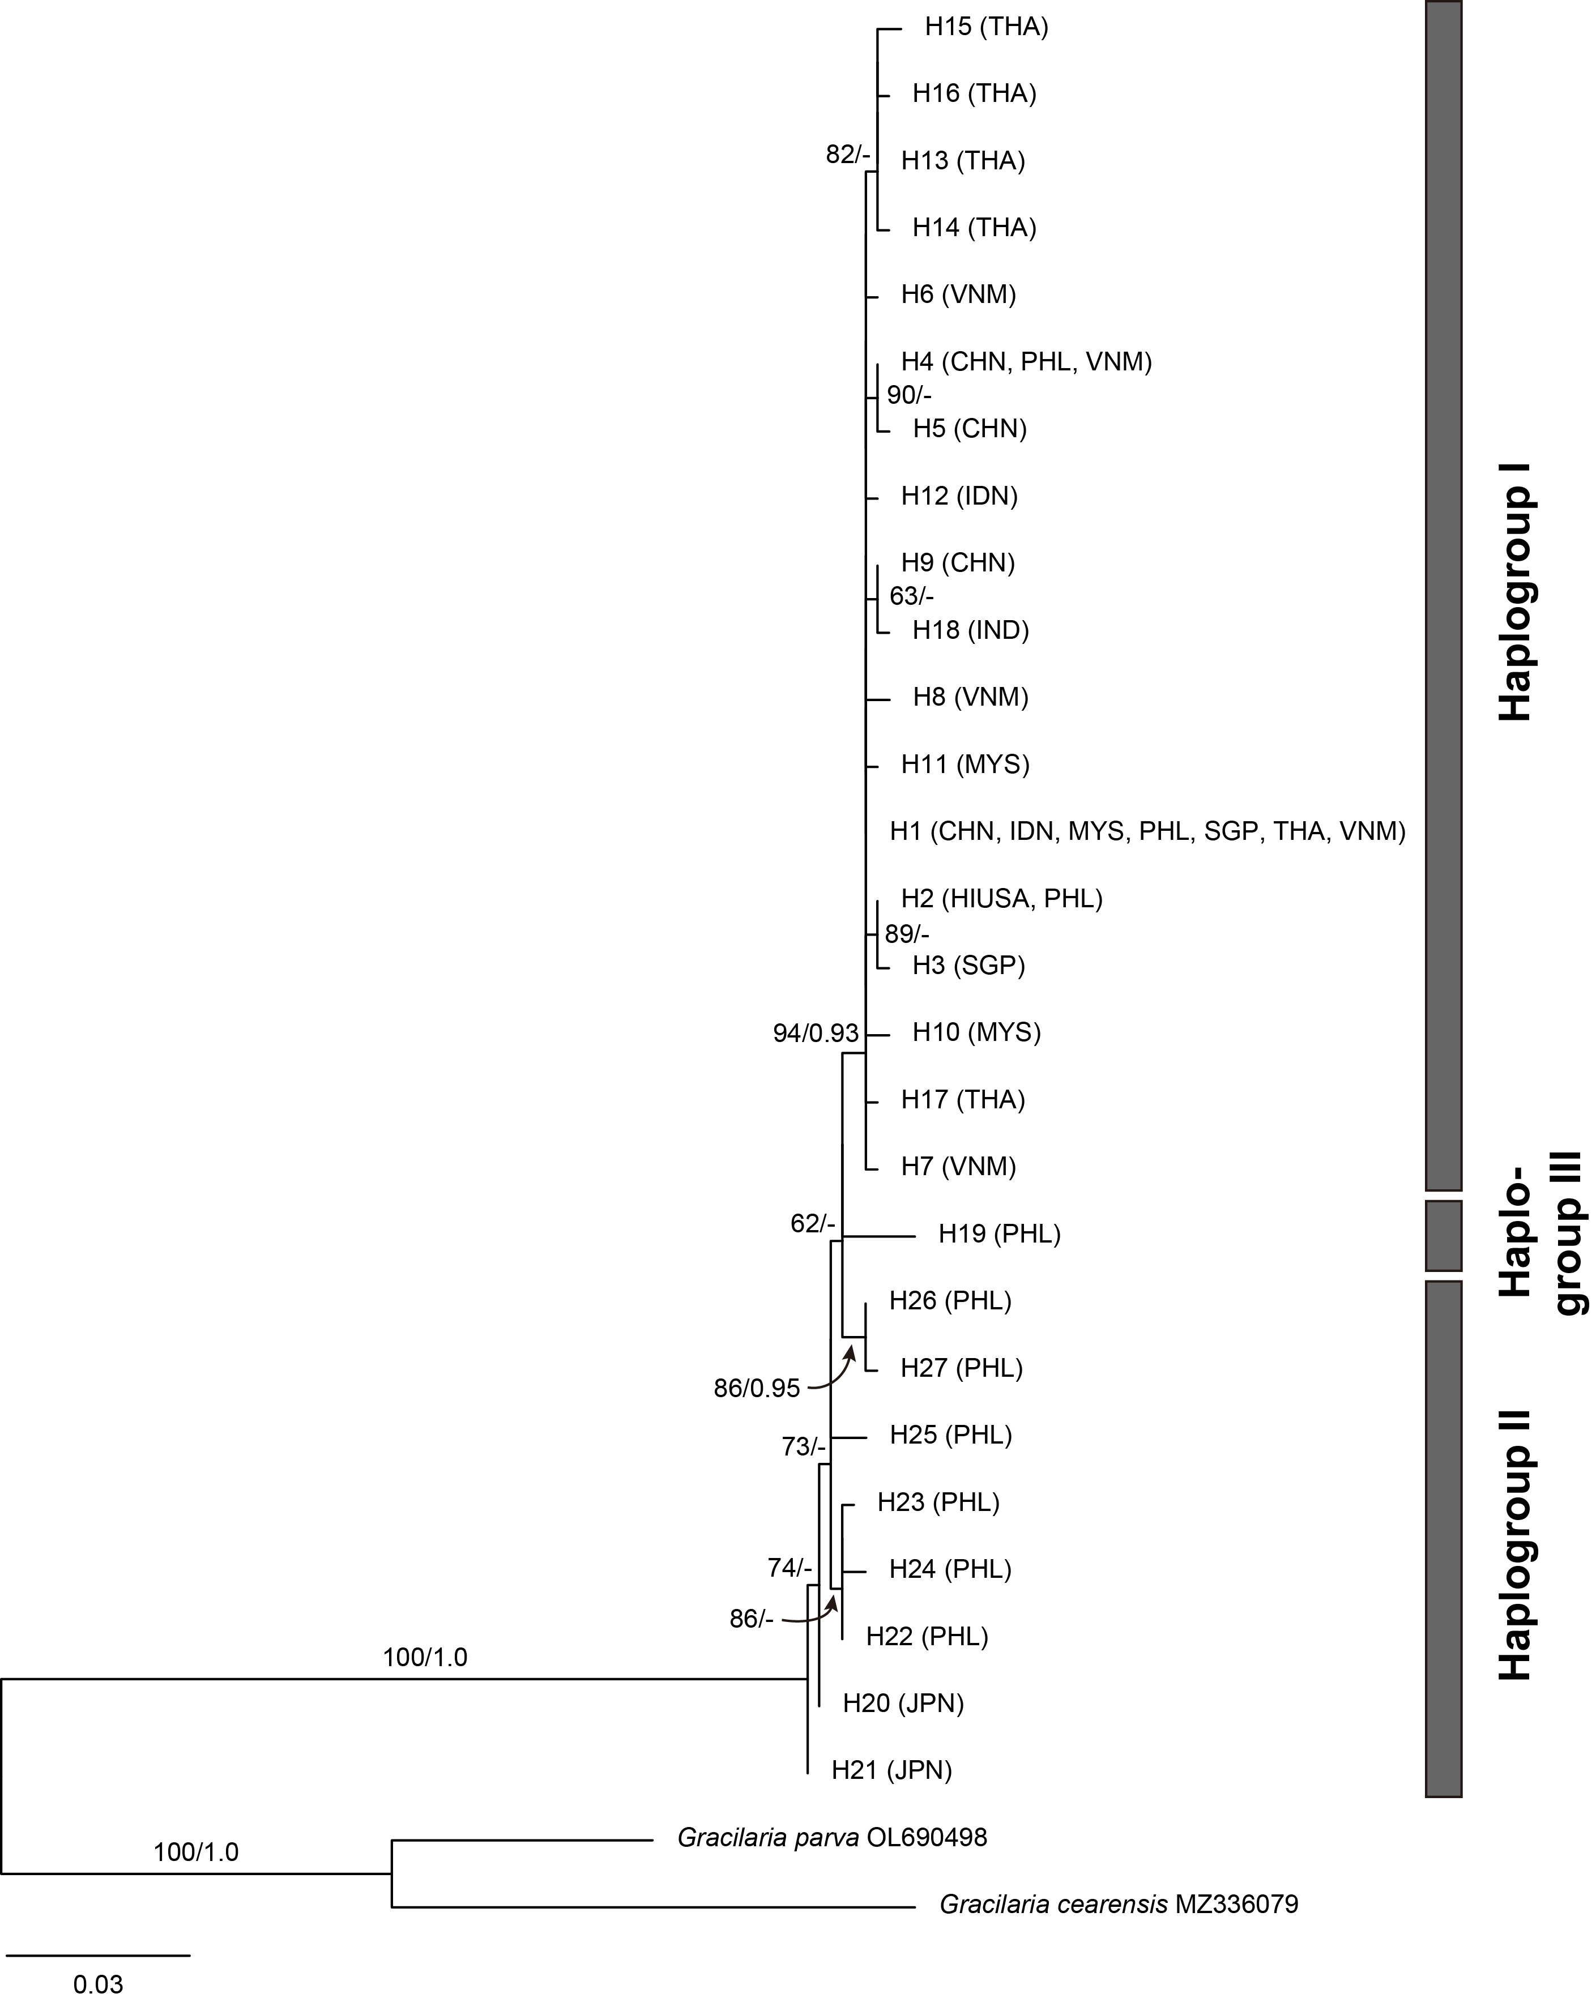

**Supplementary Figure S1:** Maximum likelihood (ML) phylogeny of *Gracilaria salicornia* using mitochondrial COI-5P sequences. ML bootstrap values (≥50%) and Bayesian posterior probabilities (≥0.9) are shown at branches.