Supplementary Material
Chemical profiling of seaweeds of the Arabian Gulf by liquid chromatography-mass spectrometry and in-silico screening against MPOX
Hanan Al-Adilah et al.
DOI 10.1515/bot-2024-0032

Supplementary Table S1: Putative annotation of metabolites of different seaweed extracts showing similarities with seaweed metabolites list generated in-house from ChemFinder database.
Seaweed | R_{t} (min) | m/z | Molecular formula [M] | Mass error (ppm) | mSigma | Score (%) | RDB | Molecular formula [M] in AntiBase | Exact mass | Mass difference (amu) | Compound identification in antibase | Similarity level | Activity
Seaweed | Data analysis software |  |  |  |  |  |  | AntiBase
Codium papillatum (Cpa) | 10.9 | 429.3724 | C₂₉H₄₉O₂ | 0.6 | 19.4 | 100 | 5.5 | C₂₉H₄₈O₂ | 429.3727 | 0.0003 | (1)(2)(3) | Genus | (3) against cancer  (Ahmad et al., 1993)
Cladophora vagabunda (Cva | 10.9 | 429.3721 | C₂₉H₄₉O₂ | 1.3 | 20.2 | 100 | 5.5 | C₂₉H₄₈O₂ | 429.3727 | 0.0006 | (1)(2)(3)(4) | Phylum | (3) against cancer (He et al., 2010)  (4) cytotoxic activity (Shi et al., 2008)
Sargassum aquifolium (Saq)
Sargassum asperifolium (Sas) | 10.9 | 429.3588 | C₂₆H₄₅N₄O | -11.1 | 3.3 | 100 | 6.5 | C₂₈H₄₄O₃ | 429.3363 | 0.0225 | (5) | Phylum | (5) active against P-388 leukaemia cells (IC₅₀ 0.6 μg/ml) and also exhibited anti-fungal properties.
Sargassum ilicifolium (Sil) | 3.9  10.9 | 289.1405  429.3719 | C₁₃H₁₇N₆O₂  C₂₉H₄₉O₂ | -0.1  1.9 | 4.7  9.1 | 100  100 | 8.5  5.5 | C₁₇H₂₀O₄  C₂₉H₄₈O₂ | 289.1434  429.3727 | 0.0029  0.0008 | (6)(7)(8) | Phylum | (6) active against P-388 leukaemia cells (IC50 0.6 μg/ml) and also exhibited anti-fungal properties (Perry et al., 1991)
Sargassum ilicifolium var. acaraeocarpum (Sia)
Feldmannia indica (Fin)
Padina boergesenii (Pbo)
Dictyota dichotoma (Ddi)
Colpomenia sinuosa (Csi) | 10.9 | 429.3719 | C₂₉H₄₉O₂ | 1.9 | 9.1 | 100 | 5.5 | C₂₉H₄₈O₂ | 429.3727 | 0.0008 | (7)(8) | Phylum | (7)(8) exhibited cytotoxic activity against various cancer cell lines(Tang et al., 2002)
Iyengaria stellata (IS) | 6 | 303.2317 | C₂₀H₃₁O₂ | 0.5 | 10.7 | 100 | 5.5 | C₂₀H₃₀O₂ | 303.2318 | 0.0001 | (9)(10)(11) | Phylum
Chondria sp. (Csp)

Supplementary Table S2: ¹H, ¹³C, COSY and HMBC NMR data of loliolide.
Position | δ_{C} | δ_{H} | COSY | HMBC
1 | 35.1 | -
2 | 49.3 | 1.33 m, 2.03 m | H-3 | C-1, C-3, C-6, C-11
3 | 63.9 | 4.11 m | H-3, H-4 | C-2
4 | 47.7 | 1.45 m, 2.50 m | H-3 | C-2, C-3, C-5, C-6
5 | 87.2 | -
6 | 183.1 | -
7 | 112.3 | 5.80 br s |  | C-1, C-5, C-6, C-8
8 | 173.5 | -
9 | 24.7 | 1.60 s |  | C-4, C-5, C-6
10ª | 24.5 | 1.33 s |  | C-1, C-2, C-6, C-11
11ª | 29.4 | 1.30 s |  | C-1, C-2, C-6, C-10

Supplementary Figure S1: Chemical structures of compounds found in the present study in seaweeds from Kuwait according to the Antibase database. Note that stereochemical information represented in the individual structures has been taken “as is” from individual database entries and has not been confirmed for individual algal samples. Similarly, information about source organisms is provided “as is”.
12 loliolide
Supplementary Figure S2: MS/MS data for compounds 6, 9, 10 and 11.

MS/MS data for Compound 6: Mass peak found in Sargassum ilicifolium at 3.9 min along with a fragment which shows loss of two methoxy groups confirming the structure.

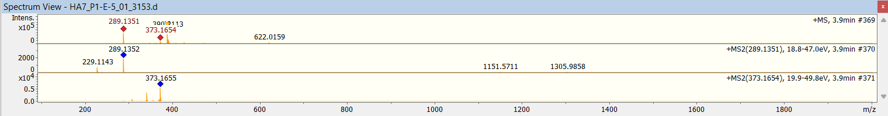

MS/MS data for Compound 9: Mass peak found in Iyengaria stellata at 8 min along with a fragment which shows loss of isopropyl group.
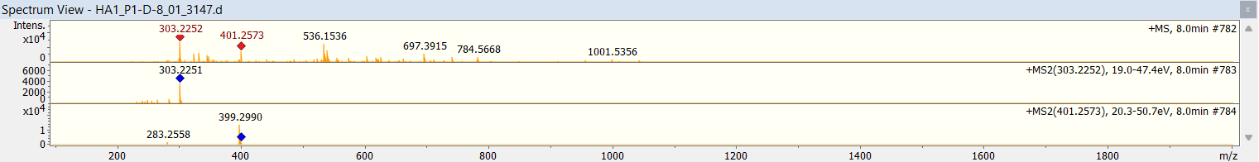

MS/MS data for Compound 10: Mass peak found in Iyengaria stellata at 6.9 min along with a mass that shows loss of the hydroxyl group.
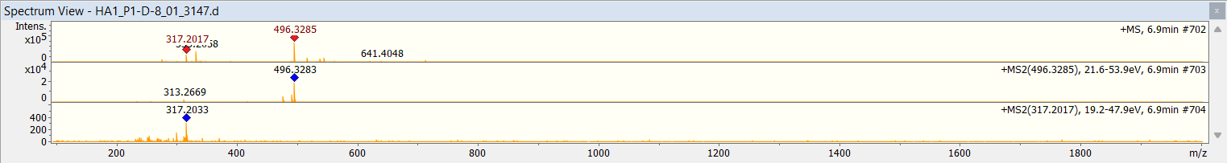

MS/MS data for Compound 11: mass peak found in Iyengaria stellata at 3.9 min along with mass that shows loss of the hydroxyl group.
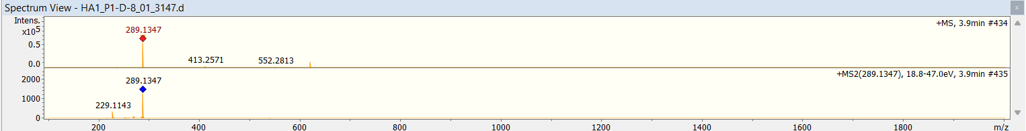

Supplementary references

Ahmad, V. U., Aliya, R., Perveen, S., and Shameel, M. (1993). Sterols from marine green alga Codium decorticatum. Phytochemistry 33(5): 1189-1192.
He, Z., Zhang, A., Ding, L., Lei, X., Sun, J., and Zhang, L. (2010). Chemical composition of the green alga Codium divaricatum Holmes. Fitoterapia 81(8): 1125-1128.
Perry, N. B., Blunt, J. W., and Munro, M. H. (1991). A cytotoxic and antifungal 1, 4-naphthoquinone and related compounds from a New Zealand brown alga, Landsburgia quercifolia. J. Nat. Prod. 54(4): 978-985.
Shi, D., Fan, X., Sun, J., Han, L., and Shi, J. (2008). Steroids from green alga Chaetomorpha basiretorsa Setchell. Chinese J. Ocean. Limnol. 26(4): 415-418.
Tang, H. F., Yi, Y. H., Yao, X. S., Xu, Q. Z., Zhang, S.Y., and Lin, H.W. (2002). Bioactive steroids from the brown alga Sargassum carpophyllum. J. Asian Nat. Prod. Res 4(2): 95-101.

