**Supplementary Material**

**Phylogeographic patterns in attached and free-living marine macroalga *Fucus vesiculosus* (Fucaceae, Phaeophyceae) in the Baltic Sea**

Roxana Preston et al.

DOI 10.1515/bot-2022-0016

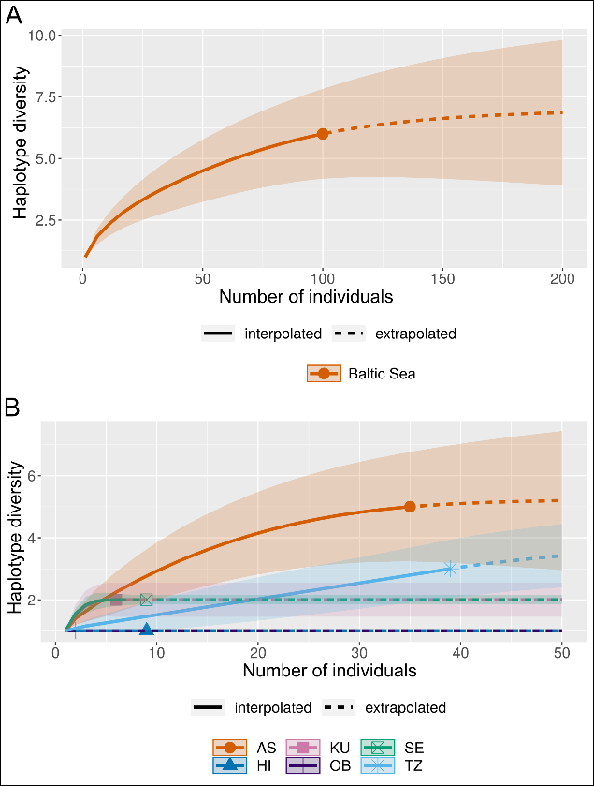

**Supplementary Figure S1:** Rarefaction and extrapolation sampling curves as functions of the number of samples. For the whole Baltic Sea population (A) and per site (B). Shaded area represents 95% confidence intervals obtained using the bootstrap method on the basis of 1000 repetitions. Site abbreviations: AS, Askö; HS, Hiddensee; OL, Olkiluoto; SA, Saaremaa; SE, Seili; TZ, Tvärminne.

|  |  |
| --- | --- |
| **Supplementary Table S1:** PCR primers tested within the laboratory. (†) | |
| Name | RuBisCO |
| Target genome | Chloroplast |
| Gene region | Plastid-encoded RUBISCO region spanning the large subunit gene (RbcL), the small subunit gene (RbcS), and the spacer between the subunits. |
| Forward primer (5’–3’) | TTG TGG TCA AAT GCA TCA ACT |
| Reverse primer (5’–3’) | AGC CCC CAT AAT TCC CAA TA |
| Original author | Bergström et al., 2005 (#) |
| Problem | Consistency unobtainable. Failed first stage amplification. Secondary sequencing PCR or cloning attempted on several first stage PCR products, generally resulting in short, noisy or failed reads. |
| Tested sample number | 12 |
| (†) nrDNA-ITS markers where not tested within the laboratory due to the identification of low sequence variance within the reference database (Genbank); (#) Bergström, L., Tatarenkov, A., Johannesson, K., Jönsson, R.B. and Kautsky, L., 2005. Genetic and morphological identification of Fucus radicans sp. nov. (Fucales, Phaeophyceae) in the brackish Baltic Sea. Journal of Phycology [Online], 41(5), pp.1025–1038. Available from: https://doi.org/10.1111/J.1529-8817.2005.00125.X. | |

|  |  |  |
| --- | --- | --- |
| **Supplementary Table S2:** Number of samples from each population trialed for mtDNA intergenic spacer and 23S sequencing. | | |
| **Population** | **Total number of thalli** | **Total number of successfully amplified sequences** |
| AS A | 18 | 18 |
| AS F | 18 | 17 |
| HS A | 6 | 6 |
| HS F | 3 | 3 |
| OL F | 2 | 2 |
| SA F | 6 | 6 |
| SE A | 8 | 5 |
| SE F | 10 | 4 |
| TZ A | 25 | 24 |
| TZ F | 15 | 15 |
| Site abbreviations: AS, Askö; HS, Hiddensee; OL, Olkiluoto; SA, Saaremaa; SE, Seili; TZ, Tvärminne. Form abbreviations A, attached; F, free-living. | | |

|  |  |
| --- | --- |
| **Supplementary Table S3:** Accession numbers of all sequences obtained from Genbank (NCBI). | |
| **Marker** | **Accession number** |
| IGS | AY494079, AY659884–AY659913, AY941092–AY941094 |
| (FACTORIAL ANALYSIS) | EU309506–EU309510 |
| GQ385113-GQ385125, GQ385158-GQ385190 |
| HQ316130, HQ316132, HQ316135–HQ316139, HQ316141-HQ316142 |
| JN084347–JN084364, JN084366–JN084379, JN084384–JN084388, JN084390–JN084394, JN084396 |
| KP828759–KP828761 |
| KT306685–KT306724, KT306726 |
| KU872204–KU872207, KU872209–KU872215 |
| KY678904 |
| MG922856 |
|  |
|  |
| pr-IGS  (NETWORK ANALYSIS) | AY494079,AY659898-AY659899, AY659901–AY659903, AY659905  EU309506–EU309508  GQ385120–GQ385121, GQ385123-GQ385125  HM583778–HM583794  KP828759 |
| IGS, mtDNA intergenic spacer; pr-IGS, highly polymorphic region of the mtDNA intergenic spacer. | |

|  |  |  |  |  |  |  |  |  |  |
| --- | --- | --- | --- | --- | --- | --- | --- | --- | --- |
| **Supplementary Table S4:** Genetic differentiation among populations defined by form and subbasin. | | | | | | | | | |
|  | **TZ A** | **TZ F** | **AS A** | **AS F** | **HS A** | **HS F** | **SE A** | **SE F** | **SA F** |
| TZ F | -0.003  (0.538) |  |  |  |  |  |  |  |  |
| AS A | 0.009  (0.373) | 0.063  (0.25) |  |  |  |  |  |  |  |
| AS F | 0.076  (0.057) | 0.161 (0.042*) | 0.039  (0.190) |  |  |  |  |  |  |
| HS A | -0.07  (0.999) | 0.000  (0.999) | -0.021  (0.696) | 0.061  (0.318) |  |  |  |  |  |
| HS F | -0.180  (0.999) | 0.000  (0.999) | -0.131  (0.999) | -0.046  (0.497) | 0.000  (0.999) |  |  |  |  |
| SE A | 0.725  (0.000***) | 0.876  (0.001***) | 0.6  (0.001***) | 0.365  (0.021*) | 0.774  (0.010**) | 0.681  (0.157) |  |  |  |
| SE F | -0.123  (0.999) | 0.000  (0.999) | -0.075  (0.999) | 0.006  (0.533) | 0.000  (0.999) | 0.000  (0.999) | 0.720  (0.045*) |  |  |
| SA F | 0.181 (0.093) | 0.403  (0.065) | 0.094 (0.134) | -0.078  (0.808) | 0.200  (0.442) | 0.040  (0.508) | 0.216 (0.264) | 0.111  (0.440) |  |
| OL F | -0.311  (0.999) | 0.000  (0.999) | -0.255  (0.999) | -0.157  (0.999) | 0.000  (0.999) | 0.000  (0.999) | 0.623  (0.140) | 0.000  (0.999) | -0.091  (0.999) |
| Population pairwise *FST* computing conventional *F*-Statistics from haplotype frequencies. Values display population pairwise *FST* including bracketed p-values generated by 1000 permutations (p-value significance level: *≤0.05, **≤0.01, *** ≤0.001). Sympatric populations are shaded grey. Site abbreviations: AS, Askö; HS, Hiddensee; OL, Olkiluoto; SA, Saaremaa; SE, Seili; TZ, Tvärminne. Form abbreviations A, attached; F, free-living. | | | | | | | | | |