ONLINE APPENDIX

A1. A $pp$ game (Bertrand Competition)
We use the superscript PPN to denote equilibrium outcome for firms not adopting ECSR in $pp$ game i.e., Bertrand competition, otherwise PPC. Solving the game, we get
$q_{1}^{PPN}=q_{2}^{PPN}=\frac{A}{2+γ-γ^{2}} ;p_{1}^{PPN}=p_{2}^{PPN}=\frac{A(1-γ)}{2-γ}; π_{1}^{PPN}=π_{2}^{PPN}= \frac{A^{2}(1-γ)}{{(2-γ)}^{2}(1+γ)} ; {NCS}^{PPN}=\frac{A^{2}(1-2d+γ)}{{(2+γ-γ^{2})}^{2}}$ (1)
If the firms decide to adopt for ECSR and get certification for the same, the outcomes are
$$q_{1}^{PPC}=q_{1}^{PPC}=\frac{A+α\underline{s}}{2+γ-γ^{2}} ;p_{1}^{PPC}=p_{2}^{PPC}=\frac{\left(1-γ\right)\left(A+α\underline{s}\right)}{2-γ}; π_{1}^{PPC}=π_{2}^{PPC}=\frac{\left(1-γ\right){\left(A+α\underline{s}\right)}^{2}}{\left(2-γ\right)\left(2+γ-γ^{2}\right)}-{\underline{s}}^{2} ;$$
${NCS}^{PPC}=\frac{{(A+α\underline{s})}^{2}}{{(2-γ)}^{2}(1+γ)}-\frac{2d{(A+(α+(-2+γ)(1+γ))\underline{s})}^{2}}{{(2+γ-γ^{2})}^{2}}$ (2)
For a firm to be adopting ECSR, the certification threshold needs to be lower than the level of pollution, otherwise the cost will be more than its benefits. For $q_{i}^{PPC}>\underline{s}, \underline{s}<\frac{A}{2-α+γ-γ^{2}}$ should be satisfied.
Comparing the profits of firms with or without ECSR,
$$π_{1}^{PPC}-π_{1}^{PPN}= \frac{A^{2}\left(1-γ\right)+2Aα\left(1-γ\right)\underline{s}-(4-α^{2}\left(1-γ\right)-(3-γ)γ^{2}){\underline{s}}^{2}}{{(2-γ)}^{2}(1+γ)}$$
We observe that $π_{1}^{PPC}-π_{1}^{PPN}>0$ if $\underline{s}< {\underline{s}}^{PPU}=\frac{2Aα(1-γ)}{4-α^{2}+α^{2}γ-3γ^{2}+γ^{3}}$ , which provides the upper bound for the ECSR spending to adopt the ECSR certification. So, firms will spend strategically on ECSR and get certification if $\underline{s}<{\underline{s}}^{PPU}$.

Optimal ECSR Certification Standard

We obtain the optimal choice of ECSR certification standard in case of NGO certifier by evaluating $\frac{d {NCS}^{PPC}}{ds}=0$. We get,
$${\underline{s}}^{PP*}=\frac{A(α+αγ-2d(α-(2-γ)(1+γ)))}{2d{(α-(2-γ)(1+γ))}^{2}-α^{2}(1+γ)}$$
${\underline{s}}^{PP*}>0$ if $d>\frac{α^{2}+α^{2}γ}{2{(α-(2-γ)(1+γ))}^{2}}$ holds. Further, ${\underline{s}}^{PP*}>{\underline{s}}^{PPU}$ when $d>\frac{α^{2}+α^{2}γ}{2{(α-(2-γ)(1+γ))}^{2}}$. This means that an NGO certifier’s optimal level of ECSR standard would be higher that the upper limit for the firms in Bertrand competition and a firm would not choose to spend on ECSR if a certifier sets the standard at ${\underline{s}}^{PP*}$. Therefore, to induce the firms, the standard would be set at $\underline{s}= {\underline{s}}^{PPU}$ by the NGO certifier. Further, we can also show that consumer and firms would benefit from such ECSR standard as compared to no ECSR at all i.e., ${NCS}^{PPC}>{NCS}^{PPN}$.

Proposition A1: An NGO certifier would set the ECSR standard below the optimal level if firms engage in Bertrand competition and, it is beneficial for both firms and consumers in terms of profit and net consumer surplus, respectively.

A2. A $qq$ game (Cournot Competition)
For Cournot game, we use the superscript QQ. The outcomes of the product market competition, if firms do not adopt ECSR are, $q_{1}^{QQN}=q_{2}^{QQN}=\frac{A}{2+γ} ;p_{1}^{QQN}=p_{2}^{QQN}=\frac{A}{2+γ}; π_{1}^{QQN}=π_{2}^{QQN}= \frac{A^{2}}{{(2+γ)}^{2}} ; {NCS}^{QQN}=\frac{A^{2}(1-2d+γ)}{{(2+γ)}^{2}}$ (3)
On the other hand, if the firms decide to adopt ECSR certification, the outcomes would be,
$q_{1}^{QQC}=q_{2}^{PPC}=\frac{A+α\underline{s}}{2+γ} ;p_{1}^{QQC}=p_{2}^{QQC}=\frac{A+α\underline{s}}{2+γ}; π_{1}^{QQC}=π_{2}^{QQC}= \frac{{(A+α\underline{s})}^{2}}{{(2+γ)}^{2}}- {\underline{s}}^{2}; {NCS}^{QQC}=\frac{\left(1+γ\right){\left(A+α\underline{s}\right)}^{2}-2d{(A-(2-α+γ)\underline{s})}^{2}}{{(2+γ)}^{2}}$ (4)
For $q_{i}^{QQC}>\underline{s} , \underline{s}<\frac{A}{2-α+γ}$ should be satisfied. Further comparing the profits of firms with and without adopting ECSR,
$$π_{1}^{QQC}-π_{1}^{QQN}= \frac{A^{2}+2Aα\underline{s}+(-2+α-γ)(2+α+γ){\underline{s}}^{2}}{{(2+γ)}^{2}}$$
A firm would profit from adopting ECSR if $π_{1}^{QQC}>π_{1}^{QQN}$ i.e., when $\underline{s}< {\underline{s}}^{QQU}=\frac{2Aα}{4-α^{2}+4γ+γ^{2}}$. This denotes the upper bound to spend on ECSR for certification.

Optimal ECSR Certification Standard
We obtain the optimal choice of ECSR certification standard in case of NGO certifier by evaluating $\frac{d {NCS}^{QQC}}{ds}=0$. We get,
$${\underline{s}}^{QQ*}=\frac{A(α+αγ+2d(2-α+γ))}{2d{(2-α+γ)}^{2}-α^{2}(1+γ)}$$
${\underline{s}}^{QQ*}>0$ if $d>\frac{α^{2}+α^{2}γ}{2{(2-α+γ)}^{2}}$ holds. Further, ${\underline{s}}^{QQ*}>{\underline{s}}^{QQU}$ when $d>\frac{α^{2}+α^{2}γ}{2{(2-α+γ)}^{2}}$. This means that a certifier’s optimal level of ECSR standard would be higher than the upper limit for the firms in Cournot competition and a firm would not choose to spend on ECSR if a certifier sets the standard at ${\underline{s}}^{QQ*}$. Therefore, to induce the firms, the standard would be set at $\underline{s}= {\underline{s}}^{QQU}$ by the NGO certifier. Further, we can also show that consumer and firms would benefit from such ECSR standard as compared to no ECSR at all i.e., ${NCS}^{QQC}>{NCS}^{QQN}$.

Proposition A2: An NGO certifier would set the ECSR standard below the optimal level if firms engage in Cournot competition and, it is beneficial for both firms and consumers in terms of profit and net consumer surplus, respectively.

A3. Proof for Proposition 5
Proof:
- In all three cases, we observe that $π_{1}^{QPC}>π_{1}^{PPC}$ and $π_{1}^{QQC}>π_{1}^{PQC}$ for firm 1; and $π_{2}^{PQC}>π_{2}^{PPC}$ and $π_{2}^{QQC}>π_{2}^{QPC}$ for firm 2. This makes ‘Quantity contract’ as the dominant strategy for both the firms and the Nash equilibrium is {Quantity, Quantity}.
- In this case, we observe that $π_{1}^{QPC}>π_{1}^{PPC}$ and $π_{1}^{QQC}<π_{1}^{PQC}$ for firm 1; and $π_{2}^{PQC}>π_{2}^{PPC}$ and $π_{2}^{QQC}<π_{2}^{QPC}$ for firm 2. This means that there are no dominant strategies, and the best response of either firm is the choice of opposite strategy, and the Nash equilibria are {Price, Quantity}, {Quantity, Price}.

A4. Proof of Proposition 6 (part a)
If the ECSR standards are set at at ${\underline{s}}^{PPU}, {\underline{s}}^{PQU2}$ respectively for price and quantity choosing firms, then the profit levels for the various parts of the price-quantity game are as follows.
$π_{1}^{PPC}=-\frac{A^{2}(-1+γ)}{{(-2+γ)}^{2}(1+γ)}$ , $π_{2}^{PPC}=-\frac{A^{2}(-1+γ)}{{(-2+γ)}^{2}(1+γ)}$
$π_{1}^{QQC}= -\frac{A^{2}(α^{2}{(-1+γ)}^{4}{(2+γ)}^{6}-{(4-3γ^{2})}^{4})}{{(2+γ)}^{2}{({(4-3γ^{2})}^{2}-α^{2}{(-2+γ+γ^{2})}^{2})}^{2}}$, $π_{2}^{QQC}= -\frac{A^{2}(α^{2}{(-1+γ)}^{4}{(2+γ)}^{6}-{(4-3γ^{2})}^{4})}{{(2+γ)}^{2}{({(4-3γ^{2})}^{2}-α^{2}{(-2+γ+γ^{2})}^{2})}^{2}}$
$π_{1}^{PQC}=\frac{A^{2}(-2+α-γ){(-1+γ)}^{2}(2+α+γ)(4+(-3+γ)γ^{2}+α(-2+γ+γ^{2}))(-{(-2+γ)}^{2}(1+γ)+α(-2+γ+γ^{2}))}{{(4-3γ^{2})}^{2}{(4+α^{2}(-1+γ)+(-3+γ)γ^{2})}^{2}}$,
$π_{2}^{PQC}=-\frac{A^{2}(-1+γ)(α^{2}{(-1+γ)}^{3}{(2+γ)}^{4}+{(-2+γ)}^{2}(1+γ){(4-3γ^{2})}^{2})}{{({(4-3γ^{2})}^{2}-α^{2}{(-2+γ+γ^{2})}^{2})}^{2}}$,
$π_{1}^{QPC}=-\frac{A^{2}(-1+γ)(α^{2}{(-1+γ)}^{3}{(2+γ)}^{4}+{(-2+γ)}^{2}(1+γ){(4-3γ^{2})}^{2})}{{({(4-3γ^{2})}^{2}-α^{2}{(-2+γ+γ^{2})}^{2})}^{2}}$,
$π_{2}^{QPC}=\frac{A^{2}(-2+α-γ){(-1+γ)}^{2}(2+α+γ)(4+(-3+γ)γ^{2}+α(-2+γ+γ^{2}))(-{(-2+γ)}^{2}(1+γ)+α(-2+γ+γ^{2}))}{{(4-3γ^{2})}^{2}{(4+α^{2}(-1+γ)+(-3+γ)γ^{2})}^{2}},$
All values of the profits are non-negative, with $1≥α≥0$.
We observe that $π_{1}^{QPC}>π_{1}^{PPC}$ and $π_{1}^{QQC}>π_{1}^{PQC}$ for firm 1; and $π_{2}^{PQC}>π_{2}^{PPC}$ and $π_{2}^{QQC}>π_{2}^{QPC}$ for firm 2. This leads to quantity contract as the dominant strategy for each of the firms and the subgame perfect Nash equilibrium is Quantity, Quantity.

A5. Proof of Proposition 6 (part b)
If the ECSR standards are set at at ${\underline{s}}^{PPU}, {\underline{s}}^{QQU}$ respectively for price and quantity choosing firms, then the profit levels for the various parts of the price-quantity game are as follows.
$π_{1}^{PPC}=-\frac{A^{2}(-1+γ)}{{(-2+γ)}^{2}(1+γ)}$ , $π_{2}^{PPC}=-\frac{A^{2}(-1+γ)}{{(-2+γ)}^{2}(1+γ)}$
$π_{1}^{QQC}= \frac{A^{2}}{{(2+γ)}^{2}}$, $π_{2}^{QQC}= \frac{A^{2}}{{(2+γ)}^{2}}$
$$π_{1}^{PQC}= \frac{A^{2}(-2+α-γ){(-1+γ)}^{2}(2+α+γ)(4+(-3+γ)γ^{2}+α(-2+γ+γ^{2}))(-{(-2+γ)}^{2}(1+γ)+α(-2+γ+γ^{2}))}{{(4-3γ^{2})}^{2}{(4+α^{2}(-1+γ)+(-3+γ)γ^{2})}^{2}}$$
$$π_{2}^{PQC}= -\frac{A^{2}(4+α^{2}(-1+γ)+(-3+γ)γ^{2})(α^{2}{(-2+γ)}^{2}(1+γ)+(-1+γ){(2+γ)}^{4})}{{(4-3γ^{2})}^{2}{(α^{2}-{(2+γ)}^{2})}^{2}}$$
$$π_{1}^{QPC}=-\frac{A^{2}(4+α^{2}(-1+γ)+(-3+γ)γ^{2})(α^{2}{(-2+γ)}^{2}(1+γ)+(-1+γ){(2+γ)}^{4})}{{(4-3γ^{2})}^{2}{(α^{2}-{(2+γ)}^{2})}^{2}}$$
$$π_{2}^{QPC}=\frac{A^{2}(-2+α-γ){(-1+γ)}^{2}(2+α+γ)(4+(-3+γ)γ^{2}+α(-2+γ+γ^{2}))(-{(-2+γ)}^{2}(1+γ)+α(-2+γ+γ^{2}))}{{(4-3γ^{2})}^{2}{(4+α^{2}(-1+γ)+(-3+γ)γ^{2})}^{2}}$$
All values of the profits are non-negative, with $1≥α≥0$.
In these settings, for $γ_{1}= Root[-128+64α^{2}-8α^{4}+(-128+8α^{4})\#1+(160-96α^{2}+6α^{4}){\#1}^{2}+(208+8α^{2}-7α^{4}){\#1}^{3}+(-8+36α^{2}+α^{4}){\#1}^{4}+(-80-6α^{2}){\#1}^{5}+(-26+2α^{2}){\#1}^{6}+{\#1}^{7}+{\#1}^{8}\&,2]$, we find that,
- If $0≤γ≤γ_{1},$then $π_{1}^{QPC}>π_{1}^{PPC}$ and $π_{1}^{QQC}>π_{1}^{PQC}$ for firm 1; and $π_{2}^{PQC}>π_{2}^{PPC}$ and $π_{2}^{QQC}>π_{2}^{QPC}$ for firm 2.
- If $γ_{1}<γ≤1$, then, $π_{1}^{QPC}<π_{1}^{PPC}and π_{1}^{QQC}>π_{1}^{PQC}$ for firm 1; and $π_{2}^{PQC}<π_{2}^{PPC}$ and $π_{2}^{QQC}>π_{2}^{QPC}$ for firm 2.
Given these sets of strategies, we observe that for condition (a) subgame perfect Nash equilibrium is {Quantity, Quantity} and for condition (b), two subgame perfect Nash equilibria are {Price, Price} and {Quantity, Quantity}.
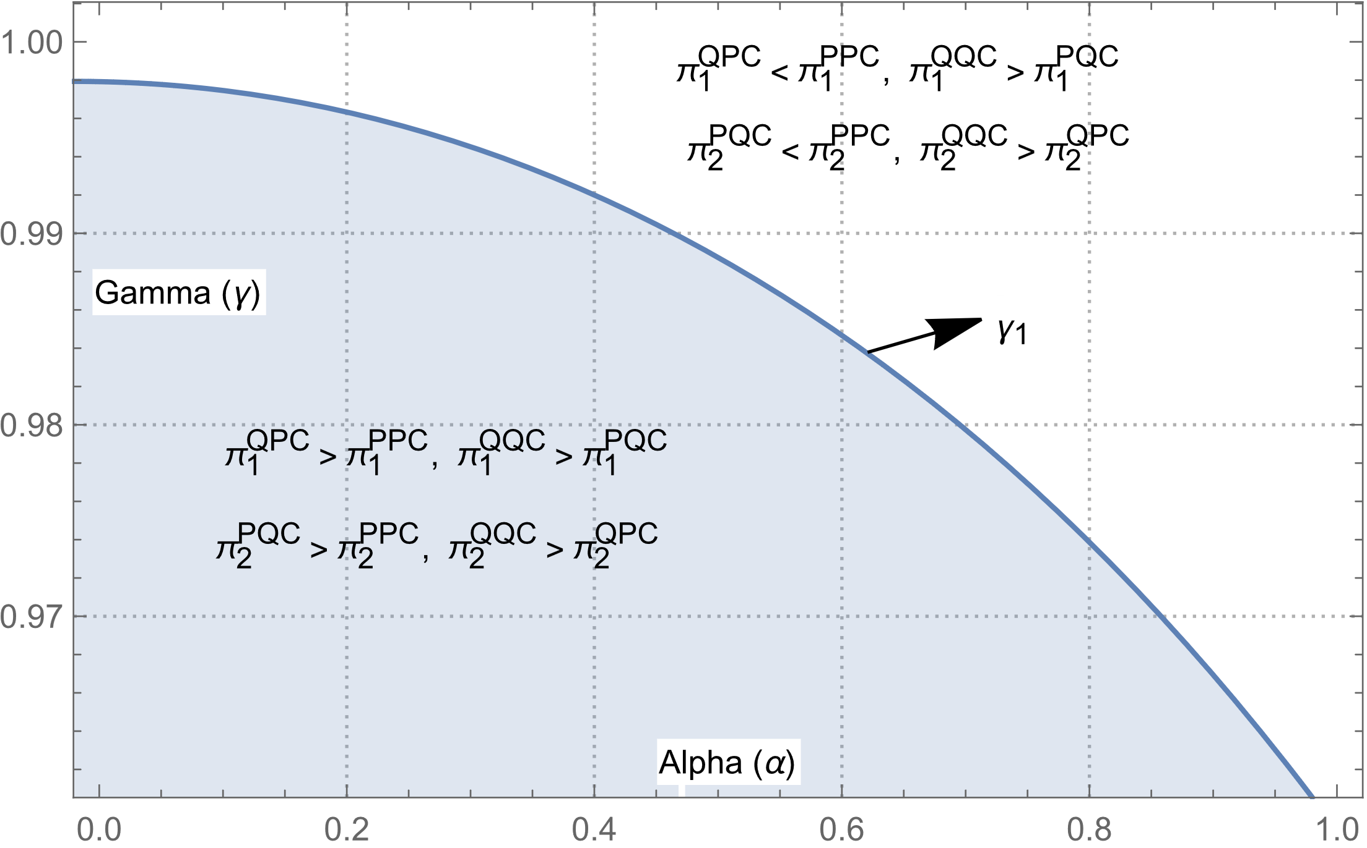
Figure 1: A graphical representation of threshold condition $γ_{1}$

A6. Proof of Proposition 7
If the ECSR standards are set at at ${\underline{s}}^{PPU}, {\underline{s}}^{QQU}, {\underline{s}}^{PQU2}$ respectively for Bertrand, Cournot and mixed markets respectively, then the profit levels for the various parts of the price-quantity game are as follows.
$π_{1}^{PPC}=-\frac{A^{2}(-1+γ)}{{(-2+γ)}^{2}(1+γ)}$ , $π_{2}^{PPC}=-\frac{A^{2}(-1+γ)}{{(-2+γ)}^{2}(1+γ)}$
$π_{1}^{QQC}= \frac{A^{2}}{{(2+γ)}^{2}}$, $π_{2}^{QQC}= \frac{A^{2}}{{(2+γ)}^{2}}$
$$π_{1}^{PQC}=-\frac{A^{2}{(γ^{2}+γ-2)}^{2}}{α^{2}{(γ^{2}+γ-2)}^{2}-{(4-3γ^{2})}^{2}}$$
$$π_{2}^{PQC}= -\frac{A^{2}(γ-1)(α^{2}{(γ-1)}^{3}{(γ+2)}^{4}+{(γ-2)}^{2}(γ+1){(4-3γ^{2})}^{2})}{{({(4-3γ^{2})}^{2}-α^{2}{(γ^{2}+γ-2)}^{2})}^{2}}$$
$$π_{1}^{QPC}= -\frac{A^{2}(γ-1)(α^{2}{(γ-1)}^{3}{(γ+2)}^{4}+{(γ-2)}^{2}(γ+1){(4-3γ^{2})}^{2})}{{({(4-3γ^{2})}^{2}-α^{2}{(γ^{2}+γ-2)}^{2})}^{2}}$$
$$π_{2}^{QPC}=-\frac{A^{2}{(γ^{2}+γ-2)}^{2}}{α^{2}{(γ^{2}+γ-2)}^{2}-{(4-3γ^{2})}^{2}}$$

All values of the profits are non-negative, with $1≥α≥0$.
In these settings, for $γ_{2}=Root[4α^{2}-4α^{2}\#1-3α^{2}{\#1}^{2}+(-8+2α^{2}){\#1}^{3}+α^{2}{\#1}^{4}+6{\#1}^{5}+{\#1}^{6}\&,3]$, we find that,
- If $0≤γ≤γ_{2},$then $π_{1}^{QPC}>π_{1}^{PPC}$ and $π_{1}^{QQC}<π_{1}^{PQC}$ for firm 1; and $π_{2}^{PQC}>π_{2}^{PPC}$ and $π_{2}^{QQC}<π_{2}^{QPC}$ for firm 2.
- If $γ_{2}<γ≤1$, then, $π_{1}^{QPC}<π_{1}^{PPC}and π_{1}^{QQC}>π_{1}^{PQC}$ for firm 1; and $π_{2}^{PQC}<π_{2}^{PPC}$ and $π_{2}^{QQC}>π_{2}^{QPC}$ for firm 2.
Given these sets of strategies, we observe that for condition (a) subgame perfect Nash equilibria are {Price, Quantity}, {Quantity, Price} and for condition (b), subgame perfect Nash equilibrium is {Quantity, Quantity}.

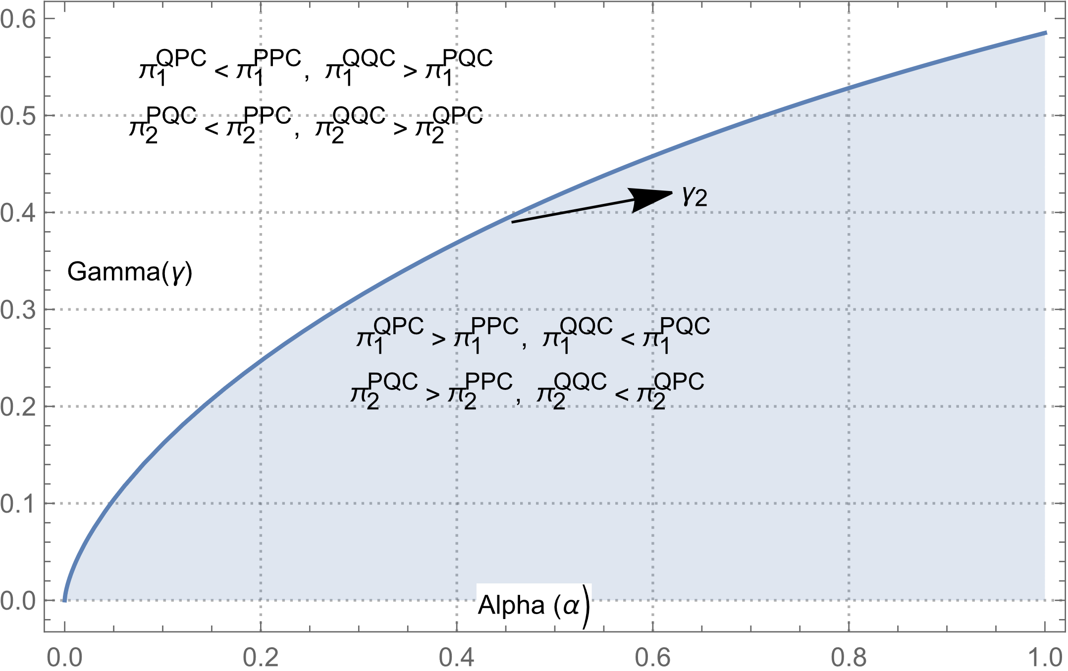

Figure 2: A graphical representation of threshold condition $γ_{2}$

A7. Comparing the welfare outcomes of committed and non-committed policy regime

In the non-committed regime sets the ECSR standards at ${\underline{s}}^{PPU}$ and committed regime sets the ECSR standards at ${\underline{s}}^{QQU}$ with market structure being Cournot. In this case given the threshold value of $γ_{3}$, we find that non-committed regime has higher social welfare than committed regime if $γ ≤$ $γ_{3}$ and the reverse is true if $γ$is more than threshold value. The threshold value $γ_{3}=Root[{\#1}^{3}(16-4α^{2})+{\#1}^{2}(α^{4}-12α^{2}+24)+{\#1}^{6}+4{\#1}^{5}+7{\#1}^{4}+2\#1α^{4}-3α^{4}+16α^{2}-16\&,4]$.

A graphical representation of this comparison is as follows.

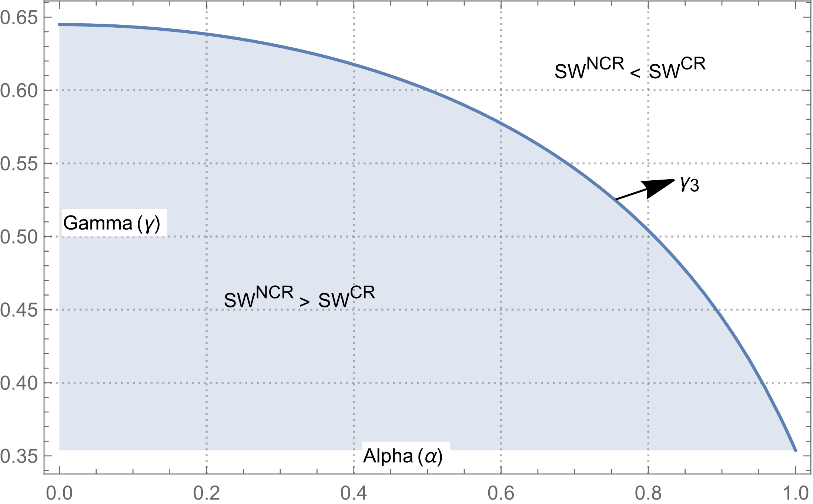

Figure 3: A graphical representation of threshold condition $γ_{3}$ and comparison of social welfare in committed (${SW}^{CR}$) and non-committed regime (${SW}^{NCR}$)

Given the symmetry of the firms and their outcomes, we only compare the results of one firm, and it holds for both of them.
Superscript U denotes upper bound.
Please refer to discussion in appendix A7 for graphical representation.

