The R&D investment decision game with product differentiation

Domenico Buccella¹, Luciano Fanti² and Luca Gori^{3*}
¹Department of Economics, Kozminski University, Warsaw, Poland, ²Department of Economics and Management, University of Pisa, Pisa, Italy, and ³Department of Law, University of Pisa, Pisa, Italy

*Corresponding author. Email: luca.gori@unipi.it or dr.luca.gori@gmail.com

ONLINE APPENDIX

The symmetric subgame in which both firms invest in R&D (I/I)

By considering the analysis of the second-order condition $g_{SOC}(β,d)$ – i.e., Eq. (9) in the main text –, the stability conditions $g_{SC}^{β_{low}}(β,d)$ and $g_{SC}^{β_{high}}(β,d)$ – i.e., Eqs. (11) and Eq. (12) in the main text –, and the R&D cost condition $g_{T}^{I/I}(β,d,w)$ – i.e., Eq. (14) in the main text –, it can be interesting studying the effects of product differentiation on the shape and position of these constraints in the $\left(β,g\right)$ space for the subgame I/I. To this purpose, a graph can help clarify this behaviour. Figure A.1, drawn in the $\left(β,g\right)$ space, depicts the second-order condition in (9), with the black line, and the stability conditions in (11) and (12), with the orange and green lines, respectively. The figure depicts the case of homogeneous products ($d=1$) showing that $g>g_{SOC}(β,d)$ holds for every $g$ satisfying the stability conditions irrespective of the value of $β$ for which (given $d$) $x_{i}$ and $x_{j}$ are strategic substitutes and strategic complements. If $q_{i}$ and $q_{j}$ are complements (negative values of $d$), the relevant stability condition is always given by the inequality in (12), i.e., $x_{i}$ and $x_{j}$ are strategic complements for any couple $\left(β,g\right)$ in that case. An increase in the degree of product differentiation ($d↓$) changes the shape of the stability conditions in the $\left(β,g\right)$ space. In particular, the $β$-threshold separating the region of strategic substitutability from the region of strategic complementarity, i.e., $\frac{d}{2}$, shifts leftward in the $\left(β,g\right)$ space, thus favouring strategic complementarity in the R&D effort that works therefore out as a device enforcing the R&D externality. Figure A.2 contrasts Figure A.1 and clearly shows this result for the case heterogeneous products, in which Panel A refers to product substitutability ($d=0.5$) and Panel B to product complementarity ($d=-0.5$).
Finally, Figure A.3, plotted in the $\left(β,g\right)$ space for four different values of $w$ depicted in Panels A-D, clarifies the behaviour of the R&D cost condition $g_{T}^{I/I}(β,d,w)$ for the subgame I/I (the blue line in the figure) by overlapping it with the stability conditions in (11) and (12), as depicted in Figure A.1 for the case of homogeneous products (the second-order condition was not drawn as it is always fulfilled once the stability conditions are satisfied).

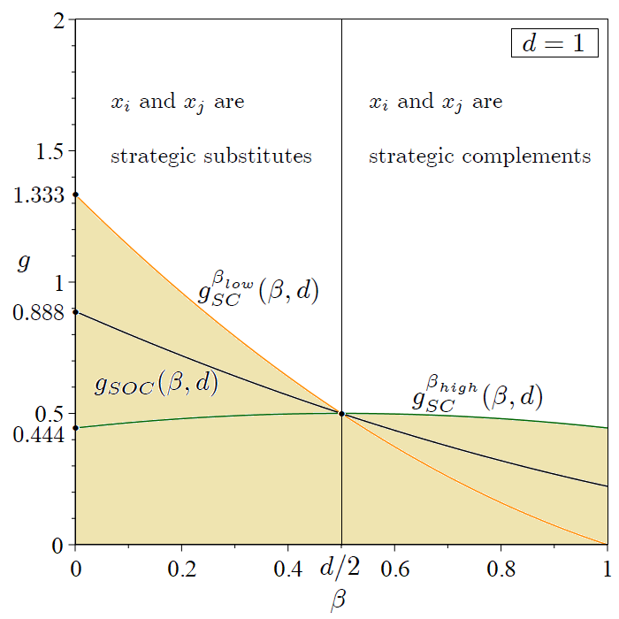
Figure A.1. Second-order condition (black line) and stability conditions (orange and green lines) in the $\left(β,g\right)$ space when products are homogeneous ($d=1$). The sand-coloured area represents the parametric region of unfeasibility.

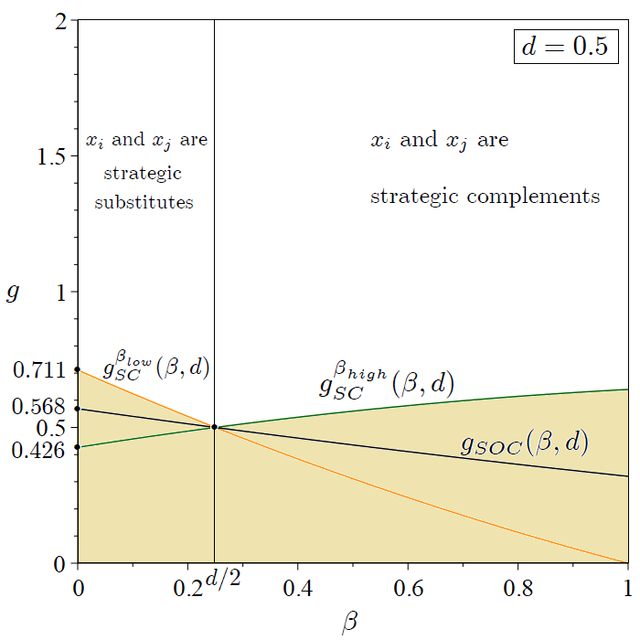
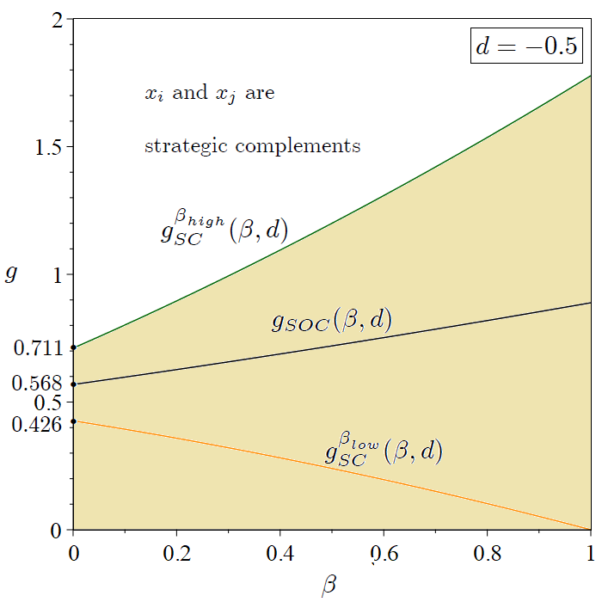

(A) (B)
Figure A.2. Second-order condition (black line) and stability conditions (orange and green lines) in the $\left(β,g\right)$ space when products are substitutes ($d=0.5$), Panel A, and complements ($d=-0.5$), Panel B. The sand-coloured area represents the parametric region of unfeasibility.

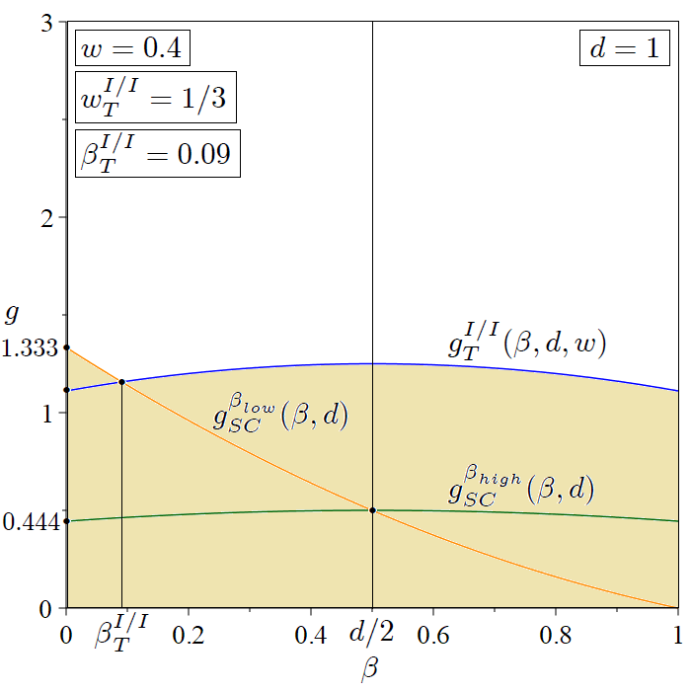
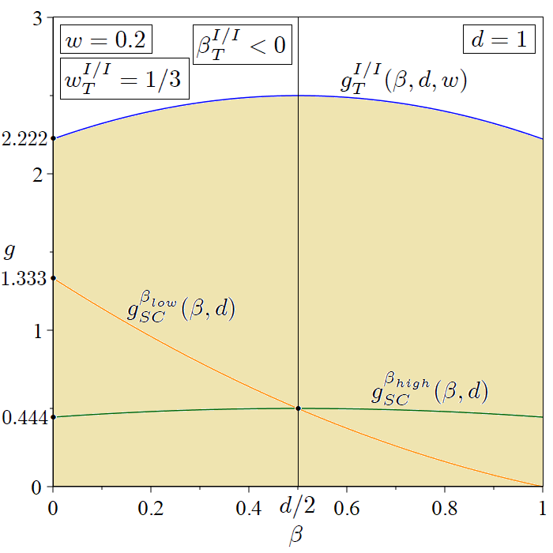

(A) (B)
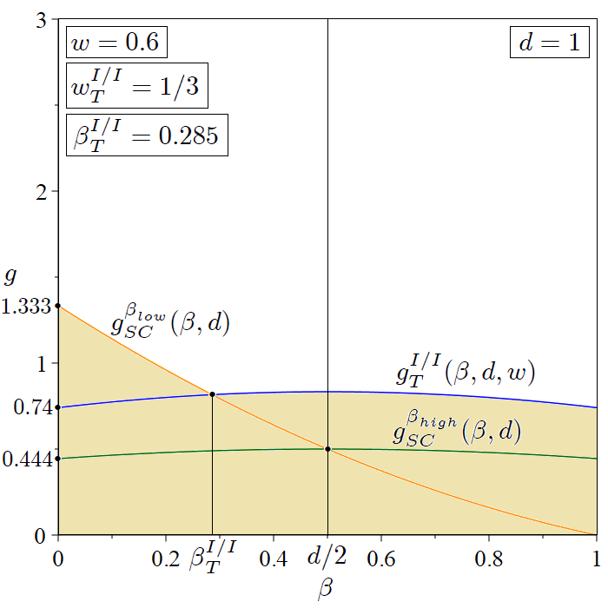
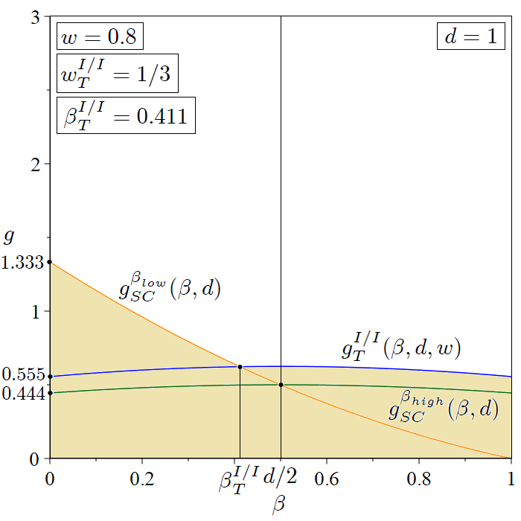

(C) (D)
Figure A.3. The R&D cost condition (blue line) and the stability conditions (orange and green lines) for different values of the unitary cost resulting from the technology of production ($0<w<1$) and product homogeneity ($d=1$): Panel A: $w=0.2$. Panel B: $w=0.4$. Panel C: $w=0.6$. Panel D: $w=0.8$. The sand-coloured area represents the parametric region of unfeasibility.

The symmetric subgame in which firms do not invest in R&D (NI/NI)

Consider the possibility that firms symmetrically choose not to invest in R&D, that is $x_{i}=0$ and $X_{i}\left(x_{i}\right)=0$ ($i=\left\{1,2\right\}, i≠j$). By using Eqs. (1) and (2), the profit function of firm $i$ is:
$Π_{i}^{NI/NI}=p_{i}q_{i}-C_{i}\left(q_{i},0,0\right)=\left(1-q_{i}-dq_{j}-w\right)q_{i}$, (A.1)
where the upper script NI/NI stands for universally no R&D investments. At the market stage of the game, each firm chooses the amount of output to maximise profits. Maximisation of (A.1) with respect to $q_{i}$ leads to the following downward-sloping reaction function of firm $i$ in the output space:
$\frac{{∂Π}_{i}^{NI/NI}}{∂q_{i}}=0⇔{\overline{q}}_{i}^{NI/NI}\left(q_{j}\right)=\frac{1-w-dq_{j}}{2}$. (A.2)
Using Eq. (A.2) together with the symmetric counterpart for firm $j$ allows us to obtain the system of reaction functions in the $(q_{i},q_{j})$ space, whose solution ${\overline{q}}_{i}^{NI/NI}\left(q_{j}\right)$ ($i=\{1,2\}$, $i≠j$) leads firm $i$ to produce the following equilibrium quantity (denoted with an asterisk) of product of variety $i$ (which is symmetric to the quantity of product of variety $j$ produced by firm $j$):
$q_{i}^{*NI/NI}=\frac{1-w}{2+d}$. (A.3)
From the expression in (A.3), one can easily get the equilibrium value of the market price of product of variety $i$ and profits of firm $i$, which are respectively:
$p_{i}^{*NI/NI}=\frac{1+w(1+d)}{2+d}$. (A.4)
and
$Π_{i}^{*NI/NI}={\left(\frac{1-w}{2+d}\right)}^{2}$. (A.5)
Clearly, a change in consumers’ tastes generating an increase in the degree of product differentiation ($d↓$) causes, ceteris paribus, an increase in the demand directed to both firms for the product of their own varieties (at the expense of the rival’s share), also strengthening the market power by eventually increasing profits.
The equilibrium values of consumers’ surplus (${CS}^{*NI/NI}$) and producers’ surplus (${PS}^{*NI/NI}$) that can be obtained in the NI/NI subgame are summarised as follows:
${CS}^{*NI/NI}=\frac{1}{2}\left[{\left(q_{i}^{*NI/NI}\right)}^{2}+{\left(q_{j}^{*NI/NI}\right)}^{2}+2dq_{i}^{*NI/NI}q_{j}^{*NI/NI}\right]=\frac{{(1-w)}^{2}(1+d)}{{(2+d)}^{2}}$. (A.6)
and
${PS}^{*NI/NI}=Π_{i}^{*NI/NI}+Π_{j}^{*NI/NI}=2{\left(\frac{1-w}{2+d}\right)}^{2}$. (A.7)
Therefore, social welfare under NI/NI, $W^{*NI/NI}$, is:
$W^{*NI/NI}={CS}^{*NI/NI}+{PS}^{*NI/NI}=\frac{{(1-w)}^{2}(3+d)}{{(2+d)}^{2}}$. (A.8)

The asymmetric subgame in which only one firm invests in R&D (I/NI)

This section continues the analysis made so far by considering the asymmetric subgame in which one firm invests in R&D (say, firm $i$), and the rival does not (say, firm $j$). As the R&D investment of firm $i$ is positive and the R&D investment of firm $j$ is zero, we have that $x_{i}>0$ and $X_{i}\left(x_{i}\right)>0$, and $x_{j}=0$ and $X_{j}\left(x_{j}\right)=0$. Therefore, on the one hand, firm $i$ invests in process innovation, thus reducing its own average and marginal production costs but does not benefit from any stream of knowledge (externality) related to firm $j$’s R&D activity, which is absent in this case. On the other hand, firm $j$ does not invest in process innovation, but it can benefit from a stream of knowledge (externality) related to firm $i$’s R&D activity, whose extent is measured by the parameter $β$. Therefore, by using Eqs. (1), (2), and (3) in the main text of the article, the profit functions of firms $i$ and $j$ now read respectively as follows:
$Π_{i}^{I/NI}=p_{i}q_{i}-C_{i}\left(q_{i},x_{i},0\right)-X_{i}\left(x_{i}\right)=\left(1-q_{i}-dq_{j}\right)q_{i}-\left(w-x_{i}\right)q_{i}-\frac{g}{2}x_{i}^{2}$, (A.9)
and
$Π_{j}^{I/NI}=p_{j}q_{j}-C_{j}\left(q_{j},0,x_{i}\right)=\left(1-q_{j}-dq_{i}\right)q_{j}-\left(w-{βx}_{i}\right)q_{j}$, (A.10)
where the upper script I/NI stands for positive R&D investments of firm $i$ and no R&D investments of firm $j$. At the market stage of the game, each firm chooses the optimal amount of output production by maximising profits. Therefore, the maximisation of (A.9) and (A.10) with respect to $q_{i}$ and $q_{j}$, respectively, leads to the following downward-sloping output reaction function of firm $i$ and firm $j$ in the $(q_{i},q_{j})$ space as a function also of the R&D effort exerted by firm $i$ ($x_{i}$), that is:
$\frac{{∂Π}_{i}^{I/NI}}{∂q_{i}}=0⇔{\overline{q}}_{i}^{I/NI}(q_{j},x_{i})=\frac{1-w-dq_{j}+x_{i}}{2}$, (A.11)
and
$\frac{{∂Π}_{j}^{I/NI}}{∂q_{j}}=0⇔{\overline{q}}_{j}^{I/NI}(q_{i},x_{i})=\frac{1-w-dq_{i}+βx_{i}}{2}$. (A.12)
Eqs. (A.11) and (A.12) reveal that the output reaction functions of both firms $i$ and $j$ in the asymmetric subgame are similar, differing however in one crucial respect: an increase in the R&D investment of firm $i$, in fact, shifts outwards both reaction functions, thereby contributing to increase production of firm $i$ and firm $j$. However, the extent of the upward shift of the output reaction function of firm $i$, which sustains process innovation R&D, is larger than the upward shift of the output reaction function of firm $j$, which does not incur R&D costs and can benefit only partially ($β<1$) by the positive R&D externality generated by the rival. The extent of the upward shift of the reaction function of firm $j$ is the same as that of firm $i$ only under full disclosure of R&D-related information by firm $i$ ($β=1$). The solution of the system of output reaction functions ${\overline{q}}_{i}^{I/NI}(q_{j},x_{i})$ and ${\overline{q}}_{j}^{I/NI}(q_{i},x_{i})$ ($i=\{1,2\}$, $i≠j$) allows us to get the following equilibrium output obtained by firms $i$ and $j$ at the third stage of the asymmetric subgame I/NI, that is:
${\overline{\overline{q}}}_{i}^{I/NI}(x_{i})=\frac{\left(1-w\right)\left(2-d\right)+\left(2-dβ\right)x_{i}}{(2-d)(2+d)}$. (A.13)
and
${\overline{\overline{q}}}_{j}^{I/NI}(x_{i})=\frac{\left(1-w\right)\left(2-d\right)+(2β-d)x_{i}}{(2-d)(2+d)}$. (A.14)
A direct comparison of Eqs. (A.13) and (A.14) with Eq. (14) in the main text of the article allows us to conclude that, if products are substitutes ($d>0$), depending on the extent of technological spillovers, the amount of output production of the investing firm $i$ at the third stage of the game in the asymmetric subgame I/NI is smaller (resp. larger) than the amount of output production of firm $i$ at the third stage of the game in the symmetric subgame I/I. In particular, ${\overline{\overline{q}}}_{i}^{I/I}\left(x_{i},x_{j}\right)<{\overline{\overline{q}}}_{i}^{I/NI}(x_{i})$ if $β<\frac{d}{2}$ (i.e., $x_{i}$ and $x_{j}$ are strategic substitutes) and ${\overline{\overline{q}}}_{i}^{I/I}\left(x_{i},x_{j}\right)>{\overline{\overline{q}}}_{i}^{I/NI}(x_{i})$ if $β>\frac{d}{2}$ (i.e., $x_{i}$ and $x_{j}$ are strategic complements). In addition, the amount of output production of the non-investing firm $j$ at the third stage of the game in the asymmetric subgame I/NI is always smaller than the amount of output production obtained by the corresponding firm at the third stage of the game in the symmetric subgame I/I. Differently, if products are complements ($d<0$), the output production of both firms in the symmetric subgame I/I is always larger than the output production of the investing and non-investing firms in the asymmetric subgame I/NI.
Substituting Eqs. (A.13) and (A.14) for the profit equations (A.9) and (A.10) allows us to obtain profits of the investing and non-investing firms as a function of the R&D effort $x_{i}$, i.e., $Π_{i}^{I/NI}(x_{i})$ and $Π_{j}^{I/NI}(x_{i})$. At the second (R&D) stage of the game, the investing firm $i$ maximises its own profits $Π_{i}^{I/NI}(x_{i})$ by choosing the amount of cost-reducing investment. Formally, this implies that:
$\frac{{dΠ}_{i}^{I/NI}(x_{i})}{dx_{i}}=0⇔x_{i}^{*I/NI}=\frac{2(1-w)(2-d)\left(2-dβ\right)}{g{\left(2-d\right)}^{2}{\left(2+d\right)}^{2}-2{\left(2-dβ\right)}^{2}}$. (A.15)
As only firm $i$ does invest in R&D in this subgame, there are no R&D reaction functions so that $x_{i}^{*I/NI}$ represents the amount of equilibrium investment following the process innovation effort of firm $i$. The denominator of the expression of $x_{i}^{*I/NI}$ in (A.15) should be positive to guarantee a positive R&D effort. By imposing $x_{i}^{*I/NI}>0$ one gets $g>\frac{2{(2-dβ)}^{2}}{{\left(2-d\right)}^{2}{\left(2+d\right)}^{2}}≔g_{SOC}(β,d)$, which coincides with the second-order condition in the expression (17) in the main text. Therefore, the condition $x_{i}^{*I/NI}>0$ is always fulfilled once the stability conditions in (19) and (20) reported in the main text and the R&D cost condition in (22) reported in the main text, resulting from the symmetric subgame in which both firms do invest in process innovation are satisfied. Differentiating the expression in (A.15) with respect to $β$ gives $\frac{∂x_{i}^{*I/NI}}{∂β}<0$. In fact, as the externality of the R&D investment generated by the investing firm becomes larger, the rival can free ride at a higher degree so firm $i$ is incentivised to reduce its own amount of cost-reducing R&D investment, otherwise it would favour too much the rival by reducing its own production cost.
Like the symmetric subgame I/I, we should augment the analysis by considering the additional constraints on the side of the costs of production of both the investing firm $i$ and non-investing firm $j$ by explicitly accounting for their own R&D cost conditions resulting from the inequalities $w-x_{i}>0$ for the investing firm $i$ and $w-βx_{i}>0$ for the non-investing free-riding firm $j$, as part of their own total costs of production $C_{i}\left(q_{i},x_{i},0\right)$ and $C_{j}\left(q_{j},0,x_{i}\right)$, respectively. This can be specialised by substituting out $x_{i}^{*I/NI}$ from (A.15) into the last inequalities, showing that they are fulfilled if and only if:
$g>\frac{2(2-dβ)\left[2-d+dw(1-β)\right]}{w{\left(2-d\right)}^{2}{\left(2+d\right)}^{2}}≔g_{T}^{I/NI}(β,d,w)$, (R&D cost condition of the investing firm). (A.16)
and
$g>\frac{2(2-dβ)\left[2w\left(1-β\right)+β(2-d)\right]}{w{\left(2-d\right)}^{2}{\left(2+d\right)}^{2}}$, (R&D cost condition of the non-investing firm). (A.17)
The condition in (A.17) is never binding, as $g_{T}^{I/NI}(β,d,w)>\frac{2(2-dβ)\left[2w\left(1-β\right)+β(2-d)\right]}{w{\left(2-d\right)}^{2}{\left(2+d\right)}^{2}}$ is always fulfilled in the asymmetric subgame I/NI. Differently, the expression in (A.16) adds another (the last!) threshold to the stability condition (19) reported in the main text, i.e., $g_{SC}^{β_{low}}(β,d)$, and the R&D cost condition of the symmetric subgame I/I (22) reported in the main text, i.e., $g_{T}^{I/I}(β,d,w)$, in determining the feasible region for the emergence of meaningful Nash equilibrium outcomes of the investment decision game with product differentiation (which is drawn as the red line in Figures 4-7 in the main text). The comparison amongst the shapes of the relevant constraints of the game $g_{SC}^{β_{low}}(β,d)$, $g_{T}^{I/I}(β,d,w)$ and $g_{T}^{I/NI}(β,d,w)$ as well as their position in the $(β,g)$ space is a complex exercise, depending, amongst other factors, on the relative size of $w$. Therefore, to avoid lengthening the exposition further with additional graphs, we leave the complete geometrical analysis to Section 3.2 in the main text of the article, dealing with the study of the Nash equilibria of the game and related discussion. However, the Proposition A.1 below resembles Proposition 1 in the main text and examines further this issue analytically by definitively clarifying the position of $g_{SC}^{β_{low}}(β,d)$, $g_{T}^{I/I}(β,d,w)$ and $g_{T}^{I/NI}(β,d,w)$ in the $(β,g)$ space depending on $β$, $d$ and $w$, showing therefore which constraint is definitively binding for the R&D investment decision game.
Let us first consider the relationship between $g_{T}^{I/I}(β,d,w)$ and $g_{T}^{I/NI}(β,d,w)$ and define
$β_{T_{1}}^{I/NI}(d,w)≔\frac{dw}{2-d\left(1-w\right)}<1$, (A.18)
as a threshold value of the intensity of the R&D externality such that $g_{T}^{I/NI}(β,d,w)=g_{T}^{I/I}(β,d,w)$ in the $\left(β,g\right)$ space. If products are complements ($d<0$) then $β_{T_{1}}^{I/NI}(d,w)<0$ and $g_{T}^{I/I}(β,d,w)>g_{T}^{I/NI}(β,d,w)$ for any $0≤β≤1$. If products are substitutes ($d>0$), then $β_{T_{1}}^{I/NI}(d,w)>0$ and 1) $g_{T}^{I/NI}(β,d,w)>g_{T}^{I/I}(β,d,w)$ for any $0≤β<β_{T_{1}}^{I/NI}(d,w)$, 2) $g_{T}^{I/I}(β,d,w)>g_{T}^{I/NI}(β,d,w)$ for any $β_{T_{1}}^{I/NI}(d,w)<β≤1$. If $w→1,$ then $β_{T_{1}}^{I/NI}(d,1)→\frac{d}{2}$, $g_{T}^{I/I}(β,d,1)→g_{SC}^{β_{high}}(β,d)$, and $g_{T}^{I/NI}(β,d,1)>g_{SC}^{β_{high}}(β,d)=g_{T}^{I/I}(β,d,1)$ for any $0≤β<\frac{d}{2}$ and $g_{T}^{I/NI}(β,d,1)<g_{SC}^{β_{high}}(β,d)=g_{T}^{I/I}(β,d,1)$ for any $\frac{d}{2}<β≤1$.
Consider now the relationship between $g_{SC}^{β_{low}}(β,d)$ and $g_{T}^{I/NI}(β,d,w)$ and define
$β_{T_{2}}^{I/NI}(d,w)≔\frac{d-2(1-w)}{2w}<1$, (A.19)
as a threshold value of the intensity of the R&D externality such that $g_{T}^{I/NI}(β,d,w)=g_{SC}^{β_{low}}(β,d)$ in the $\left(β,g\right)$ space, where $β_{T_{2}}^{I/NI}(d,w)<β_{T_{1}}^{I/NI}(d,w)$ and
$d_{T}^{I/NI}(w)≔2(1-w)$, (A.20)
as a threshold value of the degree of product differentiation such that $β_{T_{2}}^{I/NI}(d,w)=0$, where $d_{T}^{I/NI}(0)=2$ if $w→0$, $d_{T}^{I/NI}\left(\frac{1}{2}\right)=1$ if $w=\frac{1}{2}$ and $d_{T}^{I/NI}(1)=0$ if $w→1$, so that $d_{T}^{I/NI}(w)>1$ for any $0<w<\frac{1}{2}$ and ${0<d}_{T}^{I/NI}(w)≤1$ for any $\frac{1}{2}≤w<1$.
By looking at the expression of $β_{T_{2}}^{I/NI}(d,w)$ in (39), it is clear that $β_{T_{2}}^{I/NI}(d,w)<0$ for any $0<w<1$ and $-1≤d≤0$, $β_{T_{2}}^{I/NI}(d,w)<0$ for any $0<w<\frac{1}{2}$ and $0≤d≤1$, $β_{T_{2}}^{I/NI}(d,w)<0$ for any $\frac{1}{2}≤w<1$ and $0≤d<d_{T}^{I/NI}(w)$, and $β_{T_{2}}^{I/NI}(d,w)>0$ for any $\frac{1}{2}≤w<1$ and $d_{T}^{I/NI}(w)≤d≤1$. Therefore,

- if products are complements ($d<0$), then $β_{T_{2}}^{I/NI}(d,w)<0$ and $g_{T}^{I/NI}(β,d,w)>g_{SC}^{β_{low}}(β,d)$ for any $0≤β≤1$ and $0<w<1$ in the $\left(β,g\right)$ space;
- if products are substitutes ($d>0$), $0<w<\frac{1}{2}$ and $0<d≤1$ then $β_{T_{2}}^{I/NI}(d,w)<0$ and $g_{T}^{I/NI}(β,d,w)>g_{SC}^{β_{low}}(β,d)$ for any $0≤β≤1$;
- if products are substitutes ($d>0$), $\frac{1}{2}≤w<1$ and $0<d<d_{T}^{\frac{I}{NI}}\left(w\right),$ then $β_{T_{2}}^{I/NI}(d,w)<0$ and $g_{T}^{I/NI}(β,d,w)>g_{SC}^{β_{low}}(β,d)$ for any $0≤β≤1$;
- if products are substitutes ($d>0$), $\frac{1}{2}≤w<1$ and $d_{T}^{\frac{I}{NI}}(w)≤d≤1,$ then $β_{T_{2}}^{I/NI}(d,w)≥0$ and 1) $g_{T}^{I/NI}(β,d,w)<g_{SC}^{β_{low}}(β,d)$ for any $0≤β<β_{T_{2}}^{I/NI}(d,w)$ and 2) $g_{T}^{I/NI}(β,d,w)>g_{SC}^{β_{low}}(β,d)$ for any $β_{T_{2}}^{I/NI}(d,w)<β≤1$;
- If products are substitutes ($d>0$) and $w→1,$ then $d_{T}^{I/NI}(w)→0$, $β_{T_{2}}^{I/NI}(d,1)→\frac{d}{2}$, $g_{T}^{I/I}(β,d,1)→g_{SC}^{β_{high}}(β,d)$, and $g_{SC}^{β_{low}}\left(β,d\right)>g_{T}^{I/NI}(β,d,1)>g_{SC}^{β_{high}}(β,d)=g_{T}^{I/I}(β,d,1)$ for any $0≤β<\frac{d}{2}$ and $g_{SC}^{β_{high}}(β,d)=g_{T}^{I/I}(β,d,1)>g_{T}^{I/NI}(β,d,1)>g_{SC}^{β_{low}}\left(β,d\right)$ for any $\frac{d}{2}<β≤1$.

These arguments together with those used to state Proposition 1 in the main text allow us to establish the following proposition to definitively clarify which constraint is binding in the $\left(β,g\right)$ space for the investment decision game.

Proposition A.1. The relevant constraints of the R&D investment decision game with quantity competition and product differentiation are as follows.

[1] If products are complements ($d<0$), then $g_{T}^{I/I}(β,d,w)$ is binding in the $\left(β,g\right)$ space for any $0≤β≤1$ and $0<w<1$ for the investment decision game.

[2] If products are substitutes ($d>0$) and $0<w<\frac{1}{2}$, then $g_{T}^{I/NI}(β,d,w)$ is binding for any $0≤β<β_{T_{1}}^{\frac{I}{NI}}\left(d,w\right),$ and $g_{T}^{I/I}(β,d,w)$ is binding for any $β_{T_{1}}^{I/NI}(d,w)<β≤1$ for the investment decision game.

[3] If products are substitutes ($d>0$), $\frac{1}{2}≤w<1$ and $d_{T}^{I/NI}(w)≤d≤1$ then $g_{SC}^{β_{low}}(β,d)$ is binding for any $0≤β<β_{T_{2}}^{I/NI}(d,w)$, $g_{T}^{I/NI}(β,d,w)$ is binding for any $β_{T_{2}}^{I/NI}(d,w)<β<β_{T_{1}}^{I/NI}(d,w)$ and $g_{T}^{I/I}(β,d,w)$ is binding $β_{T_{1}}^{I/NI}(d,w)<β≤1$ for the investment decision game.

[4] If products are substitutes ($d>0$), $\frac{1}{2}≤w<1$ and $0<d<d_{T}^{\frac{I}{NI}}\left(w\right),$ then $g_{T}^{I/NI}(β,d,w)$ is binding for any $0≤β<β_{T_{1}}^{\frac{I}{NI}}\left(d,w\right),$ and $g_{T}^{I/I}(β,d,w)$ is binding for any $β_{T_{1}}^{I/NI}(d,w)<β≤1$ for the investment decision game.

[5] If products are substitutes ($d>0$) and $w→1,$ then $g_{SC}^{β_{low}}(β,d)$ is binding for any $0≤β<\frac{d}{2}$ and $g_{SC}^{β_{high}}(β,d)$ is binding for any $\frac{d}{2}<β≤1$ for the investment decision game.

Proof. Point [1]. If products are complements ($d<0$), then $g_{T}^{I/I}(β,d,w)>g_{T}^{I/NI}(β,d,w)>g_{SC}^{β_{low}}(β,d)$ for any $0≤β≤1$ and $0<w<1$.

Points [2] and [4]. If products are substitutes ($d>0$) and $0<w<\frac{1}{2}$ or if products are substitutes ($d>0$), $\frac{1}{2}≤w<1$ and $0<d<d_{T}^{I/NI}(w)$ then $β_{T_{2}}^{I/NI}(d,w)<0$, $β_{T_{1}}^{I/NI}(d,w)>0$, $g_{T}^{I/NI}(β,d,w)>g_{SC}^{β_{low}}(β,d)$ for any $0≤β≤1$, $g_{T}^{I/NI}(β,d,w)>g_{T}^{I/I}(β,d,w)$ for any $0≤β<β_{T_{1}}^{I/NI}(d,w)$, and $g_{T}^{I/I}(β,d,w)>g_{T}^{I/NI}(β,d,w)$ for any $β_{T_{1}}^{I/NI}(d,w)<β≤1$. Therefore, $g_{T}^{I/NI}(β,d,w)$ is binding for any $0≤β<β_{T_{1}}^{I/NI}(d,w)$ and $g_{T}^{I/I}(β,d,w)$ is binding for any $β_{T_{1}}^{I/NI}(d,w)<β≤1$.

Point [3]. If products are substitutes ($d>0$), $\frac{1}{2}≤w<1$ and $d_{T}^{I/NI}(w)≤d≤1$ then $β_{T_{1}}^{I/NI}(d,w)>β_{T_{2}}^{I/NI}(d,w)>0$, $g_{SC}^{β_{low}}\left(β,d\right)>g_{T}^{I/NI}(β,d,w)>g_{T}^{I/I}(β,d,w)$ for any $0≤β<β_{T_{2}}^{I/NI}(d,w)$, $g_{T}^{I/NI}(β,d,w)>g_{SC}^{β_{low}}\left(β,d\right)$ and $g_{T}^{I/NI}(β,d,w)>g_{T}^{I/I}(β,d,w)$ for any $β_{T_{2}}^{I/NI}(d,w)<β<β_{T_{1}}^{I/NI}(d,w)$, and $g_{T}^{I/I}(β,d,w)>g_{T}^{I/NI}(β,d,w)$ for any $β_{T_{1}}^{I/NI}(d,w)<β≤1$. Therefore, $g_{SC}^{β_{low}}\left(β,d\right)$ is binding for any $0≤β<β_{T_{2}}^{I/NI}(d,w)$, $g_{T}^{I/NI}(β,d,w)$ is binding for any $β_{T_{2}}^{I/NI}(d,w)<β<β_{T_{1}}^{I/NI}(d,w)$ and $g_{T}^{I/I}(β,d,w)$ is binding for any $β_{T_{1}}^{I/NI}(d,w)<β≤1$.

Point [5]. If products are substitutes and $w→1$, then $β_{T_{1}}^{I/NI}(d,1)>0$ and $β_{T_{1}}^{I/NI}(d,1)→\frac{d}{2}$, $β_{T_{2}}^{I/NI}(d,1)>0$ and $β_{T_{2}}^{I/NI}(d,1)→\frac{d}{2}$, $g_{T}^{I/I}(β,d,1)→g_{SC}^{β_{high}}\left(β,d\right)$ from above and $g_{T}^{I/NI}(β,d,1)→g_{SOC}\left(β,d\right)$ for any $0<d≤1$, and $g_{SC}^{β_{low}}\left(β,d\right)>g_{T}^{I/NI}(β,d,1)>g_{SC}^{β_{high}}\left(β,d\right)$ for any $0≤β<\frac{d}{2}$ and $g_{SC}^{β_{high}}\left(β,d\right)>g_{T}^{I/NI}(β,d,1)>g_{SC}^{β_{low}}\left(β,d\right)$ for any $\frac{d}{2}<β≤1$. Q.E.D.

From Proposition A.1, when the unitary production cost is sufficiently small ($0<w<\frac{1}{2}$), the relevant constraint is $g_{T}^{I/NI}(β,d,w)$ if the R&D externality is low enough ($0≤β<β_{T_{1}}^{I/NI}(d,w)$). In this case, in fact, there are conditions for one (and only one) firm to invest in R&D, as the non-investing firm (in the asymmetric subgame) cannot free ride at a high degree. Thus, the investing firm is incentivised to keep its own cost-reducing investment high (whose size, however, reduces as far as $β$ increases). When the unitary production cost is sufficiently high and products are perceived as highly differentiated by customers ($\frac{1}{2}≤w<1$ and $0<d<d_{T}^{I/NI}(w)$), but the extent of technological spillovers is sufficiently high ($β_{T_{1}}^{I/NI}(d,w)<β≤1$), the incentive for only one firm to invest in R&D is reduced, as it would make its rival benefit too much through the degree of R&D externality through the cost-reducing investment activity. Therefore, the rival starts investing to avoid losing the opportunity to increase profits through the cost-reducing R&D effort, and the relevant constraint becomes $g_{T}^{I/I}(β,d,w)$.
When the unitary production cost is sufficiently high and products are perceived as poorly differentiated by customers ($\frac{1}{2}≤w<1$ and $d_{T}^{I/NI}(w)≤d≤1$), i.e., they tend to be highly substitutable or perfect substitutes, the stability condition $g_{SC}^{β_{low}}\left(β,d\right)$ becomes the relevant constraint when the extent of technological spillovers is sufficiently small ($0≤β<β_{T_{2}}^{I/NI}(d,w)$), as the R&D cost conditions tend to be always fulfilled in this case (i.e., thy become less important in defining the boundaries of the feasible region of the R&D investment decision game). Increases in the degree of the R&D externality, however, let the R&D cost conditions become the relevant thresholds to define meaningfulness of the R&D investment decision game for the same reasons discussed so far.
We now continue the equilibrium analysis of the asymmetric subgame I/NI. By using the expression in (A.15) and substituting out for $x_{i}^{*I/NI}$ in the equilibrium output obtained at the third stage of the game, one gets the amount of output produced by the investing firm $i$ and the non-investing firm $i$ ($i=\left\{1,2\right\}$, $i≠j$) at equilibrium under I/NI, that is:
$q_{i}^{*I/NI}=\frac{g\left(1-w\right){(2-d)}^{2}(2+d)}{g{\left(2-d\right)}^{2}{\left(2+d\right)}^{2}-2{\left(2-dβ\right)}^{2}}$, (A.21)
and
$q_{j}^{*I/NI}=\frac{\left(1-w\right)\left[g{\left(2-d\right)}^{2}\left(2+d\right)-2(1-β)(2-dβ)\right]}{g{\left(2-d\right)}^{2}{\left(2+d\right)}^{2}-2{\left(2-dβ\right)}^{2}}$. (A.22)
Eqs. (A.21) and (A.22) reveal that the denominator is positive for any $g>g_{SOC}(β,d)$, which is always fulfilled if the other constraints discussed in Proposition A.1 hold. Therefore, $q_{i}^{*I/NI}>0$ always holds, and $q_{j}^{*I/NI}>0$ if and only if $g>g_{SC}^{β_{low}}(β,d)$, which is one of the relevant constraints discussed so far.
From the equations determining the equilibrium quantities in the subgame I/NI as expressed in (A.21) and (A.22), one can get the equilibrium values of the market price of product of variety $i$ and variety $j$ and the corresponding profit equations, that is:
$p_{i}^{*I/NI}=\frac{g{\left(2-d\right)}^{2}(2+d)[1+w(1+d)]-2(2-dβ)[2-d+dw\left(1-β\right)]}{g{\left(2-d\right)}^{2}{\left(2+d\right)}^{2}-2{\left(2-dβ\right)}^{2}}$, (A.23)
$p_{j}^{*I/NI}=\frac{g{\left(2-d\right)}^{2}(2+d)[1+w(1+d)]-2(2-dβ)[1+w\left(1-β\right)+β(1-d)]}{g{\left(2-d\right)}^{2}{\left(2+d\right)}^{2}-2{\left(2-dβ\right)}^{2}}$, (A.24)
$Π_{i}^{*I/NI}=\frac{g{\left(1-w\right)}^{2}{\left(2-d\right)}^{2}}{g{\left(2-d\right)}^{2}{\left(2+d\right)}^{2}-2{\left(2-dβ\right)}^{2}}$, (A.25)
and
$Π_{j}^{*I/NI}=\frac{{\left(1-w\right)}^{2}{\left[g{\left(2-d\right)}^{2}\left(2+d\right)-2(1-β)(2-dβ)\right]}^{2}}{{\left[g{\left(2-d\right)}^{2}{\left(2+d\right)}^{2}-2{\left(2-dβ\right)}^{2}\right]}^{2}}$. (A.26)
Eqs. (A.23) and (A.24) easily reveal that $p_{i}^{*I/NI}>0$ if $g>\frac{2(2-dβ)[2-d+dw\left(1-β\right)]}{{\left(2-d\right)}^{2}(2+d)[1+w(1+d)]}≔g_{p_{i}}^{I/NI}(β,d,w)$ and $p_{j}^{*I/NI}>0$ if $g>\frac{2(2-dβ)[1+w\left(1-β\right)+β(1-d)]}{{\left(2-d\right)}^{2}(2+d)[1+w(1+d)]}≔g_{p_{j}}^{I/NI}(β,d,w)$.
In addition, $g_{T}^{I/NI}(β,d,w)>g_{p_{i}}^{I/NI}(β,d,w)$, $g_{T}^{I/I}(β,d,w)>g_{p_{i}}^{I/NI}(β,d,w)$, $g_{T}^{I/NI}(β,d,w)>g_{p_{j}}^{I/NI}(β,d,w)$, $g_{T}^{I/I}(β,d,w)>g_{p_{j}}^{I/NI}(β,d,w)$ and both $g_{p_{i}}^{I/NI}(β,d,w)$ and $g_{p_{j}}^{I/NI}(β,d,w)$ are never binding in the $(β,g)$ space, and thus they are always fulfilled if the three constraints discussed in Proposition A.1 are binding for any $-1≤d≤1$, $0≤β≤1$ and $0<w<1$.
If $w→1,$ then $g_{p_{i}}^{I/NI}(β,d,1)→g_{SOC}(β,d)$ and $g_{p_{j}}^{I/NI}(β,d,1)→g_{SOC}(β,d)$, which are always fulfilled. Finally, from the expressions of the equilibrium profits in (A.25) and (A.26) one gets $Π_{i}^{*I/NI}>0$ if $g>g_{SOC}(β,d)$ and $Π_{j}^{*I/NI}>0,$ and it is economically meaningful for any ${g>g}_{SOC}(β,d)$ and $g>g_{SC}^{β_{low}}(β,d)$, which are fulfilled for any $β$ if the stability conditions are satisfied.
We avoid introducing the equilibrium values of consumers’ surplus (${CS}^{*I/NI}$) and producers’ surplus (${PS}^{*I/NI}$) for the I/NI subgame (along with the corresponding social welfare $W^{*I/NI}$) because, as shown in the main text, there are no asymmetric Nash equilibria in the R&D investment decision game, and we do not want to lengthen the analysis further.

The investment-decision stage under quantity competition: Nash equilibria and discussion

The profit differentials emerging in the R&D investment decision game – allowing to disentangle the nature of it – with product differentiation are the following:
$ΔΠ_{A}=Π_{i}^{*I/NI}-Π_{i}^{*NI/NI}=\frac{2{\left(1-w\right)}^{2}{\left(2-dβ\right)}^{2}}{{\left(2+d\right)}^{2}\left[g{\left(2-d\right)}^{2}{\left(2+d\right)}^{2}-2{\left(2-dβ\right)}^{2}\right]}$, (A.27)

$ΔΠ_{B}=Π_{i}^{*NI/I}-Π_{i}^{*I/I}=\begin{matrix}\frac{-2{\left(1-w\right)}^{2}{\left(2-dβ\right)}^{2}}{{\left[g{\left(2-d\right)}^{2}{\left(2+d\right)}^{2}-2{\left(2-dβ\right)}^{2}\right]}^{2}{\left[g\left(2-d\right){\left(2+d\right)}^{2}-2\left(1+β\right)\left(2-dβ\right)\right]}^{2}} \\ ×\{d^{8}g^{3}-6d^{6}g^{2}β^{2}-16d^{6}g^{3}+12d^{4}gβ^{2}+4d^{6}g^{2}+8d^{5}g^{2}β+64d^{4}g^{2}β^{2} \\ -8d^{2}β^{6}+96d^{4}g^{3}-16d^{4}gβ^{2}-32d^{3}gβ^{3}-64d^{2}gβ^{4}-56d^{4}g^{2}-64d^{3}g^{2}β \\ -224d^{2}g^{2}β^{2}+16d^{4}β^{4}+32dβ^{5}+64d^{3}gβ-256d^{2}g^{3}+32d^{2}gβ^{2}\end{matrix}$, (A.28)
$$+256dgβ^{2}+256d^{2}g^{2}-8d^{2}β^{2}+128dg^{2}β-64dβ^{3}+256g^{2}β^{2}-32β^{4}-64d^{2}g$$
$$-128dgβ+256g^{3}-256gβ^{2}+32dβ-384g^{2}+64β^{2}+192g-32\}$$

and
$ΔΠ_{C}=Π_{i}^{*NI/NI}-Π_{i}^{*I/I}=\frac{2{\left(1-w\right)}^{2}(2-dβ)\left\{g{\left(2+d\right)}^{2}\left[2\left(1-d\right)+β(4-d)\right]-2{\left(1+β\right)}^{2}(2-dβ)\right\}}{{\left(2+d\right)}^{2}{\left[g(2-d){\left(2+d\right)}^{2}-2(1+β)(2-dβ)\right]}^{2}}$. (A.29)
Eq. (A.27) and (A.28) reveal that $ΔΠ_{A}>0$ and $ΔΠ_{B}<0$ irrespective of the parameter values, whereas $ΔΠ_{C}$ can be positive or negative depending on the relative values of $β$, $g$ and $d$ (see Eq. (24) in the main text).

Analytical results

This section provides some analytical results and the corresponding proofs.

Proposition A.2. The outcomes of the R&D investment decision game with quantity competition and product differentiation are the following.

[1] Products are complements ($d<0$). Let $0<w<1$ hold. If $-1≤d<0$ then (I,I) is the unique Pareto efficient Nash equilibrium and the R&D investment decision game with product differentiation is a deadlock for any $0≤β≤1$ and ${g>g}_{T}^{I/I}(β,d,w)$.

[2] Products are substitutes ($d>0$). Let $0<w<\frac{1}{2}$ hold. If ${\overline{d}}_{C}\left(w\right)≤d<1$ then [2.1] (I,I) is the unique Pareto inefficient Nash equilibrium and the R&D investment decision game with product differentiation is a prisoner’s dilemma for any $0≤β≤{\overline{β}}_{C}(d,w)$ and $g_{T}^{I/NI}(β,d,w)<g<g_{C}\left(β,d\right)$, and [2.2] (I,I) is the unique Pareto efficient Nash equilibrium and the R&D investment decision game with product differentiation is a deadlock for any $0≤β≤{\overline{β}}_{C}(d,w)$ and $g>g_{C}\left(β,d\right)$, for any ${\overline{β}}_{C}(d,w)<β≤β_{T_{1}}^{I/NI}(d,w)$ and $g>g_{T}^{I/NI}(β,d,w)$, and for any $β_{T_{1}}^{I/NI}(d,w)<β≤1$ and $g>g_{T}^{I/I}(β,d,w)$.

[3] Products are substitutes ($d>0$). Let $0<w<\frac{1}{2}$ hold. If $0<d<{\overline{d}}_{C}\left(w\right)$ then (I,I) is the unique Pareto efficient Nash equilibrium and the R&D investment decision game with product differentiation is a deadlock for any $0≤β≤β_{T_{1}}^{I/NI}(d,w)$ and $g>g_{T}^{I/NI}(β,d,w)$, and for any $β_{T_{1}}^{I/NI}(d,w)<β≤1$ and $g>g_{T}^{I/I}(β,d,w)$.

[4] Products are substitutes ($d>0$). Let $\frac{1}{2}≤w<\frac{5}{8}$ hold. If $d_{T}^{I/NI}(w)≤d<1$ then [4.1] (I,I) is the unique Pareto inefficient Nash equilibrium and the R&D investment decision game with product differentiation is a prisoner’s dilemma for any ${0≤β≤β}_{T_{2}}^{I/NI}(d,w)$ and $g_{SC}^{β_{low}}\left(β,d\right)<g<g_{C}\left(β,d\right)$, and for any $β_{T_{2}}^{I/NI}(d,w){<β≤\overline{β}}_{C}(d,w)$ and $g_{T}^{I/NI}(β,d,w)<g<g_{C}\left(β,d\right)$, and [4.2] (I,I) is the unique Pareto efficient Nash equilibrium and the R&D investment decision game with product differentiation is a deadlock for any ${0≤β≤β}_{T_{2}}^{I/NI}(d,w)$ and $g>g_{C}\left(β,d\right)$, for any $β_{T_{2}}^{I/NI}(d,w){<β≤\overline{β}}_{C}(d,w)$ and $g>g_{C}\left(β,d\right)$, for any ${\overline{β}}_{C}\left(d,w\right)<β≤β_{T_{1}}^{I/NI}(d,w)$ and ${g>g}_{T}^{I/NI}(β,d,w)$, and for any $β_{T_{1}}^{I/NI}(d,w)<β≤1$ and $g>g_{T}^{I/I}(β,d,w)$.

[5] Products are substitutes ($d>0$). Let $\frac{1}{2}≤w<\frac{5}{8}$ hold. If ${\overline{d}}_{C}\left(w\right)≤d<d_{T}^{I/NI}(w)$ then [5.1] (I,I) is the unique Pareto inefficient Nash equilibrium and the R&D investment decision game with product differentiation is a prisoner’s dilemma for any $0{≤β≤\overline{β}}_{C}(d,w)$ and $g_{T}^{I/NI}(β,d,w)<g<g_{C}\left(β,d\right)$, and [5.2] (I,I) is the unique Pareto efficient Nash equilibrium and the R&D investment decision game with product differentiation is a deadlock for any $0{≤β≤\overline{β}}_{C}(d,w)$ and $g>g_{C}\left(β,d\right)$, for any ${\overline{β}}_{C}\left(d,w\right)<β≤β_{T_{1}}^{I/NI}(d,w)$ and ${g>g}_{T}^{I/NI}(β,d,w)$, and for any $β_{T_{1}}^{I/NI}(d,w)<β≤1$ and $g>g_{T}^{I/I}(β,d,w)$.

[6] Products are substitutes ($d>0$). Let $\frac{1}{2}≤w<\frac{5}{8}$ hold. If $0<d<{\overline{d}}_{C}\left(w\right)$ then (I,I) is the unique Pareto efficient Nash equilibrium and the R&D investment decision game with product differentiation is a deadlock for any $0≤β≤β_{T_{1}}^{I/NI}(d,w)$ and ${g>g}_{T}^{I/NI}(β,d,w)$, and for any $β_{T_{1}}^{I/NI}(d,w)<β≤1$ and $g>g_{T}^{I/I}(β,d,w)$.

[7] Products are substitutes ($d>0$). Let $\frac{5}{8}≤w<\frac{2}{3}$ hold. If $d_{CC}(w)≤d<1$ then [7.1] (I,I) is the unique Pareto inefficient Nash equilibrium and the R&D investment decision game with product differentiation is a prisoner’s dilemma for any $0≤β≤{\overset{̿}{β}}_{C}(d)$ and $g_{SC}^{β_{low}}\left(β,d\right)<g<g_{C}\left(β,d\right)$, and [7.2] (I,I) is the unique Pareto efficient Nash equilibrium and the R&D investment decision game with product differentiation is a deadlock for any $0≤β≤{\overset{̿}{β}}_{C}(d)$ and $g>g_{C}\left(β,d\right)$, for any ${\overset{̿}{β}}_{C}\left(d\right)<β≤β_{T_{2}}^{I/NI}(d,w)$ and $g>g_{SC}^{β_{low}}\left(β,d\right)$, for any $β_{T_{2}}^{I/NI}(d,w)<β≤β_{T_{1}}^{I/NI}(d,w)$ and $g>g_{T}^{I/NI}(β,d,w)$, and for any $β_{T_{1}}^{I/NI}(d,w)<β≤1$ and $g>g_{T}^{I/I}(β,d,w)$.

[8] Products are substitutes ($d>0$). Let $\frac{5}{8}≤w<\frac{2}{3}$ hold. If $d_{T}^{I/NI}(w)≤d<d_{CC}(w)$ then [8.1] (I,I) is the unique Pareto inefficient Nash equilibrium and the R&D investment decision game with product differentiation is a prisoner’s dilemma for any ${0≤β≤β}_{T_{2}}^{I/NI}(d,w)$ and $g_{SC}^{β_{low}}\left(β,d\right)<g<g_{C}\left(β,d\right)$, and for any $β_{T_{2}}^{I/NI}(d,w){<β≤\overline{β}}_{C}(d,w)$ and $g_{T}^{I/NI}(β,d,w)<g<g_{C}\left(β,d\right)$, and [8.2] (I,I) is the unique Pareto efficient Nash equilibrium and the R&D investment decision game with product differentiation is a deadlock for any ${0≤β≤β}_{T_{2}}^{I/NI}(d,w)$ and $g>g_{C}\left(β,d\right)$, for any $β_{T_{2}}^{I/NI}(d,w){<β≤\overline{β}}_{C}(d,w)$ and $g>g_{C}\left(β,d\right)$, for any ${\overline{β}}_{C}\left(d,w\right)<β≤β_{T_{1}}^{I/NI}(d,w)$ and ${g>g}_{T}^{I/NI}(β,d,w)$, and for any $β_{T_{1}}^{I/NI}(d,w)<β≤1$ and $g>g_{T}^{I/I}(β,d,w)$.

[9] Products are substitutes ($d>0$). Let $\frac{5}{8}≤w<\frac{2}{3}$ hold. If ${\overline{d}}_{C}\left(w\right)≤d<d_{T}^{I/NI}(w)$ then [9.1] (I,I) is the unique Pareto inefficient Nash equilibrium and the R&D investment decision game with product differentiation is a prisoner’s dilemma for any $0{≤β≤\overline{β}}_{C}(d,w)$ and $g_{T}^{I/NI}(β,d,w)<g<g_{C}\left(β,d\right)$, and [9.2] (I,I) is the unique Pareto efficient Nash equilibrium and the R&D investment decision game with product differentiation is a deadlock for any $0{≤β≤\overline{β}}_{C}(d,w)$ and $g>g_{C}\left(β,d\right)$, for any ${\overline{β}}_{C}\left(d,w\right)<β≤β_{T_{1}}^{I/NI}(d,w)$ and ${g>g}_{T}^{I/NI}(β,d,w)$, and for any $β_{T_{1}}^{I/NI}(d,w)<β≤1$ and $g>g_{T}^{I/I}(β,d,w)$.

[10] Products are substitutes ($d>0$). Let $\frac{5}{8}≤w<\frac{2}{3}$ hold. If $0<d<{\overline{d}}_{C}\left(w\right)$ then (I,I) is the unique Pareto efficient Nash equilibrium and the R&D investment decision game with product differentiation is a deadlock for any $0≤β≤β_{T_{1}}^{I/NI}(d,w)$ and ${g>g}_{T}^{I/NI}(β,d,w)$, and for any $β_{T_{1}}^{I/NI}(d,w)<β≤1$ and $g>g_{T}^{I/I}(β,d,w)$.

[11] Products are substitutes ($d>0$). Let $\frac{2}{3}≤w<1$ hold. If ${\overset{̿}{d}}_{C}=\frac{2}{3}≤d<1$ then [11.1] (I,I) is the unique Pareto inefficient Nash equilibrium and the R&D investment decision game with product differentiation is a prisoner’s dilemma for any $0≤β≤{\overset{̿}{β}}_{C}(d)$ and $g_{SC}^{β_{low}}\left(β,d\right)<g<g_{C}\left(β,d\right)$, and [11.2] (I,I) is the unique Pareto efficient Nash equilibrium and the R&D investment decision game with product differentiation is a deadlock for any $0≤β≤{\overset{̿}{β}}_{C}(d)$ and $g>g_{C}\left(β,d\right)$, for any ${\overset{̿}{β}}_{C}\left(d\right)<β≤β_{T_{2}}^{I/NI}(d,w)$ and $g>g_{SC}^{β_{low}}\left(β,d\right)$, for any $β_{T_{2}}^{I/NI}(d,w)<β≤β_{T_{1}}^{I/NI}(d,w)$ and $g>g_{T}^{I/NI}(β,d,w)$, and for any $β_{T_{1}}^{I/NI}(d,w)<β≤1$ and $g>g_{T}^{I/I}(β,d,w)$.

[12] Products are substitutes ($d>0$). Let $\frac{2}{3}≤w<1$ hold. If $0<d<\frac{2}{3}={\overset{̿}{d}}_{C}$ then (I,I) is the unique Pareto efficient Nash equilibrium and the R&D investment decision game with product differentiation is a deadlock for any $0≤β≤β_{T_{2}}^{I/NI}(d,w)$ and $g>g_{SC}^{β_{low}}\left(β,d\right)$, for any $β_{T_{2}}^{I/NI}(d,w)<β≤β_{T_{1}}^{I/NI}(d,w)$ and $g>g_{T}^{I/NI}(β,d,w)$, and for any $β_{T_{1}}^{I/NI}(d,w)<β≤1$ and $g>g_{T}^{I/I}(β,d,w)$.

[13] Products are substitutes ($d>0$). Let $w→1$ hold. If ${\overset{̿}{d}}_{C}=\frac{2}{3}≤d<1$ then [13.1] (I,I) is the unique Pareto inefficient Nash equilibrium and the R&D investment decision game with product differentiation is a prisoner’s dilemma for any $0≤β≤{\overset{̿}{β}}_{C}(d)$ and $g_{SC}^{β_{low}}\left(β,d\right)<g<g_{C}\left(β,d\right)$, and [13.2] (I,I) is the unique Pareto efficient Nash equilibrium and the R&D investment decision game with product differentiation is a deadlock for any $0≤β≤{\overset{̿}{β}}_{C}(d)$ and $g>g_{C}\left(β,d\right)$, for any ${\overset{̿}{β}}_{C}\left(d\right)<β≤\frac{d}{2}$ and $g>g_{SC}^{β_{low}}\left(β,d\right)$, and for any $\frac{d}{2}<β≤1$ and $g>g_{SC}^{β_{high}}\left(β,d\right)$.

[14] Products are substitutes ($d>0$). Let $w→1$ hold. If $0<d<\frac{2}{3}={\overset{̿}{d}}_{C}$ then (I,I) is the unique Pareto efficient Nash equilibrium and the R&D investment decision game with product differentiation is a deadlock for any $0≤β≤\frac{d}{2}$ and $g>g_{SC}^{β_{low}}\left(β,d\right)$, and for any $\frac{d}{2}<β≤1$ and $g>g_{SC}^{β_{high}}\left(β,d\right)$.

Proof of Propositions A.2.

Point [1]. If products are complements ($d<0$) then $g_{T}^{I/I}(β,d,w)$ is binding for any $0≤β≤1$ and $0<w<1$ in the $\left(β,g\right)$ space (from Proposition A.1). Moreover, ${g_{C}\left(β,d\right)<g}_{T}^{I/I}(β,d,w)$ for any $-1≤d<0$, $0≤β≤1$ and $0<w<1$. If $β=0$ then ${g_{C}\left(0,d\right)<g}_{T}^{I/I}(0,d,w)$ as $2\left(1-w\right)-d\left(2-w\right)>0$ for any $-1≤d<0$ and $0<w<1$. In addition, $\frac{{∂g}_{C}\left(β,d\right)}{∂β}<0$ and $\frac{∂g_{T}^{I/I}(β,d,w)}{∂β}>0$ for any $-1≤d<0$, $0≤β≤1$ and $0<w<1$. Therefore, $ΔΠ_{A}>0$, $ΔΠ_{B}<0$ and $ΔΠ_{C}<0$ for any $0≤β≤1$ and ${g>g}_{T}^{I/I}(β,d,w).$

Points [2] and [3]. If products are substitutes ($d>0$) and $0<w<\frac{1}{2}$ then $g_{T}^{I/NI}(β,d,w)$ is binding for any $0≤β<β_{T_{1}}^{I/NI}(d,w)$ and $g_{T}^{I/I}(β,d,w)$ is binding for any $β_{T_{1}}^{I/NI}(d,w)<β≤1$ in the $\left(β,g\right)$ space (from Proposition A.1). In addition, $\frac{{∂g}_{C}\left(β,d\right)}{∂β}<0$ for any $0≤β≤1$ and $0<w<\frac{1}{2}$. If ${\overline{d}}_{C}\left(w\right)≤d<1$ then ${g_{C}\left(β,d\right)≥g}_{T}^{I/NI}(β,d,w)$ for any $0≤β≤{\overline{β}}_{C}\left(d,w\right)$ and ${g_{C}\left(β,d\right)<g}_{T}^{I/NI}(β,d,w)$ for any ${\overline{β}}_{C}\left(d,w\right)<β≤1$, where ${\overline{β}}_{C}\left(d,w\right)>0$ and ${\overline{β}}_{C}\left(d,w\right)<β_{T_{1}}^{I/NI}(d,w)$ for any $0<w<\frac{1}{2}$. Therefore, $ΔΠ_{A}>0$, $ΔΠ_{B}<0$ and $ΔΠ_{C}>0$ for any $0≤β≤{\overline{β}}_{C}(d,w)$ and $g_{T}^{I/NI}(β,d,w)<g<g_{C}\left(β,d\right)$, and $ΔΠ_{A}>0$, $ΔΠ_{B}<0$ and $ΔΠ_{C}<0$ for any $0≤β≤{\overline{β}}_{C}(d,w)$ and $g>g_{C}\left(β,d\right)$, for any ${\overline{β}}_{C}(d,w)<β≤β_{T_{1}}^{I/NI}(d,w)$ and $g>g_{T}^{I/NI}(β,d,w)$, and for any $β_{T_{1}}^{I/NI}(d,w)<β≤1$ and $g>g_{T}^{I/I}(β,d,w)$. If $0<d<{\overline{d}}_{C}\left(w\right)$ then ${\overline{β}}_{C}\left(d,w\right)<0$ and ${g_{C}\left(β,d\right)<g}_{T}^{I/NI}(β,d,w)$ for any $0≤β≤β_{T_{1}}^{I/NI}(d,w)$ and $g>g_{T}^{I/NI}(β,d,w)$, and ${g_{C}\left(β,d\right)<g}_{T}^{I/I}(β,d,w)$ for any $β_{T_{1}}^{I/NI}(d,w)<β≤1$ and $g>g_{T}^{I/I}(β,d,w)$. Therefore, $ΔΠ_{A}>0$, $ΔΠ_{B}<0$ and $ΔΠ_{C}<0$ for any $0≤β≤β_{T_{1}}^{I/NI}(d,w)$ and $g>g_{T}^{I/NI}(β,d,w)$, and for any $β_{T_{1}}^{I/NI}(d,w)<β≤1$ and $g>g_{T}^{I/I}(β,d,w)$.

Points [4], [5] and [6]. If products are substitutes ($d>0$), $\frac{1}{2}≤w<\frac{5}{8}$ and $d_{T}^{I/NI}(w)≤d<1$ then $g_{SC}^{β_{low}}\left(β,d\right)$ is binding for any ${0≤β≤β}_{T_{2}}^{I/NI}(d,w)$, $g_{T}^{I/NI}(β,d,w)$ is binding for any $β_{T_{2}}^{I/NI}(d,w)<β<β_{T_{1}}^{I/NI}(d,w)$ and $g_{T}^{I/I}(β,d,w)$ is binding $β_{T_{1}}^{I/NI}(d,w)<β≤1$ in the $\left(β,g\right)$ space (from Proposition A.1). In addition, $\frac{{∂g}_{C}\left(β,d\right)}{∂β}<0$ for any $0≤β≤1$ and $\frac{1}{2}≤w<\frac{5}{8}$. Then, ${g_{C}\left(β,d\right)>g_{SC}^{β_{low}}\left(β,d\right)>g}_{T}^{I/NI}(β,d,w)$ for any $0≤β≤β_{T_{2}}^{I/NI}(d,w)$, ${g_{C}\left(β,d\right)≥g}_{T}^{I/NI}(β,d,w)$ for any ${β_{T_{2}}^{I/NI}(d,w)≤β≤\overline{β}}_{C}\left(d,w\right)$ and ${g_{C}\left(β,d\right)<g}_{T}^{I/NI}(β,d,w)$ for any ${\overline{β}}_{C}\left(d,w\right)<β≤1$, where ${\overline{β}}_{C}\left(d,w\right)>0$ and ${β_{T_{2}}^{I/NI}(d,w)<\overline{β}}_{C}\left(d,w\right)<β_{T_{1}}^{I/NI}(d,w)$ for any $\frac{1}{2}≤w<\frac{5}{8}$. Therefore, $ΔΠ_{A}>0$, $ΔΠ_{B}<0$ and $ΔΠ_{C}>0$ for any $0≤β≤β_{T_{2}}^{I/NI}(d,w)$ and $g_{SC}^{β_{low}}\left(β,d\right)<g<g_{C}\left(β,d\right)$, and for any $β_{T_{2}}^{I/NI}(d,w){<β≤\overline{β}}_{C}(d,w)$ and $g_{T}^{I/NI}(β,d,w)<g<g_{C}\left(β,d\right)$, and $ΔΠ_{A}>0$, $ΔΠ_{B}<0$ and $ΔΠ_{C}<0$ for any $0≤β≤β_{T_{2}}^{I/NI}(d,w)$ and $g>g_{C}\left(β,d\right)$, for any $β_{T_{2}}^{I/NI}(d,w){<β≤\overline{β}}_{C}(d,w)$ and $g>g_{C}\left(β,d\right)$, for any ${\overline{β}}_{C}\left(d,w\right)<β≤β_{T_{1}}^{I/NI}(d,w)$ and ${g>g}_{T}^{I/NI}(β,d,w)$, and for any $β_{T_{1}}^{I/NI}(d,w)<β≤1$ and ${g>g}_{T}^{I/I}(β,d,w)$. If products are substitutes ($d>0$), $\frac{1}{2}≤w<\frac{5}{8}$ and ${\overline{d}}_{C}\left(w\right)≤d<d_{T}^{I/NI}(w)$ then $g_{T}^{I/NI}(β,d,w)$ is binding for any $0≤β≤β_{T_{1}}^{I/NI}(d,w)$ and $g_{T}^{I/I}(β,d,w)$ is binding $β_{T_{1}}^{I/NI}(d,w)<β≤1$ in the $\left(β,g\right)$ space (from Proposition A.1). In addition, $\frac{{∂g}_{C}\left(β,d\right)}{∂β}<0$ for any $0≤β≤1$ and $\frac{1}{2}≤w<\frac{5}{8}$. Then, ${g_{C}\left(β,d\right)>g}_{T}^{I/NI}(β,d,w)$ for any $0≤β<{\overline{β}}_{C}\left(d,w\right)$, ${g_{C}\left(β,d\right)≤g}_{T}^{I/NI}(β,d,w)$ for any ${{\overline{β}}_{C}\left(d,w\right)≤β<β}_{T_{1}}^{I/NI}(d,w)$ and ${g_{C}\left(β,d\right)<g}_{T}^{I/NI}(β,d,w)$ for any ${\overline{β}}_{C}\left(d,w\right)<β≤1$, where ${\overline{β}}_{C}\left(d,w\right)>0$ and ${\overline{β}}_{C}\left(d,w\right)<β_{T_{1}}^{I/NI}(d,w)$ for any $\frac{1}{2}≤w<\frac{5}{8}$. Therefore, $ΔΠ_{A}>0$, $ΔΠ_{B}<0$ and $ΔΠ_{C}>0$ for any $0≤β≤{\overline{β}}_{C}(d,w)$ and $g_{T}^{I/NI}(β,d,w)<g<g_{C}\left(β,d\right)$, and $ΔΠ_{A}>0$, $ΔΠ_{B}<0$ and $ΔΠ_{C}<0$ for any $0≤β≤{\overline{β}}_{C}(d,w)$ and $g>g_{C}\left(β,d\right)$, for any ${\overline{β}}_{C}(d,w)<β≤β_{T_{1}}^{I/NI}(d,w)$ and $g>g_{T}^{I/NI}(β,d,w)$, and for any $β_{T_{1}}^{I/NI}(d,w)<β≤1$ and $g>g_{T}^{I/I}(β,d,w)$. If products are substitutes ($d>0$), $\frac{1}{2}≤w<\frac{5}{8}$ and $0<d<{\overline{d}}_{C}\left(w\right)$ then $g_{T}^{I/NI}(β,d,w)$ is binding for any $0≤β≤β_{T_{1}}^{I/NI}(d,w)$ and $g_{T}^{I/I}(β,d,w)$ is binding $β_{T_{1}}^{I/NI}(d,w)<β≤1$ in the $\left(β,g\right)$ space (from Proposition A.1). In addition, $\frac{{∂g}_{C}\left(β,d\right)}{∂β}<0$ for any $0≤β≤1$ and $\frac{1}{2}≤w<\frac{5}{8}$. Then, ${g_{C}\left(β,d\right)<g}_{T}^{I/NI}(β,d,w)$ for any $0≤β≤β_{T_{1}}^{I/NI}(d,w)$ and $g>g_{T}^{I/NI}(β,d,w)$, and ${g_{C}\left(β,d\right)<g}_{T}^{I/I}(β,d,w)$ for any $β_{T_{1}}^{I/NI}(d,w)<β≤1$ and $g>g_{T}^{I/I}(β,d,w)$. Therefore, $ΔΠ_{A}>0$, $ΔΠ_{B}<0$ and $ΔΠ_{C}<0$ for any $0≤β≤β_{T_{1}}^{I/NI}(d,w)$ and $g>g_{T}^{I/NI}(β,d,w)$, and for any $β_{T_{1}}^{I/NI}(d,w)<β≤1$ and $g>g_{T}^{I/I}(β,d,w)$.

Points [7], [8], [9] and [10]. If products are substitutes ($d>0$), $\frac{5}{8}≤w<\frac{2}{3}$ and $d_{CC}(w)≤d<1$ then $g_{SC}^{β_{low}}\left(β,d\right)$ is binding for any ${0≤β≤β}_{T_{2}}^{I/NI}(d,w)$, $g_{T}^{I/NI}(β,d,w)$ is binding for any $β_{T_{2}}^{I/NI}(d,w)<β<β_{T_{1}}^{I/NI}(d,w)$ and $g_{T}^{I/I}(β,d,w)$ is binding $β_{T_{1}}^{I/NI}(d,w)<β≤1$ in the $\left(β,g\right)$ space (from Proposition A.1). In addition, $\frac{{∂g}_{C}\left(β,d\right)}{∂β}<0$ for any $0≤β≤1$ and $\frac{5}{8}≤w<\frac{2}{3}$. Then, ${g_{C}\left(β,d\right)>g_{SC}^{β_{low}}\left(β,d\right)>g}_{T}^{I/NI}(β,d,w)$ for any $0≤β<{\overset{̿}{β}}_{C}(d)$, ${g_{SC}^{β_{low}}\left(β,d\right)>g_{C}\left(β,d\right)>g}_{T}^{I/NI}(β,d,w)$ for any ${\overset{̿}{β}}_{C}(d)≤β<β_{T_{2}}^{I/NI}(d,w)$, ${g_{C}\left(β,d\right)<g}_{T}^{I/NI}(β,d,w)$ for any $β_{T_{2}}^{I/NI}(d,w)≤β<β_{T_{1}}^{I/NI}(d,w)$, ${g_{C}\left(β,d\right)<g}_{T}^{I/I}(β,d,w)$ for any $β_{T_{1}}^{I/NI}(d,w)≤β≤1$, where ${\overset{̿}{β}}_{C}(d)>0$ and ${\overset{̿}{β}}_{C}\left(d\right)<β_{T_{2}}^{I/NI}(d,w)<β_{T_{1}}^{I/NI}(d,w)$ for any $\frac{1}{2}≤w<\frac{5}{8}$. Therefore, $ΔΠ_{A}>0$, $ΔΠ_{B}<0$ and $ΔΠ_{C}>0$ for any $0≤β≤{\overset{̿}{β}}_{C}(d)$ and $g_{SC}^{β_{low}}\left(β,d\right)<g<g_{C}\left(β,d\right)$, and $ΔΠ_{A}>0$, $ΔΠ_{B}<0$ and $ΔΠ_{C}<0$ for any $0≤β≤{\overset{̿}{β}}_{C}(d)$ and $g>g_{C}\left(β,d\right)$, for any ${\overset{̿}{β}}_{C}(d)≤β<β_{T_{2}}^{I/NI}(d,w)$ and $g>g_{SC}^{β_{low}}\left(β,d\right)$, for any $β_{T_{2}}^{I/NI}(d,w)≤β<β_{T_{1}}^{I/NI}(d,w)$, ${g>g}_{T}^{I/NI}(β,d,w)$, and for any $β_{T_{1}}^{I/NI}(d,w)≤β≤1$ and ${g>g}_{T}^{I/I}(β,d,w)$. If products are substitutes ($d>0$), $\frac{5}{8}≤w<\frac{2}{3}$ and $d_{T}^{I/NI}(w)≤d<d_{CC}(w)$ then $g_{SC}^{β_{low}}\left(β,d\right)$ is binding for any ${0≤β≤β}_{T_{2}}^{I/NI}(d,w)$, $g_{T}^{I/NI}(β,d,w)$ is binding for any $β_{T_{2}}^{I/NI}(d,w)<β<β_{T_{1}}^{I/NI}(d,w)$ and $g_{T}^{I/I}(β,d,w)$ is binding $β_{T_{1}}^{I/NI}(d,w)<β≤1$ in the $\left(β,g\right)$ space (from Proposition A.1). In addition, $\frac{{∂g}_{C}\left(β,d\right)}{∂β}<0$ for any $0≤β≤1$ and $\frac{5}{8}≤w<\frac{2}{3}$. Then, ${g_{C}\left(β,d\right)>g_{SC}^{β_{low}}\left(β,d\right)>g}_{T}^{I/NI}(β,d,w)$ for any $0≤β≤β_{T_{2}}^{I/NI}(d,w)$, ${g_{C}\left(β,d\right)≥g}_{T}^{I/NI}(β,d,w)$ for any ${β_{T_{2}}^{I/NI}(d,w)≤β≤\overline{β}}_{C}\left(d,w\right)$ and ${g_{C}\left(β,d\right)<g}_{T}^{I/NI}(β,d,w)$ for any ${\overline{β}}_{C}\left(d,w\right)<β≤1$, where ${\overline{β}}_{C}\left(d,w\right)>0$ and ${β_{T_{2}}^{I/NI}(d,w)<\overline{β}}_{C}\left(d,w\right)<β_{T_{1}}^{I/NI}(d,w)$ for any $\frac{5}{8}≤w<\frac{2}{3}$. Therefore, $ΔΠ_{A}>0$, $ΔΠ_{B}<0$ and $ΔΠ_{C}>0$ for any $0≤β≤β_{T_{2}}^{I/NI}(d,w)$ and $g_{SC}^{β_{low}}\left(β,d\right)<g<g_{C}\left(β,d\right)$, and for any $β_{T_{2}}^{I/NI}(d,w){<β≤\overline{β}}_{C}(d,w)$ and $g_{T}^{I/NI}(β,d,w)<g<g_{C}\left(β,d\right)$, and $ΔΠ_{A}>0$, $ΔΠ_{B}<0$ and $ΔΠ_{C}<0$ for any $0≤β≤β_{T_{2}}^{I/NI}(d,w)$ and $g>g_{C}\left(β,d\right)$, for any $β_{T_{2}}^{I/NI}(d,w){<β≤\overline{β}}_{C}(d,w)$ and $g>g_{C}\left(β,d\right)$, for any ${\overline{β}}_{C}\left(d,w\right)<β≤β_{T_{1}}^{I/NI}(d,w)$ and ${g>g}_{T}^{I/NI}(β,d,w)$, and for any $β_{T_{1}}^{I/NI}(d,w)<β≤1$ and ${g>g}_{T}^{I/I}(β,d,w)$. If products are substitutes ($d>0$), $\frac{5}{8}≤w<\frac{2}{3}$ and ${\overline{d}}_{C}\left(w\right)≤d<d_{T}^{I/NI}(w)$ then $g_{T}^{I/NI}(β,d,w)$ is binding for any $0≤β≤β_{T_{1}}^{I/NI}(d,w)$ and $g_{T}^{I/I}(β,d,w)$ is binding $β_{T_{1}}^{I/NI}(d,w)<β≤1$ in the $\left(β,g\right)$ space (from Proposition A.1). In addition, $\frac{{∂g}_{C}\left(β,d\right)}{∂β}<0$ for any $0≤β≤1$ and $\frac{5}{8}≤w<\frac{2}{3}$. Then, ${g_{C}\left(β,d\right)>g}_{T}^{I/NI}(β,d,w)$ for any $0≤β<{\overline{β}}_{C}\left(d,w\right)$, ${g_{C}\left(β,d\right)≤g}_{T}^{I/NI}(β,d,w)$ for any ${{\overline{β}}_{C}\left(d,w\right)≤β<β}_{T_{1}}^{I/NI}(d,w)$ and ${g_{C}\left(β,d\right)<g}_{T}^{I/NI}(β,d,w)$ for any ${\overline{β}}_{C}\left(d,w\right)<β≤1$, where ${\overline{β}}_{C}\left(d,w\right)>0$ and ${\overline{β}}_{C}\left(d,w\right)<β_{T_{1}}^{I/NI}(d,w)$ for any $\frac{5}{8}≤w<\frac{2}{3}$. Therefore, $ΔΠ_{A}>0$, $ΔΠ_{B}<0$ and $ΔΠ_{C}>0$ for any $0≤β≤{\overline{β}}_{C}(d,w)$ and $g_{T}^{I/NI}(β,d,w)<g<g_{C}\left(β,d\right)$, and $ΔΠ_{A}>0$, $ΔΠ_{B}<0$ and $ΔΠ_{C}<0$ for any $0≤β≤{\overline{β}}_{C}(d,w)$ and $g>g_{C}\left(β,d\right)$, for any ${\overline{β}}_{C}(d,w)<β≤β_{T_{1}}^{I/NI}(d,w)$ and $g>g_{T}^{I/NI}(β,d,w)$, and for any $β_{T_{1}}^{I/NI}(d,w)<β≤1$ and $g>g_{T}^{I/I}(β,d,w)$. If products are substitutes ($d>0$), $\frac{5}{8}≤w<\frac{2}{3}$ and $0<d<{\overline{d}}_{C}\left(w\right)$ then $g_{T}^{I/NI}(β,d,w)$ is binding for any $0≤β≤β_{T_{1}}^{I/NI}(d,w)$ and $g_{T}^{I/I}(β,d,w)$ is binding $β_{T_{1}}^{I/NI}(d,w)<β≤1$ in the $\left(β,g\right)$ space (from Proposition A.1). In addition, $\frac{{∂g}_{C}\left(β,d\right)}{∂β}<0$ for any $0≤β≤1$ and $\frac{5}{8}≤w<\frac{2}{3}$. Then, ${g_{C}\left(β,d\right)<g}_{T}^{I/NI}(β,d,w)$ for any $0≤β≤β_{T_{1}}^{I/NI}(d,w)$ and $g>g_{T}^{I/NI}(β,d,w)$, and ${g_{C}\left(β,d\right)<g}_{T}^{I/I}(β,d,w)$ for any $β_{T_{1}}^{I/NI}(d,w)<β≤1$ and $g>g_{T}^{I/I}(β,d,w)$. Therefore, $ΔΠ_{A}>0$, $ΔΠ_{B}<0$ and $ΔΠ_{C}<0$ for any $0≤β≤β_{T_{1}}^{I/NI}(d,w)$ and $g>g_{T}^{I/NI}(β,d,w)$, and for any $β_{T_{1}}^{I/NI}(d,w)<β≤1$ and $g>g_{T}^{I/I}(β,d,w)$.

Points [11] and [12]. If products are substitutes ($d>0$), $\frac{2}{3}≤w<1$ and $\frac{2}{3}≤d<1$ then $g_{SC}^{β_{low}}\left(β,d\right)$ is binding for any ${0≤β≤β}_{T_{2}}^{I/NI}(d,w)$, $g_{T}^{I/NI}(β,d,w)$ is binding for any $β_{T_{2}}^{I/NI}(d,w)<β<β_{T_{1}}^{I/NI}(d,w)$ and $g_{T}^{I/I}(β,d,w)$ is binding $β_{T_{1}}^{I/NI}(d,w)<β≤1$ in the $\left(β,g\right)$ space (from Proposition A.1). In addition, $\frac{{∂g}_{C}\left(β,d\right)}{∂β}<0$ for any $0≤β≤1$ and $\frac{2}{3}≤w<1$. Then, ${g_{C}\left(β,d\right)>g}_{SC}^{β_{low}}\left(β,d\right)$ for any $0≤β<{\overset{̿}{β}}_{C}(d)$, ${g_{C}\left(β,d\right)<g}_{SC}^{β_{low}}\left(β,d\right)$ for any ${\overset{̿}{β}}_{C}(d)≤β<β_{T_{2}}^{I/NI}(d,w)$, ${g_{C}\left(β,d\right)<g}_{T}^{I/NI}(β,d,w)$ for any $β_{T_{2}}^{I/NI}(d,w)≤β<β_{T_{1}}^{I/NI}(d,w)$, ${g_{C}\left(β,d\right)<g}_{T}^{I/I}(β,d,w)$ for any $β_{T_{1}}^{I/NI}(d,w)≤β≤1$, where ${\overset{̿}{β}}_{C}(d)>0$ and ${\overset{̿}{β}}_{C}\left(d\right)<β_{T_{2}}^{I/NI}(d,w)<β_{T_{1}}^{I/NI}(d,w)$ for any $\frac{2}{3}≤w<1$. Therefore, $ΔΠ_{A}>0$, $ΔΠ_{B}<0$ and $ΔΠ_{C}>0$ for any $0≤β≤{\overset{̿}{β}}_{C}(d)$ and $g_{SC}^{β_{low}}\left(β,d\right)<g<g_{C}\left(β,d\right)$, and $ΔΠ_{A}>0$, $ΔΠ_{B}<0$ and $ΔΠ_{C}<0$ for any $0≤β≤{\overset{̿}{β}}_{C}(d)$ and $g>g_{C}\left(β,d\right)$, for any ${\overset{̿}{β}}_{C}(d)≤β<β_{T_{2}}^{I/NI}(d,w)$ and $g>g_{SC}^{β_{low}}\left(β,d\right)$, for any $β_{T_{2}}^{I/NI}(d,w)≤β<β_{T_{1}}^{I/NI}(d,w)$, ${g>g}_{T}^{I/NI}(β,d,w)$, and for any $β_{T_{1}}^{I/NI}(d,w)≤β≤1$ and ${g>g}_{T}^{I/I}(β,d,w)$. If products are substitutes ($d>0$), $\frac{2}{3}≤w<1$ and $0<d<\frac{2}{3}$ then $g_{SC}^{β_{low}}\left(β,d\right)$ is binding for any ${0≤β≤β}_{T_{2}}^{I/NI}(d,w)$, $g_{T}^{I/NI}(β,d,w)$ is binding for any $β_{T_{2}}^{I/NI}(d,w)<β<β_{T_{1}}^{I/NI}(d,w)$ and $g_{T}^{I/I}(β,d,w)$ is binding $β_{T_{1}}^{I/NI}(d,w)<β≤1$ in the $\left(β,g\right)$ space (from Proposition A.1). In addition, $\frac{{∂g}_{C}\left(β,d\right)}{∂β}<0$ for any $0≤β≤1$ and $\frac{2}{3}≤w<1$. Then, ${\overset{̿}{β}}_{C}\left(d\right)<0$ and $g_{C}\left(β,d\right)<g_{SC}^{β_{low}}\left(β,d\right)$ for any $0≤β≤β_{T_{2}}^{I/NI}(d,w)$, $g_{C}\left(β,d\right)<g_{T}^{I/NI}(β,d,w)$ and ${g_{C}\left(β,d\right)<g}_{T}^{I/I}(β,d,w)$ for any $β_{T_{1}}^{I/NI}(d,w)<β≤1$. Therefore, $ΔΠ_{A}>0$, $ΔΠ_{B}<0$ and $ΔΠ_{C}<0$ for any $0≤β≤β_{T_{2}}^{I/NI}(d,w)$ and $g>g_{SC}^{β_{low}}\left(β,d\right)$, for any ${β_{T_{2}}^{I/NI}(d,w)<β≤β}_{T_{1}}^{I/NI}(d,w)$ and $g>g_{T}^{I/NI}(β,d,w)$, and for any $β_{T_{1}}^{I/NI}(d,w)<β≤1$ and $g>g_{T}^{I/I}(β,d,w)$.

Points [13] and [14]. If products are substitutes ($d>0$), $w→1$ and $\frac{2}{3}≤d<1$ then $g_{SC}^{β_{low}}(β,d)$ is binding for any $0≤β≤\frac{d}{2}$ and $g_{SC}^{β_{high}}(β,d)$ is binding for any $\frac{d}{2}<β≤1$ in the $\left(β,g\right)$ space (from Proposition A.1). In addition, $\frac{{∂g}_{C}\left(β,d\right)}{∂β}<0$ for any $0≤β≤1$ and $w→1$. Then, ${g_{C}\left(β,d\right)>g}_{SC}^{β_{low}}\left(β,d\right)$ for any $0≤β<{\overset{̿}{β}}_{C}(d)$, ${g_{C}\left(β,d\right)≤g}_{SC}^{β_{low}}\left(β,d\right)$ for any ${\overset{̿}{β}}_{C}(d)≤β≤\frac{d}{2}$, $g_{C}\left(β,d\right)<g_{SC}^{β_{high}}(β,d)$ for any $\frac{d}{2}≤β≤1$, where ${\overset{̿}{β}}_{C}(d)>0$ and ${\overset{̿}{β}}_{C}\left(d\right)<\frac{d}{2}$ for any $w→1$. Therefore, $ΔΠ_{A}>0$, $ΔΠ_{B}<0$ and $ΔΠ_{C}>0$ for any $0≤β≤{\overset{̿}{β}}_{C}(d)$ and $g_{SC}^{β_{low}}\left(β,d\right)<g<g_{C}\left(β,d\right)$, and $ΔΠ_{A}>0$, $ΔΠ_{B}<0$ and $ΔΠ_{C}<0$ for any $0≤β≤{\overset{̿}{β}}_{C}(d)$ and $g>g_{C}\left(β,d\right)$, for any ${\overset{̿}{β}}_{C}(d)≤β<\frac{d}{2}$ and $g>g_{SC}^{β_{low}}\left(β,d\right)$, and for any $\frac{d}{2}≤β≤1$ and $g>g_{SC}^{β_{high}}\left(β,d\right)$. If products are substitutes ($d>0$), $w→1$ and $0<d≤\frac{2}{3}$ then $g_{SC}^{β_{low}}(β,d)$ is binding for any $0≤β≤\frac{d}{2}$ and $g_{SC}^{β_{high}}(β,d)$ is binding for any $\frac{d}{2}<β≤1$ in the $\left(β,g\right)$ space (from Proposition A.1). In addition, $\frac{{∂g}_{C}\left(β,d\right)}{∂β}<0$ for any $0≤β≤1$ and $w→1$. Then, ${g_{C}\left(β,d\right)<g}_{SC}^{β_{low}}\left(β,d\right)$ for any $0≤β<\frac{d}{2}$ and $g_{C}\left(β,d\right)≤g_{SC}^{β_{high}}(β,d)$ for any $\frac{d}{2}≤β≤1$, where ${\overset{̿}{β}}_{C}\left(d\right)<0$ for any $w→1$. Therefore, $ΔΠ_{A}>0$, $ΔΠ_{B}<0$ and $ΔΠ_{C}<0$ for any $0≤β≤\frac{d}{2}$ and $g>g_{SC}^{β_{low}}\left(β,d\right)$, and for any $\frac{d}{2}≤β≤1$ and $g>g_{SC}^{β_{high}}\left(β,d\right)$. Q.E.D.

Corollary A.1. Products are perfect substitutes ($d=1$). [1] Let $0<w<\frac{1}{2}$ hold. Then [1.1] (I,I) is the unique Pareto inefficient Nash equilibrium and the R&D investment decision game with product differentiation is a prisoner’s dilemma for any $0≤β≤{\overline{β}}_{C}(1,w)$ and $g_{T}^{I/NI}(β,1,w)<g<g_{C}\left(β,1\right)$, and [1.2] (I,I) is the unique Pareto efficient Nash equilibrium and the R&D investment decision game with product differentiation is a deadlock for any $0<β≤{\overline{β}}_{C}(1,w)$ and $g>g_{C}\left(β,1\right)$, for any ${\overline{β}}_{C}(1,w)<β≤β_{T_{1}}^{I/NI}(1,w)$ and $g>g_{T}^{I/NI}(β,1,w)$, and for any $β_{T_{1}}^{I/NI}(1,w)<β≤1$ and $g>g_{T}^{I/I}(β,1,w)$. [2] Let $\frac{1}{2}≤w<\frac{5}{8}$ hold. Then [2.1] (I,I) is the unique Pareto inefficient Nash equilibrium and the R&D investment decision game with product differentiation is a prisoner’s dilemma for any $0≤β≤β_{T_{2}}^{I/NI}(1,w)$ and $g_{SC}^{β_{low}}\left(β,1\right)<g<g_{C}\left(β,1\right)$, and for any $β_{T_{2}}^{I/NI}\left(1,w\right)<β≤{\overline{β}}_{C}(1,w)$ and $g_{T}^{I/NI}(β,1,w)<g<g_{C}\left(β,1\right)$, and [2.2] (I,I) is the unique Pareto efficient Nash equilibrium and the R&D investment decision game with product differentiation is a deadlock for any $0<β≤β_{T_{2}}^{I/NI}(1,w)$ and $g>g_{C}\left(β,1\right)$, for any $β_{T_{2}}^{I/NI}\left(1,w\right)<β≤{\overline{β}}_{C}(1,w)$ and $g>g_{C}\left(β,1\right)$, for any ${\overline{β}}_{C}\left(1,w\right)<β≤β_{T_{1}}^{I/NI}\left(1,w\right)$ and $g>g_{T}^{I/NI}(β,1,w)$, and for any $β_{T_{1}}^{I/NI}(1,w)<β≤1$ and $g>g_{T}^{I/I}(β,1,w)$. [3] Let $\frac{5}{8}≤w<\frac{2}{3}$ hold. Then [3.1] (I,I) is the unique Pareto inefficient Nash equilibrium and the R&D investment decision game with product differentiation is a prisoner’s dilemma for any $0≤β≤{\overset{̿}{β}}_{C}(1)$ and $g_{SC}^{β_{low}}\left(β,1\right)<g<g_{C}\left(β,1\right)$, and [3.2] (I,I) is the unique Pareto efficient Nash equilibrium and the R&D investment decision game with product differentiation is a deadlock for any $0<β≤{\overset{̿}{β}}_{C}(1)$ and $g>g_{C}\left(β,1\right)$, for any ${\overset{̿}{β}}_{C}\left(1\right)<β≤β_{T_{2}}^{I/NI}(1,w)$ and $g>g_{SC}^{β_{low}}\left(β,1\right)$, for any $β_{T_{2}}^{I/NI}\left(1,w\right)<β≤β_{T_{1}}^{I/NI}\left(1,w\right)$ and $g>g_{T}^{I/NI}(β,1,w)$, and for any $β_{T_{1}}^{I/NI}(1,w)<β≤1$ and $g>g_{T}^{I/I}(β,1,w)$. [4] Let $\frac{2}{3}≤w<1$ hold. Then [4.1] (I,I) is the unique Pareto inefficient Nash equilibrium and the R&D investment decision game with product differentiation is a prisoner’s dilemma for any $0≤β≤{\overset{̿}{β}}_{C}(1)$ and $g_{SC}^{β_{low}}\left(β,1\right)<g<g_{C}\left(β,1\right)$, and [4.2] (I,I) is the unique Pareto efficient Nash equilibrium and the R&D investment decision game with product differentiation is a deadlock for any $0<β≤{\overset{̿}{β}}_{C}(1)$ and $g>g_{C}\left(β,1\right)$, for any ${\overset{̿}{β}}_{C}\left(1\right)<β≤β_{T_{2}}^{I/NI}(1,w)$ and $g>g_{SC}^{β_{low}}\left(β,1\right)$, for any $β_{T_{2}}^{I/NI}\left(1,w\right)<β≤β_{T_{1}}^{I/NI}\left(1,w\right)$ and $g>g_{T}^{I/NI}(β,1,w)$, and for any $β_{T_{1}}^{I/NI}(1,w)<β≤1$ and $g>g_{T}^{I/I}(β,1,w)$. [5] Let $w→1$ hold. Then [5.1] (I,I) is the unique Pareto inefficient Nash equilibrium and the R&D investment decision game with product differentiation is a prisoner’s dilemma for any $0≤β≤{\overset{̿}{β}}_{C}(1)$ and $g_{SC}^{β_{low}}\left(β,1\right)<g<g_{C}\left(β,1\right)$, and [5.2] (I,I) is the unique Pareto efficient Nash equilibrium and the R&D investment decision game with product differentiation is a deadlock for any $0≤β≤{\overset{̿}{β}}_{C}(1)$ and $g>g_{C}\left(β,1\right)$, for any ${\overset{̿}{β}}_{C}(1)<β≤\frac{d}{2}$ and $g>g_{SC}^{β_{low}}\left(β,1\right)$, and for any $\frac{d}{2}<β≤1$ and $g>g_{SC}^{β_{high}}\left(β,1\right)$.

Proof of Corollary 1. The proof follows the same line of reasoning and uses the same arguments as the proof Proposition 4 by assuming $d=1$ and knowing that $g_{C}\left(β,1\right)≔\frac{2{\left(1+β\right)}^{2}(2-β)}{27β}$, so that $g_{C}\left(0,1\right)→+∞$ if $β→0$. This implies that it is not possible to solve the prisoner’s dilemma in the absence of R&D spillovers if products are perfect substitutes. Q.E.D.

Geometrical projections of Proposition A.2 and Corollary A.1

Figures A.4-A.7, plotted in the parameter space $(β,g)$ for different values of $w$ and $d$, represent a geometrical projection of each single case treated in Proposition A.2 and Corollary A.1. Specifically, Figures 4A and 4B refer to the case $0<w<\frac{1}{2}$ (Points [2] and [3] of Proposition A.2), Figures 5A and 5B refer to the case $\frac{1}{2}≤w<\frac{5}{8}$ (Points [4], [5] and [6] of Proposition A.2), Figures 6A and 6B refer to the case $\frac{2}{3}≤w<1$ (Points [11] and [12] of Proposition A.2, which is reported also in the main text of the article), and Figures 7A and 7B refer to the case $w→1$ (Points [13] and [14] of Proposition A.2). The figures consider only the case of product substitutability. This is because the Nash equilibrium of the game in the case of product complementarity is univocally given by the Pareto efficient outcome (I,I). The figures also skip Points [7], [8], [9], and [10], as the outcomes resemble those of Figure A.5.

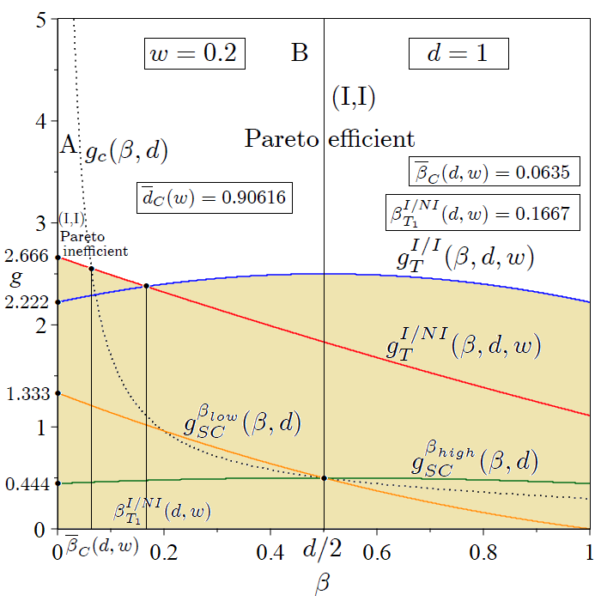
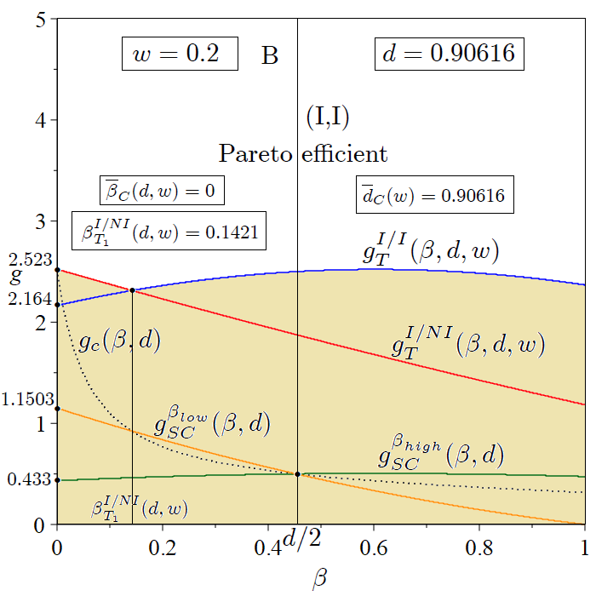

(A) (B)
Figure A.4. The R&D investment decision game: Nash equilibrium outcomes when $0<w<\frac{1}{2}$ ($w=0.2$) and ${d=1>\overline{d}}_{C}\left(w\right)$ (Panel A) and ${d=\overline{d}}_{C}\left(w\right)=0.90616$ (Panel B). The sand-coloured region represents the parametric area of unfeasibility in the $\left(β,g\right)$ space. In Panel A, the R&D game is a prisoner’s dilemma (area A) and an anti-prisoner’s dilemma (area B). In Panel B, the prisoner’s dilemma is solved, and the R&D game is anti-prisoner’s dilemma irrespective of the parameter scale (area B).

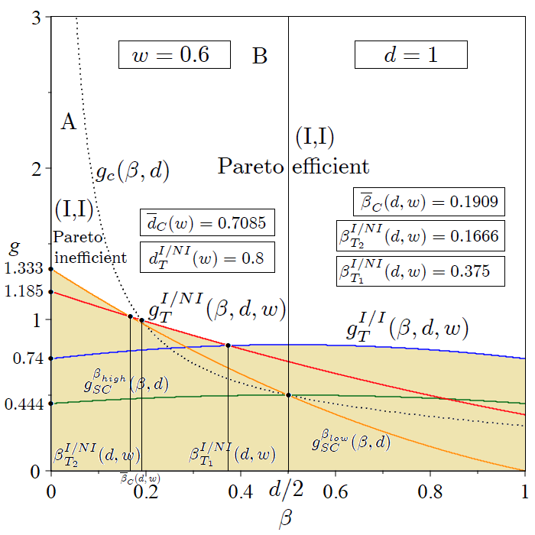
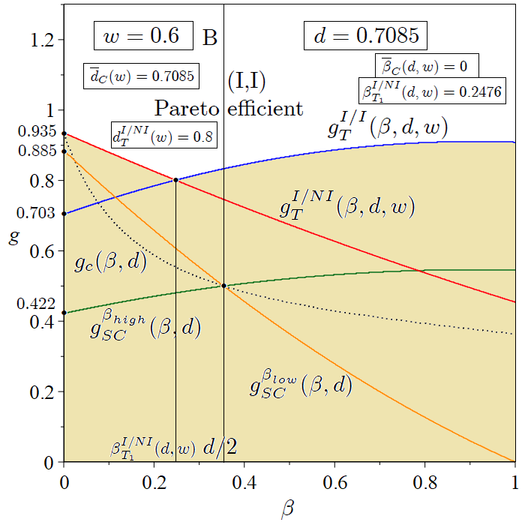

(A) (B)
Figure A.5. The R&D investment decision game: Nash equilibrium outcomes when $\frac{1}{2}≤w<\frac{5}{8}$ ($w=0.6$) and ${d=1>\overline{d}}_{C}\left(w\right)$ (Panel A) and ${d=\overline{d}}_{C}\left(w\right)=0.7085$ (Panel B). The sand-coloured region represents the parametric area of unfeasibility in the $\left(β,g\right)$ space. In Panel A, the R&D game is a prisoner’s dilemma (area A) and an anti-prisoner’s dilemma (area B). In Panel B, the prisoner’s dilemma is solved, and the R&D game is an anti-prisoner’s dilemma irrespective of the parameter scale (area B).

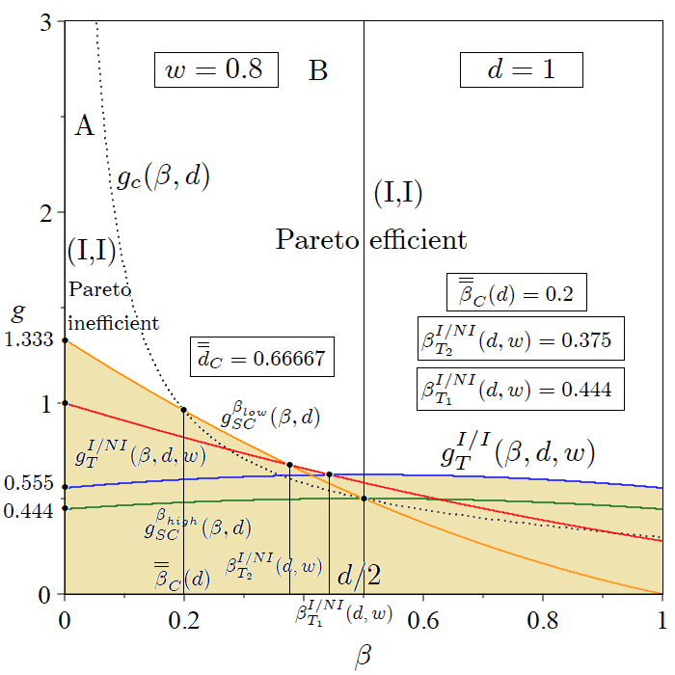
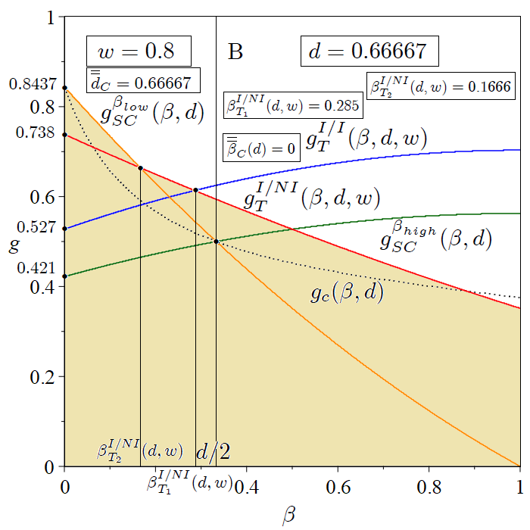

(A) (B)
Figure A.6. The R&D investment decision game: Nash equilibrium outcomes when $\frac{2}{3}≤w<1$ ($w=0.8$) and $d=1>{\overset{̿}{d}}_{C}=\frac{2}{3}$ (Panel A) and $d={\overset{̿}{d}}_{C}=\frac{2}{3}$ (Panel B). The sand-coloured region represents the parametric area of unfeasibility in the $\left(β,g\right)$ space. In Panel A, the R&D game is a prisoner’s dilemma (area A) and an anti-prisoner’s dilemma (area B). In Panel B, the prisoner’s dilemma is solved, and the R&D game is an anti-prisoner’s dilemma regardless of the parameter scale (area B).

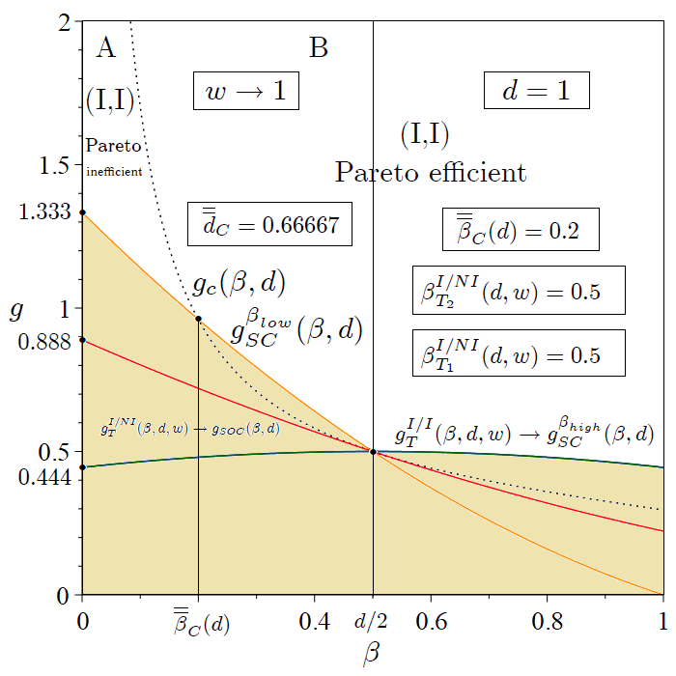
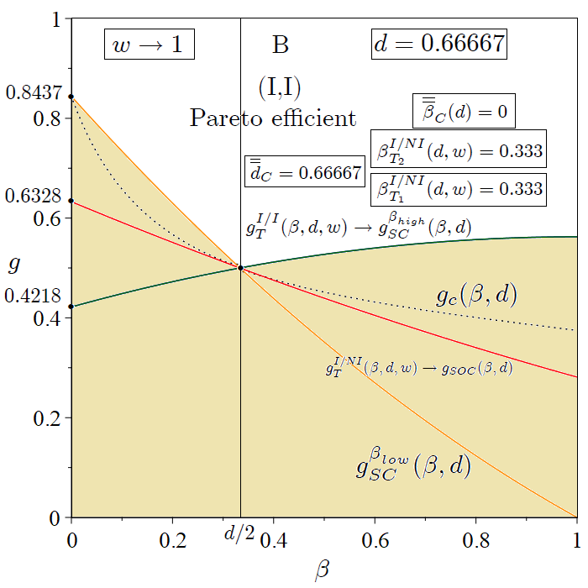

(A) (B)
Figure A.7. The R&D investment decision game: Nash equilibrium outcomes when $w→1$ and $d=1>{\overset{̿}{d}}_{C}=\frac{2}{3}$ (Panel A) and $d={\overset{̿}{d}}_{C}=\frac{2}{3}$ (Panel B). The sand-coloured region represents the parametric area of unfeasibility in the $\left(β,g\right)$ space. In Panel A, the R&D game is a prisoner’s dilemma (area A) and an anti-prisoner’s dilemma (area B). In Panel B, the prisoner’s dilemma is solved, and the R&D game is an anti-prisoner’s dilemma regardless of the parameter scale (area B).

