Appendix
Details of the computer program
1. The main window of the program
The main program window (Fig. A-1) provides access to all parts of the program. On the left side, there is a list of loaded layers with given depths at which they were made, clicking on any layer causes generating its preview in the field in the middle of the main window. At the bottom of the window, there is a message window through which the program communicates information to the user. On the right side is the button bar and sample information.
Fig. A-1
Available buttons (Fig. A-1, right side, sequentially from top):
- Add layer (Dodaj warstwę) - the program opens a new window that allows the user to load a file with an image of the surface of a new layer and to fill in the information about its depth,
- Delete layer (Usuń warstwę) - removes the layer selected in the field on the left side of the program,
- Edit layer (Edytuj warstwę) - allows the user to change the parameters of already added layers,
- Set PPU (Ustaw PPU) - allows the user to change the PPU scale factor and set the units in which the depths are given,
- Cross-sections (Przekroje) - opens the module for generating artificial cross-sections,
- Rendering - opens the surface reconstruction module,
- New project (Nowy projekt) - erases all data loaded in the program,
- Load project (Wczytaj projekt) - loads the project saved in the *.vcs file,
- Save project (Zapisz projekt) - saves the project to the *.vcs file,
- Exit (Zakończ) - ends the program.
The program offers the possibility of saving the results of work to a file as a project. This allows the user to return to the project later without having to retype the data. The data is saved as *.vcs files. In fact, these are standard text files formatted according to the following scheme: the first line contains the data necessary to recreate the PPU scale factor and the measurement unit used in the project. All the following lines contain information about the following loaded layers:
- layer depth in the units used,
- layer depth in pixels,
- name of the layer image file,
- lower and upper threshold of the thresholding range.
Please note that the image files must be in a folder with the same name as the name of the project file containing the images, and the *.vcs project file and the image folder must also be in the same folder.
2. Scale Settings (PPU Factor)
In order to translate the depths of layers given in SI units into the depth values in pixels, the scale factor PPU (Pixels per Unit) is used. It is calculated using the formula:
This factor is calculated automatically. It can be changed in the Set PPU (Ustaw PPU) window, which additionally allows the user to change the units used in the program (Fig. A-2).
Fig. A-2
3. Adding and editing layers
To add a new layer, click the "Add layer (Dodaj warstwę)" button, then a file selection window will open, allowing you to locate the image of the layer being added. After selecting the file you are interested in, click the "Open (Otwórz)" button. It is possible to read the depth from the file name as long as it conforms to the pN.jpeg scheme (it can also be pN.jpg), where N stands for a numerical value. After opening the file, the layer edition window will appear (Fig. A-3).
Fig. A-3
In the layer editing window, we can change the depth at which the layer is located and the threshold range. In order to make it easier to change the threshold range, we can preview the effect after selecting the "Preview (Podgląd)" box. Remember to select thresholds from 0 to 255, entering a different value will cause the program to perform auto-correction. After each change of thresholds, refresh the preview view by pressing the "Refresh (Odśwież)" button. To quit adding a layer, press the "Cancel (Anuluj)" button, otherwise clicking the "Save (Zapisz)" button will add the layer.
Editing of an already added layer is possible after clicking the "Edit layer (Edytuj warstwę)" button. The same window will be displayed as in the case of the "Add layer (Dodaj warstwę)" command, with the difference that all values will be completed as it was entered when adding the layer. Layer editing can be terminated by pressing the "Cancel (Anuluj)" button, this will close the window and the changes will not be saved.
The user can delete layers by clicking on the "Delete layer (Usuń warstwę)" button. Note that deleting a layer to streamline workflow is instantaneous without prompting for an additional query.
4. Cross-section module
The cross-section module allows the user to view volumetric data using cross-sections in the three basic planes X-Y, X-Z, and Y-Z. After starting the module, the cross-sections through the center of the sample are automatically selected. The X-Y plane is selected by selecting a preview of one of the selected cross-sections. The X-Z and Y-Z planes are selected with sliders. The user can read the parameters of the cross-sections from the fields in the middle of the window (Fig. A-4).
Fig. A-4
5. Surface rendering module
After pressing the Rendering button, the data processing preview window is displayed (Fig. A-5). After the operation is completed, the appropriate rendering engine is started. Rendering again bypasses the data processing, unless changes are made to the loaded layers.
Fig. A-5
In the running rendering window, the surface of the restored object is displayed. The user has the ability to rotate the object using the sliders on the bottom and the right. The P button is used to switch between the point cloud view (Fig. A-6) and the reconstructed surface view (Fig. A-7). To zoom in on an object, left-click on the object, and zoom out by right-clicking on the object.
Fig. A-6
Fig. A-7
6. Hardware requirements
The algorithms used in the program require large amounts of memory and an efficient processor. Most of the stages of data processing do not take up much computer memory except when it becomes necessary to allocate it for volumetric data interpolation, thresholding, and surface reconstruction. This is the moment when memory may run out, any errors related to it are handled in the program code and do not result in its suspension. In case of insufficient memory, a message is displayed informing about it, and processing is interrupted.
For the program to work, it is necessary to have Microsoft Windows with the .NET Framework 2.0 installed and a DirectX compatible graphics card. It is difficult to judge the exact hardware requirements as this would require testing a certain control group of computers. The application was tested on a computer with the following configuration:
- CPU: Intel Core 2 Duo T8300 2.40 GHz,
- operating memory: 4 GB.
The size of the application is less than 100KB, so the required hard disk space depends only on the number of projects you will store.

Figures (appendix):

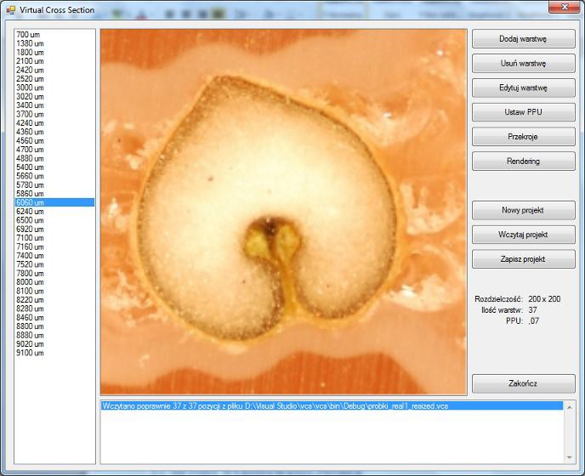
1

2

3

4

Fig. A-1. The main program window with the loaded sample set: 1 - list of loaded layers, 2 - preview of the currently selected layer, 3 - message window, 4 - buttons, and additional information. Source: Authors’ own study

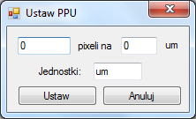
Fig. A-2. The window for setting the PPU factor and units. Source: Authors’ own study

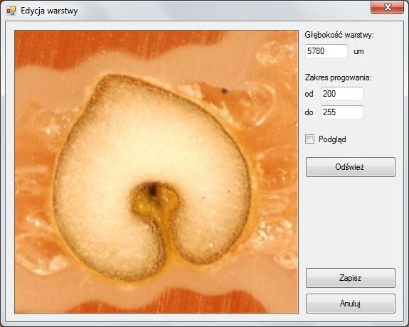
Fig. A-3. The layer edition window. Source: Authors’ own study

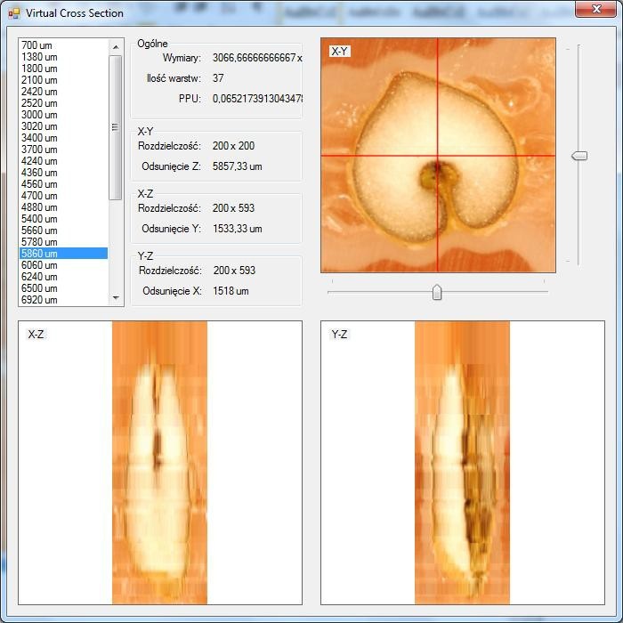
1

3

2

Fig. A-4. Cross-sections module (it is possible to run it after loading at least three layers): 1 - list of loaded layers, 2 - preview window for X-Z and Y-Z cross-sections, 3 - artificially generated cross-sections. Source: Authors’ own study

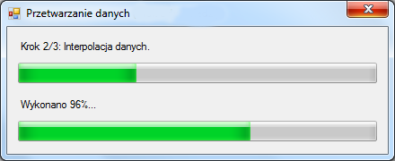
Fig. A-5. The data processing window. Source: Authors’ own study

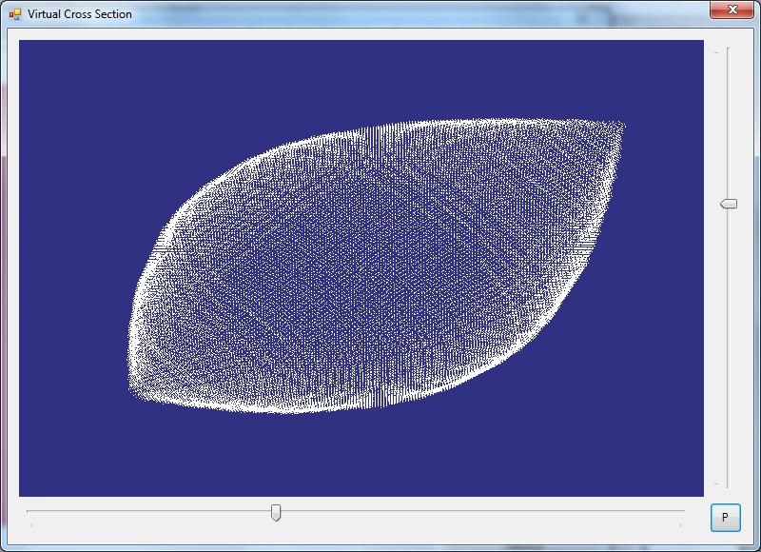
Fig. A-6. Render window opened in the point cloud display mode. Source: Authors’ own study
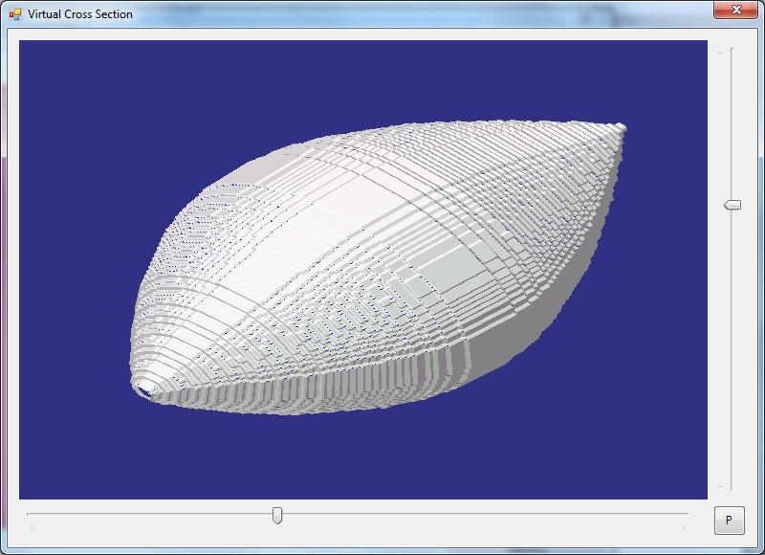
Fig. A-7. Render window launched in the surface reproduction mode. Source: Authors’ own study

