APPENDIX A: First phase of the Delphi study

Virtual Patients in MOOCs - First Phase of the Survey.

Introduction:

Virtual Patients are computer–based interactive clinical scenarios used to practice clinical reasoning skills at medical universities and in continuing medical education. Below you may find a typical example of a virtual patient:

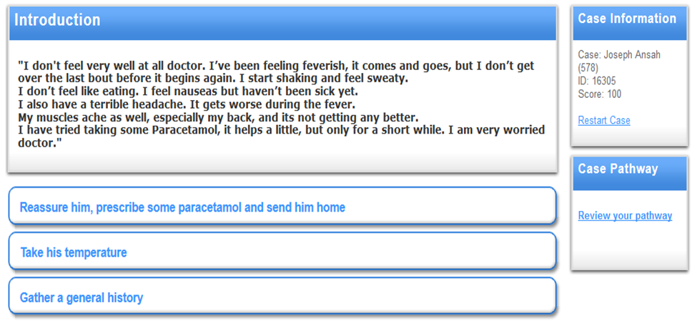
Figure 1: Virtual Patient example.

[Retrieved from: http://www.virtualpatients.eu/]

Massive Open Online Courses (MOOCs) are on–line courses offered at the same time to thousands of participants around the world. Everyone interested in the topic can participate.

Medical universities start to engage in MOOCs, but there is no previous experience in how to use virtual patients in such environments. Before investing time in the development we would like to investigate your opinion about the proposed scenarios for using virtual patients in MOOCs.

In the following questionnaire three scenarios are presented. After each scenario we ask about your opinion of its strengths and weaknesses. Please make the judgment from the viewpoint of your profession. In addition a textbox for further comments is available.

Scenario A:
Virtual Patients often begin with incomplete or conflicting clinical data. In such situations even the experts’ decisions are not in agreement. The Script Concordance Test (SCT) is a technique in medical education that measures clinical reasoning in the context of uncertainty. The story of the virtual patient is interrupted and the learner is asked to decide whether the new information provided makes the hypothesis much less likely, less likely, neutral, more likely or much more likely (Likert scale, see figure 2). At first this type of question is presented to a set of experts to collect their answers. Then the experts’ answers are used to define the score of the learners. Adding such a question type to MOOCs allows the collection of more experts’ and learners’ answers and by that an interesting comparison of the individual clinical reasoning skills. The division into experts and learners can be done at the beginning of the course manually. While observing the performance of the learners, more weight to high score answers can be given. Throughout this process, the participants are given a summary of the collected answers and are able to discuss them on–line and compare them with their own choices.

Figure 1: “Example of clinical vignettes developed for a script concordance examination used in a first aid course for third-year pharmacy students”:
Boulouffe C, Charlin B, Vanpee D. Evaluation of Clinical Reasoning in Basic Emergencies Using a Script Concordance Test. American Journal of Pharmaceutical Education. 2010; 74(10):194

Figure 2: example of the SCT approach

- Which are the strengths / weaknesses that you identify for the Scenario A? Please make the judgment from the viewpoint of your profession.
- Further comments:

Scenario B:
The way that experts are diagnosing and providing treatment globally can vary due to cultural, legal and financial differences among nationalities. The participants of the course need to consider these variances and address them further. This scenario suggests providing the participants with separate discussion boards based on national or regional level. The participants can discuss each case on a discussion forum where they are divided in a geographical hierarchical level based on the region of interest (e.g. figure 3). The selection of region can change depending on the interest of the learner. Adding separate discussion boards for the virtual patient cases in the MOOC allows the participants to address their individual information needs while the high number of participants informs the collected data further.

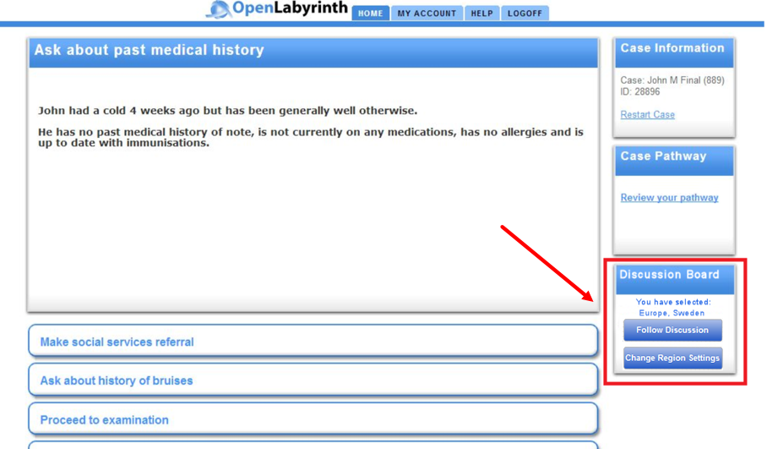
Figure 3: example of discussion board link in a case

[Retrieved from: http://www.virtualpatients.eu/, modified picture]

- Which are the strengths / weaknesses that you identify for the Scenario B? Please make the judgment from the viewpoint of your profession.
- Further comments:

Scenario C:
Each virtual patient’s story should contain unique values of the physiological and anatomical characteristics to represent real situations and by that the final outcome is depended on the initial input. Adding mathematical models to the virtual patient allows the learner to explore the different outcomes depending on the various inputs. From the users’ perspective it would be visible as: The case is interrupted by a learning discovery task where the learner is encouraged to try different input parameters (e.g. figure 4). Once the learning task is over the story continues with the initial values. This provides the MOOCs' learners the opportunity to experiment with the different values and enhances the individual learning.
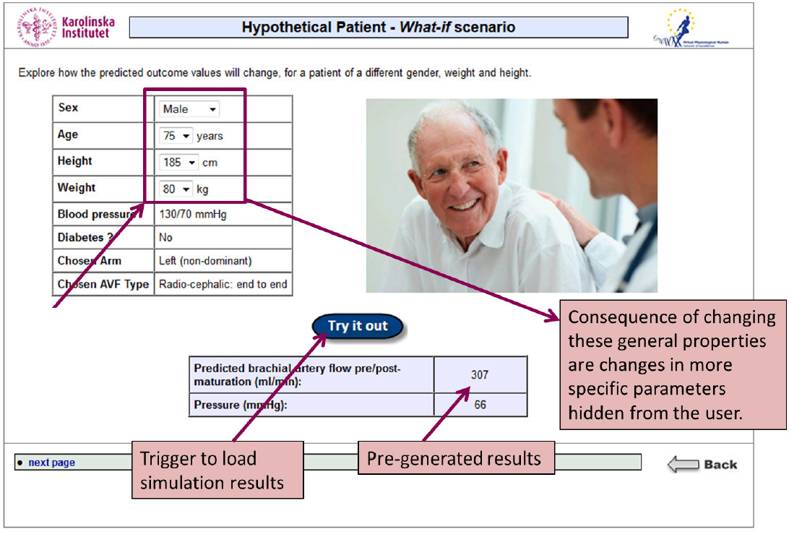
Figure 4: Learner can try different input parameters and explore how the outcome will change.

[Kononowicz AA, Narracott AJ, Manini S, Bayley M, Lawford PV, et al. A Framework for Different Levels of Integration of Computational Models into Web - Based Virtual Patients, J Med Internet Res 2014; 16:e23]

- Which are the strengths / weaknesses that you identify for the Scenario C? Please make the judgment from the viewpoint of your profession.
- Further comments:

Current profession/activity:

Please select your current profession/activity:
- Healthcare Professional (physician; nurse)
- Virtual Patient System Developer
- Medical Student
- Other: _____________________

APPENDIX B: Second phase of the Delphi study

Virtual Patients in MOOCs - Second Phase of the Survey:

Considering the collected feedback and categorization of the first round of the questionnaire (found in the attached file “collected feedback” of the e-mail) please prioritize the scenarios according to the following aspects:

- Enhancing learners’ clinical reasoning skills
- Potential of raising learners’ interest
- Taking advantage of the MOOCs’ potential
- Feasibility of their implementation

You may answer in this document or via e-mail, by writing after the number of each aspect the order that you would prioritize the scenarios. For example the following format:
      - A, C, B would mean that scenario C has the potential to enhance the clinical reasoning skills of the learners more than the scenario B but less than the scenario A.

Answers:

1.
2.
3.
4.

Thank you for your valuable contribution!

