The literature search started on March 20th 2022 and I asked two questions on Teams about the literature search. Additionally, I had an overall understanding of the methodology, which incorporates seven steps (e.g. searching, extraction) (see the picture below). 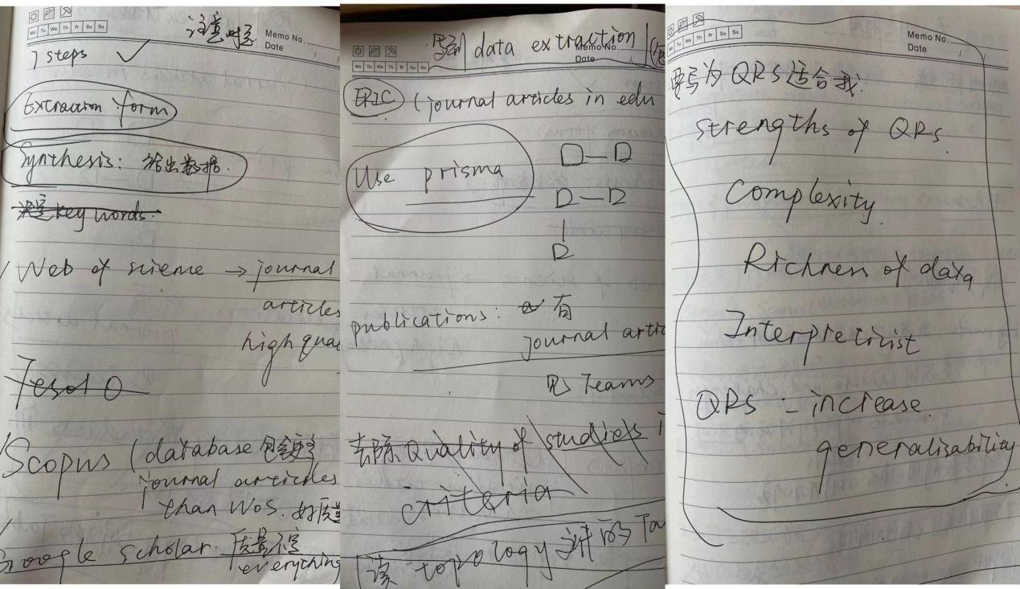
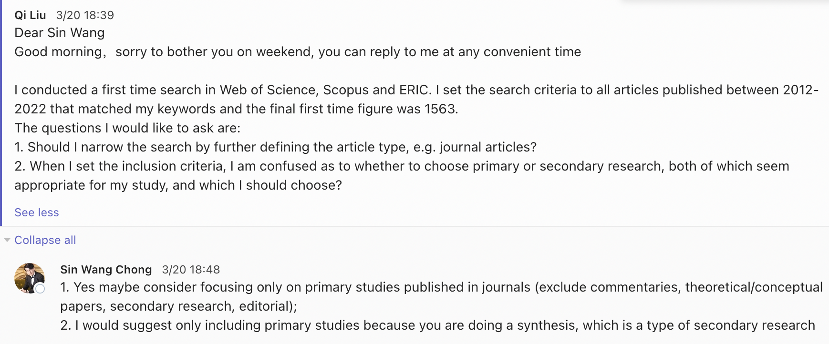
The first meeting on data extraction and literature search was on March 25th 2022. I raised a list of questions in the photo below and we discussed them together. The photo below shows not only the questions but also the solutions to fix them. Sin Wang viewed the search results and had a discussion about the results and the inclusion criteria with me. The result was to conduct the search again and to design an extraction form based on the three research questions.
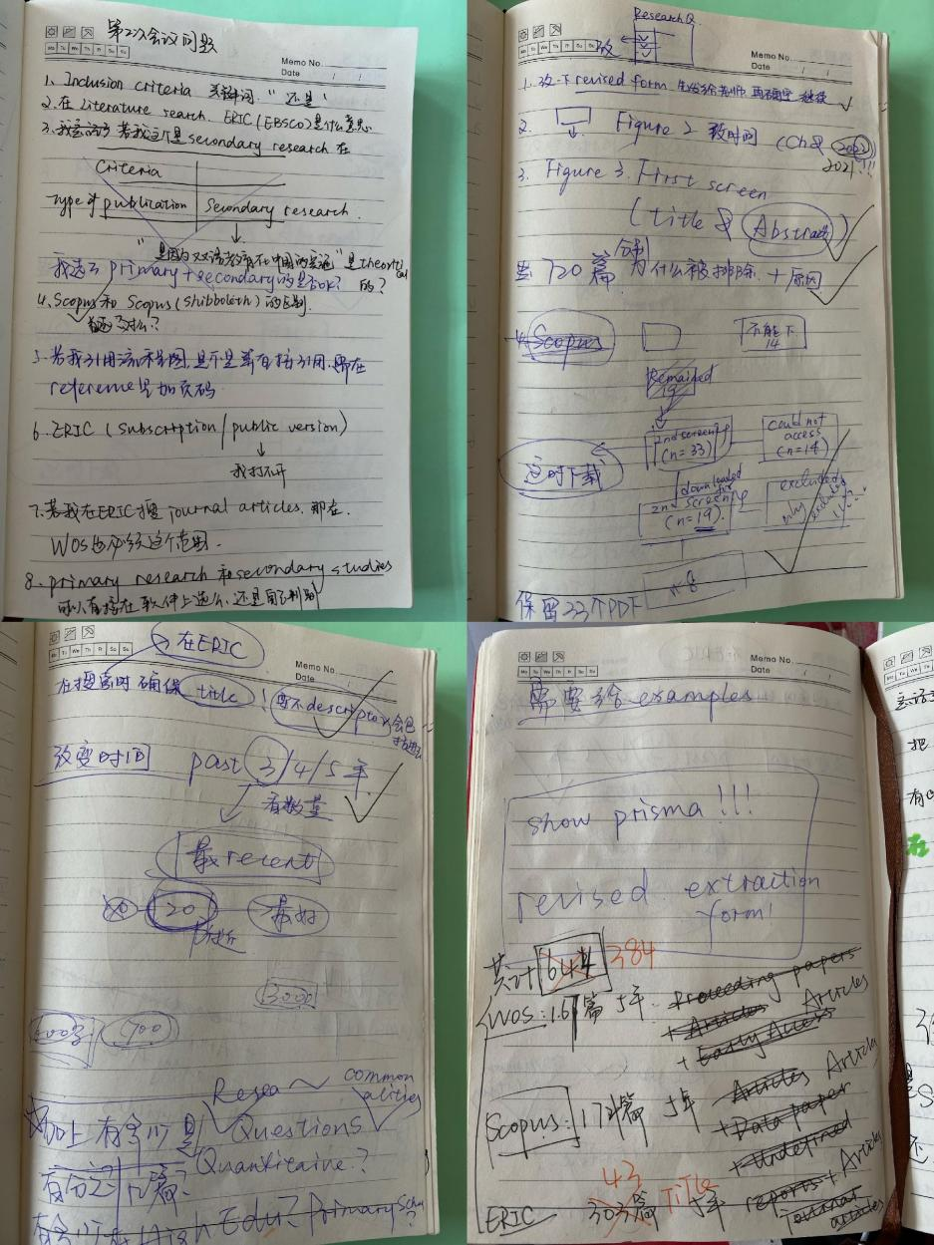
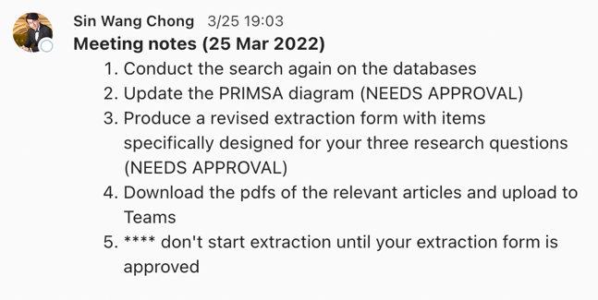

The picture below is the record of reasons for excluding studies in the first-level screening. I completed a literature search, submitted an extraction form, and received feedback from Sin Wang on March 31st 2022. I started piloting three studies.
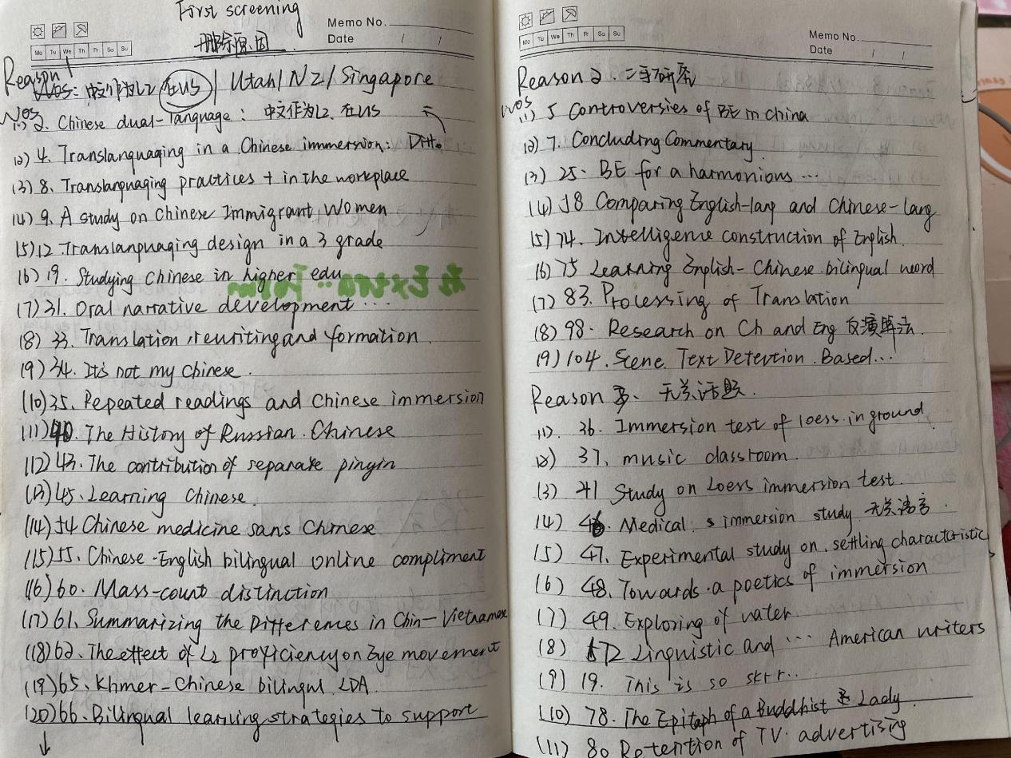
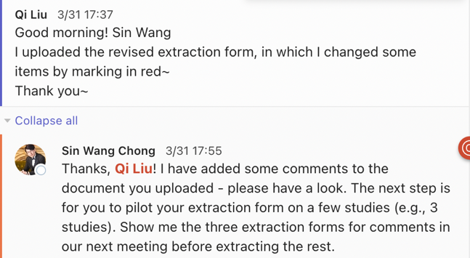
The three piloted studies were submitted on April 7th 2022. I received feedback from Sin Wang on April 8th 2022 and began extracting the remaining 13 studies. In the meeting on April 8th 2022, I had some new questions and we discussed those questions together.
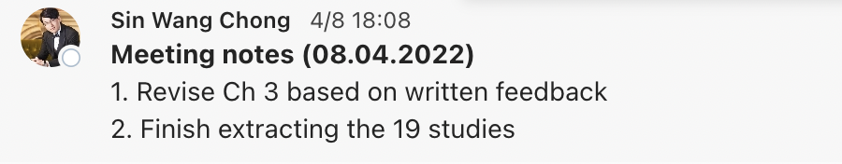
I received feedback on April 22nd 2022. Then I checked the 16 extraction forms and began coding the information in the 16 data extraction forms.
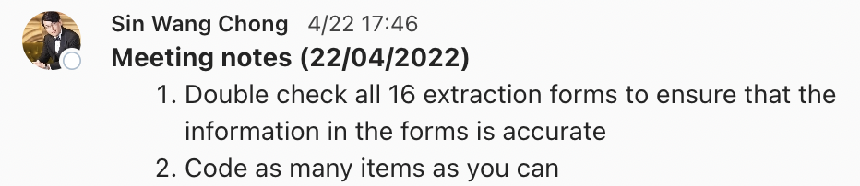
Below is an extraction from my notebook where I was in the process of developing descriptive categories from the 16 extraction form.
I received feedback on May 13th 2022 and we discussed some queries about PRISMA which is shown in the picture below. The second picture below are the notes that I took for revision and solutions to resolve the questions. Then I finished coding the background information and began synthesising the information about the first research question on May 25th 2022.
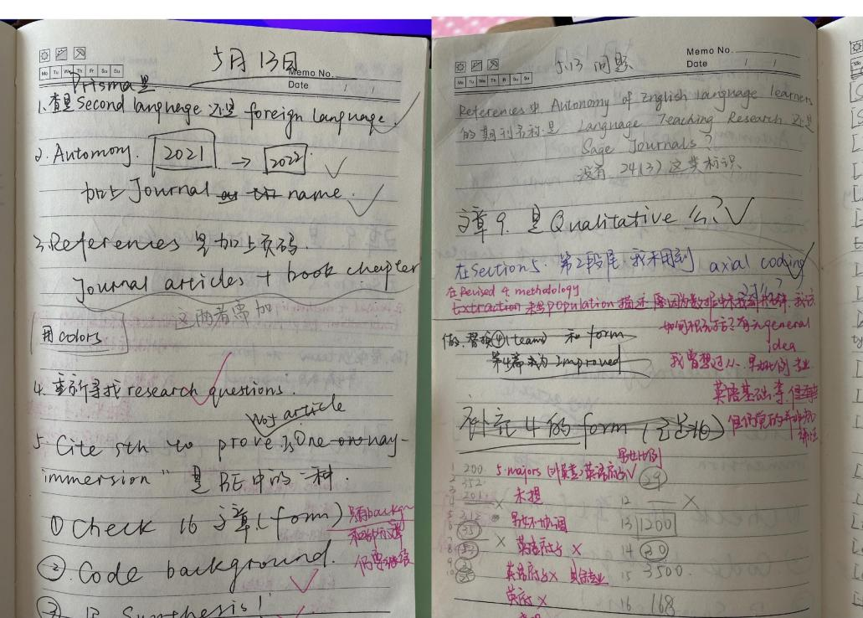
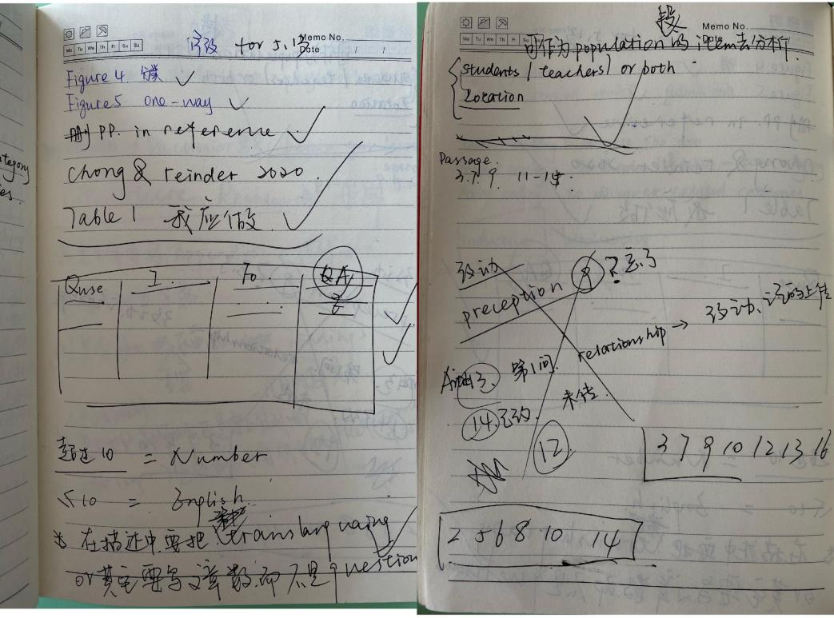
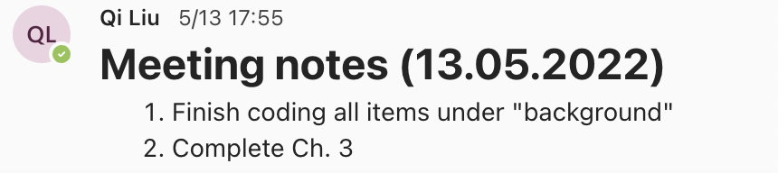
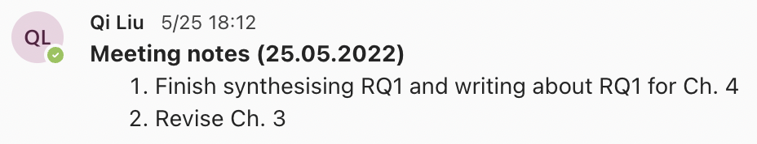
The first photo below is the questions I raised on May 25th 2022. The second photo below is the notes I took to resolve the questions mentioned above. The third photo below is the process of extraction created on May 27th 2022.
Below is a photo of my notebook where I created memos for coding three research questions. The use of memos in developing conceptual understanding of data is a recommended practice by grounded theorists such as Kathy Charmaz.
The extraction on the remaining articles began on June 1st 2022 and I received feedback on June 8th 2022. The extraction and synthesis were finished on June 14th 2022. The first photo below are the questions raised by me and the second photo below is the discussion outcomes.
