Supplementary Figure 1. Report for the individual laboratory for category 4 programmes. Years 2003 and 2019

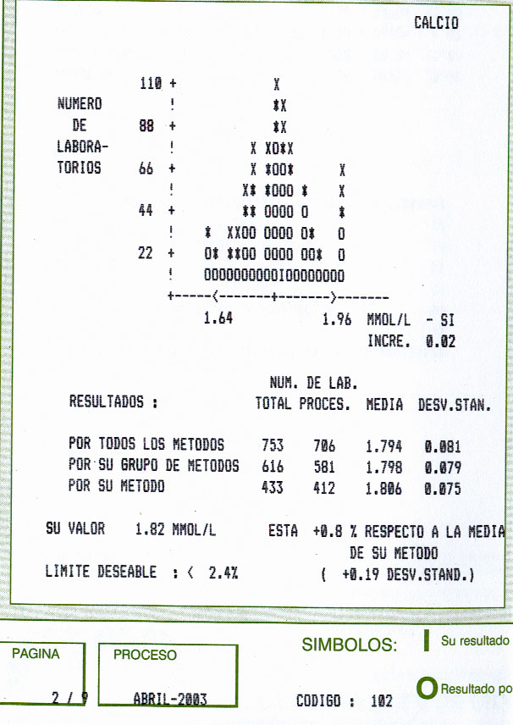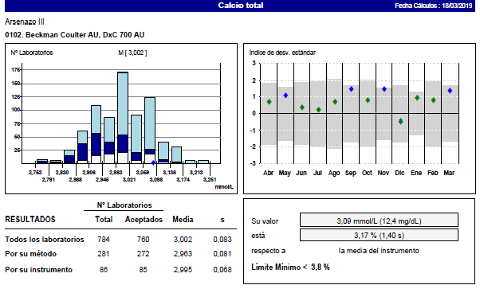

Supplementary Figure 2. Report for the individual laboratory for category 1 programmes.

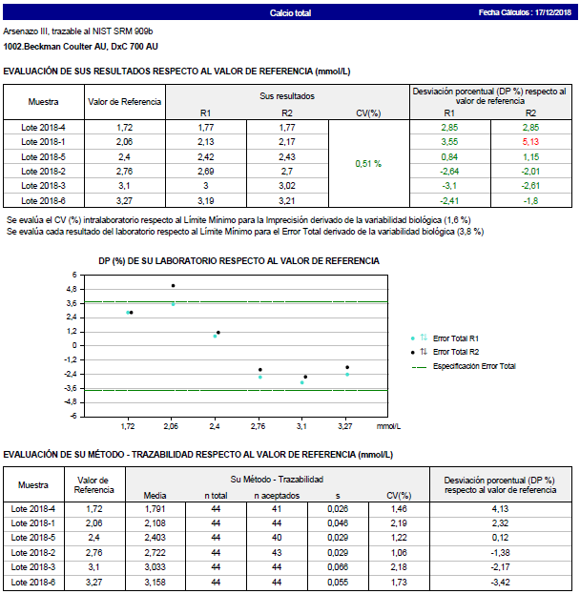

Supplementary Figure 3. Evolution of the 90th percentile of the PD% with respect to the homogeneous group (analytical ET) in the hormone programme

